
United Nations Industrial Development Organization [UNIDO]
Attn: Aymen AHMED/KP
A.Ahmed@unido.org
Procurement Services Division
UNIDO HQ, Vienna, Austria

CTCN Request Reference Number: 2019000058

FEASIBILITY STUDY FOR LOW EMISSION LAND TRANSPORT SECTOR IN VANUATU

Final feasibility report
on barrier removal program for the land transport sector of Vanuatu



Implementing organization:
Overseas Environmental Cooperation Center, Japan (OECC)

Table of Contents
Introduction 4
1. Introduction of the final report 4
Analysis of Socio-Economic Variables of the Transport Sector in Vanuatu 9
2. Socio-economic dimensions 9
3. Barriers in reducing transport GHG emission of Vanuatu 32
4. Low carbon vision and targets 45
5. Proposed measures on EV uptake in Vanuatu 50
6. Organization of the Capacity Building Seminar and 2nd Stakeholder’s consultation 87
7. Recommendations 90
Annexes 92

Introduction

1. Introduction of the final report

Currently, the Republic of Vanuatu lacks technical and financial resources as well as in-country expertise to conduct a feasibility study for low emission land transport sector. Therefore, Vanuatu has requested technical assistance to the Climate Technology Centre & Network (CTCN) to study the land transport sector and clearly identify the feasibility of reducing GHG emissions through the implementation of energy efficiency measures in Vanuatu’s land transport sector.
The CTCN has selected the Overseas Environmental Cooperation Center, Japan (OECC) to conduct this feasibility study.
This document is the final report summarizing the background analysis of barriers to low carbon development in Vanuatu’s land transport sector.

The Terms of Reference requested the organization of a stakeholder’s consultation followed by a field mission in Vanuatu. However, due to the coronavirus pandemic it was not possible for the implementing entity (OECC team) to visit the country and conduct this activity directly.

With the authorization of the Vanuatu NDE and the CTCN, the OECC team has been forced to conduct research activities through a local consultant, but difficulty in obtaining updated information has forced the team to modify the general schedule of the project.

This study describes results obtained by sourcing of primary and secondary information. A Stakeholder’s Consultation has been successfully organized and interviews to stakeholders were conducted just after conduction of “Capacity building” for stakeholders.

Also, those who are interested in the introduction EVs and the improvement of the land transport system from the Pacific Island Countries (PIC) are openly invited to this capacity building to share the benefits through the presentations and discussions afterward.

Now the barriers analysis has been finalized and opinions from the stakeholders just after the capacity building has been given, it has become available to reflect the results in this report, the OECC team was able to prepare the final report incorporating as much information obtained as possible and final results from the stakeholder consultation.

1.1 Study objectives

The study is aiming at delivering the final feasibility study report generated from this TA to provide concrete evidence to the Vanuatu government for immediate decision and action on the transport sector energy efficiency.
In consideration of the TOR, “Output 4”, “Activity 4.1” saying that “A three days’ capacity building program will be organized in Vanuatu including findings of the study and way forward.”, OECC team planned and performed the three days’ capacity building and the stakeholder consultation afterward in order to clarify what was done during the TA project and make the participants known the findings obtained through the whole course of the achieved study relating to the barriers to low carbon development in Vanuatu’s land transport sector and how they can be removed are identified and analyzed.
It was successfully completed and its result is detailed in this final feasibility study report.

The concept note on the feasibility study will be completed incorporating the feedback from the
above mentioned consultation and will be reviewed by NDE and Project proponent for finalization.
To ensure the effective continuation of the work carried out under this technical assistance, the program was developed in align with the requirements of the template of the GCF note. GCF concept note template should be attempted to be filled with best available data and information generated from the program. However, based on the gaps identified from the feasibility of the proposed barrier removal interventions, most suitable approach, as applicable, will be followed with suitable supporting mechanisms for example strengthening institutions, if found as a gap, may be advised to be addressed through readiness support from GCF.

The current study is divided in three parts: The Analysis of Socio-Economic Variables and Analysis of Technical Variables of the Transport Sector in Vanuatu, and a summary of the Stakeholder’s Consultation.

1.2 Background

Vanuatu is a small island country located below the equator in the Western Pacific Ocean. It is composed by 83 islands covering an area of 12,200 square kilometers. With an almost entirely Melanesian population of 300,019 people as registered in the 2020 census, Vanuatu is the fourth largest country in the Pacific following Papua New Guinea, Fiji, and Solomon Islands. The country is administratively divided into six provinces – Malampa, Penama, Sanma, Shefa, Tafea, and Torba. Vanuatu’s capital Port Vila, is located in Efate Island (Shefa Province), and together with Santo Island (Sanma Province), these are the largest cities of the country, and the gateways for most visitors to Vanuatu.

Vanuatu’s climate is tropical, with two distinct seasons – a warm, wet season and a cooler, dry season. The climate varies considerably from year to year, mainly due to the effects of the El Niño-Southern Oscillation (ENSO) system. Although Vanuatu is one of the lowest greenhouse gas emitters in the world, it is one of the most vulnerable nations to the impact of climate change. The island nation is affected by cyclones, droughts, extreme precipitation and flooding, and landslides. As time passes, these climatic risks are likely to become more intense because of climate change. Around Vanuatu the rate of sea level rise has been on average 6 millimeter annually over the last two decades. This has made storm surges, cyclones, strong winds, and tsunamis more damaging than ever before. Among countries which suffer average annual losses ranging between 1 and 10 percent of GDP when extreme events strike, Vanuatu ranks second with annual losses of almost 7 percent.

Vanuatu's economy is based primarily on agriculture, fishing and tourism. These sectors are already experiencing stresses from climate variability and climate change. The corona virus pandemic has further intensified the pressure mainly to the air transport and hotel sectors, as a result of international travel restrictions, which exacerbates the country’s economy as well. These climatic effects are expected to intensify, resulting in continued increases in mean annual and seasonal temperatures, changes in rainfall patterns, increases in extreme weather events such as cyclones, and continued sea level rise and ocean acidification.

In addition, climate change in Vanuatu is expected to impact human health in numerous ways, including an increase in diseases, mortality and morbidity associated with climate related disasters and a deterioration in food-safety and security. Adaptation to the health impacts of climate change in Vanuatu are hindered by environmental and socio-economic stresses already facing the country.

While not a climate-related factor, Vanuatu has also been exposed to multiple geophysical threats such as volcanic eruptions, earthquakes and tsunamis, as well as human, animal and plant diseases, and disasters, which has also been a critical factor hindering its national development.

The figure below show how dramatic is the situation faced by the country. Tide-gauge records (purple) of relative sea level and the satellite record (green) since 1993. The reconstructed sea level data at Vanuatu (since 1950) is shown in black. Multi-model mean projections from 1995–2100 are given for the very high (red solid line) and very low emissions scenarios (blue solid line), with the 5–95% uncertainty range shown by the red and blue shaded regions. The ranges of projections for the four emissions scenarios by 2100 are also shown by the bars on the right. The dashed lines are an estimate of year-to-year variability in sea level (5–95% uncertainty range about the projections) and indicate that individual monthly averages of sea level can be above or below longer-term averages.

Fig. 1.1: Registered and projected sea level rise in Vanuatu
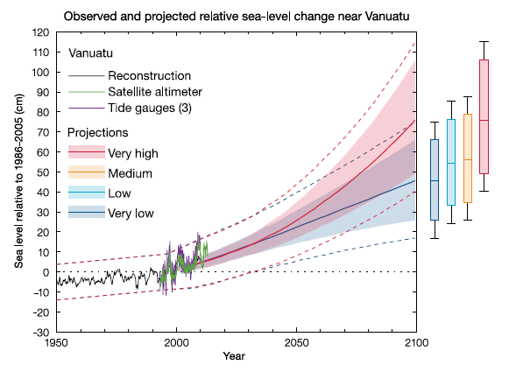
Source: Current and Future Climate of Vanuatu, Country Brochure

- Sectoral and Institutional Context

The transport sector is under the overall jurisdiction of the Ministry of Infrastructure and Public Utilities (MIPU). The Ministry has the mandate to develop, maintain, and manage the key national infrastructure assets in the areas of land transport, maritime transport, aviation and water supply. MIPU consists of 1) Public Works Department (PWD), 2) Ports and Maritime Department, 3) Civil Aviation Authority, and 4) Corporate Services Unit.

The National Sustainable Development Plan (NSDP) sets out fifteen goals within the society, environment, and economy pillars to achieve the National Vision of a stable, sustainable and prosperous Vanuatu. One goal is to improve infrastructure, another to develop climate and disaster resilience, while others refer to improvements in access to markets and services.

The Ministry of Climate Change Adaptation (MCCA) is the primary government entity in charge of climate change and disaster risk management. Established in 2013 as one of the very first ministries of climate change in the Pacific region, MCCA consists of 1) Vanuatu Meteorology and Geo-hazards Department (VMGD), 2) National Disaster Management Office (NDMO), 3) Department of Energy, 4) Department of Environmental Protection and Conservation, and 5) Corporate Services Unit.

Approximately 75% of its approximately 300,000 residents live in highly dispersed rural areas, where the provision of goods and services is limited. Increasing access to safe, efficient, and reliable transport is essential for driving socioeconomic development, and for ensuring that benefits are distributed across the population. Existing transport infrastructure includes a road network of about 2,300 km, 26 domestic airfields and 3 international airports, 10 public ports and jetties on the outer islands, and 2 international ports.

In spite of existing assets, transport services are limited, and the condition of transport infrastructure is deteriorating. This is largely due to unpredictable financial allocations and limited government capacity to support routine maintenance. Vanuatu’s placement on the Pacific Ring of Fire exposes it to heightened risk of natural disasters, and emphasizes the need to factor climate-resilient design into all transport sector development.

Analysis of Socio-Economic Variables of the Transport Sector in Vanuatu

2. Socio-economic dimensions

2.1 Social Dimension

- Demographic Analysis

< Cultural Identification>
The first inhabitants of Vanuatu were the Melanesian people. Europeans first visited the island through a Spanish expedition in 1605, claiming the archipelago for Spain. France and the United Kingdom claimed parts of the country in the 1880s and it was jointly managed in 1906. Vanuatu gained independence from France and the United Kingdom in July 30, 1980.
The inhabitants of Vanuatu are known as Ni-Vanuatu. 98.5% (1999) of the population are of Melanesian descent, ethnically distinct from Micronesian and Polynesian. The rest o 1.5% (1999) comprises a mix of Europeans, Asians (Vietnamese and Chinese) and other Pacific Islanders.

<Major Demographic Indicators>
- Population and Households
Table 2.1 shows Vanuatu’s population tabulated in 2020 National Population and Housing Census (2020 NPHC). In Vanuatu, majority (77.8%) population reside rural, although Port Vila and Luganville (total population for these 2 municipalities: 66,753) have sizable populations. Port Vila is the largest city, and capital of the country with a population of 49,034, accounting for about 16% of the country's total population. Population count and characteristics in 2016 is also shown in Table 2.2.

The population growth rates were the same rates as 2.3% (both 2017 and 2021). However, Percentages of population living in urban areas decreased to from 25.1% (2016) to 22.2% (2021) as indicated in the Tables 2.1 and 2.2.

Table 2.1 Main Indicators on Population in 2020 NPHC
DEMOGRAPHY: 2020 National Population and Housing Census 2020
Population | 300,019
Population growth rate | 2.3%
Population living in urban areas | 23.2%
Population living in rural areas | 76.8%

Table 2.2 Main Indicators on Population in 2016 Mini-Census Report
DEMOGRAPHY: 2016 Mini-Census Report
Population | 272,459
Population growth rate | 2.3%
Population living in urban areas | 25.1%
Population living in rural areas | 74.9%

As for number of households, based on the urban and rural households figures available for the years 1999 and 2010 from two reports the “Energy Efficiency Targets Report – Vanuatu” of the Promoting Energy Efficiency in the Pacific Phase 2 (PEEP2) Project financed by Asian Development Bank (ADB), and VNSO’s “Household Income and Expenditure Survey 2010”, the number of urban and rural households up to 2030 were projected as indicated in Table 3.3 in the following.

The CAGRs for the number of urban and rural households for the period 1999 and 2010 were 3.9% for urban households and 2.8% for rural households. The distribution of rural households among provinces are based on data from the Vanuatu Household Income and Expenditure Survey 2010.

Table 2.3 Projected Number of Households
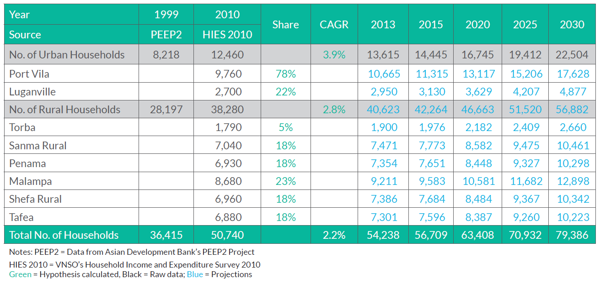

However, the projection made by the ADB study in Table 2.3 above were a little bit higher to what the 2020 NPHC has tabulated, as shown in Table 2.4 below.

Table 2.4 Number of Private Households by Region
 | 2020 Census | Share (%)
Total No. of Households | 63,365 | 100
No. of Urban Households | 14,702 | 23.2
- Port Vila | 11,118 | 17.5
- Luganville | 3,584 | 5.7
No. of Rural Households  (6 Regions) | 48,663 | 76.8
- Torba | 2,392 | 3.8
- Sanma Rural | 9,306 | 14.7
- Penama | 7,863 | 12.4
- Malampa | 9,715 | 15.3
- Shefa Rural | 11,148 | 17.6
- Tafea | 8,239 | 13

- Education
Table 2.5 Education Enrollment and Completion
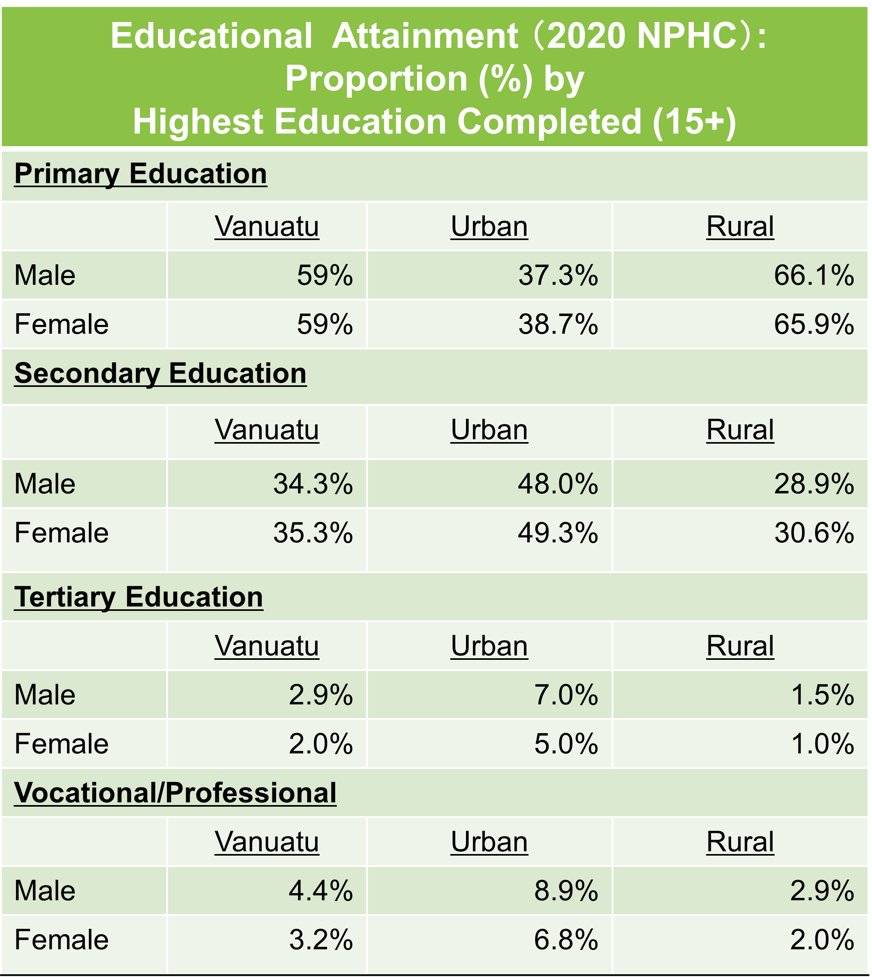
Table 2.5 shows l school enrollment and completion status in Vanuatu (2020 NPHC). From numerical figures of the school enrollment and completion status,
In Vanuatu, there is a significant difference in the proportion of urban and rural areas where enrolment and completion status is perceived as an issue. It can be understood that in rural areas the majority (more than 60% but less than 70%) of the population above 15 years old has completed primary education, while in urban areas a larger proportion has completed secondary education than in rural areas. In higher education (tertiary and vocational/professional), the gap in school completion opportunities between urban and rural areas is even wider.

Vanuatu’s on-going national development plan, that is “Vanuatu 2030: The People’s Plan, National Sustainable Development Plan 2016 to 2030,” calls visions of creating “jobs and income earning opportunities accessible to all people in rural and urban areas”, and outlines “quality of education” as one of the priority goals in social pillars. For integrating the vision and the target in the current development plan, it is expected that land transport and project opportunities as well as educational issues will be taken into account when considering urban and rural land transport options and service content.

In Vanuatu, the most secondary and tertiary education facilities is considered to be located in urban and provincial centers, and there may be aspects of schooling status in Vanuatu society that cannot be dichotomized and explained by demographics based simply on two divisions, rural and urban. However, it is also conceivable as in reality that physical distance to school, the need for transport costs associated with distance and related income levels, as well as the means and time constraints of commuting to school, are reasons for depriving students of the opportunity to enroll and complete the secondary and tertiary education.

From this point on, as explained in the gender section below, some of the literatures have shown that stratification in income and formal sector employment opportunities between urban and rural areas in Vanuatu are closely linked to levels of educational attainment.

- Gender Considerations

<Gender Considerations: “Analysis and Implications drawn from Demographic Profiles and Recent Statistics”>
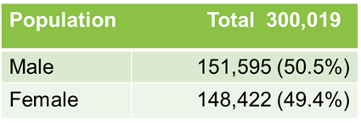
Through the examination of “2020 National Population and Housing Census (2020 NPHC),” (Vanuatu National Statistics Office),” and other literatures discussing and validating gender issues, what gender issues shall be addressed and included in land transportation development (not only in physical development, but also in reviewing and amending existing laws/regulation governing the land transport and operation means), climate change measures, infrastructure development in general, in the context of Vanuatu’s society, are identified in this section.
Table 2.6 Population of Vanuatu

“2020 National Population and Housing Census,” (Vanuatu National Statistics Office) shows that Total population of Vanuatu is 300,019 which are composed of 151,595 (50.5%) of total male and 148,422 (49.4%) of total female, as shown in the Table 2.6.
Table 2.7 Population 18+
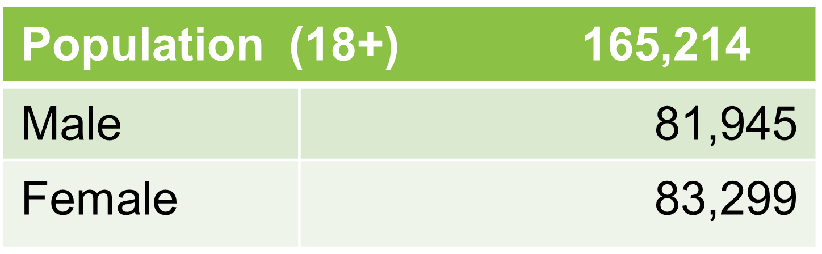
Out of the total male and female, population over 18 years old are 165,214 which are about 55% of the total population. (Table 2.7)

<Majority of the Vanuatu’s population live in rural areas, and may be commuting to workplaces in towns/cities or going into towns/cities for sales etc. by using public transport>
Table 2.8 Population in Urban and Rural

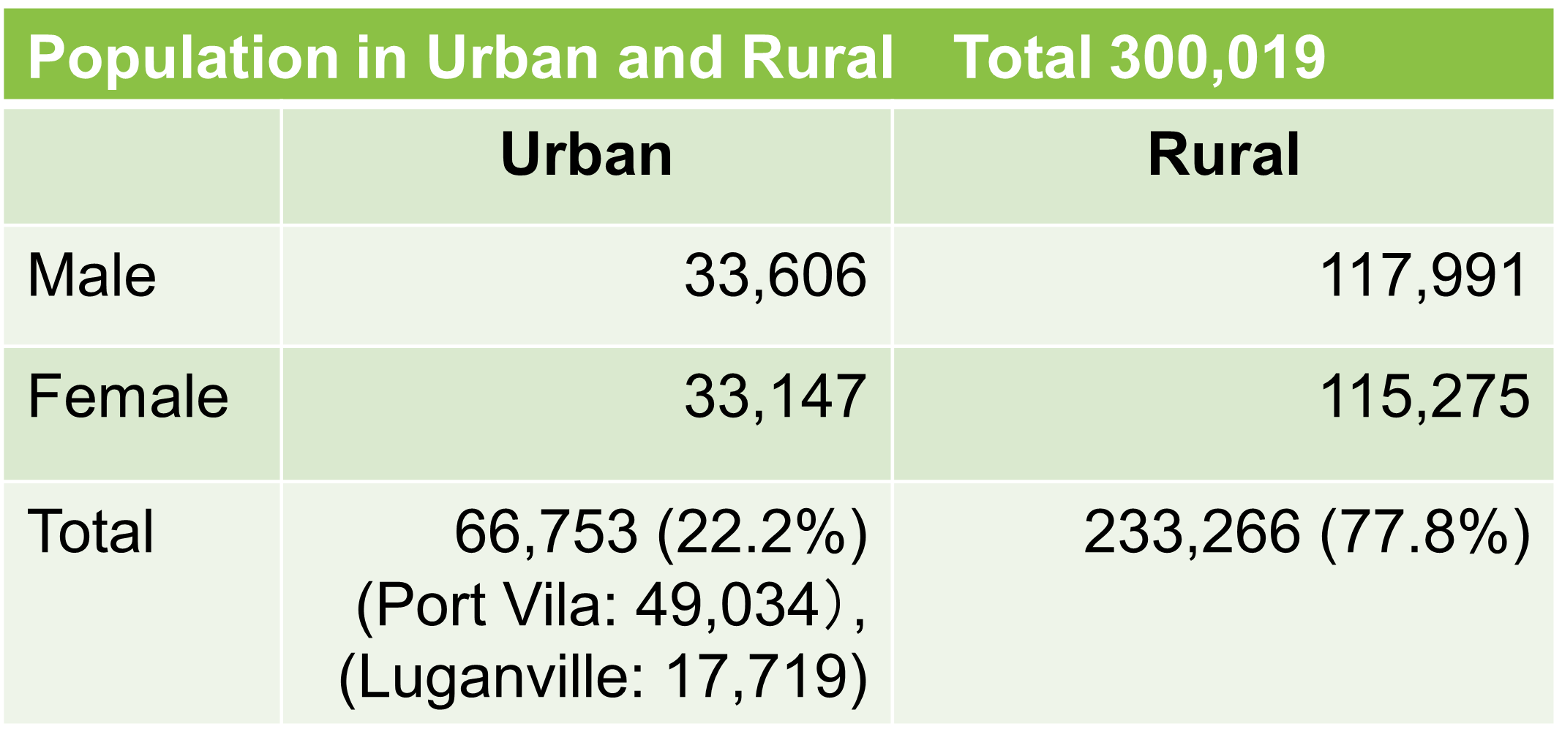
About 22.2% of population reside in urban areas (= 2 municipalities: Port Vila and Luganville) while 77.8% lives in rural areas (Table 2.8). Since 78% of population lives in rural areas, substantial proportion of population are under the circumstance of limited access to markets (either a generous size or a small size) and excessive costs of transport. (“Gender Assessment: Climate Information Services for Resilient Development Planning in Vanuatu”, 2017, GCF).

It is assumed that population residing vicinity
of urban areas or even living in rural areas, use public transport for commuting to workplaces in towns/cities, for carrying out sale activities at markets or street stalls, on daily basis to earn their livelihood or to access essential social services available in towns/cities (by using public transport such as service buses, minibuses and taxis).
Table 2.9 Characteristics of Household HH

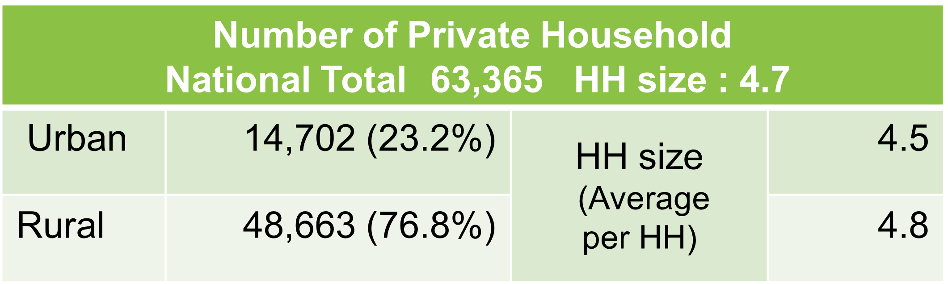
Total number of households in Vanuatu is 63,365, and the average for household size is 4.7. (Table 2.9)

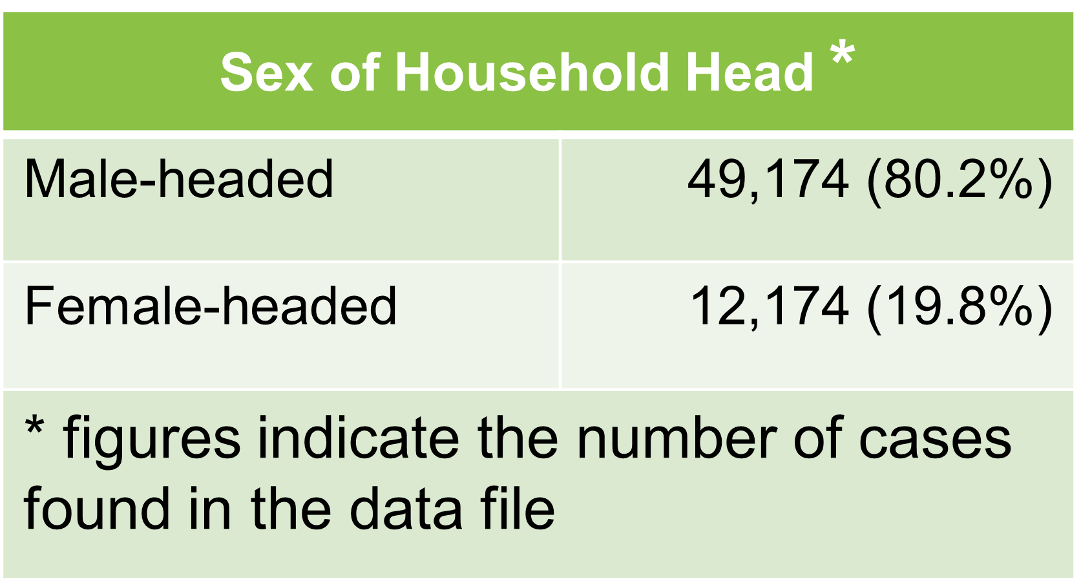
Sex of household head is about 80% are male headed while 20% are female headed.(Table 2.10) As introduced later in this section, predominant employment is in the informal sector, so it can be assumed that many women including women household heads depend on market and roadside sales for their livelihood.
Table 2.10 Sex of Household Head

<Predominant employment is in the informal sector in Vanuatu society. It can be said that the use of public transport is linked to obtaining a means of everyday livelihood for the majority of adults in Vanuatu, in particular in towns/cities and in the vicinity of towns/cities>
Table 2.11 Labor Force (15+)
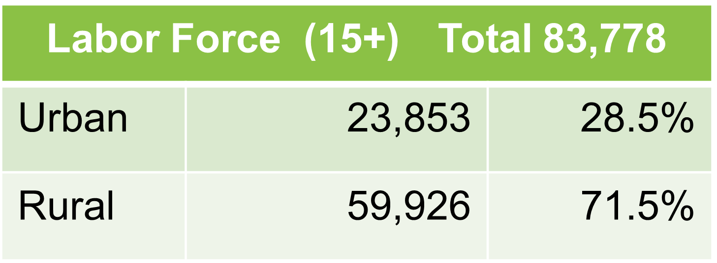
Total number of labor forces (15+) is 83, 778 in Vanuatu. About 71.5% of the total labor force reside in rural areas while 28.5% of them live in urban areas. (Table 2.11)

As a literature explains “the majority of households in Vanuatu practice subsistence farming: 88% of households are engaged in agriculture, 69% in livestock production and 49% in fisheries.”
< “The informal employment rate is a key indicator highlighting the quality of employment in the economy of Vanuatu.” (Well-being in Vanuatu, 2019–2020 NSDP Baseline Survey,2021, Vanuatu National Statistic Office)>
Table 2.12 Employed Population
by Areas & Sex (2020 NPHC)

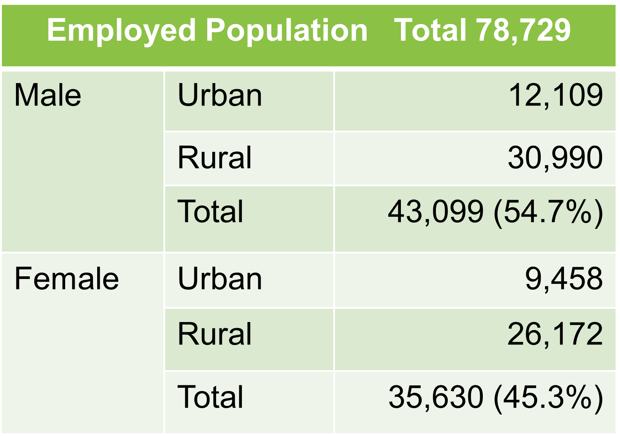
2020 NHPC shows that employment rate in Vanuatu is high as 94% of the total labor force are employed, and unemployment is 4% (Table 2.12). Among them, wage and salary dependent households are low as less than 10% of the total households in many parts in Vanuatu (in 35 of the 66 Area Councils (AC): administrative units below Province). Thus, extent of the formal economy is still small.
Table 2.13 Informal Employment
Among Employed
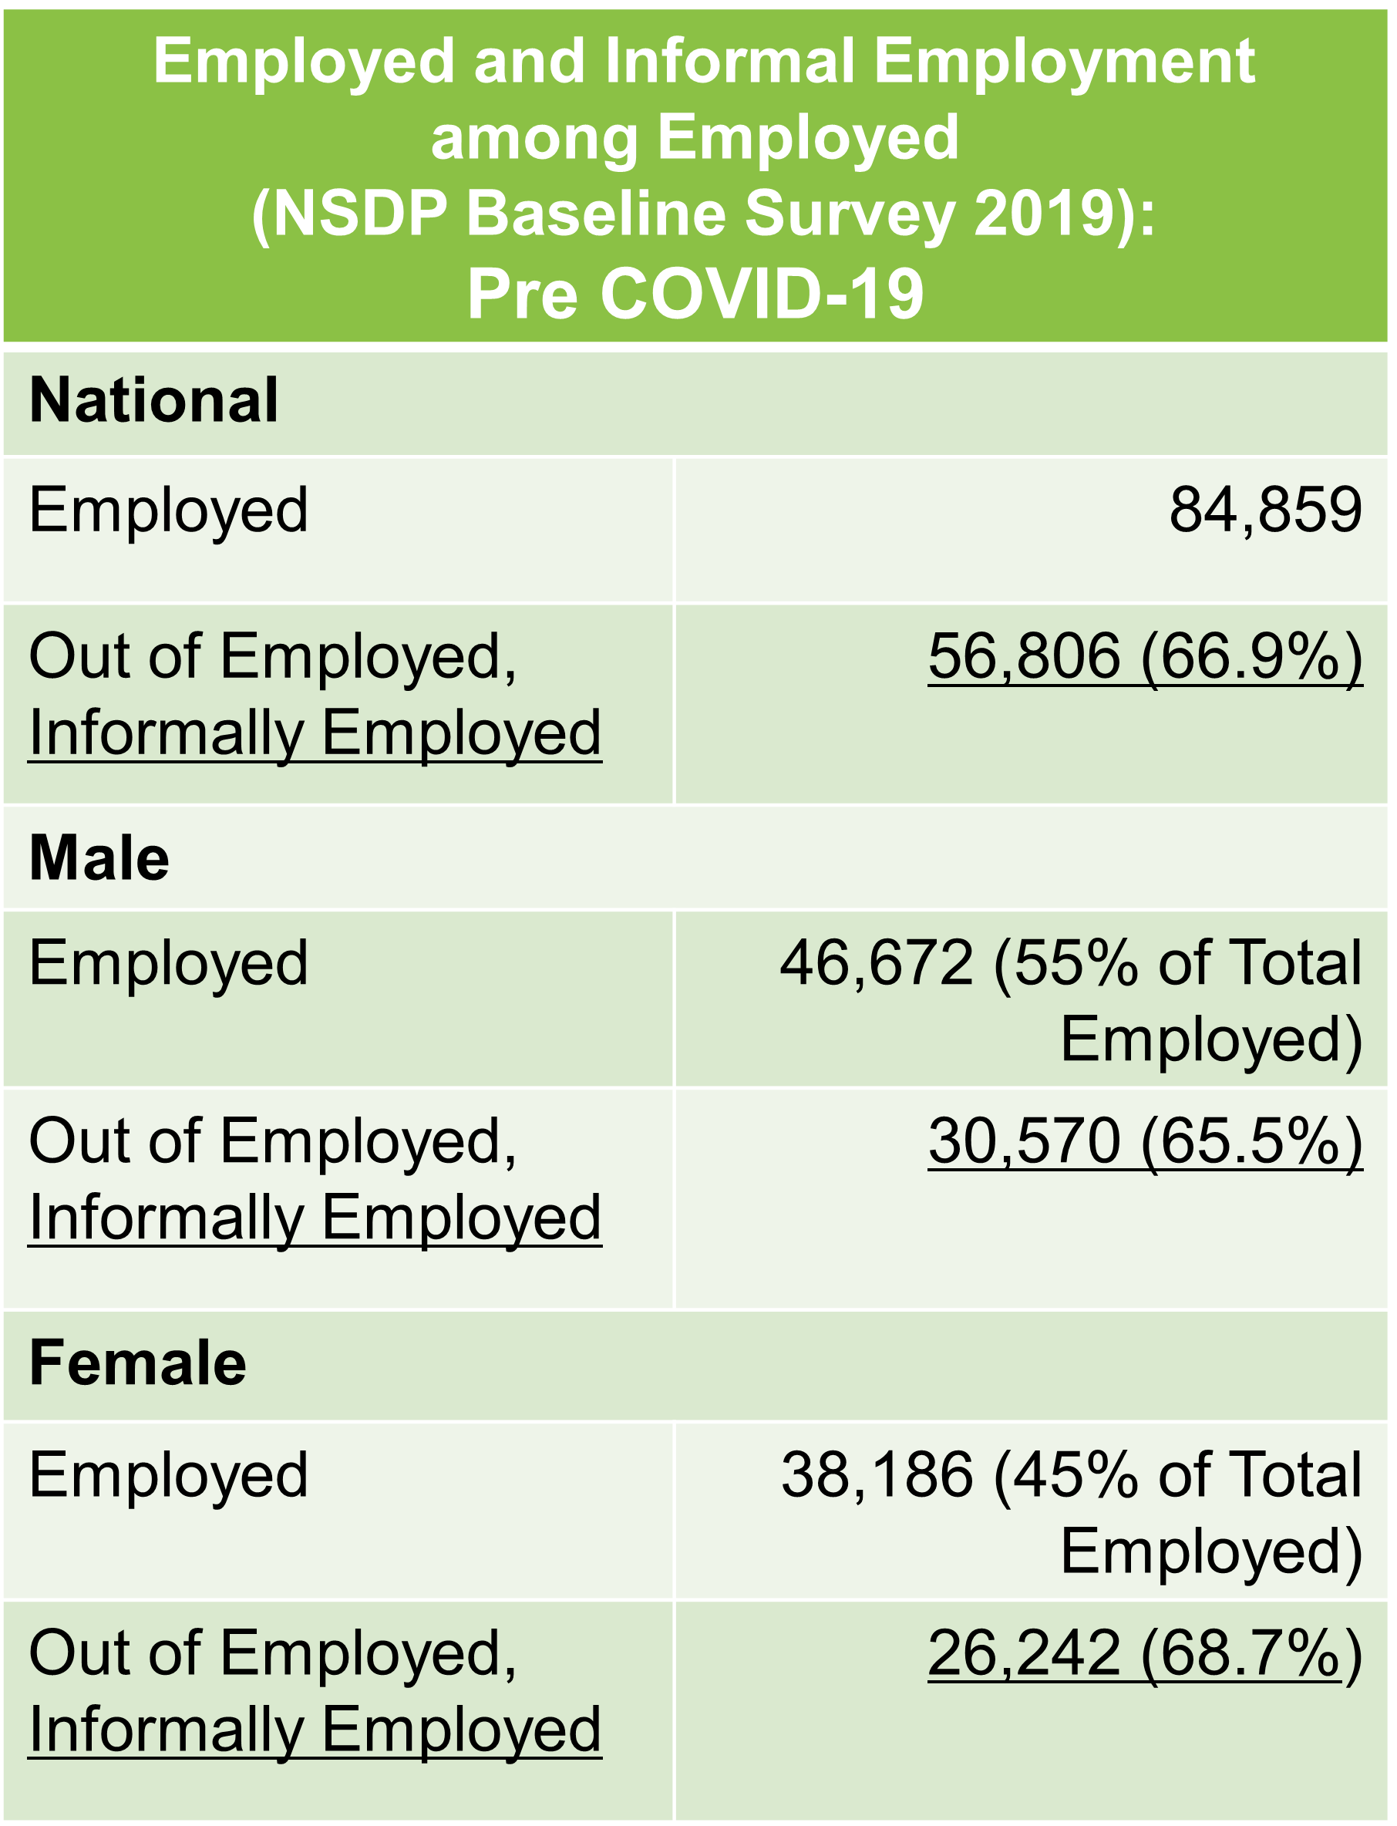
Labor participation rate is accounted high in Vanuatu, but majority of them are informally employed, as stipulate prior. Table 2.13 shows at labor force/labor market at “the pre COVID-19 period”.
(Note: Statistic of labor force in 2020 NHPC shows that total number of labor force as 78,729 which consist of 43,099 male and of 35,630 of female as in Table 2.12)

According to “Socio Economic Atlas Vanuatu 2014” (Vanuatu National Statistics Office and World Bank), 26.4% of the working age population is salaried employees (private or gov’t) in Vanuatu (while in the Urban areas % of salaried employees is high as 73% at Port Vila, and 66% at Luganville).
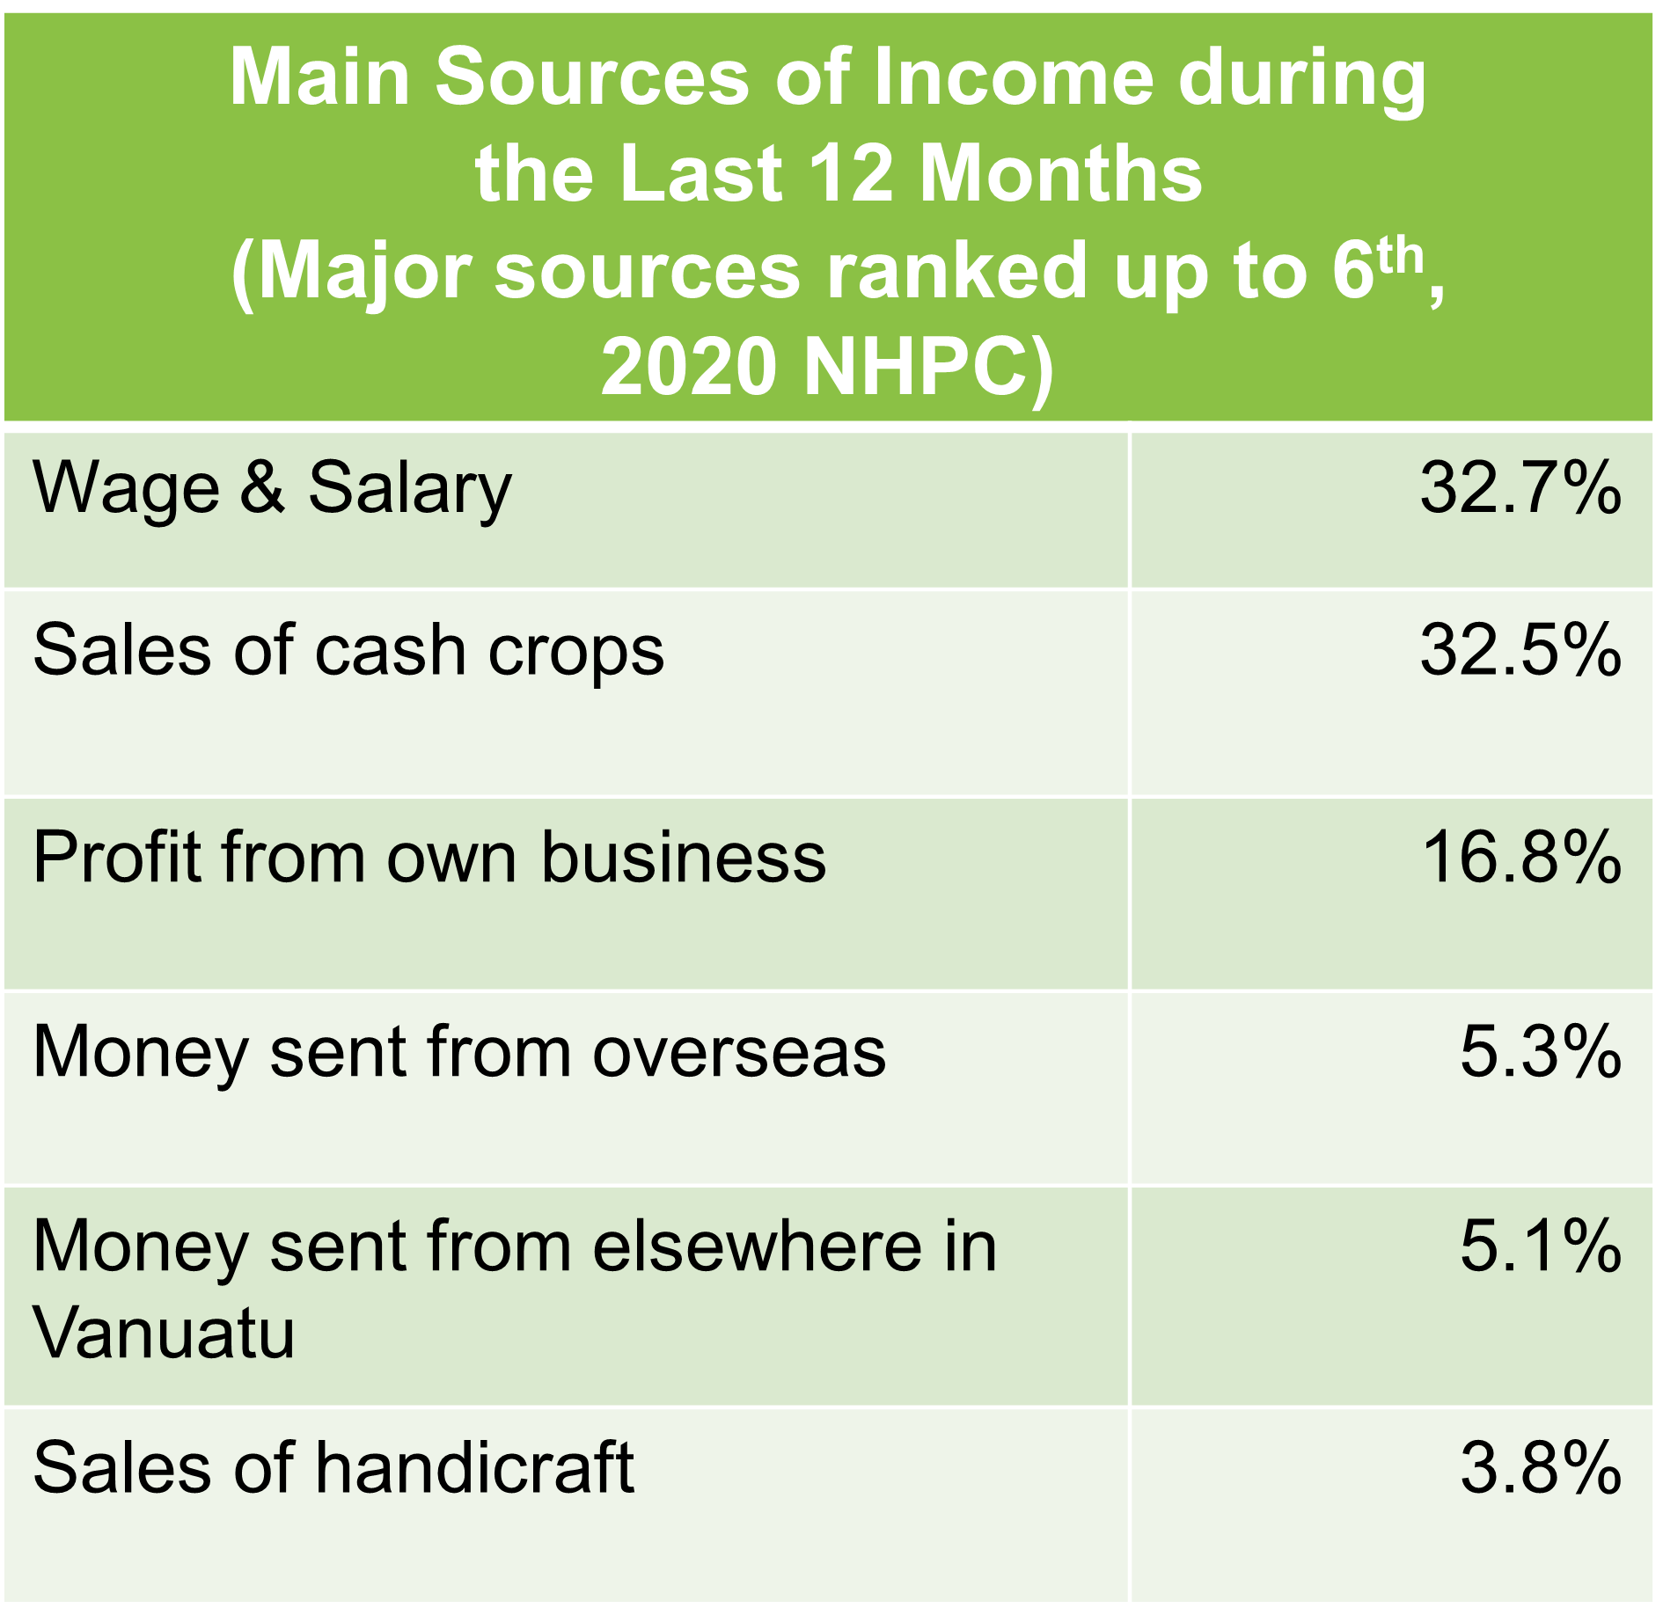
Table 2.14 Main Income Sources

Recent 2020 NHPC indicates population who make a living by “wage and salary” as main source of income increases as compared as compared with 26% verified in 2014. According to the results of the Census, 32.7% replied wage and salary as main source of income in the past 12 months, followed by 32.5% from sales of cash crops, and 16.8% profit from own business, as main income sources during the last 12 months. (Table 3.15). However, dependence on the informal economy for livelihood can be said remaining significant in Vanuatu economy at the present stage still, and it is essential to bear in mind current figures of Vanuatu society when carrying out land transport development or any types of development planning and practices.

<Most women are self-employed in micro-enterprises or in-semi subsistence agriculture. In Port Vila, almost all sellers in the market are women who are depending on to transport their goods for sale to/into the market. (Gender Assessment: Climate Information Services for Resilient Development Planning in Vanuatu & Women, Business and the Law 2021)>
Table 2.15 Monthly Household Income
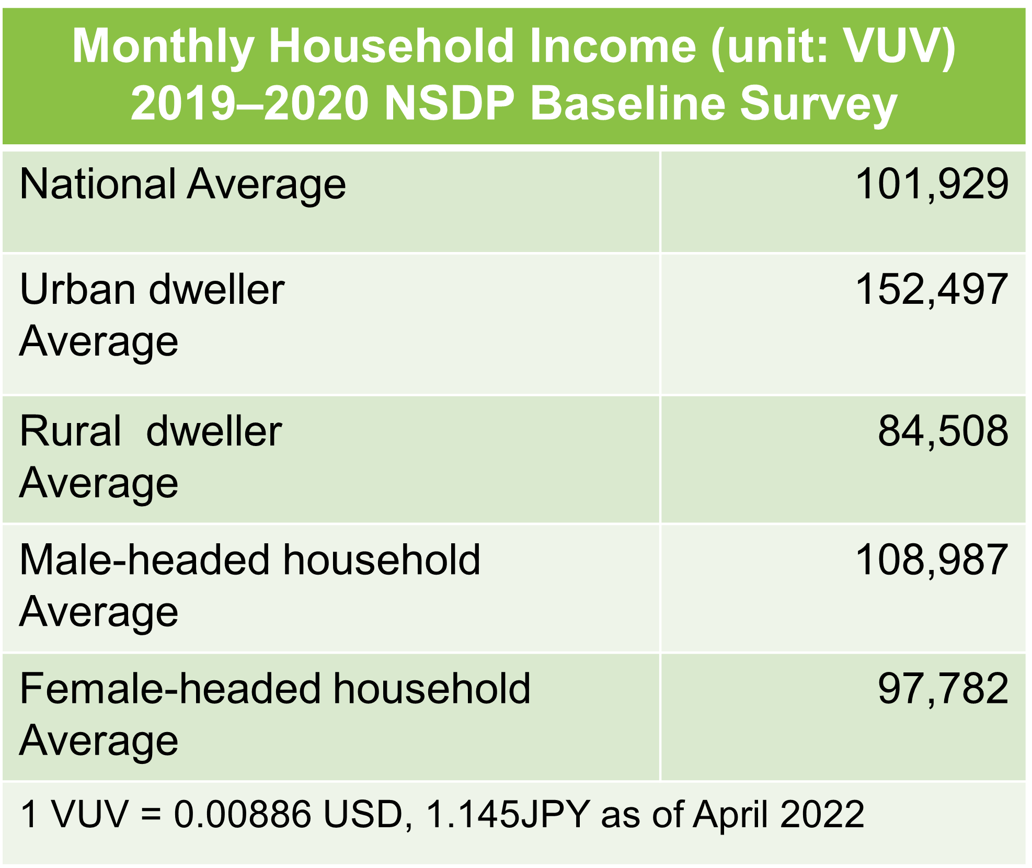
Another literature states that “relative strength in Vanuatu is women starting and running their own business, when it comes to constraints on women”. (The Socio-Economic Atlas (SEA) for Vanuatu, 2014 & 2021, Vanuatu National Statistics Office and World Bank)

<Economic stratification increases between the educated and employed in the formal sector most of whom live in urban areas, and subsistence farmers reside in rural areas>

<Female headed household is prone to financial vulnerability as their average monthly income is less than 90% of that of male-headed household>
Table 2.16 Monthly Household Expenditure

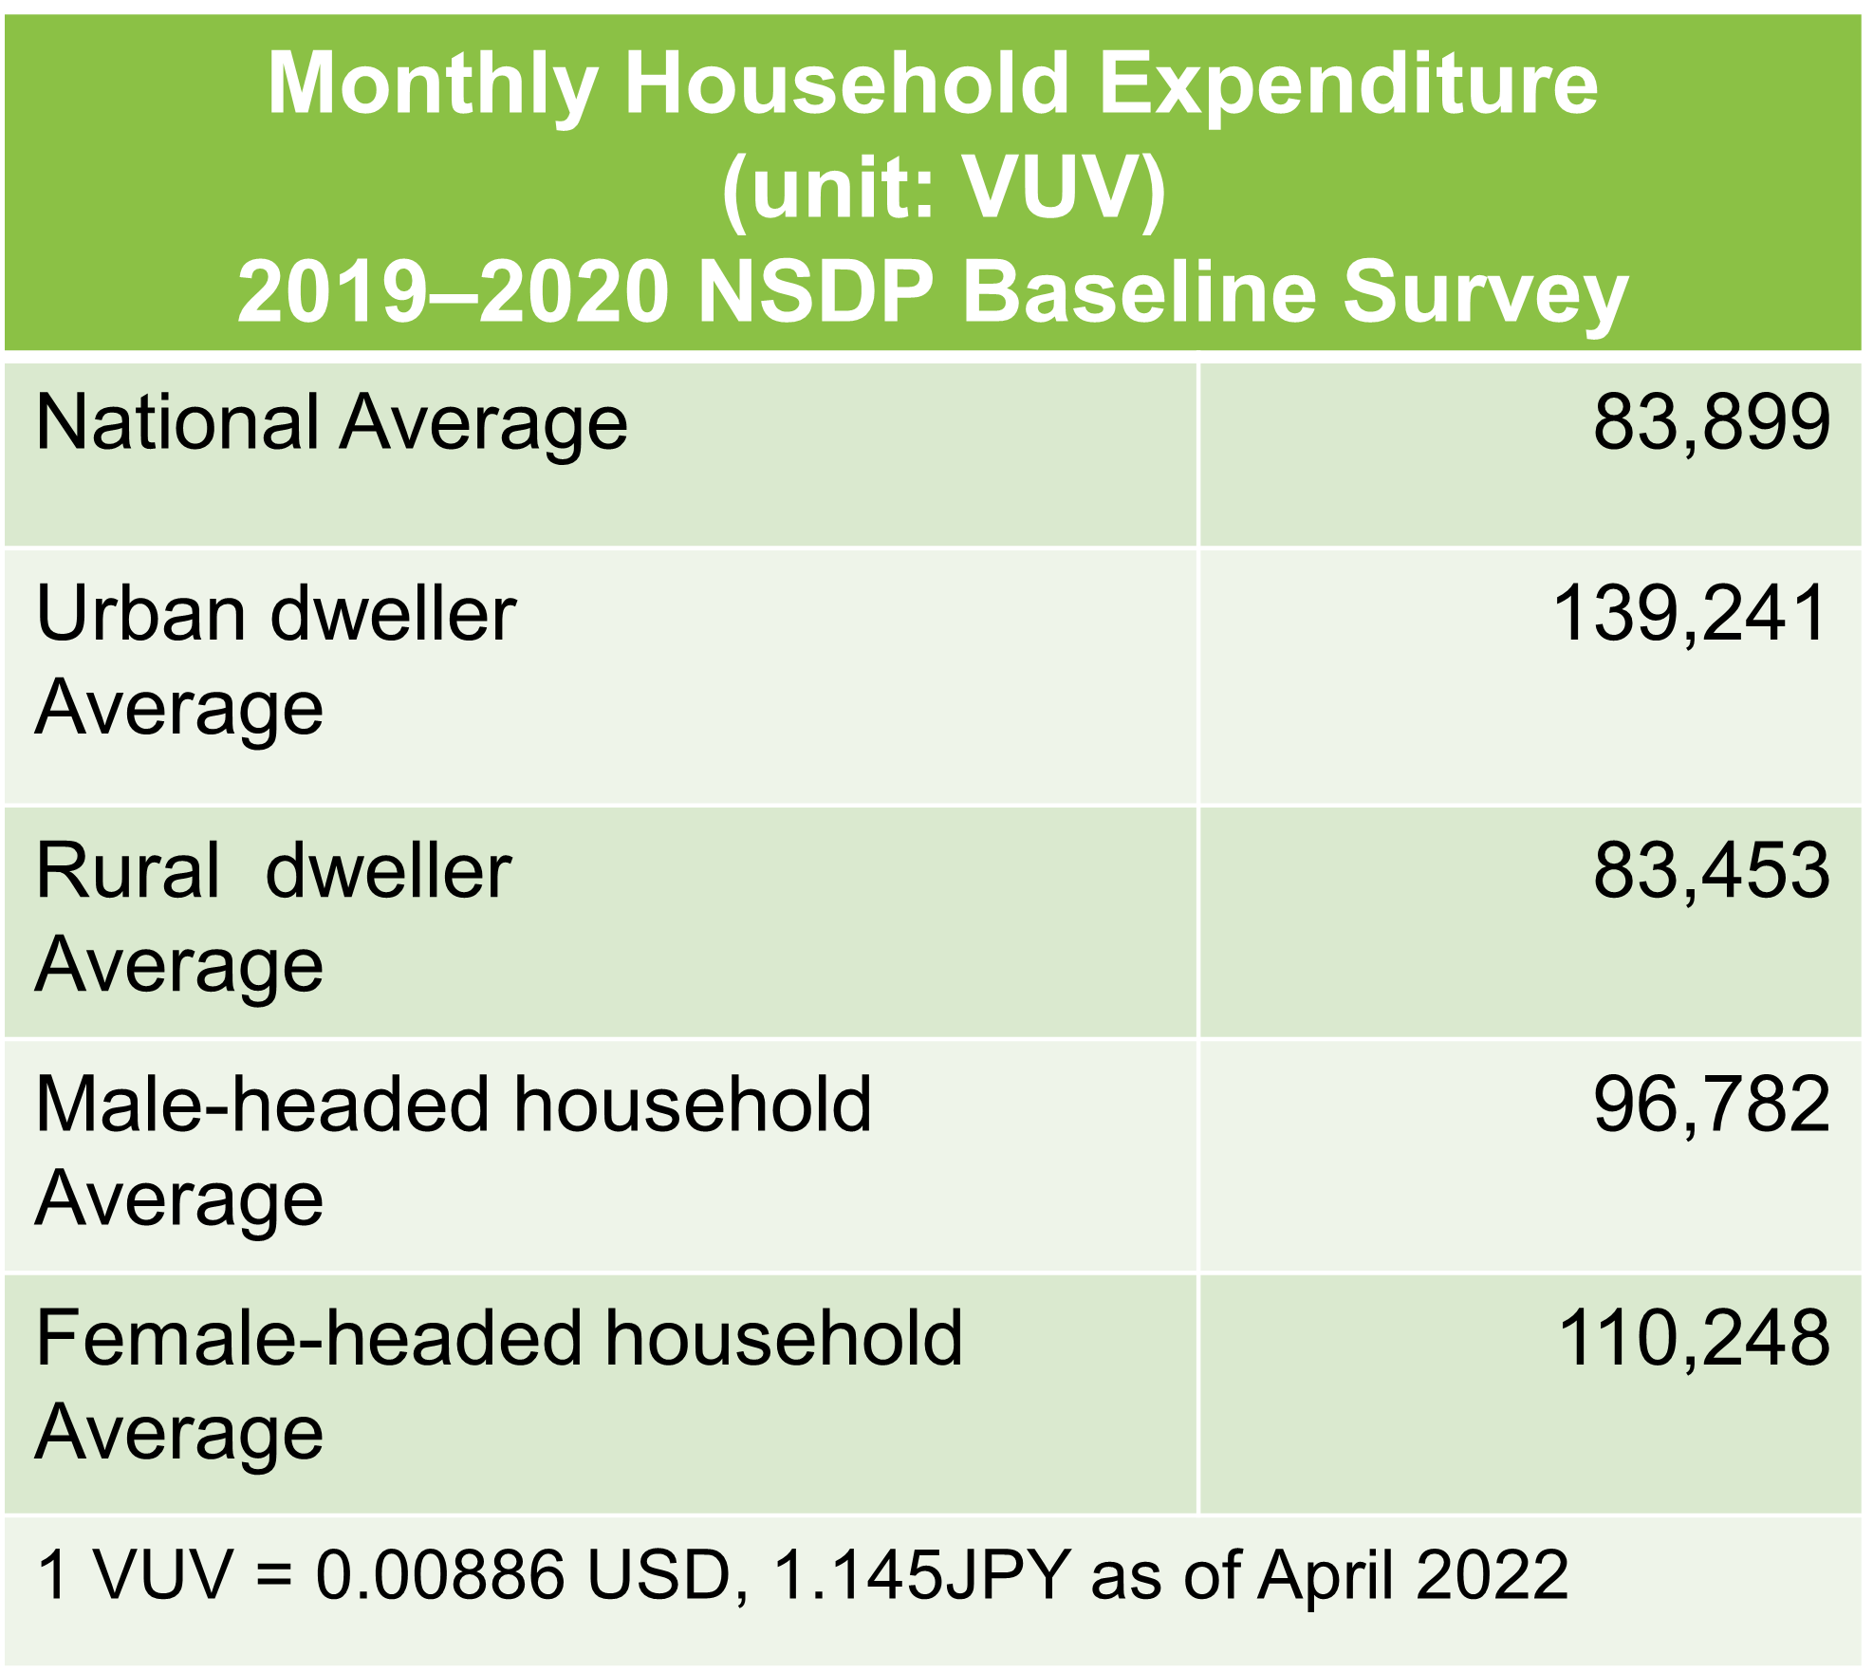
Tables from 2.15, 2.16, 2.17 to 2.18 show numerical differences of monthly household income and expenditure as national average, by urban and rural and by male-headed household and female-headed household. as well as informal sector employment (labor force participation) by educational attainment and sectors (Household Income & Expenditure 2019-2020 NSDP Baseline Survey, 2021, and NSDP Baseline Survey 2019, Vanuatu National Statistics Office).

Table 2.17 Informal Employment by
Education Attainment

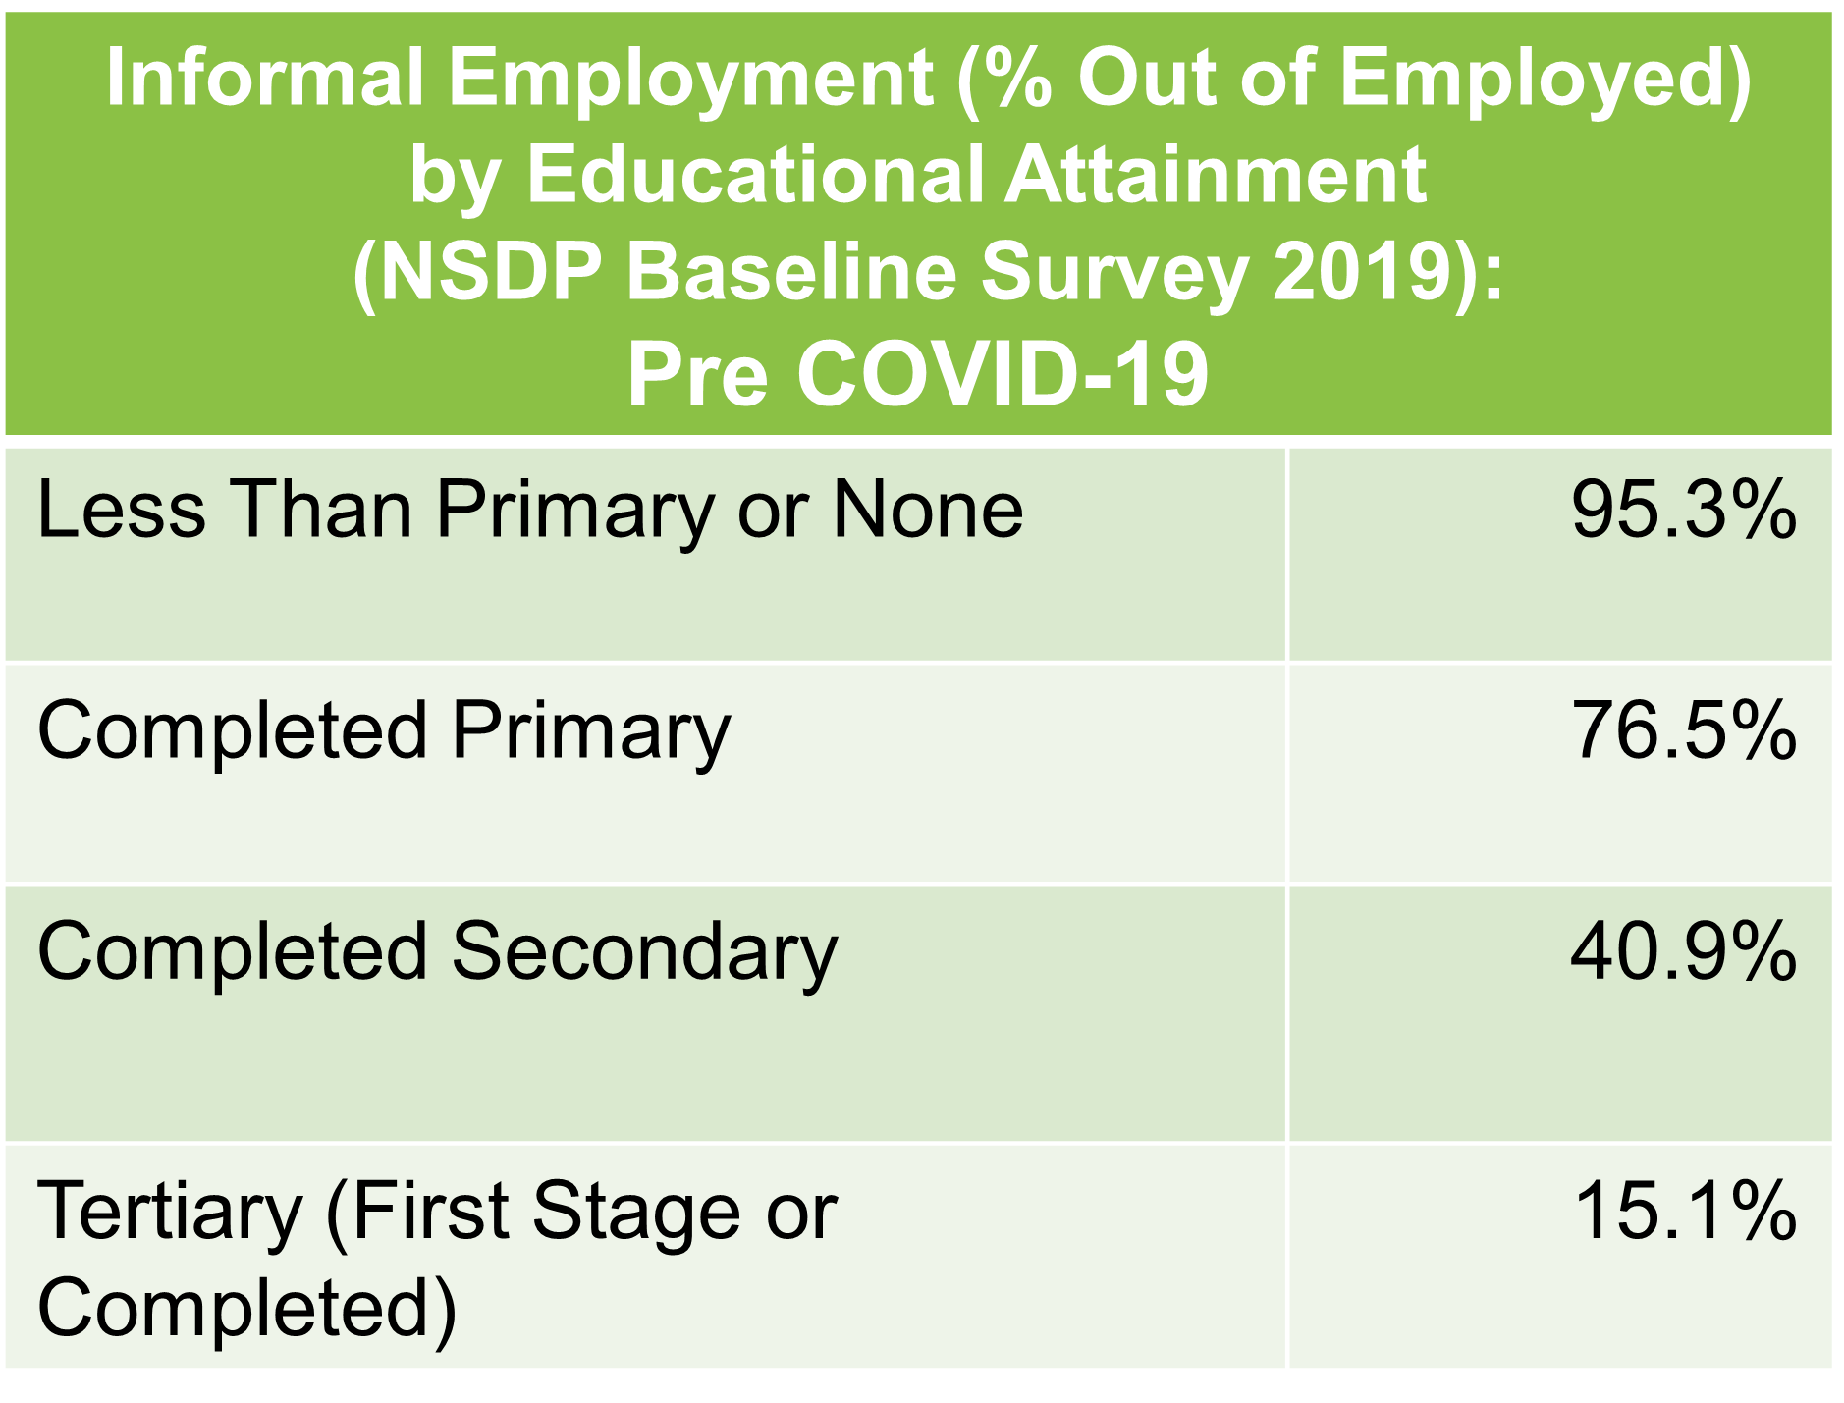
It is obviously seen income divide exist between urban dwellers whose average monthly income is higher as 152,497VUV, and rural dwellers whose average monthly income is 84,508VUV that is about 60% of that of the urban dwellers, and it also clearly indicates impact of education attainment status on opportunities of formal employment. Though it can be assumed that urban dwellers spend higher expenses for transport, rent, food purchases, etc., “there is increasing economic stratification between the educated and employed (in the formal sector), most of whom live in urban areas, and rural subsistence farmers.” in Vanuatu society currently as certain literature pointing out. (https://www.everyculture.com/To-Z/Vanuatu.html)

These numerical figures of their monthly income and expenditure show 2 implications regarding economic stratification in Vanuatu society below:
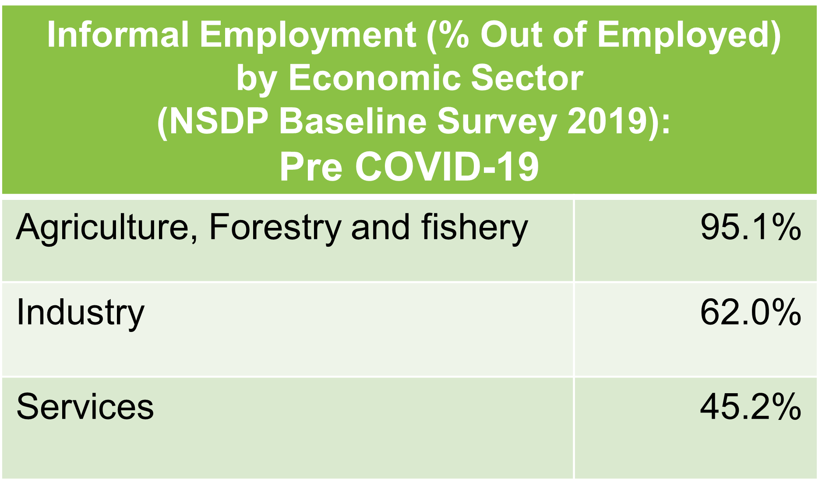
1) Rural dwellers are more living on the edge of income “in a monetary economy environment”. As the figures show that urban dwellers tend to enjoy more residuals from disbursements as compared with rural dwellers. Figures of respective average monthly incomes (152,497 VUV for dwellers in urban, and 84,508VUV in dwellers in rural), and average monthly expenditure (139,241 VUV for dwellers in urban and 83,453 VUV in dwellers in rural) tell that balance of urban dwellers have nearly 10% of their income while rural dweller’s balance is 2.3% of their monthly income.
Table 2.18 Informal Employment by Sector

2) Female headed household is prone to “financial” difficulties and vulnerability as their average monthly income is more than 10 % lower than that of male-headed household.

<Transport Related Expenditure is the 3rd ranked major spending for households>
Table 2.19 Household Spending on Transportation
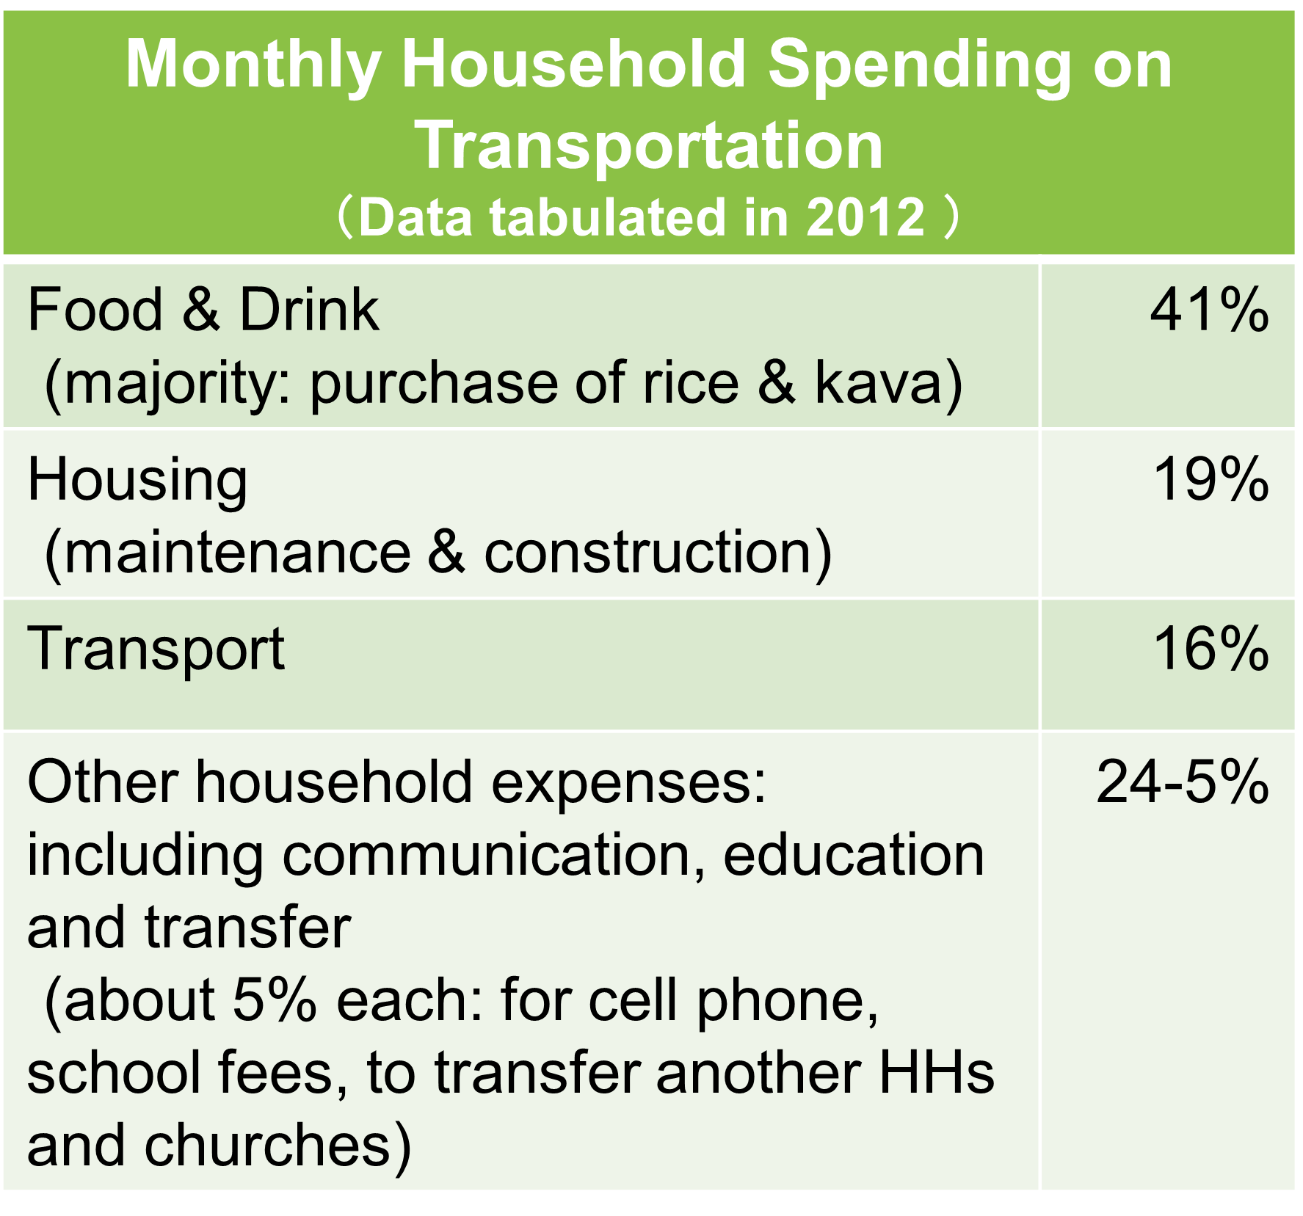
According to a survey on expenditure patterns in Vanuatu carried out in 2012 ,
76 % of total household spending was
was to food (41%), housing (19%) and
transport (16%) and the rest 24-5% was to cover other household expenses. These included communication (cell-phones), education (school fees) and transfers (5% each).

Transport was the third highest spending purpose for the Vanuatu households: 58% were for transportation service fares, such as buses and taxis fares (26.4%), boat and air fares (11-12% each). 8% of households owned a motor-vehicle and 3 % a boat in 2012. According to the survey result, 2% of respondents purchased cars in 2012, an average cost for purchasing a car was VT 1.3 million).

The above considerations, which are not only on gender aspects but also regarding extended social/economic changes currently happening as the phenomena in socio-economic life in Vanuatu, need to be taken into account when planning and implementing land transport projects, and climate change mitigation measures. Including deliberations on how population in rural are moving and relating as their daily activities in/to towns/cities (e.g., transportation costs among the total expenses are, in general high proportion, as from 5 to 10% of total expenses according to statistics. In the circumstances, how people use public/private transport and what purpose they take shall be very indispensable to understand etc.), and what are reciprocal relations between towns/cities and rural areas or connection with the agriculture sector in Vanuatu in the planning activities, the rural population and agricultural sector could enjoy positive impacts rather than just advantaging convenience for the urban dwellers and educated classes. Eventually, it will maintain Vanuatu society being sustainable, and enriched.

<Discussions and Questionnaires relating Land Transportation and Gender Issues in Vanuatu>
During the workshop on “Capacity Building Program on Sustainable and Decarbonization Transport Strategies in Vanuatu,” organized from April 12 to 14, 2022 (note: details of agenda and presentations/discussions made at the workshop are also summarized in Annex), “in what way women in Vanuatu are using land transport, how is it linked to women's lives and what challenges can be identified, are addressed during the presentation time on Gender Issues (the 3rd day) to the workshop participants. There was no opportunity for the study team to visit Vanuatu, and unfortunately the opportunities for information interviews and exchange of views through online were also close to not possible due to the rock-down measures taken at Vanuatu.

As it was not easy to assess the local situations due to this constraint, receiving opinions in the workshop and requested to response to the questionnaires were sought in order to understand the actual use of land transport by women in Vanuatu.

Below is a summary of the views and comments presented by the workshop participants, and questions and answers to the questionnaires, as well as the implications gained from listening the views and comments in the workshop and verifying responses to the questionnaire.

<Land Transport Improvement and Gender Issues>
1) Assumptions and questions addressed for inviting views and comments in the workshop are as follows:
  - Is women and men have different mobility needs and patterns, which transport policies need to consider? Does the current transport system constrain women’s access to economic opportunities, health care and education?
  - In Vanuatu, majority of women are self-employed such as retailing goods in the market, and access to markets and transportation of goods through taking public transport (or private vehicles) are important to increase productivity, social equity and maintaining their cultural roles as main caretakers of their family members.

2) Views and comments received, and responses to the questionnaire from the workshop participants (Note: view and comments expressed by the workshop participants are also recorded in Annex)
- The most transport option for adult female, in general, is bus services.
- Buses are operated by using the 2nd hand buses, and now they have bus routes available (before there was no fixed route).
- Both in the car and on the road in close proximity (corridor/streets are quite congested in the morning).
- Private vehicles are not common (for women to drive by themselves or to own).
- The bus fares in Port Vila are more efficient as both of a cost and energy use than that in Santo Island, where most women use taxis even it is expensive (depending on locations/locality).
- Women use pick-up trucks to transport goods and move the market (from villages) more now. Trucks and taxis are convenient because they can be hailed to where you are by calling to truck/taxi operators.
- Shared car costs per passenger are 20 times less than hiring a bus to commute in the Efate Island (500 vatu vs 10,000-12,000 vatu).
- In Port Vila, the most bus fares are 150 VUV while the minimum wage is 220 VUV/hour. (High public transport fares as compared to wages.)
- Women are open to land transport systems to call taxi drivers, family/friends, etc.
- 70-80% of market vendors are women, responsible for marketing/selling farming products while men are for farming.

3) Questions and Responses to the Questionnaires

Question | Answers
1. What are differences of demands and access for transport and transport services/means (e.g., vehicle, bus, taxi etc.) between women and men in Vanuatu? | - The bus being used in Vanuatu is a Van type that men and women are using the service hand on hand.  - There are no gender preference in the public transport industry, all gender are qual.  - One price for all passenger and all access to what transport s available.  - Female participation depends on entry into industry and satisfying the required criteria for entry as an owner or a driver. we have both female owners, operators and drivers effective in the industry.  - Participation in an executive capacity will depend on choice of election by members.  - There is no difference.  - Since Vanuatu does not have buses, perhaps it should consider introducing bigger-mini buses.  - Current mini-buses have some disadvantages to children, women, the elderly, and those with disability given its compact spaces. It could also be problematic to pregnant women, who may have to take the expensive option - taxi.  - In terms of access, the timing has to be consistent so that people especially women can schedule/plan their movements around the bus schedule.  - In terms of demand: it depends on the activity that individuals are engaged in and whether they are employed, self-employed or unemployed.  - In terms of access: Public transport, especially (Hyundai Buses and Toyota buses) are the main sources of public transportation - although transportation for transportation of local good for markets is open cart public transports - sometimes shared transportation.  - To define access in Vanuatu, in general for anyone who can afford public transport buses do not have specific routes so there is opportunity to catch a bus anywhere in town or main bus points - there are main bus points specifically for Villages within Efate Island.  - in my opinion, selectivity of transport use lies with the public and vice versa - for instance some members of the public prefer Toyota buses rather than Hyundai buses. Another example is if a market vendor stops a bus to transport their goods - some buses would decline or ask for an extra charge to cover spaces accounted for by market goods.
2. Do you anticipate that changes in land transport toward adapting climate changes and zero-emission vehicles contribute to needs of the Vanuatu society and benefits to women? | - It will be good in general to the public because the service will be better due to newer equipment. Women might be using the service with safer and better equipment.  - All gender is equal and will reap equally what is beneficiary to the overall development. lesser operating cost will mean bigger profit margin from running of transport services or selling of market products. only change will be in the transport sector cost. marketing section will basically remain.  - In Vanuatu, the female gender will continue to dominate the vendor and marketing or sales of agricultural products as the male will always be responsible for the farming sector.  - I don't anticipate any change (neither better or worst).  - Changes would also introduce vehicles that are suitable to Vanuatu's terrain and transportation needs of its people.  - While the Department of Energy administers the Fuel and gas in Vanuatu - the regulation of these is with the Department of Environment. For example, Pollution Control Act specifies a clause on fuel quality standards and emission standards - this is yet to be achieved. So with no data to analyze air quality, we can’t really inform good decision making in terms of Air quality in Vanuatu - this is an example of gaps we are faced with.
3. In the sector you are working for, are policies/strategies for promoting gender equality practiced? | - Women are given equal opportunity for work. Bullying is not tolerated.  - Yes, there is equal opportunity for both male and female gender in managing and operating a public transport business. There are no existing policies or regulations that demands otherwise.  - Entry into work force is by qualification and merit and there will be no discrimination in this regard.  - We have obligation of gender equity. 1/4 to 1/3 of our employees are female (mostly on customer services, accounting, HRs but more recently with technical department: power generation, automatism).  - Barrier is mainly technical curriculum appetence for women in Vanuatu.  - It made formulating gender policies in the private orgs & public sector easier; and experts were available to conduct training and help in writing work policies on gender and equality (Vanuatu needs more resources to be able to do so).  - Within the Environmental sector I would say the policies and strategies do not directly promote gender equality, but the Department of Women’s Affairs does have on gender. The Department of Women Affairs is the main stakeholder consulted with any Government policy developed, other women groups such as those from specific communities are also engaged.
4. Opinions and views as you like to express:  If you provide me of the currently happening changes relating Gender issues, not limiting in the transport issues, in culture and society in Vanuatu, it will be also very much appreciated (as I could know as an implication for proposing future plans etc.). | - Improve the handling of family issues giving more authority to women in the family.  - We still don't have female MP or ministers.  - Collectively policies such as on young women empowerment, disability, women from minority groups could help the Vanuatu gov’t develop a comprehensive national strategy on gender & equality, which covers transport sector as well.  - Overall, Vanuatu has recently seen the emerging of the gender issue for example, an Australian funded Project called the Balance of Power is influencing change - there are also other governance projects that are contributing to the course.  - While women may be represented well at mid-management level within the Government, few women are actually heads of Departments and Ministries. Moreover the National Parliament of Vanuatu has 52 members that are all males - the agenda of reserve seats for women in Vanuatu to provide Temporary Special Measures (TSM) for women is yet being debated within the Government.

4) Implications obtained:
- In Vanuatu, adult women are economically active in particular, at the marketplace, and have a significant impact on their livelihoods. Women are responsible for the day-to-day sales of agricultural products.
- Adult women’s reliance on public transport means such as buses, taxis and pick-up trucks to transport goods for sale to the market is very high. There seems to be many improvement for services to be done such as considerations on friendliness for elders, disadvantaged and pregnant women, safety for women, routes, standardized fares, interior of public transport, timing of services etc..
- To increase women operating and working in transportation industry, in particular, in technical and engineering positions, is an aim to be challenged also.
- Cost on (public) transport in income in Vanuatu need to be studied whether it is sustainable for daily users to use them. If so, how they are coping the costs.
- It is essential to gather information on how land public transport services (including fares setting) are related to users’ purposes, such as market related marketing activities of people (not only women), in order to understand closely both how people users and operators of land public transport, what problems on land public transport exist now and what changes may occur in the future in the project planning stage.
- In terms of gender issues, linkages between land public transport, women’s daily economic productivity and practical measures for promoting women’s status in Vanuatu society need to be comprehensively studied, and results shall be incorporated/considered into planning and activities in land transport.

<International Commitment and Domestic Policies Incorporating the Right of Women and Gender Mainstreaming>

In the following, International Conventions Declarations and agreement adopted by the Vanuatu government, and policies incorporating the right of women and gender mainstreaming are listed.

＜ International Conventions Declarations/Agreements ratified and adopted by
the Vanuatu Government＞

- Convention on the Elimination of All Forms of Discrimination against Women (CEDAW)  - Optional protocol to CEDAW (2006） | Ratified in 1995
- Beijing Platform for Action (BPA) : Working on Women Together | Adopted by the Govt and NGOs in 1996, reviewed in September 2006
- Bamako Millennium Framework for Action Toward the Asian Pacific Decade of the Persons with Disability 2003-2012
- Pacific Leaders Gender Equality Declaration 2012, and the Pacific Platform for Action on Gender Equality and Women’s Human Rights 2018-2030 | Regional commitment
- Framework for Pacific Regionalism 2014, and the Small Island Developing States Accelerated Modalities of Action (S.A.M.O.A) Pathway 2014, | Regional commitment
- Millennium Development Goals | Adopted in United Nations and signed in 2000  Commitment on 8 goals to be achieved till 2015 (including promote gender equality and empower women)
- Sustainable Development Goals | Agenda for 2030  SDGs 5: Gender equality

＜Policy Incorporating the Right of Women and Gender＞
- “Vanuatu 2030” (National Sustainable Development Plan 2016 to 2030) | Society Pillar (social inclusion)  Note: the Plan also calls “Enhanced resilience and adaptive capacity to climate change”
- The National Gender Equality Policy 2020-2030 | Launched in August 2021.  <Policy Vision>  A safe, just and secure society where everyone works together to build happy families, strong communities and a resilient Vanuatu.  <Policy Goal >  To promote respect and equal rights, opportunities and responsibilities among men and women of all ages and abilities in Vanuatu  <5 Strategic Areas: 5th area on aspect of “climate and disaster resilience” is newly added from the previous gender equality plan>  - Eliminating discrimination and violence against women and girls  - Enhancing women’s economic empowerment and skills development  - Advancing women’s leadership and political participation  - Strengthening the foundation for gender mainstreaming  - Fostering gender responsive and community-driven solutions to climate and disaster resilience
- National Gender Equality Policy 2015-2019 | Introduced in 2016  <Policy Vision>  A safe and secure society where women and men of all ages and abilities live in harmony  and work together for a better Vanuatu.  <Policy Mission>  To promote equal rights, opportunities and responsibilities among men and women and  to eliminate all forms of discrimination and violence against women and girls  <4 Strategic Areas>  - Reducing Domestic and Gender Based Violence  - Enhancing Women’s Economic Empowerment  - Promoting Women’s Leadership and Equal Political Participation  - Building a Foundation for Gender Mainstreaming
Family Protection Act (FPA) | Approved in 2008, but yet to be fully realized by authorities specified in the Act.
Sectoral Polices | Ministry of Education and Training  Ministry of Heath  Ministry of Justice & Social Welfare

3）Health Considerations
“The health issues now facing Vanuatu are increasingly complex, with the dual burden of communicable and non-communicable disease and the on-going challenges of delivering health services to a small but widely dispersed population, with a limited, ageing workforce. The health system needs to become more resilient in the face of the emerging challenges posed by climate change.” (Vanuatu Ministry of Health, Health Sector Strategy (HSS) 2017- 2020)

“Face(ing) distinct challenges that render them particularly vulnerable to the impacts of climate change on food and nutrition security including: small, and widely dispersed, land masses and populations; large rural populations; fragile natural environments and lack of arable land; high vulnerability to climate change, external economic shocks, and natural disasters; high dependence on food imports; dependence on a limited number of economic sectors; and distance from global markets. The majority of SIDS (Small Island Developing States) also face a ‘triple-burden’ of malnutrition whereby undernutrition, micronutrient deficiencies and overweight and obesity exist simultaneously within a population, alongside increasing rates of diet-related NCDs” (WHO, Vanuatu Health & Climate Change Country Profile 2020)

The above two paragraphs, extracted from 2 different references: one is the previous “Vanuatu’s Health Sector Strategy (2017-2020)” , and another is “Vanuatu Health & Climate Change Country Profile 2020” (WHO), describe the ongoing health and sanitation situations and challenges that contemporary Vanuatu has faced in the recent years, and the current pressure to address the impact of climate change on health and sanitation in Vanuatu.

In this section, outlines of key health and sanitation issues are presented in line with the above 2 aspects.
i) “data and information on the status of major diseases, heath/sanitation, and health system in Vanuatu, and
ii) vulnerability to climate changes on health/sanitation in Vanuatu

i) Status of Major Diseases and Heath/Sanitation

＜Major Indicators on Health/Sanitation＞
Table 3.21 Major Indicators on Health/Sanitation, Mother and Child Health,
Health Expenditure | 3.7% | As % of gross domestic product (GDP), 2016  5% in 2014
Per capita Total Expenditure on Health at Average Exchange Rate (US$) | 157.51 US$ | 2014
Universal Health Coverage | 52 | Service Coverage Index, 2019
Coverage of Essential Health Services | 80% | 2018
Life Expectancy at Birth | 70.5 Years | 2019. 72 Years in 2015
Tuberculosis Incidence | 41 | Per 100,000 Population, 2020
Malaria Annual Parasitic Incidence | 1.7 | Per 1,000 Population, 2018
Total Fertility Rate per Woman | 3.6 | 2020
Births Attended by Skilled Health Personnel | 89% | 2004-2020
Maternal Mortality Ratio | 72 | Per 100,000 live births, 2017 Estimate
Iron Deficiency Anemia in Women of Reproductive Health | 24% | 2019
Under Five Mortality Rate | 25.9 | Per 1,000 live births, 2017
Wasting in Children under 5 Years of Age | 4.4% | 2013
Stunting in Children under 5 Years of Age | 28.5% | 2013
Immunization Coverage Rate for Diphtheria-Tetanus-Pertussis  (3 doses) (DTP3) (%) | 81% | 2016
Immunization Coverage Rate for Measles-containing Vaccine  (1st dose) (MCV1) (% | 84% | 2016
People with Access to Improved Water  Supply at least basic | 91.4% | 2020
People with Access to Improved Sanitation Facilities at least basic | 52.7% | 2020
Prevalence of Obesity in Adult Population | 23.5% | 2019 Estimate
Prevalence of High Blood Pressure in Adult Population | 29% | 2011
Prevalence of Stunting | 29% | 2013-18
Family Planning Modern Method | 61% | % of demand satisfied with modern methods, women aged 15-49, 2022
Intimate Partner Violence in Past 12 Months | 29% | 2018
Adolescent Birth Rate per 1,000 Girls Age 15-19 | 51 | 2004-2020
Child/ Adolescent Marriage by Age 18 | 21% | 2005-2020:
Sources: WHO, Vanuatu-WHO Country Cooperation Strategy 2018–2022, and Climate and Health County Profile 2017, VANUATU, and 2020, Ministry of Heath, Vanuatu, Vanuatu Health Sector Strategy 2021-2030 and 2017-2020, UNFPA, World Population Dashboard Vanuatu

<Major Issues and Challenges on Health/Sanitation Suggested by Data and Reference >
- Health spending per capita: in Vanuatu from 2000 to 2018 Health spending per capita shows an average value of 83.92 US$ with a minimum of 46.26 US$ in 2001 and a maximum of 157.51 USD$ in 2014. The latest value from 2018 is 105.39 US$. For comparison, the world average in 2018 based on 182 countries is 1,172.05 US$.
- Non-Communicable Diseases and Communicable Disease: Dual challenges of deal both communicable diseases and growing cases of non-communicable diseases. Non communicable cases are in diabetes and diabetic related and hypertension increases, which leads chronic diseases and disability. Fewer malaria incidents occur at present, but Tuberculosis (TB) and Sexually Transmitted Infections (STIs) rises.
- Poor sanitary facilities: % of People with Access to Improved Water
Supply at least basic is 91.4% (2020) but almost half of the population do not have access to proper sanitation facilities (52.7% in 2020 uses improved sanitation facilities at least basic). Under unsanitary conditions，infectious diseases, such as TB, Acute Respiratory Infection (ARI), diarrhea and skin diseases, are prone to spread out.

ii) Vulnerability and Health/Sanitation to climate changes

“Vanuatu's CO2 emissions are amongst the lowest of all nations, and yet it is one that will suffer the most devastating impacts of climate change.” (WHO, Vanuatu Health & Climate Change Country Profile 2020)

According to references of WHO, major consequences of climate change and the impacts by the climate hazard in Vanuatu would be, increase in temperatures accompanied by heat waves and increase in precipitation patterns , rise of sea levels, and weather event, such as tropical cyclones, and typhoons. Projection of health impact by the climate hazard are as in Table 3.22.

Table 2.21 Priority Climate Sensitive Health Risk in Vanuatu
Direct Effects | Indirect Effects | Diffuse Effects
- Health impacts of extreme weather events  - Heat relate illness | - Water security and safety (including waterborne disease)  - Food security and safety (including malnutrition and foodborne diseases  - Vector-borne diseases  - Respiratory illness  - Disorders of the eyes, ears, skin, and other body system | - Disorders of mental/psychosocial health  - Noncommunicable diseases
Source: WHO, Vanuatu Health & Climate Change Country Profile 2020

3. Barriers in reducing transport GHG emission of Vanuatu

3.1 Identified barriers and issues in introducing EV in Vanuatu

Barriers and issues in introducing EV in Vanuatu are assessed through review of the National Communication, the NDC and related documents such as laws and regulations on motor vehicles, and the Stakeholders Consultation, interviews to stakeholders. These barriers are categorized into “Policy/legislative”, “Institutional”, “Technical”, “Education/ awareness”, “Financial” and others. Direction to address these barriers and potential interventions are also described.

Policy/ legislative barriers and potential interventions

In “Enhancing and Fast-tracking Implementation of Vanuatu’s NDC”, several measures on electric vehicles are defined as “additional NDC measures”, such as “Additional NDC measure 1.1 – Electric vehicles (e-buses) for public transportation (10% of total public buses)”. However, there is lack of common direction such as government’s roadmap/strategies on EV introduction. Some of stakeholders recognize that, by 2030, most of the car manufacturers in the world will only be producing hybrid vehicles, and by 2040, only electric vehicles will be available, therefore, need to establish a vision for Vanuatu, for example, only hybrid vehicles and EV will be allowed to be registered by 2030. Considering movements of the world market, it is needed for Vanuatu to formulate an EV roadmap as an common direction to shift to EV and low emission vehicles. Collaborative works are necessary to develop the EV roadmap by the responsible ministry in collaboration with related ministries, agencies, stakeholders.
Currently, there is no law/regulation/standard on EV and related facilities, such as definition of EV, registration of EV, required specifications of charging stations. It is crucial to prepare those regulations/standards and/or revise existing documents such as through amendment of the Road Traffic Control Act and Public Land Transport Act.
The price of EV are still high in the world market, and electricity tariff in Vanuatu is also expensive compared with gasoline/diesel. Therefore, various incentives to introduce EV, such as reduction in import duty, tax exemption, reduction in vehicle registration, are crucial for Vanuatu to accelerate introduction of EV, yet currently there is no such incentive. Besides, incentives for introducing charging infrastructures, including public, home/working place charging facilities are also needed to be developed.
Another barrier/issue is on laws/regulations on vehicle imports. There is no law/policy on types of cars imported into Vanuatu such as importing second hand vehicles, except for right-hand drive vehicles. Currently there is no law/regulation/standard on fuel efficiency and emissions of vehicles, but those would be effective for transition to EV or other low emission vehicles.
Lack of regulation to carry out quality check of vehicles is also some issues. Public works carry out car inspections every year, but most of the vehicles being used today are more than 10-15 years old in Vanuatu, and emissions/fuel economy from these vehicles supposed to be not in good conditions.

Institutional barriers and potential interventions

Since introduction and operation of EV are new in Vanuatu and are cross-sectoral issues in nature, it is effective to form an inter-ministerial coordinating entity on EV promotion such as committee and working groups to make decisions and implement actions on promotion of EV. This Study is leaded by the Ministry of Climate Change of Vanuatu, Currently, however there is no coordinating entity for planning and introducing EV in Vanuatu.
Besides, the power sector has key roles in this transition to EV, and collaboration with the Government and power sector is essential. For example, in considering tariff for EV charging, development of charging stations, incentives including electricity tariff for EV to make EV more affordable, renewable energy development to increase the share of renewable energy to maximize GHG emission reductions through the EV transition.

Technical barriers and potential interventions

Through the stakeholder’s consultation and interviews to stakeholders, it is indicated that there is lack of knowledge and experiences on technical advantages/disadvantages of EV such as mileage, power, financial and environmental benefits. Operation of EV is foreign to people in Vanuatu and they would be hesitant to buy EV if they do not how to operate them. Disseminations on EV such as seminars/workshops, campaigns, lectures at schools are essential for people in Vanuatu to increase capacity on EV and low emission vehicles and to make the transition smoother.
There is no EV in Vanuatu, therefore there is lack of maintenance skills. It is necessary to enhance capacity to properly maintenance EV in Vanuatu through trainings on EV maintenance for car maintenance companies as well as technical colleges such as Vanuatu Institute of Technology. Currently, car dealers has capacity to maintenance ICE vehicles, therefore they have potential to acquire skills to maintain EV.
Another barrier is limited supply area of electricity. Electricity is supplied only in the main centres of Vanuatu (Efate, Malekula, Santo and Tanna). Besides, in these areas, electricity supply is limited to urban and peri-urban areas. All rural parts have no access to electricity. Stability of grid electricity is also an issue for EV charging.
Poor road and environmental conditions are also barriers for EV operation. Because of unpaved roads or poor conditions of roads, 4x4 vehicles are very popular in Vanuatu even though they are more expensive than smaller cars. Many narrow roads which are not suitable for large vehicles. These barriers would limit the types of EV to be introduced in Vanuatu. For smooth and stable operation of EV in Vanuatu, it is important to continuously work on removing barriers on electricity and road described above in collaboration with related ministries/agencies.

Financial barriers and potential interventions

As is the case in most of other countries, costs for EV and related facilities are one of the major barriers in accelerating the shift to EV. Since, Vanuatu has to import all the EV from other countries and take into account current price of EV in the market, purchase prices of EV in Vanuatu would be significantly higher than ICE vehicles. High electricity tariff in Vanuatu (around 50 Vatu/kWh (1 Vatu = 0.01 USD)) is also big issue to be considered. Further, since there is no charging station, investment is required to set up a charging network.
In order to remove above mentioned barriers, various incentives should be studied and introduced, such as import incentives (reduction in import duty, excise duty), purchase incentives (tax exemptions), ownership incentives (reduction in vehicle registration fee), use incentives (discounted or free EV charging). Non-monetary incentives such as zero-emission zones and free parking would be support promoting EV.

Other barriers and potential interventions

In the Stakeholders Consultation and interview to stakeholders, there are opinions that the Government should take the lead in introducing EV and developing infrastructures to support EV including charging stations. In this context, for example, Government vehicle fleet is one of the target fleet to introduce EV as a model to show the benefits and technologies of EV to citizens in Vanuatu. Including the model project, several pilot projects would be effective in the first stage to introduce EV in which people in Vanuatu and tourists can experience EV. It will be good to test out the pilots to see if they are suitable for Vanuatu. Through the pilot projects, market acceptance would be expected to gradually increase, besides issues related to introduction and operation of EV can be identified in order for further EV uptake.

3.2 Identified barriers and issues in relation to public transportation in Vanuatu

Improving public transportation is one of the key points in realizing low carbon transportation in Vanuatu. In the current situation, types of public transportation in large cities in Vanuatu such as Port Vila are limited in mini-bus (commonly defined as vans) and taxi. They are mostly individually owned and not by such as public transport companies, and have no fixed route operation. The vehicles used for the public transportation are often old second-hand vehicles and suppose to emit more air pollutants and use more fuels. There is room for improvement in parallel with introducing EV.
As same approach as for EV, barriers and issues in improving public transportation in Vanuatu are assessed through review of the National Communication, the NDC and related documents such as laws and regulations on motor vehicles, and the Stakeholders Consultation, interviews to stakeholders. These barriers are categorized into “Policy/legislative”, “Institutional”, “Technical”, “Education/ awareness”, “Financial” and others. Direction to address these barriers and potential interventions are also described.

Policy/ legislative barriers and potential interventions

In “Public Land Transport Act No.4 of 2015”, there are descriptions on public transportations such as functions of public land transport authority and associations, driver’s permit, vehicle permit. However, the existing legal framework is obsolete in a sense that certain chapters and sections, subsections are no longer applicable to address the current situation. There is a need to review the existing land transport laws to accommodate and address current issues in land transport sector.

Institutional barriers and potential interventions

As mentioned above, public transport in Vanuatu consists of privately-owned mini-buses that run unspecified routes through Port Vila and Santo. Bus system (mini-bus) is a merry go around and bus drivers need to go around to look for customers and make money which is consuming more fuels. It seems that there should have dedicated routes for public transportation in Port Vila and Santo, however, stakeholders mentioned current bus system is still convenient for them. Given the amount of privately owned transport, it would take a lot of work for the government to take into consideration and enforce dedicated routes for public transportation.
Setting up public transport companies (or a well-organized association) that can run mini-buses more efficiently and effectively in terms of costs and environmental effects would be a solution. One proposed amendment to the Public Land Transport act, which is suggested by a stakeholder, is to add a provision that enables Ni-Vanuatu people set up a land transport company and operates as public transport. In addition to this point, it was suggested that establishment of three or four land transport companies in Port Vila will greatly help with the enforcement of legislations and policies.

Technical barriers and potential interventions

Majority of public transportation are second hand vehicles and old models ( About 70% of buses that make up the public transport are second hand vehicles). It is needed to quantify the emissions and fuel consumption of these fleets, and examine effective measures to reduce these emissions and fuel consumption including introduction of fixed route buses utilizing EV.
It is also important to disseminate advantages and benefits of public transportation in seminars/ workshops or educational programs in schools.

Financial barriers and potential interventions
Most of the mini-buses and taxis are individually owned, therefore the replacement of these vehicles to new and low emission vehicles are dependent on individual’s budget and decisions. The price of transport services such as buses, taxis, airfares and shipping are not regulated or are regulated in part. Setting up public transport companies (or an well-organised association) can be one solution to effectively introduce public transportation vehicles with low emission technologies.

Other barriers and potential interventions
There is no data on vehicle mileage and fuel economy of public transportation in Vanuatu. Also, limited information on what type of vehicles are still on the road and what vehicles are off the road. Only have information regarding the registration of vehicle or business license and insurance. Vanuatu public transport is basically individual owned and no data or research to quantify emissions. No data on vehicles by fuel type (diesel, gasoline or other) and engine sizes/cylinder capacity sizes. These data would also enable further and more in-depth analysis of transport sector energy consumption and GHG emissions.

3.3 Identified barriers and issues in relation to Power Sector in Vanuatu

Power sector is closely related to the introduction of EV together with the charging stations as associated infrastructure since the major objective of introducing EV to the transportation system in Vanuatu is to reduce GHG emissions from the diesel or petrol fuel based vehicles.
From that point of view, increasing the ratio of the renewable energy based power generation is crucial for the reason of reducing electricity tariff as well as GHG.
In addition, extension the power supply network and stabilizing electricity security are also important to establish to maximize the effect of introducing EVs.
Focusing on the Port Villa, the renewable energy based electricity ratio on the grid is about 21% while total consumption 60,000MWh.
Under such circumstance, it would be realistic approach to realization of 100% renewable energy based electricity supply by 3 phases, that is 1st phase 2022-2024, 2nd phase 2025-2027 and 3rd phase 2028-2030.
Detail will be discussed in the following paragraphs.

Policy/ legislative barriers and potential interventions
In the most recent NDC submitted, the target in Energy Industry (Electricity Generation) is that Renewable Energy Capacity Addition and substituting (replacement) of fossil fuels with Coconut (Copra) Oil based Electricity Generation is transitioning to close to 100% renewable energy in the electricity generation sector.

As for the further development of power generation based on the coconut oil, following scenario is considered in NDC.
May 2021 tariff arbitration, led by international arbitrators, has decided that the specific consumption must be 0.250 l Diesel per kWh. This is not compatible with CNO which is less 5% efficient.
It has been difficult to get the amount of CNO we could use mainly because of the price. It is worth saying that 2013-2014 showed high use of CNO in our electricity generation mix and that the Diesel price was then well above the already high current price.
With the recent evolution of the price of diesel, the Government wishes to reintroduce CNO as a major source of for electricity generation. It is in line with several development goals of Vanuatu (development of renewable energy, development of the agriculture sector, development of the livestock activity, development of a local industry, provision of jobs, development of the activities in the outer islands…). The Government of Vanuatu has plans to trade the electricity generation from CNO with carbon credits. These carbon credits would be used to mitigate the price of the oil and to make it competitive with Diesel. The Utility Regulator is involved in the process.

At any rate, dependence of imported diesel oil based power generation could be said better to avoid in terms of energy security. Accordingly, as far as there could be available enough self-sufficient coconut-oil, that would be preferable choice.

Institutional barriers and potential interventions
Electricity market in Vanuatu is currently being undertaken by two private utilities, UNELCO and VUI, under a contract with the government (Utilities Regulatory Authority) in their respective concession areas, with an electricity business activities ranging from power generation, transmission, distribution, supply and customer service.
Now the regulatory framework for Independent Power Producers (IPPs) and Power Purchase Agreement (PPA) is not well developed, so the principle of competition would not seem work effectively in terms of effective organizational framework from the view point of recent power business practice in the world.
If the entry of some new IPPs into the power business framework in Vanuatu could be welcome among the existing stakeholders including concession companies, it might be expected that the free and open competition among IPPs including UNELCO and VUI would be in place and lead to the positive effect of pushing tariff down and improving efficiency.
As shown below, more IPPs are to be encouraged to enter the electric power business so that the free competition on the supply level is activated, and costs and electricity tariff could be expected to decrease

Fig. 3.1: Regulation, supply and demand levels in Vanuatu
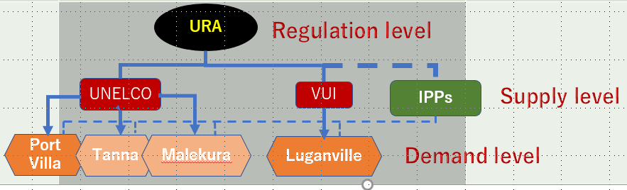

At this stage, IPPs connected with the broken line in the above figure are not existing.
In the future, if electric power companies (supply level) would be further divided and privatized at the functional level (Power generation, transmission, distribution, etc), further efficiency and price reduction could be expected, but considering the fairly small market size in Vanuatu, it may be necessary to evaluate the effect carefully.

Technical barriers and potential interventions
According to the energy road map based on NDC, the government of Vanuatu seeks mainly coconut –oil based renewable energy power generation to achieve the substitution of existing diesel oil based power generating plant.
Considering only the case of Port Villa (Efate Island), power generation capacity by diesel is about 21MW in place, which is considerably huge amount.
Considering the such conditions, following barriers and interventions are to be noted:
a) Barriers
1) Coconut-oil based power generation:
Feasibility of substitution of all existing diesel units (21MW) with coconut-oil based power generation units is to be secured.
Pure coconut-oil could be equivalent to current applied diesel oil. If mixture with diesel is required, optimum ratio of mixing should be verified.
Guarantee of self sufficient supply of coconut-oil has to be made at reasonable price for both buyer and supplier. (Whether long time purchase contract is indispensable.)
2) If new solar-PV is introduced, the matter of degradation of power output during life time:
In the case of solar-PV introduced instead of coconut-oil for some reason, the maximum output is inevitably reduced by 10 to 20% in 10 years.
In addition, its system life time would be up to 20 years considering the power conditioner durability.
3) Intermittent nature of electricity supply:
Solar-PV and wind farm cannot supply electricity continually in its nature. Sunlight or wind depend on the weather conditions. Accordingly, considerable capacity battery might be required for stable electricity supply, which require large amount of additional cost.
4) Unstable condition of electricity supply:
Without a considerable capacity of stable electricity supply as a base load, it is not easy to keep good condition of 100% renewable energy network. If coconut-oil could be totally replaced with the diesel, no concern about it is needed.
If it wouldn’t be the case, diesel should be replaced with solar or wind as source of renewable energy and in such case continuous control and monitoring for keeping electricity balance of supply and consumption is very needed to avoid abnormal voltage or frequency level on the transmission line and distribution line.
If supply and demand imbalance on the grid is not rightly controlled, the shutdown of electricity system could happen.
As preventive measure of such an event, introduction of EMS (Energy Management System) would be useful to continually monitor and keep safe for the total network condition.
5) Securing the site for RE plant:
When considering that substitution is carried out by solar only, 1.0MW solar-PV need 10,000 ~ 20,000 m2 land space, which means 21MW solar PV require 220,000 m2~ 440,000 m2.
This matter was discussed during the stakeholder consultation.
It would be still needed to watch so that the land acquisition could not be an issue.

b) possible interventions
1) Substitution existing diesel plant with RE in step by step manner in Efate Island:
- 1st phase (2022-2024): 7MW out of existing 21MW diesel to replace with solar-PV (or wind) and Coconut-oil plant
- 2nd phase (2025-2027): 7MW out of remaining 14MW diesel to replace with solar-PV (or wind) and Coconut-oil plant
- 3rd phase (2028-2030): Remaining 7MW diesel with solar-PV (or wind) and Coconut-oil plant

2) Additional electricity plant required by introduction of EV
(a) Electricity demand increase projection
Efate island electricity demand projection in consideration of EV introduction.
UNELCO kindly provided for the study by OECC team:

Fig. 3.2: Electricity demand in Efate Island
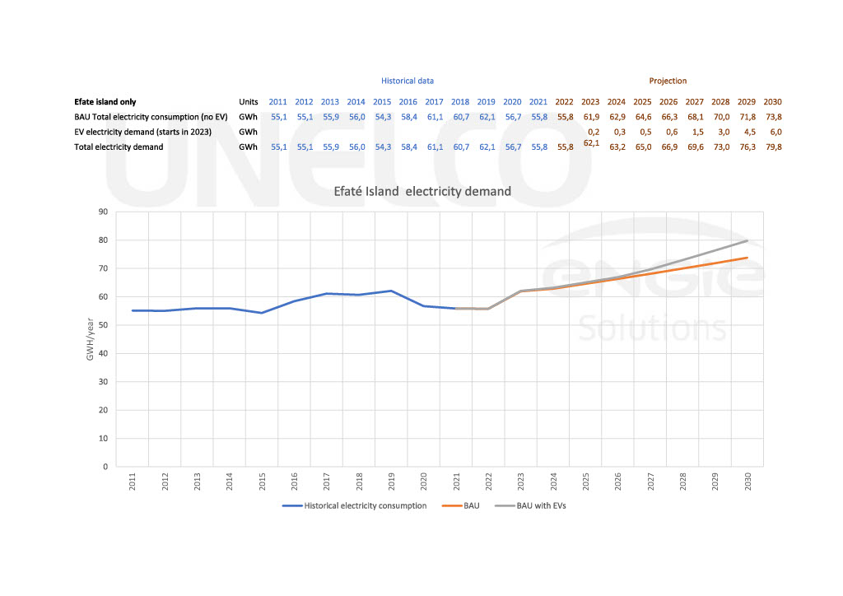

As the data table and the projection trend graph is not clear, the result of the analysis is summarized in the below table for better understandings:

Table 3.1: Results of the analysis
Year | 2021 | 2022 - 2024 | 2025 - 2027 | 2028 - 2030
BAU(GWh) | 55.8 | 62.9(+7.1) | 68.1(+12.3) | 73.8(+18)
Diesel(MW)  (GWh) | 21.0  55.2 | 15.0  39.45 | 9.0  23.7 | 0.0  0.00
Solar/Wind (Replace) | 0.0  0.0 | 3MW  5.25GWh | 3MW  5.25GWh | 5MW  8.76GWh
Coconut  (Replace) | 0.0  0.0 | 4MW  10.5GWh | 4MW  10.5GWh | 4MW  10.5GWh
Solar/Wind (Additional) | 0.0  0.0 | 4.06MW  7.1GWh | 7.02MW  12.3GWh | 10.3MW  18GWh
Demand by EV | 0.0  0.0 | 0.3GWh | 1.5GWh | 6GWh
Solar/Wind (～2027)  OTEC (2028～2030) | 0.0  0.0 | 0.2MW  0.3GWh | 0.86MW  1.5GWh | 0.8MW  6GWh
Total |  | 63.2GWh | 69.6GWh | 79.8GWh

Conversion between electric power (MW) and electric energy (MWh or GWh) is based on the capacity factor of each power generating facility as follows:
Solar-PV 20%
Wind power 20%
Diesel power 30%
Coconut-oil power 30%
OTEC 90%
Following basic idea is intended in the process of introduction of renewable energy devises in to the grid system toward 100% renewable energy in 2030 which is shown in Table 4.1:
a) Existing diesel power plant: Replaced with solar/wind and coconut-oil based plant year by year
b) Increase of electricity demand in BAU manner will be loaded by additional solar/wind power newly constructed for that purpose.
c) Yearly electric power demand increases as the number of EVs increases will be loaded by the additionally constructed solar/wind power plant by the end of 2027.
d) Increase of electricity demand by a number of EV increase after 2028 will be planed to be loaded by newly constructed OTEC plant.

(b) Estimation of additional annual electricity consumption by introducing EVs in 2030
In Table 4.1, additional electricity demand by EVs are specified, 0.3GWh in 2024, 1.5GWh in
2027 and 6GWh in 2030 respectively.
These figures are taken from the Fig. 4.2 which was provided by UNELCO.
The supporting data is not available from UNELCO, however the estimated data in 2030
(6GWh) is similar to the value of our assumptions shown in Table 4.3, in chapter 5.

The number of targeted EVs are as follows:

Table 3.2: The number of targeted EVs
Type of EV | No. of target | Battery capacity (kWh) | Mileage/year (km) | Cruising distant  (km) | Electricity  Consumption  (GWh)
Motorcars(1) | 191 | 66 | 10,000 | 610 | 0.21
Motorcars(2) | 200 | 9.3 | 10,000 | 120 | 0.16
Pick-ups | 307 | 131 | 10,000 | 480 | 0.83
Buses | 201 | 105.6 | 20,000 | 150 | 2.83
Van | 100 | 50 | 20,000 | 118 | 0.84
Trucks | 85 | 753 | 10,000 | 560 | 1.14
Bikes | 74 | --- | --- | --- | ---
Total | 1058 |  |  |  | 6.01

3) Batteries to introduce for purposes explained below as an intervention during the stage of mixture of diesel and RE powers enabling below functions:
(i) Peak Shift
Peak shift means charging the batteries during daytime for the night time use by discharging when needed.
(ii) Back-up purpose
Keeping the batteries fully charged for the use of emergency
(iii) Electricity Quality improvement
When the sudden output fluctuation occurs, battery supply quickly electricity to the grid to maintain balance between supply and demand of the entire power system which keep frequency stable as a result.
Also the increase of electricity supply on the distribution network due to surplus electricity from roof-top solar might cause reverse power flow, and in such a case quick charging to the batteries from the distribution line could maintain voltage stable.
In order to make such intelligent function, introduction of the Energy Management System (EMS) which is always monitoring the condition of the grid and giving necessary control to keep the desirable condition of the grid.

c) Introducing a large amount of RE power supply system to the grid after 2028:
Study and research about the introduction of RE power source as the most suitable one to the Island country when thinking about the future up to 2030, “Ocean Thermal Energy Conversion” (=OTEC) which is taken up to consider as a renewable energy source more suitable to introduce into the country like Vanuatu and is introduced to the stakeholders during the capacity building.
As explained during the capacity building course, OTEC is having below advantages:

OTEC advantages for island country in Pacific region
(i) Sea water temp difference (to be < 20degree) is power resource (= fuel)
(ii) Technology expected to become practical around 2025, although MW class is now in the verification test stage
(iii) Nature of continuous supply (high load factor) with steady output (no fluctuation)
(iv) Long life span (40yrs)
(v) Small land occupancy for installation
(vi) No disturbance to the quality of electricity on the grid
(viii) No batteries required
(ix) Small O&M cost
(x) Various co-benefits (ex. Fresh water production)

Financial barriers and potential interventions
As far as the energy sector’s improvement, as mentioned above, the renewable Energy Capacity Addition and substituting (replacement) of fossil fuels with Coconut (Copra) Oil based Electricity Generation is considered for transitioning to close to 100% renewable energy in the electricity generation sector until 2030.
In NDC document, it is described that to achieve the NDC targets, Vanuatu would expect financial, technological and capacity building support from global funds such as the Green Climate Fund (GCF), Global Environment Facility (GEF), Adaptation Fund, Least Developed Countries Fund; and bilateral/multilateral agencies and development partners. These funds will be utilized to bolster limited national resources and technical capacities for scaling up climate action.

Other barriers and potential interventions
Although there is no actual occurrence reported, it would be better to remind following unwanted issues as possible barriers:
- When a large amount of PV or other type of RE is introduced into a small-scale power system like Vanuatu, there might be a concern that the existing diesel generator (DG) will be in low-load operation during times when the grid load is low or when the RE output is high.
- Generally, DG is desirable to operate at an output of 50% or more, and if operation is continued at a low load, incomplete combustion of fuel due to a decrease in intake pressure and increase in carbon could cause adhesiveness due to incomplete combustion, etc.
- In addition, it is possible that the maintenance cycle and DG life will be shortened due to low-load operation, so it is necessary to avoid long-term continuation of low-load operation.
- Securing electricity in the event of disaster possibly without causing blackout is another barrier.
- If supply and demand imbalance on the grid is not rightly controlled, the stable and reliable electricity supply become difficult.
- A large amount of renewable energy introduction into small-scale power grids like Vanuatu, there would be a concern that the power quality (frequency and voltage) may be adversely affected.

Possible solutions to avoid above mentioned occurrence, introduction of EMS (Energy Management System) which is already above-mentioned is effective and applicable to:
(a) Continually monitor and control each power generating plant to keep more than a critical
level of generation of electricity of DGs as well as to keep balance of respective DGs operation hours.
(b) To suppress voltage and frequency fluctuations within an appropriate range.
(c) To keep balance of supply and demand electricity
(d) At the event of blackout, establishing a system that can continuously supply electricity to the grid by connecting batteries of EVs as a source of electricity.

EMS (Energy Management System)
Equipment that supports optimal energy activities. By "visualizing" energy usage status, which is difficult to grasp only by human hands, using information and communication technology, general energy management such as data analysis and efficient device control becomes possible.

4. Low carbon vision and targets

Based on various analyses conducted, such as review of government plans such as NDC, barrier analysis on EV / public transportation / power sector, and international trends on electric mobility, the direction of low carbonization of land transportation in Vanuatu was explored. As a result, it was found that there are two major issues especially in urban area, those are motor vehicles itself and public transportation.
As for motor vehicles, since there are a lot of old vehicles and second-hand cars, and there is lack of laws and regulations on importing poor-quality vehicles in terms of safety, emissions and fuel economy as well as proper maintenance on emissions, it can be observed that fuel efficiency is lower and exhaust gas such as air pollutants is higher. Thus contribute to higher transport emissions.
As for public transportation, mini-buses (vans) and taxis are the main means of transportation, and they are owned and operated by individual business owners with the exception of tour operators. Mini-buses are basically on-demand services and there is no fixed route buses. The number of mini-buses continues to increase, and most of these are old vehicles. These mini-buses are causing traffic congestion and deterioration of air quality in the urban area.

Vision
In order to solve these problems, promote low emission vehicles such as EV and enhance organized and efficient public transportation, and aim to realize low-carbon, clean and sustainable land transportation throughout Vanuatu.

Promotion of EV uptake
Since there is lack of experience in introducing EV in Vanuatu, it is necessary to develop and conduct various measures such as legal system, incentives, awareness rising, technical training on EV, and infrastructure development such as charging stations. Through introducing EV and replacing existing high-emission vehicles, it is expected that not only GHG emissions will be reduced, but also air quality will be improved as well as noise and vibration. These will bring significant benefits for maintaining and improving citizens health as well as realizing a more attractive tourism. An outline of proposed measures toward the year 2030 are shown in Fig. 5.1, and their details are described in the Section 6.
In addition, it is needless to say that, in order to maximize the effect of electrification of land transportation, it is indispensable to raise the renewable energy ratio in electricity supply. Improvement of road infrastructures such as road pavement is also important things to conduct.

Fig. 4.1: An outline of proposed measures toward the year 2030

Targets of EV uptake
The targets of EV uptake by 2030 are also shown in Fig. 4.2. Basically, these are in line with the targets in “Vanuatu’s First Nationally Determined Contribution (NDC) (Updated Submission 2020)”, 10% of government fleet and total public buses. As for commercial fleet and private fleet, same rate of 10% is applied, therefore, 10% of all the motor vehicles.
Number of in-used motor vehicles by types in 2030 are estimated as well as number of EV under 10% penetration ratio (Fig. 4.2), based on the data “the projected number of land vehicles in use” and “ratio of each type of motor vehicle” in “The Republic of Vanuatu Third National Communication to the UNFCCC”.
In addition, it is also recommended to set targets and promote various measures in the fields of electricity supply and road development which are closely related with EV uptake.

Fig. 4.2: Targets and benefits

Table 4.1: Estimated number of motor vehicles in use and EV targets
 | 2020 | 2025 | 2030 | EV targets in 2030 (10%)
Motorcars | 3,152 | 3,569 | 3,914 | 391
Pick-ups | 2,470 | 2,798 | 3,068 | 307
Buses | 1,618 | 1,833 | 2,010 | 201
Trucks | 681 | 772 | 846 | 85
Bikes | 596 | 675 | 741 | 74
Total | 8,517 | 9,647 | 10,579 | 1,058
Source: As for 2020, 2025, 2030, calculated by the Study Team based on the data described in “The Republic of Vanuatu Third National Communication to the UNFCCC”.

Improvement and enhancement of public transportation
On the other hand, as for improvement and enhancement of public transportation, considering growing demand of traffic, it is needed to build more efficient and effective public transportation such as fixed route buses in urban areas such as Port Vila and Luganville.
As a result, it is possible to reduce traffic congestion and emissions while improving the convenience and user-friendliness of mobility, and to realize a comfortable life for citizens and tourists in Vanuatu. It is proposed that improvement/enhancement of public transportation will be gradually realized by incorporating it into the proposed pilot projects shown in the Section 6.6. It is important to further enhance public transportation in light of the issues that have arisen in the process of promoting pilot projects.

GHG emission reductions
Through promoting the electrification of motor vehicles and the improvement/enhancement of public transportation especially in urban areas, GHG emissions from motor vehicles themselves will be reduced, and further GHG emission reductions will be expected through passenger modal shift from mini-buses (vans) to fixed-route buses.
GHG emission reductions through the 10% EV target will be estimated at 5,300 tCO₂e/year in 2030, which is 4.9% reduction compared with the transport BAU estimation. The BAU (business as usual) emission in 2030 is estimated at 108,000 tCO₂e based on the transport sector GHG emission data in “The Republic of Vanuatu Third National Communication to the UNFCCC” and assuming 4.0% annual increase of emissions referring to “Global Green Growth Institute (GGGI), 2016. Vanuatu Energy Demand Projections: Business As Usual Scenario”. The emission with 10% EV scenario will be 102,700 tCO₂e, by applying default grid electricity emission factor of Vanuatu provided by IFI TWG (The Technical Working Group of the International Financial Institutions) which is 0.504 kgCO₂/kWh.
On the other hand, the emission reduction through the 10% EV target under the 100% renewable energy scenario will be estimated at 10,800 tCO₂e/year in 2030, which is 100% reduction compared with the BAU estimation (Fig. 4.3).

Fig. 4.3: GHG emission reductions under the 10% EV target

Just for a reference, Fig. 4.4 shows a simple calculation that how GHG emission reductions through EV is dependent on the types of power plants. It is a case of a EV van compared with a gasoline van. GHG emissions of EV are highly dependent on the types of power plants which supply electricity to the EV through the grid. Emission reductions will be maximized when using electricity produced by renewable or low emission energy sources.

Fig. 4.4: CO₂ emissions of EV vans by types of electricity generation mix (gCO₂/km)

5. Proposed measures on EV uptake in Vanuatu

Based on the identified barriers in terms of policy/legislative, institutional, technical, financial aspects, necessary measures to promote EV uptake are proposed herewith. Fig. 5.1 shows pillars of measures which are linked with major barriers and issues identified.
11 pillars of measures are proposed as follows: “EV roadmap” is agreed direction to promote and accelerate EV uptake across all related parties in Vanuatu and one of the most essential pillars in the beginning stage. Since introduction of EV is new for all the parties in Vanuatu and it will be inter-sectoral activities, effective “Coordination body to promote EV” should be set up. In order to promote EV smoothly, “Regulations on EV and other vehicles” such as laws, regulations and guidelines should be prepared. In most countries, “Incentives to promote EV” have been provided at the time of purchase and operation of EV, so effective incentives are well considered taking into account Vanuatu’s local demand. “Awareness raising” is fundamental measures since there is few information on technologies and pros/cons of EV in Vanuatu. To accelerate EV uptake in the beginning stage, it is often effective to conduct “Pilot projects” for demonstration purposes for local citizens and tourists. The Study Team proposes several pilot projects including EV and public transportation. “Training programs on EV maintenance” is important for people to use EV with confidence, since lack of such technicians in this field in Vanuatu. “Develop public charging stations” is one of bottle necks on accelerating EV uptake, and the distribution of stations should be well designed. “Improvement of electricity supply” should be enhanced in terms of accessibility and stability. Poor road conditions limit the choice of EV types and mileage, thus “Improvement of road infrastructure” is necessary. “Studies and researches” should be continuously conducted.

Fig. 5.1: Pillars of proposed measures

5.1 EV roadmap

1) Objectives
To promote and accelerate EV uptake by formulating an agreed EV roadmap across all related parties in Vanuatu and fostering a common understanding on EV introduction among stakeholders.

2) Background
In Vanuatu, some measures related to EV are stipulated as “additional measures of NDC²⁷” in “Enhancing and Fast-tracking Implementation of Vanuatu’s Nationally Determined Contribution (NDC), November 2020”, but currently there is no strategy or plan or common direction for EV uptake.
In the first stage of EV uptake, it is necessary to formulate and show agreed direction and set of measures on EV uptake, both soft and hard measures such as laws/regulations, incentives and infrastructures related to EV as well as low emission vehicles, and to promote them in collaboration with related parties.

3) Contents
Based on the output of this feasibility study, formulate a comprehensive roadmap for EV which will be a common direction with set of measures for EV uptake in Vanuatu, under participation of all the stakeholders concerned.
In addition to measures related to EV, measures for existing motor vehicles (mainly second-hand cars) should also be included in the roadmap.
The table of contents of the roadmap will involve such items as;
- Background
- Objectives
- Scenarios and targets
- Barriers
- Policies and measures to promote EV uptake
  - Organizational structure
  - Laws and regulations
  - Incentives
  - Awareness raising
  - Pilot projects
  - Training programs on EV maintenance
  - Public charging stations
  - Improvement of electricity supply
  - Improvement of road infrastructure
  - Studies and researches
- Time frame

4) Responsible organizations/ stakeholders
Leading organization: Department of Energy / Ministry of Climate Change and Planning
Supporting organizations: Ministry of Infrastructure and Public Utilities, and related ministries, departments, agencies.

The roadmap should be developed in collaboration of all the stakeholders concerned, and recommend to formulate it in a committee/working group. -> see “6.2 Coordination body to promote EV”

5) Time frame
Short term: 2022-2024 (3 years)

6) Cost/financing
Cost: 3 person-month for support drafting the roadmap (external experts)
Financing: GCF

7) Expected results/impacts
The roadmap will be a document showing the common direction and necessary measures of EV uptake in Vanuatu. Through formulating the roadmap in collaboration with all the relevant parties, common understanding of EV uptake in Vanuatu will be fostered among stakeholders, and thus effective and efficient EV uptake will be promoted.

5.2 Coordination body to promote EV

1) Objectives
To set up a coordination body for EV uptake, and accelerate EV uptake in collaboration with the public and private sectors.

2) Background
In order to promote introduction of EV effectively and efficiently, it is necessary for various stakeholders, such as relevant ministries, electric power companies, tourism organizations/ companies, car dealers, educational institutions, and citizens, to work together in a common direction and understanding. It is important to establish a cross-sectoral organization that coordinates and conduct measures on EV uptake.

3) Contents
In line with the established EV roadmap, a cross-sectoral organization will be set up to coordinate and conduct variety of measures on EV uptake under defined roles and responsibilities.

Item | Contents
Name of the coordination body | e.g., The Vanuatu Electric Vehicle Association
Members | All public and private organizations in relation to EV uptake in Vanuatu, such as relevant ministries, agencies, electric power companies, tourism organizations/ companies, car dealers, educational institutions, academics, NPO, etc.
Roles | As the leading organization to conduct EV promotion under the roadmap, it has roles on coordination, information gathering/sharing, implementation of relevant measures, as well as hold periodical meetings to manage progresses of measures listed in the roadmap.

4) Responsible organizations/ stakeholders
Leading organization: Department of Energy / Ministry of Climate Change and Planning
Members: Ministry of Infrastructure and Public Utilities, Ministry of Finance and Economic Management, Department of Strategic Policy, Planning and Aid Coordination/Prime Minister's Office, other relevant ministries, agencies, electric power companies, tourism organizations/ companies, car dealers, logistic companies, educational institutions, academics, NPO, etc.

5) Time frame
Short term: 2022-2024 (3 years)

6) Cost/financing
Cost: N.A.
Financing: N.A.

7) Expected results/impacts
The organization will lead the measures on EV uptake and consider variety of measures under the participation of related organizations, and introduction of EV will be effectively promoted and accelerated.

Fig. 5.2: Image of the coordination body
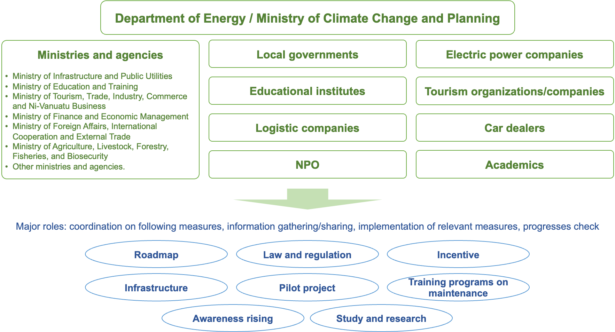

5.3 Regulations on EV and other vehicles

1) Objectives
To develop and amend necessary laws and regulations in regard to EV and charging infrastructure, and to promote EV uptake and shift to EV.

2) Background
In Vanuatu, there is no law or regulation regarding EV and charging infrastructure. Laws such as the Road Traffic Control Act and the Public Land Transport Act need to be amended from view point of introducing EV, as well as setting regulations and standards on EV registration and charging infrastructure.
On the other hand, it is necessary to promote shift from existing high emission vehicles to low emission ones such as EV, by establishing and amending related laws and regulations such as on fuel efficiency and exhaust gases, imported second-hand cars as well as vehicle inspection. Besides, taking account on Vanuatu’s unique situation as an island country, it will be needed to establish regulations on battery tracking in order to ensure the disposal and recycling of EV batteries in the future.

3) Contents
Review relevant laws and regulations, and newly develop and amend necessary legal documents to promote introduction of EV. Examples are shown below.

Item | Contents
EV | - Amendment of Road Traffic (Control) Act as appropriate, e.g. define EV in “Part 3 General Provision for Vehicles”, “Part 4 Registration and Licensing” and “Schedule 10 Annual Motor Vehicle Tax”.  - Amendment of Public Land Transport Act as appropriate, e.g. define EV in “Part 5 public land transport vehicle permit”.  - Development of standards on EV to be imported to Vanuatu, e.g. along with international standards.
Charging infrastructure | - Development of standards and guidelines on specifications, installation and safety requirements on EV charging infrastructure in Vanuatu.
Imported second-hand cars | - Development of minimum standards on second-hand cars at the time of import to avoid penetration of poor-quality vehicles in terms of safety, emissions and fuel economy.  - Increase in import duty, excise duty, import VAT as appropriate.
Emissions and inspection | - Development of regulations on fuel/electricity economy and emissions.  - Amendment of regulations on vehicle inspection as appropriate, e.g. Road Traffic (Control) Act, “Part 3 General Provision for Vehicles, 32. Certificate of roadworthiness” by adding viewpoints of emission tests.

4) Responsible organizations/ stakeholders
Leading organization: Public Works Department/Ministry of Infrastructure and Public Utilities, Ministry of Climate Change and Planning, Customs & Inland Revenue Department/Ministry of Finance and Economic Management, Port Vila Municipality Council, etc.

5) Time frame
Short to medium term: 2022-2024 (3 years)

6) Cost/financing
Cost: 6 person-month for support drafting the documents (external experts)
Financing: GCF and government budget

7) Expected results/impacts
Introduction of EV and shift to EV will be effectively promoted and accelerated through development and amendment of related laws/ regulations in regard to EV and charging infrastructure as well as imported second-hand vehicles, emissions, inspection.

Box: An example of regulation on imported vehicles: New Zealand, the Clean Car Import Standard – reducing vehicle CO₂ emissions to 105 grams per kilometre by 2025

The Clean Car Standard is a CO₂ target for light vehicles. It progressively lowers the CO₂ emissions of vehicles entering New Zealand from an average of 171 grams of CO₂/km today to 105 grams by 2025, a reduction of almost 40% in five years Suppliers will meet this target by bringing in more Electric Vehicles (EVs), more hybrids and more fuel efficient conventional vehicles.
Currently, the light vehicles coming into New Zealand are among the most fuel inefficient, and emission intensive, of any OECD country. The average vehicle in New Zealand has CO₂ emissions of around 171 grams per kilometre (g/km). Cars and SUVs alone average 161 g/km, compared to 105 g/km in Europe. In 2017, the most efficient vehicle models on New Zealand market had, on average, 21 percent higher emissions than their counterpart models in the United Kingdom. On average, New Zealanders pay 65 percent more in annual vehicle fuel costs than people in the European Union, even though Europe’s petrol prices are higher.

The Clean Car Discount (rebates and fees)

5.4 Incentives to promote EV

1) Objectives
To provide variety of incentives to promote and accelerate EV uptake and shift to EV.

2) Background
EV has not been introduced in Vanuatu yet, and it is expected that the EV prices and its operational costs will be higher than the existing ICE vehicle, since it is necessary to import all the vehicles to Vanuatu and the high electricity tariff. For this reason, for the time being, it is indispensable to provide incentives so that consumers can reasonably select low-emission vehicles such as EV.

3) Contents
Consider effective incentives with the aim of minimizing the cost difference with ICE vehicles. Examples are shown below.

Incentives | Contents
EV import | - Reduction in import duty, excise duty, import VAT as appropriate.  - Following table shows examples of current duties for motor vehicles in Customs Tariff HS2022. EV passenger cars (less than 10 passenger including the driver) are duty free.
   | Import Duty Rate | Excise Duty | Import VAT
  Motor vehicles for the transport of ten or more persons, including the driver
  - With only compression-ignition internal combustion piston engine (diesel or semi-diesel) : NEW | 15% | Free | 15%
  - With only compression-ignition internal combustion piston engine (diesel or semi-diesel) : USED or Reconditioned | 15% | 20% or 200,000VT whichever the greater | 15%
  - With both compression- ignition internal combustion piston engine (diesel or semi- diesel) and electric motor as motors for propulsion <- such as HEV | 15% | Free | 15%
  - With both spark-ignition internal combustion piston engine and electric motor as motors for propulsion <- such as HEV | 15% | Free | 15%
  - With only electric motor for propulsion <- such as BEV | 15% | Free | 15%
  Motor cars and other motor vehicles principally designed for the transport of persons (other than those of heading 87.02), including station wagons and racing cars.
  - Other vehicles, with only spark-ignition internal combustion piston engine: of a cylinder capacity not exceeding 1,000cc: New | 15% | Free | 15%
  - (Same as above): Used or reconditioned | 15% | 20% or 200,000VT whichever the greater | 15%
  - Other vehicles, with only spark-ignition internal combustion piston engine: of a cylinder capacity exceeding 3,000cc: New | 40% | Free | 15%
  - (Same as above): Used or reconditioned | 40% | 40% or 250,000VT whichever the greater | 15%
  - Other vehicles, with both spark-ignition internal combustion piston engine and electric motor as motors for propulsion, other than those capable of being charged by plugging to external source of electric power <- such as HEV | Free | Free | 15%
  - Other vehicles, with both spark-ignition internal combustion piston engine and electric motor as motors for propulsion, cable of being charged by plugging to external source of electric power <- such as PHEV | Free | Free | 15%
  - Other vehicles, with only electric motor for propulsion <- such as BEV | Free | Free | 15%
EV purchase and ownership | - Reduction in vehicle registration fee (registration fee + road tax), etc. (currently, registration fee is 7% of retail price of vehicles, and road tax is based on engine capacity for motor vehicles in “Schedule 10 Annual Motor Vehicle Tax” of Road Traffic (Control) Act, and there is no definition on EV.)
EV use | - Discounted electricity tariff for EV charging, etc.
Charging Infrastructure | - Subsidies for charger procurement and installation, etc.
Non-monetary | - Zero-emission vehicle zones, free parking for EV, priority use in tourism area, etc.

4) Responsible organizations/ stakeholders
Incentives on taxes; Customs & Inland Revenue Department/Ministry of Finance and Economic Management
Incentives on electricity tariff; Department of Energy/Ministry of Climate Change and Planning, UNELCO, VUI
Non-monetary incentives: Ministry of Infrastructure and Public Utilities, Ministry of Tourism, Trade, Industry, Commerce and Ni-Vanuatu Business, Port-Vila Municipality Council

5) Time frame
Import, purchase/ownership, non-monetary incentives: Start during short term: 2022-2024 (3 years)
Use, infrastructure incentives: Start during short to mid-term: 2022-2027 (6 years)

6) Cost/financing
Cost: 6 person-month for support developing the incentives (external experts)
Financing: GCF and government budget

7) Expected results/impacts
Through providing variety of incentives on EV, EV uptake will be effectively promoted and accelerated.

5.5 Awareness raising

1) Objectives
By conducting dissemination and awareness raising on EV and low carbon transportation, public transportation for all layers of society in Vanuatu, to increase consumer demand on these options and promote low carbonization of land transport in Vanuatu.

2) Background
EV and low carbon transportation are currently new and unfamiliar in Vanuatu. Public transportation is also limited in such as individually owned vans and taxis. In order to introduce and disseminate EV, low carbon transportation and public transportation, it is necessary for citizens and related organizations to have a good understanding of the advantages and disadvantages of EV, comparison with ICE (Internal Combustion Engine) vehicles, public transportation, GHG emission reductions and co-benefits. It is important to provide them a wide range of information in relation to low carbon transportation.

3) Contents
Organize awareness raising programs on EV, low carbon transportation and public transportation. Followings are examples.
- Seminars and workshops on EV and low carbon transportation including public transportation, and collaboration with other events.
- Short classes on climate change, local environment, and low-carbon transport for students at schools.
- Short classes on how to use public transportation for students at schools (after pilot projects on school buses and fix-route buses will be initiated).
- Set up a government portal site for EV and low carbon transportation.
- Demonstration of EV at events and tourist spots.
- Demonstration of EV through pilot projects.

4) Responsible organizations/ stakeholders
Leading organization: Department of Energy/Ministry of Climate Change and Planning, Ministry of Education and Training.
Supporting organizations: relevant ministries such as Ministry of Infrastructure and Public Utilities, agencies, municipalities, electric power companies, tourism organizations/companies, car dealers, educational institutions, academics, NPO, etc.

5) Time frame
Short to medium term: 2022-2027 (6 years)

6) Cost/financing
Cost (example): Half day seminars on EV and low carbon transportation: USD 3,000/event. USD 12,000 for 4 events/year.
Financing: GCF, other donors and government budget

7) Expected results/impacts
Citizens and related organizations will be able to easily access to information on EV, low carbon transportation, public transportation, and their capacity will be enhanced, thus EV and low emission vehicles will be further promoted and accelerated.

Fig. 5.3: Image of awareness rising event at school
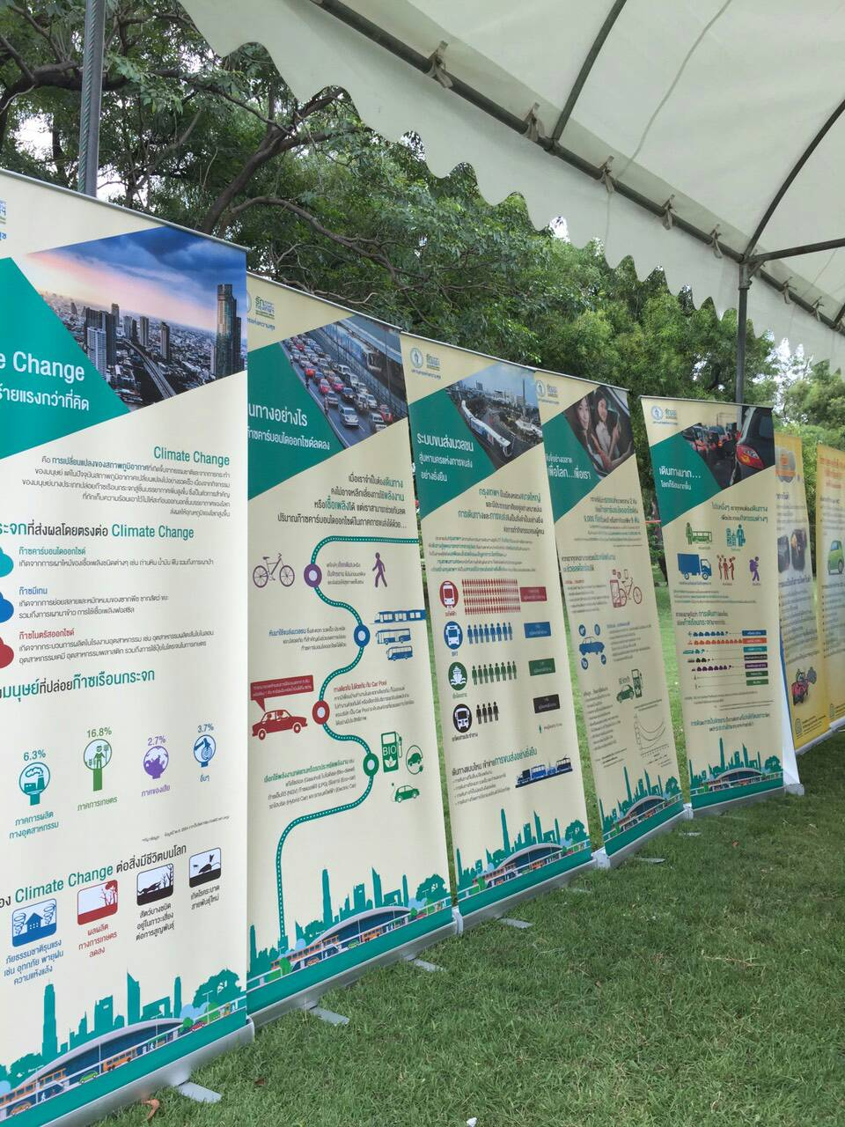
Source: Traffic and Transportation Department, Bangkok Metropolitan Administration.

5.6 Pilot projects

1) Objectives
To promote EV uptake through implementing demonstrative pilot projects for citizens and tourists in Vanuatu.

2) Background
EV have not yet been introduced in Vanuatu, and there is little knowledge or experience regarding EV in all layers of society. For this reason, it is essential to introduce EV as a demonstrative project, and provide opportunities for citizens and tourists to see and experience EV, and enhance the momentum for EV uptake. At the same time, through implementation of the pilot projects, identify issues and solutions for full-scale introduction of EV.
On the other hand public transport in Vanuatu consists of privately-owned mini-buses that run unspecified routes even in Port Vila and Santo, and about 70% of these vehicles area second hand vehicles. Bus system (mini-bus) is a merry-go-round and bus drivers need to go around to look for customers which is consuming more fuels. For the future sustainable development for cities in Vanuatu, there should have fixed route buses as an efficient public transportation.

3) Contents
Implement several pilot projects dividing into several phases.
Phase 1: School EV bus project in Port Vila (see details in the next pages)
Phase 2: EV for government vehicle fleet (see details in the next pages)
Phase 3: EV public transportation in Port Vila (see details in the next pages)

4) Responsible organizations/ stakeholders
Phase 1: Ministry of Education and Training, Ministry of Climate Change and Planning, Port-Vila Municipality Council
Phase 2: Ministry of Climate Change and Planning, relevant ministries.
Phase 3: Port Vila Land Transport Association (PVLTA)

5) Time frame
Phase 1 and 2: Start during short term: 2022-2024 (3 years)
Phase 3: Start during medium term: 2025-2027 (3 years)

6) Cost/financing
Phase 1: 5.95 million USD (GCF)
Phase 2: 0.62 (GCF)
Phase 3: 6.53 million USD (GCF)

7) Expected results/impacts
Citizens and tourists can see and experience EV on a daily basis, and will promote and accelerate further EV uptake. Issues for further introduction of EV will be identified, and possible for related organizations to consider countermeasures. Know-how on operation and maintenance of EV will be accumulated, and necessary measures on capacity enhancement can be developed.

Details of “Phase 1: School EV bus project in Port Vila”
Title | School EV bus project in Port Vila
Objectives | Electric school buses will be introduced for commuting to schools in Port Villa in order to improve the convenience of students commuting to school, and to reduce GHG emissions by switching from existing diesel/gasoline vehicles, and also to improve the air quality in urban areas of Port Villa. At the same time, it is expected that awareness of students for low emission transportation as well as climate change mitigation will rise through experiencing EV.
Background | Under the NDC, Vanuatu is aiming at 100% renewable energy for electricity supply in 2030. In the transport sector, introduction of EV is one of the pillars of measures, there are targets; introduction of EV into public buses (10% of the total buses), introduction of EV into government fleet (10% of the total vehicles), introduction of electric motorcycles/electric tricycles (1,000 vehicles). However, EV has not yet been introduced in Vanuatu, and there are lack of laws/regulations/incentives/infrastructures in place to promote its introduction.  On the other hand, public transportation in Vanuatu is mainly mini-bus (van) and taxi, but they are basically individually owned and operated on-demand basis without any fixed routes. Students of schools in Vanuatu usually commute to school by foot or mini-buses or sending by parent’s private cars.  Electric minibus for commuting to school is an effective step to raise awareness and acceptance of EV and public transportation among especially younger generations (primary school students to university students) toward further EV uptake in the future.
Implementation structure | Executing agency: Ministry of Education and Training, Ministry of Climate Change and Planning, Port-Vila Municipality Council  Operator of EV: Port Vila Land Transport Association (PVLTA)  Maintenance structure: Car dealers, Vanuatu Institute of Technology
Bus route | Introduce 15* electric buses for government owned primary/secondary schools in Port Villa.  *Around half of government owned primary/secondary schools in Port Villa.
EV specification  (examples) | Number of buses: 15 units (one EV bus for each school)  Capacity: 30 person, Width/length/height: 6,990 x 2,080 x 3,060 mm, Vehicle weight: 6,220kg  Battery capacity: 105.6 kWh, Maximum driving distance:150km, Maximum hill climbing ability: 20%, Minimum turning radius: 7.9m  Charging type: Fast: AC Type2 (<3 hours), Slow: DC CHAdeMO (>2 hours)  Images of electric bus  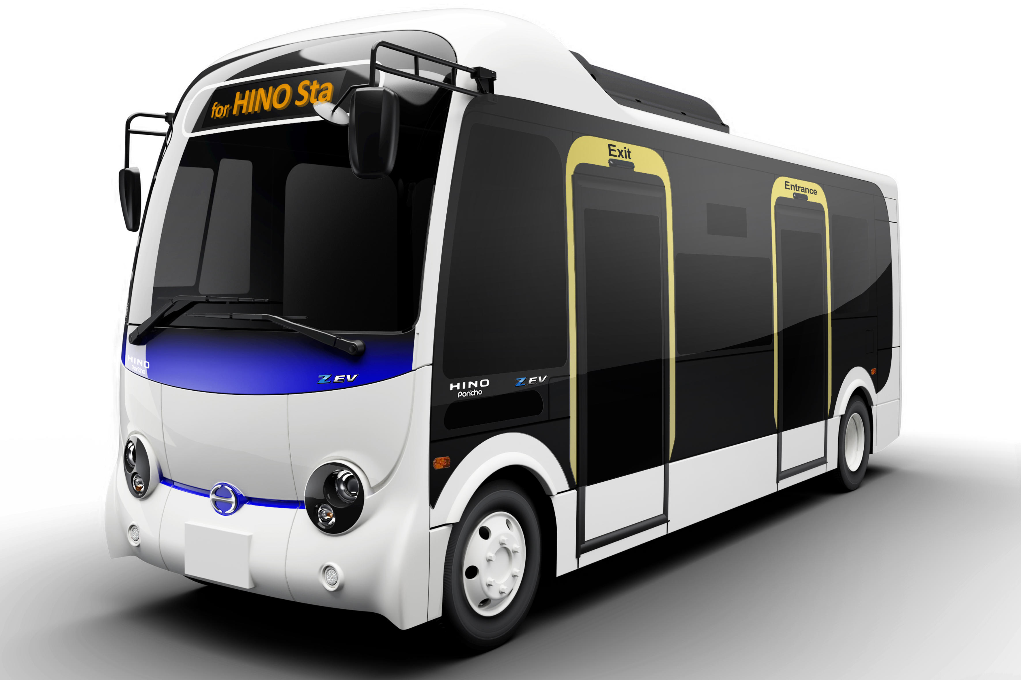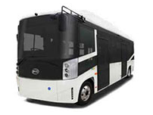  Source: Hino Motors, Ltd. Source: BYD Company Ltd.
Charging facility | Level 3 (fast) charging station: 15 stations (one for each school)  * For the purpose of enhancing EV uptake, charging stations should be used by the private taking into account the demand of both the pilot project and private use.
Cost evaluation | 1) Capital cost (for 15 units)  EV: 2.70 million USD (180,000 USD/unit)  Import duty, Import VAT, transportation cost: 0.96 million USD  Sub-total: 3.66 million USD for EV  Charging facility: 1.125 million USD (75,000 USD/unit)  Import duty, Import VAT, transportation cost: 0.237 million USD  Installation cost: 0.717 million USD  Sub-total: 2.08 million USD for charging facility  Battery replacement (at the 8th year of operation): 0.158 million USD (0.011 USD/unit)  Import duty, Import VAT, transportation cost: 0.051 million USD  Sub-total: 0.209 million USD  Total: 5.95 million USD  2) Operational cost (for 15 units)  EV electricity cost: 0.175 million USD/year  EV maintenance cost: 0.219 million USD/year  Charging facility maintenance cost: 0.056 million USD/year  Total: 0.450 million USD/year  *See Table 20 in details.
Benefits | Estimated GHG emission reduction: 212 tCO₂/year (14.1 tCO₂/year/unit)  Co-benefits:  Air pollutants reduction: CO 4,188 kg/year, NOx 115 kg/year  Rising awareness of students for low emission transportation as well as climate change mitigation.  Noise reduction.

Details of “Phase 2: EV for government vehicle fleet”
Title | EV for government vehicle fleet
Objectives | Various EV will be introduced for the government fleet, for the purpose of testing the EV and identifying any issues of EV operation in the Vanuatu’s context as well as of demonstration for the people in Vanuatu.
Background | Under the NDC, Vanuatu is aiming at 100% renewable energy for electricity supply in 2030. In the transport sector, introduction of EV is one of the pillars of measures, there are targets; introduction of EV into public buses (10% of the total buses), introduction of EV into government fleet (10% of the total vehicles), introduction of electric motorcycles/electric tricycles (1,000 vehicles). However, EV has not yet been introduced in Vanuatu even for the Government fleet.
Implementation structure | Executing agency: Ministry of Climate Change and Planning  Maintenance structure: Car dealers, Vanuatu Institute of Technology
Introduction of EV | Introduce 6 EV for vehicle fleet of the Ministry of Climate Change and Planning.
EV specification (examples) | Sedan  Number of EV: 2 units  Capacity: 5 person  Battery capacity: 84 kWh, Maximum driving distance: 470km  SUV  Number of EV: 2 units  Capacity: 5 person  Battery capacity: 91 kWh, Maximum driving distance: 445km  Pick-up  Number of EV: 2 units  Capacity: 5 person  Battery capacity: 98 kWh, Maximum driving distance: 370km
Charging facility | Level 2 charging station: 1 station  Level 3 (fast) charging station: 1 station  * For the purpose of enhancing EV uptake, charging stations should be used by the private taking into account the demand of both the pilot project and private use.
Cost evaluation | 1) Capital cost (for 6 EV)  EV: 0.34 million USD  Import duty, Import VAT, transportation cost: 0.059 million USD  Sub-total: 0.399 million USD for EV  Charging facility: 0.078 million USD  Import duty, Import VAT, transportation cost: 0.020 million USD  Installation cost: 0.051 million USD  Sub-total: 0.149 million USD for charging facility  Battery replacement (at the 8th year of operation): 0.055 million USD  Import duty, Import VAT, transportation cost: 0.018 million USD  Sub-total: 0.072 million USD  Total: 0.62 million USD  2) Operational cost (for 6 EV)  EV electricity cost: 0.019 million USD/year  EV maintenance cost: 0.044 million USD/year  Charging facility maintenance cost: 0.008 million USD/year  Total: 0.071 million USD/year
Benefits | Estimated GHG emission reduction: 19 tCO₂/year (for 6 EV)  Co-benefits:  Air pollutants reduction: CO 84 kg/year, NOx 4 kg/year  Noise reduction  Rising awareness of people in Vanuatu.

Details of “Phase 3: EV public transportation in Port Vila”
Title | EV public transportation in Port Vila
Objectives | Electric buses and minibuses (vans) will be introduced to upgrade public transportation in Port Vila. In order to improve traffic congestions and to enhance efficiency of mobility by both introducing organized public transportation (fixed route bus) and replacing existing old ICE vans. As well as to reduce GHG emissions by switching from existing diesel/gasoline vehicles, and to improve the air quality in urban areas of Port Villa. Besides, formulate a organizational structure or a public transport company in order for smooth operation of the buses and for preparation toward more sophisticated organized public transportation.
Background | Under the NDC, Vanuatu is aiming at 100% renewable energy for electricity supply in 2030. In the transport sector, introduction of EV is one of the pillars of measures, there are targets; introduction of EV into public buses (10% of the total buses), introduction of EV into government fleet (10% of the total vehicles), introduction of electric motorcycles/electric tricycles (1,000 vehicles). However, EV has not yet been introduced in Vanuatu, and there are lack of laws/regulations/incentives/infrastructures in place to promote its introduction.  On the other hand, public transportation in Vanuatu is mainly mini-bus (van) and taxi, but they are basically individually owned and operated on-demand basis without any fixed routes. Every year 100 to 400 units of (ICE) buses and minibuses (vans) are newly registered in Port Vila and Luganville. Growing number of these vans leads to traffic congestion and emissions. Traffic congestion in the city center of Port Vila are getting worth year by year and leading to inefficient mobility as well as deterioration of air quality.  There are also concerns that existing vans are using gasoline/diesel vehicles with poor fuel efficiency and high emissions. Vehicle inspection, emission/fuel efficiency standards are not sufficient enough.
Implementation structure | Executing agency: Ministry of Climate Change and Planning, Port-Vila Municipality Council  Operator of EV: Port Vila Land Transport Association (PVLTA)  Maintenance structure: Car dealers, Vanuatu Institute of Technology  *Formulate a organizational structure or a public transport company in order for smooth operation of the public transportation.
Introduction of EV | Introduce 5 electric buses and 50 electric vans in Port Villa.  5 electric buses will be dedicated to the newly established fixed routes, for the purpose to introduce organized public transportation in Port Via.  50 electric vans will replace old existing vans in Port Via.
EV specification  (examples) | Electric bus (fixed-route bus)  Number of buses: 5 units  Capacity: 30 person, Width/length/height: 6,990 x 2,080 x 3,060 mm, Vehicle weight: 6,220kg  Battery capacity: 105.6 kWh, Maximum driving distance:150km, Maximum hill climbing ability: 20%, Minimum turning radius: 7.9m  Charging type: Fast: AC Type2 (<3 hours), Slow: DC CHAdeMO (>2 hours)  Electric van  Number of vans: 50 units  Capacity: 9 person  Battery capacity: 50 kWh, Maximum driving distance:189km  Images of electric minibus/vans  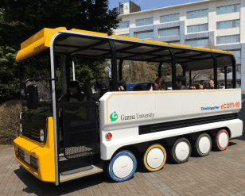  Source: Thinktogether, Ltd. Source: Toyota
Charging facility | Level 2 charging station: 50 stations  Level 3 (fast) charging station: 5 stations  * For the purpose of enhancing EV uptake, charging stations should be used by the private taking into account the demand of both the pilot project and private use.
Cost evaluation | Electric buses (5 units)  1) Capital cost (for 5 units)  EV: 0.900 million USD (180,000 USD/unit)  Import duty, Import VAT, transportation cost: 0.320 million USD  Sub-total: 1.22 million USD for EV  Charging facility: 0.375 million USD (75,000 USD/unit)  Import duty, Import VAT, transportation cost: 0.080 million USD  Installation cost: 0.239 million USD  Sub-total: 0.694 million USD for charging facility  Battery replacement (at the 8th year of operation): 0.053 million USD (0.011 USD/unit)  Import duty, Import VAT, transportation cost: 0.017 million USD  Sub-total: 0.070 million USD  Total: 1.98 million USD  2) Operational cost (for 5 units)  EV electricity cost: 0.058 million USD/year  EV maintenance cost: 0.073 million USD/year  Charging facility maintenance cost: 0.019 million USD/year  Total: 0.150 million USD/year  Electric vans (50 units)  1) Capital cost (for 50 units)  EV: 3.27 million USD (65,324 USD/unit)  Import duty, Import VAT, transportation cost: 0.61 million USD  Sub-total: 3.88 million USD for EV  Charging facility: 0.156 million USD (3,127 USD/unit)  Import duty, Import VAT, transportation cost: 0.040 million USD  Installation cost: 0.142 million USD  Sub-total: 0.338 million USD for charging facility  Battery replacement (at the 8th year of operation): 0.250 million USD (0.005 USD/unit)  Import duty, Import VAT, transportation cost: 0.081 million USD  Sub-total: 0.331 million USD  Total: 4.55 million USD  2) Operational cost (for 50 units)  EV electricity cost: 0.201 million USD/year  EV maintenance cost: 0.365 million USD/year  Charging facility maintenance cost: 0.008 million USD/year  Total: 0.574 million USD/year  *See Table 21 in details.
Benefits | Estimated GHG emission reduction: 306 tCO₂/year  Co-benefits  - Air pollutants reduction: CO 5,119 kg/year, NOx 141 kg/year  - Noise reduction

Box: Major advantages and challenges of EV bus compared with conventional diesel bus

Advantages of EV bus
- Contribute to revitalize the region such as promoting tourism and improving the image of companies and the area.
- No air pollutant emission from the tailpipe and less noise and vibration than ICE buses, so that local environment is expected to improve.
- Brakes works better than ICE buses.
- Reduction of running costs (40% reduction compared to diesel vehicles in Japanese case).
- Reduction of maintenance cost (repair cost is about half that of diesel vehicles, oil replacement is unnecessary, and there are few replacement parts. Few inspection items, so there is also an effect of reducing the time cost of maintenance staff)

Challenges of EV bus
- Often higher price than ICE buses.
- Often shorter driving distances per a charging
- Operating hours would be shorter, because of longer charging time than diesel fuel.
- Longer time required for repair in case of accidents, because of procurement of spare parts.
- Need well-coordinated maintenance structure including both vehicles and charging facilities.

Source: partially from “Guidelines on electric bus installation. Ministry of Land, Infrastructure, Transport and Tourism, Japan.”

Table 5.1: Cost comparison of an EV bus and Gasoline Vans
 | EV bus | Vans  (Gasoline) | Difference  (EV minibus – 3 Vans)
Specifications/parameters (assumptions)
Capacity | 30 passenger | 10 passenger | -
Energy | Electricity  (105.6 kWh) | Gasoline | -
Electricity/fuel consumption | 800 Wh/km | 8.8 km/liter | -
Driving distance | 36,500 km/year | 36,500 km/year | -
Energy consumption | 29,200 kWh/year | 12,443 liter/year  (4,148 for 1 van) | -
Energy tariff | 0.4 USD/kWh | 1.5 USD/liter | -
Capital costs (in USD)
Vehicle
Vehicle price | 180,000 | 105,000 (3 vans) | 75,000
Import duty | 27,750 | 16,875 (3 vans) | 10,875
Excise duty | 0 | 0 (3 vans) | 0
Import VAT | 31,163 | 18,281 (3 vans) | 12,881
Transportation cost | 5,000 | 7,500 (3 vans) | -2,500
Sub-total | 243,913 | 147,656 (3 vans) | 96,256
Charger
Charger price | 75,000 | N.A. | N.A.
Import duty | 3,850 | N.A. | N.A.
Excise duty | 0 | N.A. | N.A.
Import VAT | 11,828 | N.A. | N.A.
Transportation cost | 2,000 | N.A. | N.A.
Installation cost | 47,781 | N.A. | N.A.
Sub-total | 140,459 | N.A. | N.A.
Battery replacement (at the 8th year of operation)
Battery price | 10,560 | N.A. | N.A.
Import duty | 1,584 | N.A. | N.A.
Excise duty | 0 | N.A. | N.A.
Import VAT | 1,822 | N.A. | N.A.
Sub-total | 13,966 | N.A. | N.A.
Total | 398,337 | 147,656 (3 vans) | 250,680
Operational costs (in USD/year)
Energy cost | 11,680 | 18,615 (3 vans) | -6,935
Vehicle maintenance cost | 14,600 | 30,113 (3 vans) | -15,513
Charger maintenance cost | 3,750 | N.A. | N.A.
Total | 30,030 | 48,728 | -18,698
CO₂ emission | 14.7 tCO₂/year | 28.8 tCO₂/year  (9.6 for 1 van) | -14.1 tCO₂/year  (reduction)

Table 5.2: Cost comparison of an EV van and a gasoline van
 | EV van | Van  (Gasoline) | Difference
Specifications/parameters (assumptions)
Capacity | 9 passenger | 10 passenger | -
Energy | Electricity  (50 kWh) | Gasoline | -
Electricity/fuel consumption | 264 Wh/km | 8.8 km/liter | -
Driving distance | 36,500 km/year | 36,500 km/year | -
Energy consumption | 9,636 kWh/year | 12,443 liter/year  (4,148 for 1 van) | -
Energy tariff | 0.4 USD/kWh | 1.5 USD/liter | -
Capital costs (in USD)
Vehicle
Vehicle price | 65,324 | 35,000 | 30,324
Import duty | 0 | 5,625 | -5,250
Excise duty | 0 | 0 | 0
Import VAT | 9,799 | 6,094 | 3,761
Transportation cost | 2,500 | 2,500 | 0
Sub-total | 77,622 | 49,219 | 28,835
Charger
Charger price | 3,127 | N.A. | N.A.
Import duty | 256 | N.A. | N.A.
Excise duty | 0 | N.A. | N.A.
Import VAT | 508 | N.A. | N.A.
Transportation cost | 2,000 | N.A. | N.A.
Installation cost | 2,836 | N.A. | N.A.
Sub-total | 8,727 | N.A. | N.A.
Battery replacement (at the 8th year of operation)
Battery price | 5,000 | N.A. | N.A.
Import duty | 750 | N.A. | N.A.
Excise duty | 0 | N.A. | N.A.
Import VAT | 863 | N.A. | N.A.
Sub-total | 6,613 | N.A. | N.A.
Total | 92,961 | 49,219 | 43,743
Operational costs (in USD/year)
Energy cost | 4,015 | 6,205 | -2,190
Vehicle maintenance cost | 7,300 | 10,038 | -2,738
Charger maintenance cost | 156 | N.A. | N.A.
Total | 11,471 | 16,243 | -4,928
CO₂ emission | 4.9 tCO₂/year | 9.6 tCO₂/year | -4.7 tCO₂/year  (reduction)

5.7 Training programs on EV maintenance

1) Objectives
To enhance capacity and establish structure of technicians in Vanuatu so that EV maintenance can be properly performed, and thus promote the smooth introduction and operation of EV.

2) Background
EV has not been introduced in Vanuatu yet, and there is no know-how on maintenance of EV and charging infrastructure. In the future, when EV is widely introduced, proper maintenance will be indispensable, and it is necessary to develop human resources for the maintenances.

3) Contents
In Vanuatu, car dealers routinely provide car maintenance and repair services in their business. Therefore, it will be effective to provide trainings on EV maintenance for these car dealers.
On the other hand, the Vanuatu Institute of Technology (VIT) has a course on Automotive Engineering, therefore it will be also effective to provide trainings for students in VIT to establish a medium- to long-term EV maintenance structure in Vanuatu.
The contents of the training courses will minimally include following items.
- Roles and works of EV technician
- Background such as global EV industry
- Technology and performance differences of EV compared with ICE vehicles.
- Basic of electrical mechanics such as motor, battery, power control unit, charger.
- Safety requirements for EV and charging infrastructure.
- Major failures and troubleshooting of EV including software and hardware.

4) Responsible organizations/ stakeholders
Leading organization: Department of Energy / Ministry of Climate Change and Planning, Ministry of Infrastructure and Public Utilities, Ministry of Education and Training, VIT
Supporting organizations: Vanuatu Qualification Authorities, car manufacturers

5) Time frame
Short to long term: 2022-2030 (9 years)

6) Cost/financing
Cost: 4 person-month (four times per year of one week training course, including preparation)
Financing: GCF, other international donors and government budget

7) Expected results/impacts
Human resources and systems in relation to the maintenance of EV and charging infrastructure will be enhanced, and periodical maintenance of EV will progress, and thus support smooth introduction and operation of EV in Vanuatu.

5.8 Develop public charging stations

1) Objectives
To install charging infrastructure (fast and slow) in various places in major cities in Vanuatu to support full-range of EV uptake in the future.

2) Background
Since EV has not been introduced in Vanuatu yet, no charging infrastructure has been installed. When EV are widely introduced in the future, it will be essential to develop a large number of charging stations. Taking into account characteristics of vehicle use in Vanuatu, it is important to appropriately place the infrastructure in various places of the city.

3) Contents
Considering the widespread uptake of EV in around 2030 and people’s behavior on motor vehicle use, develop an optimized layout plan of charging stations that can be used by citizens and tourist (Level 1 to Level 3 charging stations in public facilities, shopping centers, hotels, airports, etc. See Fig. 13 for a reference). At the same time, consider the specifications of charging infrastructure that meet relevant international standards or standards set by the Government of Vanuatu. Based on an EV diffusion scenario, consider increase of the number of installations.
In addition to public charging stations, consider measures to promote the installation of residential charging as well as workplace charging.

4) Responsible organizations/ stakeholders
Leading organization: Ministry of Infrastructure and Public Utilities, Department of Energy/Ministry of Climate Change and Planning, UNELCO, VUI, Port-Vila Municipality Council
Supporting organization: Ministries, agencies, fuel stations, hotels, shopping centers, etc.

5) Time frame
Short to long term: 2022-2030 (9 years)

6) Cost/financing
Cost: Level 2 (higher voltage): 4,000 – 6,000 USD/charger
Level 3 (DCFC: DC fast charging)): 74,000-200,000 USD/charger)
Financing: Government budget, private finance.

7) Expected results/impacts
Through developing charging stations in various places, citizens and businesses can use EV without thinking of running out of electricity and thus promote smooth introduction of EV.

Fig. 5.4: Levels of EV charging
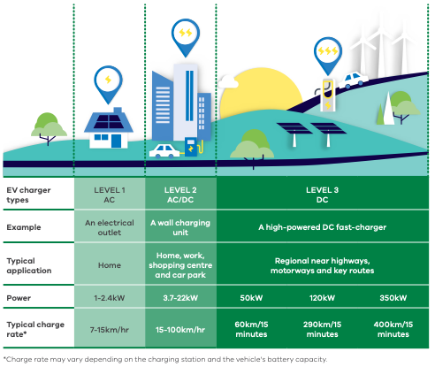
Source: Victoria’s Zero Emissions Vehicle Roadmap. The State of Victoria Department of Environment, Land, Water and Planning, 2021.

5.9 Improvement of electricity supply

1) Objectives
By expanding the power supply network, stabilizing electricity security and the developing more renewable energy-based power sources with reduction of electricity tariff, aiming to establish the infrastructure of the coming EV society and to maximize the effect of introducing EVs.

2) Background
For the spread of EVs, a stable supply of green power over the driving range of EVs is indispensable under a cheap and convenient charging environment.
Diesel power generation is the mainstream on all islands except Santo Island in Vanuatu at this moment, therefore the expected reduction of GHG emissions by introducing EVs will be limited. In order to maximize the effect of introducing EVs, it is necessary to steadily aim to achieve the government target of renewable energy ratio (100% in 2030).

3) Contents
The government and existing electric power companies are required to work together to encourage more IPPs to enter to the power business in order to energize open competition for raising efficiency and for reducing electricity tariff in the market.
It is also important to design the necessary electricity systems considering the need for green power development and supply in anticipation of the power demand at the time of full-scale introduction of EV toward the end of 2030.
The draft of the specific electricity system required such as amount of additional electricity capacity, electricity network distance would be planned in consideration of number of EVs, charging stations with its installation plan over the time frame.
The government is required to draft laws and enact the legislation necessary for the operation of such power systems.

4) Responsible organizations/ stakeholders
Leading organization: Ministry of Infrastructure and Public Utilities, Concession companies as UNELCO etc.
Supporting organization: Ministry of Climate Change and Planning, international donors

5) Time frame
Short term: 2022-2024 (3 years) as 1st step of RE further introduction (Solar, Wind, Coconut-oil)
Mid-term 2025-2027 (3 years) as 2nd step of RE introduction (Solar, Wind, Coconut-oil)
Long term 2027-2030 (3 years) as 3rd step of RE introduction up to 100% (Solar, Wind, Coconut-oil and OTEC)

6) Cost/financing
As this feasibility study focus on the improvement of land transportation, which means, OECC team considers that the cost/financing for the infrastructure of the electricity network including the power plant itself is even deeply related with the land transport system, especially EV charging system by the renewable electricity system, however, it seems that the electricity system must be little off the core part of the system. Accordingly, we would like to refrain from specifying the amount and including it as part of the application to the fund.

1) Short term:
Cost: NA
Financing: GCF, other international donors such as World Bank/ JICA/ ADB etc.
2) Mid-term
Cost: NA
Financing: GCF, other international donors such as World Bank/ JICA/ ADB etc.
3) Long term
Cost: NA
Financing: GCF, other international donors such as World Bank/ JICA/ ADB etc.

7) Expected results/impacts

1) Short term:
Sufficient RE (Solar, Wind, Coconut-oil) based power supply addition including replacement diesel-based power will be available in the range where EVs run, and smooth introduction of EV will be promoted under RE based electricity system enabling utilization of green electricity reducing GHG emissions over the area of introduction of EVs.
2) Mid-term
Following the first phase (short term), replacement of the existing diesel power with solar power, wind power and coconut-oil based power will be performed. Renewable energy based electricity will be sufficiently supplied for the EV introduced during this period.
3) Long term
100% renewable energy based electricity supply will be achieved at the end of this term. More than 1,000 EVs will be introduced and all those EVs will be charged with renewable energy based electricity.
Toward the end of this term (period), replacement of all grid electricity with renewable energy based electricity will be completed.
Total grid electricity supply will reach to 79.8GWh, of which breakdown is as below:
Solar/Wind power: 42GWh (24MW)
Coconut-oil based power: 31.5GWh (12MW)
OTEC: 6.0GWh (0.8MW)

As for OTEC, some supplementary description may be needed because this facility would not have been referred much so far.
It is introduced during the capacity building and it attracted the attention of the audience very much.
Therefore more explanation is presented below in order to deepen the understanding for the readers:
OTEC advantages for island country in Pacific region
(i) Sea water temp difference (to be < 20degree) is power resource (= fuel)
(ii) Technology expected to become practical around 2025, although MW class is now in the verification test stage
(iii) Nature of continuous supply (high load factor) with steady output (no fluctuation)
(iv) Long life span (40yrs or more)
(v) Small land occupancy for installation (less than 1000m2 for 1MW)
(vi) No disturbance to the quality of electricity on the grid (stable output continuously)
(viii) No batteries required (suitable as base load)
(ix) Small O&M cost (comparing to Solar or wind)
(x) Various co-benefits (ex. Fresh water production, deep ocean water)
technology of OTEC might be not widely-known now, however its basic system is called “Rankin cycle” similar to the conventional BTG (Boiler-Turbine-Generator) configuration, shown as below:

Fig. 5.5: Basic Rankine Cycle Concept
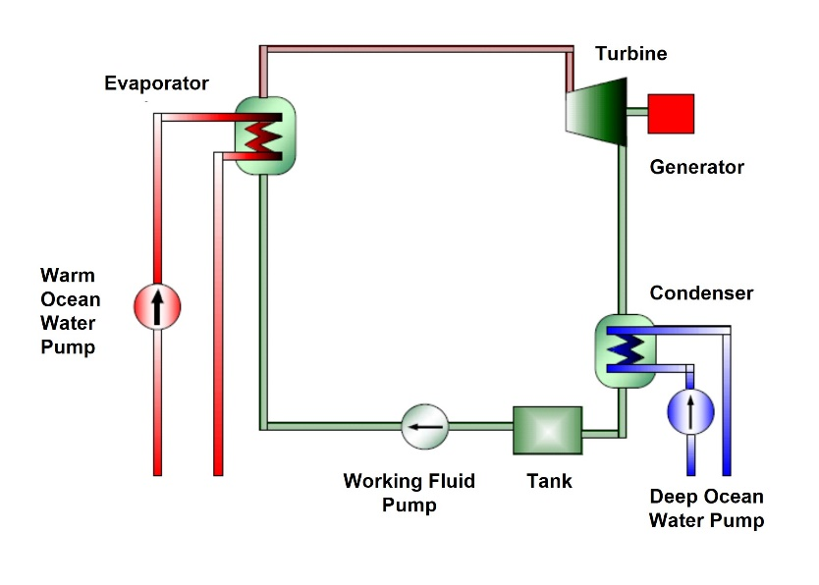

Below explains how OTEC is advantageous in comparison with solar-PV:
a. Service Life
Solar: 17yrs – 20yrs (unavoidable to 20% degradation in output power during first 10 years)
OTEC: 40yrs or more (no output degradation in its life span)
b. Maintenance
Solar: Panel cleaning required to keep module output level, which will need huge man-power.
About 4000 panels are installed for 1MW plant
OTEC: Minimum cost for maintenance, which will require easy regular inspection on some equipment
c. Required size of land for installation:
Solar: need 20 times size of land for that of OTEC (20,000m2 / 1.0MW)
OTEC: 1,000m2 /1.0MW
d. Annual electricity generation
Solar: 2,075MWh / 1.0MW (= 12.450MWh/6.0MW, GHD FS report for ADB 6.0MW solar project)
OTEC: 8,322MWh /1.0MW (1.0MW x 8,760h x 0.92, Technical report for CTCN TA project)
e. Electricity generation in life span for 1MW plant
Solar: 41,500MWh (= 2,075MWh x 20yrs) degradation ignored
OTEC: 332,880MWh (= 8,322MWh x 40yrs)
f. Investment
Solar: 17,500,000USD (GHD FS report)
OTEC: 18,820,000USD (Expected cost for production model, not included intake pipe)
58,820,000USD (Expected cost for production model, including intake pipe)
g. Investment cost per MWh in life:
Solar: 17,500,000 / 41,500MWh ⇒ 421.7 USD/MWh
OTEC: 18,820,000 / 332,880MWh ⇒ 56.53 USD/MWh
(OTEC: 58,820,000 / 332,880MWh ⇒ 176.7 USD/MWh)
In conclusion, when it comes to the renewable energy introduction, the investment cost for OTEC would be far less than the solar PV comparing both production model.

5.10 Improvement of road infrastructure

1) Objectives
Through improving roads (e.g. paving, width) and expanding the road network in Vanuatu, to support the comfortable driving of EV and to contribute to the expansion of driving area.

2) Background
In Vanuatu, the pavement rate of roads is low (13%), and many roads are narrow, so people prefer vehicles such as small four-wheel drive pickup. In addition, large capacity buses are rarely introduced because of these narrow roads, especially city center in Port Vila. On the other hand, since the road pavement affects fuel efficiency (electricity cost) of vehicles, it is important to improve the pavement condition. In order to promote spread of a wide variety of EV in the future, it is necessary that the roads are in good condition and the areas where EV can travel are expanded.

3) Contents
Promote in close cooperation with the road development plans and projects, such as;
- Public Roads Policy and Strategy of MIPU;
- Vanuatu Infrastructure Strategic Investment Plan 2015-2024. Prime Minister’s Office;
- Projects such as, Vanuatu Climate Resilient Transport Project of the World Bank.

4) Responsible organizations/ stakeholders
Leading organization: Ministry of Infrastructure and Public Utilities, Municipality Councils
Supporting organization: Ministry of Climate Change and Planning

5) Time frame
Short to long term: 2022-2030 (9 years)

6) Cost/financing
Cost: Estimated in each of the road project
Financing: International donors such as World Bank/ JICA/ ADB etc.

7) Expected results/impacts
Through improving the pavement condition and roads width as well as expanding the road network, EV will become more comfortable to use and their introduction will be further promoted.

5.11 Studies and researches

1) Objectives
To study and research various issues related to the introduction of EV and consider necessary measures.

2) Background
Large-scale deployment of EV has not yet progressed much in island countries in the world, and it is expected that some issues will arise when EV uptake will gradually progress in Vanuatu. It is important to study and research the best ways to deal with these issues in collaboration with experts, donors, and advanced countries/cities on EV uptake, and to establish a good EV uptake model which is unique to the situations of Vanuatu.

3) Contents
Study and research on issues when EV are introduced in large-scale, such as;
- Monitoring of GHG emission reduction and environmental improvement by introducing EV;
- Person trip survey in cities in Vanuatu such as Port Vila and Luganville;
- Supply and demand balance (between EV charging and power supply);
- Disposal and recycle of used batteries, monitoring of batteries;
- Utilization of EV as an emergency power source in case of disaster.

4) Responsible organizations/ stakeholders
Leading organization: National University of Vanuatu, recycle companies (such as RecycleCorp which currently collect and recycle batteries in Vanuatu), Department of Energy/Ministry of Climate Change and Planning, car dealers.
Supporting organizations: Academic, NPO

5) Time frame
Short to long term: 2022-2030 (9 years)

6) Cost/financing
Financing: International donors, own budget

7) Expected results/impacts
Measures to deal with issues related to the introduction of EV will be studied and provided, and contribute to accelerate further EV uptake in Vanuatu.

- Techno-economic aspects of EV introduction and its feasibility
Thse interventions are expected to bring multiple social, technical and economic benefits to the nation. The proposal is supposed to improve mobility, which could potentially accelerate economic activities in the nation in the line with eleven pillars mentioned on Fig. 6.1. The impact on the island's economy is expected to be wide, including on the income not only in urban but also rural area as well as on macroeconomic indicators such as the rate of population poverty line. At the same time, co-benefits of introducing EV has wider implications in economic as well as environmental, health, energy supply and gender-sensitive development. Similarly, thse interventions could also bring negative impacts on key sectors and provoke negative attitudes from local communities such as car dealers towards drastic paradigm shift. This section summarizes these some aspects of proposal.

Impact on poverty reduction
It likely that introducing EV will have a long term impact on poverty reduction. The number of jobs created during the building up public transport companies (or a well-organized association) and developing public charging stations including developing technicians in the field of EV maintenance as well as operation of the organization are expected to be limited. However, with providing urban and rural populations with accessible public transportation and various co-benefits of this proposal is likely to provide benefit low-income and vulnerable groups through stimulating economic activities, expanding employment opportunities as well as narrowing the economic gap between rural and urban area.

In the updated Nationally Determined Contribution (NDC) of Vanuatu in March 2021, which includes a stable economy based on equitable, sustainable growth that creates job and income earning opportunities accessible to all people in rural and urban area. At the same time, it is noteworthy that Vanuatu’s population is largely based within its’ rural areas 75% as per 2016 mini census, and there are significant differences in the Basic Needs Poverty Line (BNPL)s between the urban and rural areas. In 2010, the rural BNPL is 55%, and Luganville’s BNPL is 72% of the Port Vila BNPL. Thus, to achieve the National Sustainable Development Plan (NSDP) 2016 to 2030 also called Vanuatu 2030, it is essential for transport and energy sector to introduce the institutional development required as well as the technical support in order to cause paradigm shift drastically for transportation convenience, from the perspective of redressing population, job and income disparities.

Increase of energy security and potential economic development
The volatility and prices in energy supply in Vanuatu are significant factors of vulnerability as electricity needs are mostly based on fossil fuels, which are imported. In 2017, Vanuatu’s economy grew by 4.4% with a strong performance over the last three previous years. Subsequently it was further projected for the economy to grow by 3.4% in 2018 from 2017 growth levels. For keeping this economic grew and departing from vulnerability, expanding renewable energy production as well as introducing EV uptake are the key strategies for the Vanuatu Government to achieve its sustainable development by lowering its vulnerabilities, as well as to achieve its climate commitments. In 2016, a quantitative policy target for energy sector was also set, the government aiming to the energy target as 100% of grid electricity supplied from renewable energy sources by 2030. It is likely that ”convert to renewable energy” and "introducing EV uptake" will work together to make resilient society effectively.

In terms of adaptation measures at infrastructure, such as charging stations of EV are recognized also as asset for adaptation to climate change/disaster risk reduction, part of the operational cost will be covered by the government budget of Vanuatu, Electric vehicles (EVs) could become electricity source under the event of a disaster at home or offices for certain length of time because it is equipped with a large-capacity battery for driving and an AC outlet and it could run to the disaster sites.

Impact on Environment and health issue
The uptake of EV will reduce the use of fossil fuels in Vanuatu, this will lead to less air pollution and thus important environmental co-benefits. Environmental health concerns on the traffic fumes has been highlighted also as contributing factor to increasing rate of respiratory cases in the two major urban centres, Port Vila and Luganville. However, according to reducing air pollution also has important health co-benefits, such as reduced lung diseases, among others. It is likely important for women, young adults and children as vulnerable groups that the health co-benefits in terms of reduction of medical costs or maintain quality of life whom aspect of economic.

Impact on Gender-sensitive development
Climate change has differential impacts on men and women due to their differing gender roles, social and cultural norms, and as a result, power relations. Women in the context of this project are more vulnerable than their male counterparts in terms of food security, income and health. In Vanuatu, the sex of household head is about 80% are make while 20% are female headed, and predominant employment is in the informal sector, thus it is considerable that many women including women household heads depend on market and roadside sales for their livelihood. The project will actively involve women in all activities, including income generating activities for pilot project. The project will therefore directly contribute to improving the resilience of women in Vanuatu.

These aspects are closely interlinked with each other and need to be addressed in an gradual manner. The proposed project on EV introduction highlights promotion of the renewable energy and gender sensitive development, together with the technology transfer of EV operation and operational capacity of EV bus network, as essential component. As the outputs of the intervention, the reduction of reliance on economic fossil fuels, such as diesels and gas, and empowerment of women, enhancement of mobility from rural area to cities, and improvement of air quality. These direct outputs are expected to further positive impacts on increased energy security, economic development, and health improvement. Also, enhancement of mobility increases adaptive capacity to climate and non-climate related natural disaster by improving emergency evacuation. The below diagram shows the interlinkages between the issues and how interventions of EV introduction and associated actions can address them.

Fig. 5.6 Interlinkages of benefits/impacts relevant with sustainable development by introducing EVs in Vanuatu, other than GHG reduction
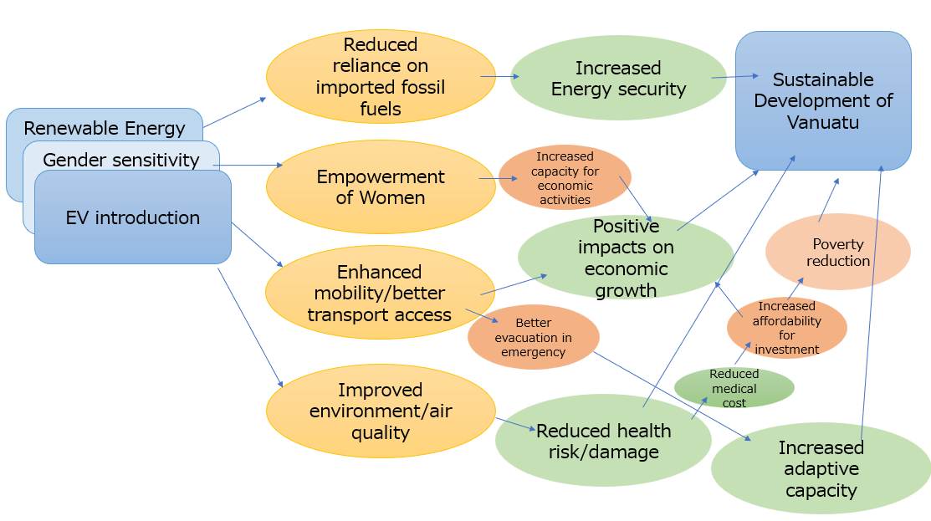

Detailed action plans with required budget and timeline

To implement the barrier removal interventions in the field of transportation, action plan propose with three-phasing short-term, 2022-2024, middle-term, 2025-2027, and long-term, 2028-2030 as well as required budget below corresponding to eleven "Pillars of measures" which is identified on fig. 6.1..

Timeline | Contents | Indicative cost | Description
2022-2024 | Pillar 1: Institutional framework strengthening EV uptake e.g. EV roadmap, organizational structure | 30,000USD
2022-2024 | Pillar 3: Regulations on EV and other vehicles | 60,000USD
2022-2027 | Pillar 4: Incentives to promote EV | 60,000USD
2022-2030 | Pillar 5: Awareness raising program | 72,000USD
2022-2024 | Pillar 6 (Phase 1): Demonstrative pilot project, School EV bus project in Port Vila | 6,995,000USD | Soft infrastructure:  5.95MUSD  Hard infrastructure:  1.045MUSD
2022-2024 | Pillar 6 (Phase 2): Demonstrative pilot project, EV for government vehicle fleet | 753,000USD | Soft infrastructure:  0.62MUSD  Hard infrastructure:  0.133MUSD
2025-2027 | Pillar 6 (Phase 3): Demonstrative pilot project, EV public transportation in Port Vila | 7,907,000USD | Soft infrastructure:  6.53MUSD  Hard infrastructure:  1.377MUSD
2022-2030 | Pillar 7: Training programs on EV maintenance | 160,000USD
Indicative total cost (USD) |  | 16,037M USD

6. Organization of the Capacity Building Seminar and 2nd Stakeholder’s consultation

The Capacity Building Seminar and Stakeholder’s Consultation have been co-organized by the Department of Energy / Ministry of Climate Change Adaptation, Meteorology, Geo-Hazards, Environment, Energy and Disaster Management, and OECC.

The Capacity Building Seminar has been conducted on April 12th to 14th, 2022 (2nd Consultation has been held on the final day, April 14th), participants joined the meeting online due to the lock down in Vanuatu by COVID-19 pandemic.

These Seminar and consultation’s objective was:
- To inform stakeholders about the country’s objective in relation to the land transport sector and the contents and results of the feasibility study.
- To discuss with stakeholders the contents of the barrier analysis and possible interventions, which will serve as the contents for the GCF concept note.
- To request stakeholder’s inputs and opinions in order to prepare the final version of the GCF concept note.

Among the participants, it was possible to participate the following stakeholders:
▪ Representatives from National Government (Ministries)
▪ Representatives from Local and Provincial Governments
▪ Transport sector authorities
▪ Transport related organizations
▪ International organizations

Presentations from the South Pacific Community (SPC), Department of Energy, Next Generation Vehicle Promotion Center (NeV), ALMEC Corporation and OECC have been delivered.

The agenda and the meeting minute of the Capacity Building Seminar and 2nd consultation are attached in the Annex.

In the first day of the Capacity Building Seminar, Ms. Esline Garaebiti, Director General, Ministry of Climate Change delivered opening remarks, Mr. Makoto Kato (OECC) introduced Actions under UNFCCC, updates of NDC and future international frameworks and actions, and Mr. Masayoshi Futami (OECC) described observed/future climate change in the PICs and Vulnerability and impact of climate change in PICs. Mr. Hiroyuki Ikegami (Saga univ) and Benjamin Martin (Xenesys Inc.) Renewable energy infrastructure for improved transport while introducing the examples of introducing Ocean Thermal Energy Conversion (OTEC) in Kumejima. And finally, Mr. Norikazu Ogino (NeV) presented Policy/Regulation and actions for introduction of EVs in Japan and Mr. Solomone Fifita (SPC) presented Policy and Regulations for introduction of EVs in PICs.

The second day of the seminar, Mr. Antony Garae (Dept of Energy) updates current status of energy and transport issues in Vanuatu, Mr. Yasuki Shirakawa (ALMEC Corporation) described overview and progress of mitigation options, Mr. Satoshi Iemoto (OECC) showcased how to utilize and access climate finance and introduced examples. Mr. Yasuki Shirakawa and Mr. Yosui Seki (ALMEC Corporation) explained “Current situation of transport in Vanuatu” and “Public transportation focusing on bus services” while sharing Japan’s experiences.

The third day of the seminar, Ms. Masako Ogawa (PCCC) presented “Initiatives on climate change capacity development in PICs”, Mr. Abraham Simpson (Pacific Power Association) introduced “New technology applied adaptation options for the transport sector”. Ms. Rie Kawahara (R-Quest) delivered presentation regarding gender consideration and discussion to identify the issue or constrains on gender integration.
The last programme, 2nd consultation, served to discuss with stakeholders regarding “the Future vision on transport in terms of resiliency and low carbon development” and “Major barriers in realizing the future vision & Necessary low emission options and interventions”.

Among the main conclusions of the consultation, it is suggested that some technical key aspects should be further examined in future pilot projects of the EV transportation suggested by this Feasibility Study. The keys include the feasibility of charging stations, characteristics of driving ranges, maintenance capacity building, etc, which will help accomplish the goals of the pilot projects more realistically.

It was acknowledged that the automotive industry is moving towards E-mobility and the production of EVs, with some makers announcing the end of production of fuel-based cars in the next few years. Thus, the consultation advised the measures proposed by the Feasibility Study from the point of the economic, legislative, and regulatory aspirations. Ideally, the faster and more cross-departmental and cross-sectional actions and governance should be developed and commenced by the government to meet the goals by 2030. And, such projects should also examine the longer-term economic scenarios, taking into account the future variations in tax revenue situations when the EV policy is further implemented with favorable importing taxation of EVs. The cross-departmental actions can add a well-balanced policy of transportation industrial success and environmental management in creating the E-mobility society in Vanuatu.

To provide additional venue for key stakeholders in Vanuatu to deepen understanding and strategiyzing the introduction of EV technologies, the Project supported them to participate in EV Academy (https://pmanifoldevacademy.com/). The e-Bus System Planning and Optimization program has been designed toenable developing holistic understanding of e-Bus eco-system, its elements and their inter linkages. The training program will take you through theory and practical sessions to help choosing of bus, battery, charging infrastructure, transit network and route planning considerations and understand overall effect on e-bus operations. It also aims to develop understanding of analyzing and relating with real-time challenges in e-Bus electrification and techniques for problem solving and decision making.

The training by the EV academy consists of the following caricurum, involving theory and case studies and hands-on practice via online format. Participants at expert level from government officials, transportation authorities, utilities, and relevant service providers were selected, under consultation with the NDE.

 | Contents | Method of delivery
Session-1 | Elements of e-Bus System and Planning | Theory
Session-2 | Introduction to e-Bus system modeling | Theory + Case Study
Session-3 | e-Bus System Modeling – Introduction and Base case setup | Practice
Session-4 | e-Bus Routes & Depot Selection and Network Planning | Theory + Case study
Session-5 | e-Bus Charging Strategies and Trade-offs | Theory + Case Study
Session-6 | e-Bus System Modelling and Simulation – Base case analysis | Practical
Session-7 | e-Bus Fleet performance Scenarios and Optimization | Theory+ Case Study
Session-8 | e-Bus Life cycle Costs and Optimization | Theory + Case study
Session-9 | e-Bus System Modeling and Simulation – Scenarios analysis | Practical
Session-10 | Final Examination | MCQ

7. Recommendations

In order to further promote low carbon land transport in Vanuatu, in addition to a set of policies and measures proposed in the Chapter 6, the Study Team offers its recommendations herewith to the government of Vanuatu.

- Consideration of characteristics of each island: In this survey, port villa was mainly targeted as a start to realize low carbon land transport in Vanuatu. In the future, it is important to consider low-carbon strategies for land transport that matches the characteristics of each island, taking into consideration diverse regional characteristics of Vanuatu.
- Cooperation with neighboring island countries: The island countries and regions have common issues in realizing low carbon land transport such as importing cars, second-hand cars, public transportation and renewable energy uptake. It is expected that more effective results can be obtained efficiently by promoting efforts in collaboration with these countries, such as sharing information.
- Integrated approach: Low carbon transport cannot be realized only by the efforts in the land transport sector, and cross-sectoral actions are indispensable. In order to minimize GHG emissions in the land transport sector, it is important to promote it through integrated approaches while coordinating with ministries/organizations on energy policy, land use planning, road development etc.
- Cross-cutting consideration for adaptation and resilience: As the EV associated with battery technologies is effective not only for GHG emissions reduction but also for providing back-up energy supply especially under energy constraint situation due to natural disaster. Also, the improvement of transporation can contribute to the enhanced access to resilience, such as timely early warning system. As the counry is faced with both climate-induced and non-climate natural disasters, the project should take into cross-cutting consideration for adaptation and disaster resilience. Also, infrastructure for EVs should integrate climate-fit design for its own resilience.
- Optimal public transportation: In Vanuatu, the number of vehicles is continuously increasing. Currently, on-demand mini-buses and taxis are the main means of transportation for people, but it is necessary to optimize public transportation especially in Port Villa and Luganville before issues such as traffic congestion and emissions do not become serious. In this regard, the Government of Vanuatu should seek international supports on planning, management and operation of suitable public transportation in especially in Port Villa.
- Preparation of basic data: In Vanuatu, there is a lack of statistical data for examining possibilities of low emission vehicles and public transportation in detail. For example, it is necessary to conduct basic surveys such as person trip surveys and mileage / fuel economy surveys before for example introducing public transportation in Port Villa and Luganville.
- Promotion of awareness rising: As proposed in the Chapter 6, dissemination regarding low carbon transport is extremely important. In Vanuatu, low carbon transport such as EV are new to all stakeholders. The Government and related organizations need to keep providing information to stakeholders on low carbon transport such as significance of introducing low carbon transport, advantages, limitations, etc.
- Decrease in car-related tax revenue: If the introduction of low emission transport such as EV is promoted with preferential treatment such as import duty free, the government tax revenue due to the introduction of cars may decrease in the future. A detailed evaluation may be required for these impacts and countermeasures.
- Renewable energy based electricity infrastructure: More strengthened RE based electricity supply infrastructure will be required in the EV society. Solid electricity supply network will be achieved by the stable base load electricity source.
OTEC is still under verification stage however it has a proven track record in long test runs and is expected to start its commercial operation very soon.
In consideration of the possibility of OTEC in near future, it can be strongly recommended to consider its introduction as a RE base load facility especially in PIC.

- Consideration for sustainable material flow: Batteries after their use sometimes create risks of environmental pollution, if not treated properly. As Vanuatu has a basic infrastructure/service industry for recyclying used vehicles, it is important that future efforts include strengthening the technical capacity to cover collecting and recycling batteries and other E-waste, avoiding potential contamination.

Annexes

Implementing Entity:
Overseas Environmental Cooperation Center, Japan (OECC)

- Agenda of Capacity Building Seminar and 2nd Consultation
As of 11 April 2022
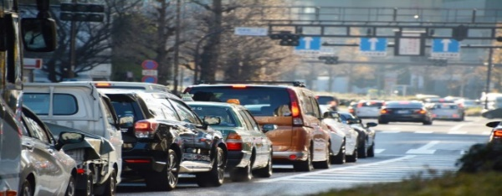
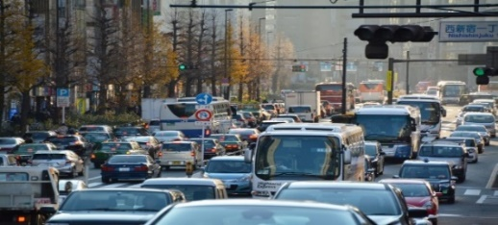
Climate Technology Centre & Network (CTCN) Feasibility Study for
Low Emission Land Transport Sector in Vanuatu
CTCN: VANUATU CAPACITY BUILDING PROGRAM on transport strategies

Date: 12-14 April 2022, 11:00 – 16:20 (VST) / 9:00 - 14:20 (JST)
Venue: @Zoom online
Organized by: Department of Energy / Ministry of Climate Change Adaptation, Meteorology, Geo-Hazards, Environment, Energy and Disaster Management
Supported by: Overseas Environmental Cooperation Center, Japan (OECC)

- Background
Vanuatu faces difficult challenges posed by the effects of climate change. In the land transport sector, issues such as the constant reliance on fossil fuels, poor condition of road infrastructure, weaknesses in the planning and management of the land transport sector and increasing environmental health concerns have been identified. However, there are still a lack of information and uncertainty due to barriers that prevent the country to overcome this situation and to comply with its national obligations, as stated in their National Determined Contribution (NDC) and contributions in terms of global climate change mitigation.

The Government of Vanuatu has requested the Climate Technology Centre & Network (CTCN) to provide support in the form of a feasibility study, and entrusted the Overseas Environmental Cooperation Center, with the task of: Identifying barriers, propose interventions to eliminate them, elaborate an action plan to implement barriers removal, and to identify financial sources that will facilitate the implementation of actions.

- Objectives
- To inform stakeholders about the country’s objective in relation to the land transport sector and the contents and results of the feasibility study.
- To discuss with stakeholders the contents of the barrier analysis and possible interventions, which will serve as the contents for the GCF concept note.
- To request stakeholder’s inputs and opinions in order to prepare the final version of the GCF concept note.

- Participants
- Representatives from National Government (Ministries)
- Representatives from Local and Provincial Governments
- Transport sector authorities
- Transport related organizations
- International organizations

Agenda
Time (VUT) | Time (JST) | Context | Presenter
DAY1: Tuesday, April 12th Zoom: https://us06web.zoom.us/j/86368206211 (ID: 863 6820 6211)
11:00-11:30 | 9:00-9:30 | [INTRODUCTION TO THE CAPACITY BUILDING COURSE]  - Opening remarks (Vanuatu NDE)  - Vanuatu's goal in relation to land transport sector  Housekeeping Announcement (5min) | - Ms. Esline Garaebiti (Vanuatu NDE)  - Mr. Makoto Kato, Project Manager, (OECC)
11:30-12:20 | 9:30-10:20 | [LAND TRANSPORT SECTOR IN THE INTERNATIONAL FRAMEWORK]  - Actions under UNFCCC, e.g. Paris Agreement  - Updates of NDC, BUR, BTR, etc.  - Future international framework/actions | - Mr. Makoto Kato (OECC)
12:20-12:30 | 10:20-10:30 | Break time (10min)
12:30-13:20 | 10:30-11:20 | [SCIENCE OF CLIMATE CHANGE]  - Climate adptation and mitigation  - Observed/future climate change in the world and PICs  - Vulnerability and impact of climate change in PICs | - Mr. Masayoshi Futami (OECC)
13:20-14:30 | 11:20-12:30 | Lunch break
14:30-15:20 | 12:30-13:20 | [RENEWABLE ENERGY INFRASTRUCTURE FOR IMPROVED TRANSPORT]  - Importance of stable RE source for land transport sector in PICs  - Overview of sustainable energy by Ocean Thermal Energy Conversion (OTEC) for transport policies/measures  - Co-benefits of OTEC introduced for transport sector | - Prof. Ikegami (Saga University)  - Benjamin Martin, Project Manager, Xenesys Inc.
15:30-16:20 | 13:30-14:20 | [EXAMPLES OF LAND TRANSPORT STRATEGIES]  - Policy/Regulation and actions for introduction of EVs in Japan  - Policy and Regulations for introduction of EVs in PICs | - Mr. Norikazu Ogino, Next Generation Vehicle Promotion Center (NeV)  - Mr. Solomone Fifita (SPC)

Time (VUT) | Time (JST) | Context | Presenter
DAY2: Wednesday, April 13th Zoom: https://us06web.zoom.us/j/85688567387 (ID: 856 8856 7387)
11:00-11:30 | 9:00-9:30 | [STATUS OF ENERGY AND TRANSPORT ISSUES IN VANUATU]  - Energy sources in Vanuatu  - Status of transport in Vanuatu | - Mr. Antony Garae (Department of Energy)
11:30-12:20 | 9:30-10:20 | [MITIGATION OPTIONS FOR THE TRANSPORT SECTOR]  - Reducing GHG emissions in the transport sector  - Overview of mitigation measures in the transport sector  - Progress check and management of mitigation measures | - Mr. Yasuki Shirakawa (ALMEC)
12:20-12:30 | 10:20-10:30 | Break time (10min)
12:30-13:20 | 10:30-11:20 | [CLIMATE FINANCE FOR TRANSPORT RELATED PROJECTS]  - Examples of climate finance programs  - How to utilize the finance programs  - Introduction of the draft GCF concept note | - Mr. Satoshi Iemoto (OECC)
13:20-14:30 | 11:20-12:30 | Lunch break
14:30-15:20 | 12:30-13:20 | [CURRENT SITUATION OF TRANSPORT IN VANUATU]  - Current situation of transport in Vanuatu from view point of low carbon development  - Barriers and issues in realizing low emission transport in Vanuatu  - Mitigation options | - Mr. Yasuki Shirakawa (ALMEC)
15:30-16:20 | 13:30-14:20 | [PUBLIC TRANSPORTATION FOCUSING ON BUS SERVICES] | - Mr. Yosui Seki (ALMEC)

Time (VUT) | Time (JST) | Context | Presenter
DAY3: Thursday, April 14th Zoom: https://us06web.zoom.us/j/85325078799 (ID: 853 2507 8799)
11:00-11:30 | 9:00-9:30 | [INITIATIVES ON CLIMATE CHANGE CAPACITY DEVELOPMEMNT IN PICs]  - PCCC's activities on capacity development on climate change,  - Ways to bring climate finance and technology to PICs through partnership | - Ms. Masako Ogawa (PCCC)
11:30-12:20 | 9:30-10:20 | [NEW TECHNOLOGY APPLIED ADAPTATION OPTIONS FOR THE TRANSPORT SECTOR]  - Energy management system (EMS) on the electricity network for the small island country  - Renewable energy-based electricity infrastructure for EV society | - Mr. Abraham Simpson  SEIDP Project Implementation Officer  Pacific Power Association
12:20-12:30 | 10:20-10:30 | Break time (10min)
12:30-13:20 | 10:30-11:20 | [GENDER CONSIDERATIONS FOR THE TRANSPORT SECTOR]  - Issues/constraints found on gender integration relating to land transport  - Findings in Vanuatu | - Ms. Rie Kawahara (R-Quest)
13:20-14:30 | 11:20-12:30 | Lunch break
14:30-17:10 | 12:30-15:10 | [MULTI-STAKEHOLDER CONSULTATION: LAND TRANSPORT INITIATIVES IN VAN UATU]  ■ Presentation  (JST12:30 - 13:10, VST14:30 - 15:10)  - Vanuatu NDE (20min )  Future vision on transport in terms of resiliency and low carbon development  - Mr. Shirakawa (20min)  Major barriers in realizing the future vision & Necessary low emission options and interventions  ■ Discussion with stakeholders  JST13:10 - 15:00  VST15:10 - 17:00  ■ Closing remark (JST15:00 - 15:10, VST17:00 - 17:10)  - Vanuatu NDE (5min)  - Mr. Kato (5min) | - Moderator:  Mr. Makoto Kato (OECC)

- Meeting minute
Meeting minutes
for
the Climate Technology Centre and Network (CTCN): Capacity Building Program on sustainable and decarbonization transport strategies in Vanuatu

We have undertaken a capacity building seminar toward the people from the Vanuatu government and private sectors and the Pacific Islands countries to promote sustainable and decarbonizing transport in Vanuatu. The meeting details and the summaries of each session are as follows.

Date: 12-14 April 2022, 11:00 – 16:20 (VST) / 9:00 - 14:20 (JST)
Venue: Zoom online
Organized by: Department of Energy / Ministry of Climate Change Adaptation, Meteorology, Geo-Hazards, Environment, Energy and Disaster Management
Supported by: Overseas Environmental Cooperation Center, Japan (OECC)
Materials: A concept note titled “CTCN Feasibility Study for Low Emission Land Transport Sector in Vanuatu. CTCN: Vanuatu Capacity Building Program on transport strategies.”
Participants list:
Vanuatu
 | Name | Surname | Position | Affiliation
1 | Esline | Garaebiti | Director General | Ministry of Climate Change
2 | Anthony | Garae | Director | Department of Energy
3 | Joseph | Temakon | PSO Urban Electrification | Department of Energy
4 | Mathew | Tasale | Manager Electrification | Department of Energy
5 | Royson | Willie | PRO | Ministry of Climate Change
6 | Erickson | Packett | NAB Policy & Planning | Ministry of Climate Change
7 | Keith | Vusi | Engineer Officer | Utility Regulatory Authority (URA)
8 | Robinson | Dickinson | Foreshore Officer | Department of Urban Affairs & Planning
9 | Reginald | Tabi Gerian | CEO | Public Land Transport Authority (PVLTA)
10 | Ionie | Bolenga | Principal Waste Officer | Environmental Protection Divsion, Department of Environmental Protection & Conservation (DEPC)
11 | Donald | Massing | President | SPVPLTA (SHEFA Port Vila Land Transport Association)
12 | Elmer | Sionosa | Group Financial Controller | Melanesian & Mooring Hotels
13 | Antonio | Korikalo | Sales Manager | Intraco/Ford
14 | Frederic | Petit | Director of Development | UNELCO
15 | Jessie | Benjamin | SO | Global Green Growth Institute (GGGI)
16 | Harold | Allanson | Project Support Unit | Public Works Department (PWD)
17 | Peter | Allen | General Manager | Vanuatu Utilities and Infrastructure, Ltd (VUI)
18 | John | Tangis | Sales Manager | Asco Motors

Other countries and international organizations
 | Name | Surname | Country | Affiliation
1 | Tessa | Vaetoru | Cook Islands | Ministry of Finance and Economic Management
2 | Jennifer | Henry | Cook Islands | Bank of the Cook Islands
3 | Filipe | Koro | Fiji | Fiji Development Bank
4 | Solomone | Fifita | Fiji | Pacific Community
5 | Peceli | Nakavulevu | Fiji | International Renewable Energy Agency
6 | Fathimath | Rashid | Madives | Ministry of Environment, Climate Change and Technology
7 | Pauline | Siret | Others | The Pacific Community
9 | Doumeraj | Jahajeeah | Others | Ministry of Energy and Public Utilities
10 | Sanjay | Sookhraz | Others | Central Electricity Board
11 | Naweed | Bundhoo | Others | Mauritius Renewable Energy Agency
12 | Sione | Misi | Tonga | Pacific Community (SPC)
13 | Abraham | Simpson | Others | Pacific Power Association
14 | Rie | Kawahara | Japan | R-Quest Corp.
15 | Masako | Ogawa | Others | The Pacific Climate Change Centre (PCCC) / The Secretariat of the Pacific Regional Environment Programme (SPREP)
16 | Yasuki | Shirakawa | Japan | Almec Corp.
17 | Yasuyuki | Ikegami | Japan | Saga University
18 | Benjamin | Martin | Japan | Xenesys Inc.
19 | Norikazu | Ogino | Japan | Next Generation Vehicle Promotion Center (NeV)
20 | Yosui | Seki | Japan | Almec Inc.
21 | Makoto | Kato | Japan | OECC (Overseas Environmental Cooperation Center)
22 | Riki | Nakajima | Japan | OECC
23 | Kisato | Nagakuro | Japan | OECC
24 | Shigeo | Aoki | Japan | OECC
25 | Kanae | Komaki | Japan | OECC
26 | Masayoshi | Futami | Japan | OECC
27 | Satoshi | Iemoto | Japan | OECC

Session summary
DAY1:
INTRODUCTION TO THE CAPACITY BUILDING COURSE

Opening remarks summary

Esline Garaebiti
Climate change is the issue, especially for SIDS like Vanuatu. The future depends on our response to this issue. 1.5C target is now a global goal for future generations. Vanuatu will play a role in reducing GHGs to achieve SDGs. Capacity building with stakeholders is an important aspect. With Colleagues from PICs, we hope to have a fruitful discussion.

Makoto Kato
Climate change is one of the biggest challenges, especially for SIDS like Vanuatu. In our feasibility study on land transport, we expect the key is to upgrade land transport in a sustainable way in Vanuatu. To enhance the wider scope of (climate change, land transport, access to climate finance), we invited a wider audience today. We will discuss what are important elements in the upgrading, what are the strategies and deliver a concept note for Green Climate Fund (GCF). OECC is also planning to cover the fee of EV academy (paid course) to be discussed on the 3rd day. Interactive discussion with as many participants is highly welcome.
LAND TRANSPORT SECTOR IN THE INTERNATIONAL FRAMEWORK

Presentation summary:

Makoto Kato
“Transport and NDCs in the international climate change agenda”
At COP26, Vanuatu Prime Minister greatly highlighted global collecting efforts over politics would affect the future of SIDS. OECC committed there too. The Paris Agreement GHG emission targets at major emitters were not enough from the SIDS perspective. In 2021’s Climate Leaders’ Summit, the upgraded targets had still some gaps. At COP26, they further updated and discussed how to implement it. Because Nationally Determined Contributions (NDCs) were not enough for the target, which was discussed at COP26. In transport, we concluded in our study that effort such as energy efficiency improvement was important for Vanuatu. Also, for SDGs, sustainable energy sources and security are important. Any co-benefitting strategy will be effective in Vanuatu (referencing Trinidad Tobago’s NDC target strategy for 2030; Fiji Roadmap in energy/transport for 2030). Transport targets to achieve climate mitigation have been being implemented in many countries, which Vanuatu could seek as well.
Discussion summary (see below for more detaild of remarks):

The discussion focused on the major issues in transport in Vanuatu. There are two concerns raised by the audience. One is the current price rise in fossil fuels in SIDS along with the global instability due to the Pandemic and Ukraine incident (Elmer Sionosa and Antony Garae from Vanuatu, Carter Vuri from PNG, Mackzine Lakjohn from Marshal Islands, etc). Vanuatu’s transport has a close connection to the hospitality industry (Elmer Sionosa in the 2nd Session of Day 1) and the Feasibility Study should include this issue (Kato in the 2nd Session). The other concern is about the lack of institutional frameworks for air quality by traffic (Ionie Bologna). The Feasibility Study Report could deal with the other GHG gas emission reduction institutions so as to develop future potential, more paradigm-shifting projects in Vanuatu. Such projects are urged by Global Climate Fund (Makoto Kato). Some participants pointed out that the project should differentiate target areas between cities (Port Villa and others) and rural areas, in terms of their traffic volumes (Frederic Petit). In response, an explanation was made that the feasibility study would focus on certain areas of public transportation (i.e. public bus services) and the concern would be addressed, as spatial differences on the island and traffic volume with time in Vanuatu would be taken into account (Makoto Kato)..

SCIENCE OF CLIMATE CHANGE

Presentation summary:

Masayoshi Futami
“Science of climate change”
An introduction from the IPCC to the 6th assessment report series. The reports assess the global observing system and the data. The reports apply the global observation data and simulated projections for the assessment (free downloading available). The climate change impacts are highly variable in regions and cases (global warming rates). Within temperature reduction targets (1.5C – 2.0C by 2030), there is a tipping point to impact various environmental elements. For example, tropical mountain glaciers in Bolivia. To achieve the targets, IPCC recommends renewable energy usage. Transport will be one of the key areas and it will include Green H2 technology and EVs.
Discussion summary:

Actual climate change impacts are found in Vanuatu and PICs are cyclones and sea-level rise (Elmer Sionosa, Joseph Temakon), however, the discussion suggested it was not confirmed whether the possible impacts suggested by IPCC reports were caused only by climate change (Frederic Petit, Riki Nakajima). Another discussion point was about necessary climate change policies: some suggested more initiatives by developed countries such as Japan, a longer-term perspective to reduce various GHG gases and prioritize technologies (Makoto Kato), and a science-driven approach with local communities to monitor transport emission data (Futami). A legislative review and comprehensive administrative response including institutional development for the transport sector were suggested. (Ionie Bolenga, Kato). Some participants pointed out refrigerants used for car air conditioners are either ozone-depleting substances (ODS) or HFCs with high global warming potential (GWP), which could also be considered as an issue of transportation-related issues. Stakeholder engagement to understand the current situation in Vanuatu was proposed (by Rie Kawahara) and is to be conducted on Day 3.
RENEWABLE ENERGY INFRASTRUCTURE FOR IMPROVED TRANSPORT

Presentation summary:

Ikegami & Martin
“Ocean thermal energy for transportation improvement”
Ocean Thermal Energy Conversion (OTEC) system can contribute to low emission transport sectors. Deep Ocean Water (DOW) is a resource used for industries such as products and the systems of seawater air conditioning, low-temperature thermal desalination, and OTEC. Our focus is on closed-cycle OTEC, which contains a heat exchanger, a turbine generator, and a condenser. Water temperatures are stable and ideal for continuous power generation. Japan’s OTEC has experienced over 4 decades and advanced efficiency. The Equatorial region has good potential for OTEC as Japan has implemented it in Okinawa with the perspective of increasing production. For transportation, OTEC has advantages because of its compactness, policy-led city planning, the potential for new industries with new jobs, disaster resistance, stable energy, higher economic efficiency and cost performance with higher initial costs, good for the environment, etc. The initial high costs (challenging) could be recovered from public infrastructure facilities. The example of Kumejima, Okinawa, indicates the vision that the OTEC could increase to more than 50% and cover the diurnal variation in the solar generation there by 2035. The OTEC also cooperates with other industries like aquaculture.
Discussion summary:

The audience showed a strong interest in OTEC technology (Elmer Sionosa, Mackzine Lakjohn, Sione Tausinga, etc). Sionosa from the Government of Vanuatu suggested that he would bring this technology idea to his colleagues and also consider applying for the GCF to implement it in Vanuatu (A pre-feasibility study of the OTEC project has already been done in Nauru with OECC). The Feasibility Study in low carbon transport should be an advantage (Sionosa). However, OTEC has yet to become a real breakthrough in the global energy market, and technology cooperation between PICs and Japan should be able to realize it (Peceli Nakavulevu). If a 1MW pilot project could be implemented in the PICs, then it is expected that such a project could be accelerated by any private sector (Ikegami). Some questions on the OTEC specifications were raised by the audience such as costs per facility and subsidy mechanisms in Japan.
EXAMPLES OF LAND TRANSPORT STRATEGIES

Presentation summary:

Norikazu Ogino
“Policy/regulation and actions for introduction of EVs in Japan”
Next Generation Vehicle Promotion Center subsidies for purchases of eco vehicles and charging facilities. Japan promotes the EV promotion strategy by 2050 (BEV, HEV, FCV, PHEV) with the targets of electrification of passenger cars (100% by 2030) and small trucks (100% by 2040) with the public chargers. In Japan, while HEV became to meet a higher registration rate, other cars are not yet. For BEVs, since 2010, with the more battery amount and driving range, they became close to gasoline cars. BEVs, PHEVs and FCVs have been increasing in a variety of manufacturing companies. Car chargers have been installed all over Japanese highways. Standardization in the chargers is necessary as currently, it varies in the country. Government subsidies for these EV cars became almost doubled. For manufacturing companies, many governments in the world regulate the selling rate of zero-emission cars in EVs. Japan started to use Evs as an electric source in disasters.

Solomone Fifita
“Policy and regulations for introduction of EVs in PICs”
The motivations to increase EVs in PICs would be to reduce transportation costs, GHG emissions, and fossil fuel costs/dependency. SDGs, Paris Agreement, Samoa Pathway, Forum Leaders’ Communities & outcomes are international policy drivers. These are supported by national instruments and documents. The 1st NDC was only one but the 2nd NDCs are in more countries, e.g., Samoa’s NDCs expect feasibility studies in transportation. Regional e-mobility and SIDS-SIDS cooperations are necessary (documented by the 2030 and 2050 regional e-mobility targets). Incentive schemes are subsidies, CO2 mandates, sales targets, et. For example, in Fiji, ~50 EV cars are used in 2020 along with the Electricity Act. Niue adopted the strategy of 1% EV cars by 2020. PNG implemented National Energy Plan 2017-2027, which aims for shifting to CNG (Compressed Natural Gas) and LPG (Liquefied Petroleum Gas) from diesel and petrol seeking the EV options. Samoa promotes the import of EV cars through de-taxes. Tonga implements the Energy Efficiency Maser Plan. Vanuatu signed a contract for the supply of e-scooters from a Chinese supplier.
Discussion summary:

A few questions were raised about Japan’s situation around PHEVs. Referencing Japanese cases, it was suggested (by Ogino) that car electricity fast chargers might not be necessary for small islands like Vanuatu due to the shorter running range and that it should be examined.
Closing remarks

Tasale Mathew
From today’s sessions, the new tech would assist Vanuatu to find new areas to look into.

DAY2
Opening remarks

Antony Garae
Today’s session goes more into the details of financing and possible public transport services and he hopes that participants enhance the maximum efforts to consider the solutions.

Announcements:
Given by Rie Kawahara for the stakeholder engagement activity plan in her session on Day3.
STATUS OF ENERGY AND TRANSPORT ISSUES IN VANUATU

Presentation summary:

Antony Garae
“Status of energy and transport issues in Vanuatu”
Vanuatu has established several transport-related policies such as ‘National Energy Road Map (NERM) 2013-2020 & 2016-2030’, which aims for transport energy efficiency improvement of 2% by 2020 and of 10% by 2030, ‘National Sustainability Development Plans’, which addresses safe transport, Priorities & Action Agenda 2006-2015, etc. Nearly 30% of the total energy comes from renewable energy and nearly 90% of the renewable energy comes from bioenergy as of 2018. Nearly 50% of fossil fuel is demanded by the transport sector. The major CO2 emission comes from the agriculture sector, which is a much lower percentage than transport. Vanuatu has issues with the lack of investment mobilization, coordination, and technical support for the national energy strategy implementation.
Discussion summary:

Due to a time constraint, there was only one comment from Vanuatu (Elmer Sionosa) on whether a future feasibility study on renewable energy would include the hospitality industry.
MITIGATION OPTIONS FOR THE TRANSPORT SECTOR

Presentation summary:

Yasushi Shirakawa
“Mitigation options for the transport sector”
GHGs and air pollutants are all important aspects in terms of transport. Reducing CO2 emissions, shifting to public transportation from private ones, shifting from fossil to biofuel energy, and creating a compact city, are the keys to low emission transport. Transport sectors account for 20% of the global CO2 emissions but aim for a net-zero society by 2050. The gas emissions keep increasing by urbanization, motorization, high emitter cars, and congestion. The solution will be to “avoid” using high emitter cars, “shift” to the public and eco-friendly transportation, and “improve” it with low emission technology (e.g., Japan’s air pollution improvement history). Regulatory measures to stop importing old types of vehicles and facilitate EVs, public transportation with buses and bus routes development, port facilitation, the use of coconut oil, and multiple transportation measures like fixed-route buses would be effective for Vanuatu. Emission reductions by EVs highly depend on electricity generation types: renewable energy can reduce more emissions in Vanuatu.
Discussion summary:

Regarding the current situation in transport in Vanuatu, the Feasibility Study suggested that transportation (e.g., mini buses) highly depended on the islands and cities (Yasushi Shirakawa). Some challenging information to Vanuatu was added by the audience that old and second-hand vehicles were allowed with only a few checking-up requirements and that the COVID situation required more social distancing in the buses harming the transporting efficiency (Elmer Sionosa). It was also suggested that resilience should be considered in building transport systems due to coastal hazards like Tsunamis and earthquakes (Yasushi Shirakawa, Kanae Komaki).
CLIMATE FINANCE FOR TRANSPORT RELATED PROJECTS

Presentation summary:

Satoshi Iemoto
“Climate finance for transport related projects”
The presentation provided an overview of the climate finances under the UNFCCC and other international funds (GEF trust fund, Green climate fund, multilateral development banks, etc). The sustainable transport sector covers 28% of the total climate finances. Currently, 9 projects with 530M USD are related to transport in the GCF (e.g., light rails in Costa Rica, bus rapid in Pakistan). The GCF concept note needs to include Climate rationale, paradigm shifts, sustainability (stakeholder engagement, gender equality), and additionality. For the GCF, accredited entities can be international, national, and regional. There are 6 investment criteria (e.g., impact, paradigm shift, contribution to SDGs). The concept note contains three sections to address needs, possible results, etc, which should be well focused. As for Joint Crediting Mechanism (JCM), the Government of Japan covers some investment costs for technology (e.g., the digital tachograph system in Vietnam). Transport sectors have the potential to increase the project numbers in JCM as well and there is room to try to apply.
Discussion summary:

The talk brought a movement to apply for the GCF among the PICs (suggested by Elmer Sionosa in Vanuatu) in the discussion. It was confirmed that the Feasibility Study could be used for the application. The next question will be who is going to take the initiative to apply. It was confirmed that we should contact the national designated authority (NDA) of GCF in Vanuatu (Esline Garaebiti) when questions and suggestions are raised on the GCF application. There was another question about how to share the JCM carbon credits and pricing (Frederic Petit) and OECC agreed to share the information with Mr. Frederic.

CURRENT SITUATION OF TRANSPORT IN VANUATU

Presentation summary:

Yasushi Shirakawa
“Current situation of transport in Vanuatu from view point of low carbon development”
While not many measures were so far implemented in PICs, Vanuatu has been enhancing the NDCs, e-mobility, and e-cars measures to reduce emissions. It is required to assess in detail the feasibility and appropriateness of various types of EVs. Transport acts in Vanuatu should be revised to increase EVs including importing tax systems. Road conditions and networks should be improved for e-mobility. Energy sources depend on diesel generation of ~76% with the remaining part of renewable energies, which is far low from the target. Barriers to reducing GHGs and introducing EVs and public transportation are identified in many areas such as the lack of policy (e.g., incentives, regulations), technologies (e.g., information sharing, awareness, big battery system, renewable energy sources), institutions (e.g., inter-ministerial working group), finance (e.g, incentives), and other areas (e.g., pilot projects). A roadmap toward 2030 to promote EVs with targets and benefits was developed in the study.
Discussion summary:

The major discussion focused on Vanuatu’s challenges in introducing EVs, which were 1: infrastructures as the first priority, not incentives; and 2: the electric power stability. For the first point, manufacturing companies and distributors are willing not to sell fossil fuel vehicles in Vanuatu by 2030 (The 1st stakeholders' consultation report), however, infrastructures for EVs have yet to be installed, which is suggested as more concerning barriers to be cleared than incentives (Elmer Sionosa, Ionie Bolenga). For the second point, with increasing EVs and shifting to renewable energy sources near future, electric power generation has to be a more stable system. In order to realize this stability, it was suggested that huge battery banks and smart grid management facilities will be required for any renewable energies (Keith Vusi, Shigeru Aoki). Also, for small islands cases aside from Efate Island, it was pointed out that huge batteries would not be always required and recycling batteries and cars would be more efficient to implement (Frederic Petit).
PUBLIC TRANSPORTATION FOCUSING ON BUS SERVICES

Presentation summary:

Yosui Seki
“Public transportation focusing on bus services”
Public transportation planning is always coordinated by any government side. In Hitachi city’s case in Japan, potential public transport areas and routes were defined by using population density and the urban structure (city center, transport corridors, etc). The expected capacity and volume of passengers determine transportation types (rail, bus, taxi, etc). Then, the government starts licensing and considering the other community services in minor areas. In many Asian cities cases, traffic congestion and low usage of public transportation are the issues, which are partly caused by a high demand for private cars. Bus transport service improvement is key to reducing traffic congestion. Users and transport operators also both have issues initially due to unbalance of demand and supply, which governments should take a lead to well manage. The management system has several types with regards to roles of the public side (regulators, suppliers) and operators depending on the cases. Some cases of bus operation in Japan show that communication among employees and easy directions for passengers on busses are important for good operation.
Discussion summary:

The audience were interested in whether the public bus transportation system could be a fit in Vanuatu considering the size and space (Elmer Sionosa, Antony Garae). It was recommended (by Yosui Seki) to conduct planning of routes, operation hours, and ridership first to find the best EV capacity in various geographic conditions. This plan would show the applicable size and types of buses. In Noumea with a similar topography as Port Vila, EVs are smoothly operated (Frederic Petit).

DAY3:
INITIATIVES ON CLIMATE CHANGE CAPACITY DEVELOPMENT IN PICs

Presentation summary:

Masako Ogawa
“Pacific Climate Change Centre and the project for capacity building on climate resilience in the Pacific (CBCRP-PCCC)”
The Center was established in 2019 based on the needs of the PICs discussed since 2008. It aims to build partnerships and a robust and scientific knowledge base to make decisions. E-mobility is quite new to the PICs and a new initiative is important. The Center has been engaged in the Pacific Climate Change Portal (PCCP), partnerships with universities to work on scientific issues like IPCC reports, capacity building courses, innovative knowledge-sharing events (mid-2022), and other activities like solar panel installation. It also provides climate resilience training to the sectors of ecosystem, food, tourism, disaster risks, etc, as well as training programs to access climate finance. Open courses are also available in 2022.
Discussion summary:

Regarding the targeted sectors of PCCC, the transportation sector recently became a higher priority in many countries. It is a good time to apply for climate finance opportunities in transportation. It was recommended (by Masako Ogawa) that Vanuatu check the NDC hubs (e.g., the Pacific Community) and possible financial sources like the GEF (The GEF is commencing a new replenishment period with the zero-emission mobility).
NEW TECHNOLOGY APPLIED ADAPTATION OPTIONS FOR THE TRANSPORT SECTOR

Presentation summary:

Abraham Simpson
“New technology applied adaptation options for the transport sector”
The presentation is about impacts on the grid side. Grid demand will become 5 times higher than the current amount by 2050 assuming energy demand from EVs, etc. In Vanuatu, if the fossil fuel-type vehicles are replaced, the energy demand would be 2-3 times higher by 2030 based on the GGGI 2016 report. It is more energy-efficient to have all consolidated grid facilities. Battery chargers would need more power demand. Minimizing the impact of e-mobility is challenging. Renewable energy has uncertainties in the production rate (e.g., unstable Nauru’s solar power generation). Energy management systems of energy control to maintain energy stability, battery energy storage (costly though), and charging stations, are needed, but challenging too. Possible strategies will be in increasing renewable energy, control system, balancing energy supply with demand, optimizing energy storage, tariffs, charger techs, etc.
Discussion summary:

Along with the energy source shifting, it was recommended (by Abraham Simpson) to assess all potential energy sources for Vanuatu’s conditions and examine the pros and cons first. For example, solar power, the price is lowering but it needs more land space. For OTEC, the technology building is costly and needs natural-hazard resilience, but it is ongoing in development (e.g., Japan, Korea, France, and Nauru). Wind power needs to find effective areas and biomass power needs timber. Then, the discussion went into the feasibility of mega solar power plants in Vanuatu. The government has established a process to manage land ownership to build mega solar plants (Antony Garae, Shigeru Aoki). Audience suggested mega solar plants had enough possibility in Efate Island considering the land space: the GCF finance for solar power has been secured already (Frederic Petit). However, with any energy resources, it was highly recommended that Vanuatu/OECC first should research the maximum energy demand for EVs on each island to seek financial opportunities (Frederic Petit). Once finance is secured, then, energy-side operators would examine plans.
GENDER CONSIDERATIONS FOR THE TRANSPORT SECTOR

Presentation summary:

Rie Kawahara
“Gender issues: feasibility study for low emission land transport sector in Vanuatu”
In Vanuatu, 22% of the population are living in the urban areas of which 20% are female-headed households. A higher employment rate exists in the urban. Most women are self-employed while in Port Vila women are mostly employed by vendors. Laws do not protect the decisions of women regarding living places, work, payment, etc. Gender differences exist in the needs and patterns of mobility. To supplement necessary data for the Feasibility Study, Kawahara facilitated collecting answers from the audience for the following three questions.
- Q1: What are the gender differences in demands and access in terms of transport service?
- Q2: Any expected changes and potential risks for gender or society gaps in land transport adapting to climate change?
- Q3: What are the necessary communications among stakeholders toward low emission transport?
Discussion summary:

Along with the questions, the presenter talked to the audience to gather information. It was likely that most women in Port Vila used buses or pick-up trucks (shared cars) but not private cars. This is different on Santo Island, where taxis are more common. The shared cars and taxis are easy for women to call. Most bus fees are a little less amount of the minimum wage in Port Vila. The government believes all women have access to transportation services (Donald Massing). 70-80% of women are employed in market vendors while men are in farming (Wesley Obed) and the government has been organizing the gender equity in employment (Massing). However, it is expected that a lack of awareness and access to information in transportation can be the risk to widen society's gaps (Donald Massing). In Efate Island, for stakeholders’ communication, the energy private sector and the government seem to work closely on developing projects to build a low carbon society including the regulator side (Frederic Petit). But, consultations with consumers and the public have not been yet implemented, although consumers could communicate through the government. The government is working on the national low carbon society plan with the private sectors and stakeholders, but the assets will belong to the government afterward (Donald Massing).

Meeting discussion details
DAY1:
LAND TRANSPORT SECTOR IN THE INTERNATIONAL FRAMEWORK
Frederic Petit
The other island nations’ examples in the presentation are far from the situation of Vanuatu. For example, Trinidad Tobago has 1.4M inhabitants and energy demand of 8.8 TeraW/hour. Fiji has 0.9M inhabitants with 8 TeraW/hour. Carbo Verde has 0.6M inhabitants and 4TeraW/hour. Efate Island in Vanuatu has only 6GW/hour for the total energy generation.
- Kato: The energy demand is different by island (but, it is important that now every island country has set Nationally Determined Contributions (NDCs) which includes emission reduction targets in the transportation sector).

Makoto Kato
What are the major issues in traffic/transport in Vanuatu?
- Bolenga: Need for Institutional frameworks for air quality
- Kato: GCF demands a paradigm shift, which could scope such consideration into a project development as well as the draft concept note in the feasibility study report.

Makoto Kato
Situations and the satisfaction level in fuel price?
- Sionosa: Due to the pandemic, transport is limited to a minimum, we are concerned. The public transport cost goes up while income goes down.
- Garae: We only have 1 fuel supplier. Big traffic in Pot Vila especially in the morning.
- Vuri: nationally high in PNG.
- Lakjohn: Fuel price is really high in Marshal Islands.

Frederic Petit: Traditional way to cook (with fire) is another aspect of energy. Situations are different with islands. Traffic congestion should be mitigated (~5km).
- Kato: future business and volume will be also important aspects.
SCIENCE OF CLIMATE CHANGE
Riki Nakajima: What are the specific impacts of temperature increase on the SIDS like Vanuatu?
- Futami: The pH change impacts corals.

Riki Nakajima: What are the gaps in science and politics?
- Kato: Developed countries like Japan need to take the lead. Other GHGs than CO2 like Methane gas and HFCs can also be reduced with longer perspectives. In transport, we need to map and prioritize which technologies can be implemented. Wider scopes (not only CO2 or short-term benefits) should be important.
- Petit: It is not our tiny emissions of CO2 damaging our coral.

Riki Nakajima: What sciences are needed to maintain normal life?
- Futami: Transport emission data monitoring is important in public transportation areas. Science-driven approach back and forth between local communities could be applicable.

Riki Nakajima: Any impacts by climate change already observed in Vanuatu?
- Sionosa: Cyclones
- Temakon: Sea level rise
- Petit: La Nina/El Nino is difficult to find the cause (could not be climate change).
- Riki: La Nina/El Nino also could be by climate change

Ionie Bolenga: The feasibility study has already been done with legislative reviews?
- Kato: Not fully yet. The study is more on the technical side like standards. It is being considered as part of the preparation for the GCF in the next phase.

Elmer Sionosa: Higher costs in energy in the hospitality industry should be dealt with in the report.
- Kato: we could do it in our report because it’s highly related to transport issues.

Rie Kawahara: Stakeholder engagement to know the current situation is possible? Thinking of the 3rd day in my presentation time.
- Kato: Possible

Ionie Bolenga: the current mechanisms under the Ozone Layer Protection Act (Montreal Protocol). Ozone Depleting substances are regulated. Need to check the permits.
- Kato: We could look into the fact and elaborate on the relevance of the issues.
RENEWABLE ENERGY INFRASTRUCTURE FOR IMPROVED TRANSPORT
Elmer Sionosa: Very interesting techlonogy (also from Mackzine Lakjohn, Sione Tausinga). Any project in the Philippines? I will contact some people who might be interested in this.
- Ikegami: We can share the contacts in the Philippines. We are very willing to contribute to SIDS.

Peceli Nakavulevu: The technology has been around for some time. In Japan itself it has been around for more than 50 years. Sadly it has not been able to make a breakthrough in the market. OTEC is the answer for Power Generation in the Pacific Islands. If we can harness them, OTEC will surely be able to provide the answer to most of our problems.
- Ikegami: I agree with your proposal. First, we need a 1 MW demonstration project in the Pacific Islands with the support of international organizations. After the success of this project, I think OTEC will spread in the Pacific Islands at an accelerated pace by the private sector. I am sure that it will be able to provide answers to most of the many problems.

Elmer Sionosa: Can we use the GCF for the OTEC project?
- Riki Nakajima: There is actually a Pre-FS planned in Nauru for the GCF.

Jun Fernandez: Cost per kwh?
- Martin: 10000 kw/h in offshore.

Antony Garae: How much for 1MW facility including pipeline?
- Ikegami: Cost is 100MW 9-10UScent/kWh. 1MW 20-40UScent/kWh with DOWA.

Riki Nakajima: Subsidies? Facilities?
- Martin: The government subsidizes research first and deep water intakes to the commercial sectors later. Deep seawater intake facilities are variable in place and small in Japan near the coast but offshore they should be larger.

Frédéric Petit: What would be a decent temperature difference?
- Martin: Annual average temperature difference of 20C is considered necessary
EXAMPLES OF LAND TRANSPORT STRATEGIES
Riki Nakajima: Why PHEV are slow to be increased in Japan?
- Ogino: Car variety is small in Japan.

Norikazu Ogino: In islands with a shorter running range, it might be better to consider if fast charger infrastructures are really needed or not.

DAY2
STATUS OF ENERGY AND TRANSPORT ISSUES IN VANUATU
Elmer Sionosa: Can we also do a feasibility study on renewable energy in the Hospitality industry near future?
MITIGATION OPTIONS FOR THE TRANSPORT SECTOR
Yasushi Shirakawa: Transportation is different by islands and cities. Minibusses and public transportation are dominant.

Yasushi Shirakawa: Resilience should be considered (coastal hazards).

Elmer Sionosa: Old and send hand vehicles are allowed in Vanuatu and checking up the units is only once a year. Schools are still open despite COVID, but the social distance harms the efficiency of bus transportation density.
CLIMATE FINANCE FOR TRANSPORT RELATED PROJECTS
Elmer Sionosa: PICs should seek GCF. Who’s taking initiative? The feasibility study can use to apply for the GCF.

Frederic Petit: Who can write the GCF concept note?
- Iemoto: Anyone can write but needs to submit through the national designated authority (NDA). JCM generates carbon credits but shares them only between the two parties. I will share the info on the carbon price of JCM with Mr. Petit.

Riki Nakajima: Any questions regarding GCF in Vanuatu can be to the NDA of GCF in Vanuatu (Esline Garaebiti).
CURRENT SITUATION OF TRANSPORT IN VANUATU
Elmer Sionosa: I think on the first consultation previous months ago, the distributors of vehicles in Vanuatu have advised that fossil-driven vehicles will not be sold to Vanuatu in the next 10? years or so. There is no choice once this plan will be implemented but to bring EV-type vehicles. But there is no current infrastructure in Vanuatu so even with duty-free incentives, no one is bringing any EV vehicles presently.
- Bolenga: Perhaps the incentive is not the interest, infrastructure availability is more the concern.
- Wesley Obed: At least the initial report is identifying a lot of baseline for the development of a National report
- Shirakawa: The dealer mentioned, but it is not mandated in Vanuatu, but said about car manufacture’s trends, some companies will stop selling ICE vehicles.
- Sionosa: I think it was the manufacturer's plan to stop selling ICE vehicles.

Shigeo Aoki: We know that electricity supply may be stable now, because 80% of electricity is based on diesel power generation. However, we are considering when a renewable base reaches 100% what will happen. If mostly solar or wind, it will be difficult to keep a stable supply. Some interventions must be needed. We think coconut-oil base electricity is very limited (about 20%) at that time. Some kinds of measures are needed to secure a stable electricity supply toward 2030.
- Vusi: We are now also considering the option of integrating Solar Power into the existing Grid Concessions... and Grid Stability is a concern. So there is the option of establishing Battery Banks in the Grid to help offset any instability of the grid in cases where a significant cloud cover can disturb the amount of sunlight required by solar power installations. From your experience in Japan, would this be a suitable solution to ensure a Stable Grid? And would this also support the introduction of EVs in Pacific countries such as Vanuatu?
- Aoki: To me huge battery banks only are not good enough. Some intelligent facilities like an energy management system, of which function covers monitoring and control for charging and discharging.

Frederic Petit: Vanuatu is an archipelago and the report only sees the urban centers like Port Vila, which areas are very different from the other islands. In some areas, the power grid is not stable (referring to Pacific Power Association data), and the grid availability is also low. Enabling recycling batteries and recycling cars will be more efficient. We need more technology and maintenance (for OTEC). The current tariff for importing EVs is already done. How can you improve energy security? Car batteries are not an issue in small islands like Efate Island.
PUBLIC TRANSPORTATION FOCUSING ON BUS SERVICES
Frederic Petit: A range of a battery of e-buses (not hydrogen buses)?
- Seki: I will share info with him (look into the Yokohama case and get back to him).

Antony Garae: It is not flat around the city in Vanuatu.
- Seki: It depends on geographic conditions. Route planning and operating hours are important to adjust the capacity of Evs.

Elmer Sionosa: Are these bus systems applicable to Vanuatu considering the size of the vehicle, the space allotted for the buses on the road and the number of passengers that the bus can carry? How Vanuatu can introduce bus services?
- Seki: Kowing the ridership and average trip distance, then we can determine the size and types of buses.

Frédéric Petit: What is the range of battery EV buses for a day? I have driven EVs in Nouméa which has a similar topography to Vila. There was no problem, it was even smoother.
- Shirakawa: Small EV bus of BYD, capacity 30 persons, 105.6kWh.

DAY3:
INITIATIVES ON CLIMATE CHANGE CAPACITY DEVELOPMENT IN PICs
Riki Nakajima: What is the sectorial priority?
- Ogawa: They could not include transportation as of 2015 but now almost all countries are targeting transportation. Now is the good timing. Check the NDC hub such as SPC and communicate with these experts. See all other climate finance opportunities such as the GEF, a new replenishment period starting from July, which aiming zero-emission mobility.
NEW TECHNOLOGY APPLIED ADAPTATION OPTIONS FOR THE TRANSPORT SECTOR
Peceli Nakavulevu: What options do we have to take toward the energy source shifting?
- Simpson: Vanuatu needs to assess all the potential options of renewable energy sources first. For example, solar power generation price is down nowadays, but on small islands, due to the limited land space, better land usage should be considered. OTEC (like Japan, Korea, France, and Nauru) has the potential. Wind power generation needs to search good areas. Biomass power generation needs a lot of timber growth. Energy demand itself needs to grow renewable energy.

Aoki: Land ownership has any difficulty in building mega solar plants in Vanuatu?
- Garae: The government has a certain process to do it (Land Acquisition Act).

Frederic Petit: In Efate, mega solar plants can be an option. There’s no problem with the land size. The efficiency is good and a GCF project finance has been already secured with the government.
- Nakajima: Mega solar plants might bring a biodiversity problem in Vanuatu. Continuing dialogues among sectors are important.
- Frederic: I don’t think petroleum is really good for biodiversity.

Frederic Petit: The amount of demand for EVs is really needed to be examined first by the Report to get actual financial opportunities. For example, 20% EV increase within 10 years would increase only 10% energy demand. Financial capacity is needed first to implement renewable energy plans. Once finance is secured, then, operators can start implementation. Efate Island does not have the potential for hydropower generation, but mega solar power has some potential (currently being requested by GCF).
GENDER CONSIDERATIONS FOR THE TRANSPORT SECTOR
Q1:
Joseph Tamakon: Most transport option for female adults is bus service (2nd hand buses) or taxis. Private vehicles are not common. The bus fees in Port Vila are more efficient as both of a cost and energy use than that in Santo Island, where most women use taxis.
- Garae: Women use pick-up trucks more now. You can get the trucks by calling.
- Willie: Shared car costs per passenger are 20 times less than hiring a bus to commute over Efate Island (500 vatu vs 10,000-12000 vatu).
- Petit: In Port Vila, the most bus fee is 150 VUV while the minimum wage is 220 VUV/hour
- Massing: Women are open to land transport systems to call taxi drivers, family/friends, etc. (To the question Kawahara asked if women’s having an occupation is an issue in transportation, the government still organizing gender equity in employment. All women have access to transportation services to travel to the offshore islands.

Wesley Obed: 70-80% of market vendors are women, responsible for marketing products while men are for farming.
- Massing: (To the question Kawahara asked if women’s having an occupation is an issue in transportation, the government still organizing gender equity in employment.

Q2:
Donald Massing: A lack of awareness and access to information are risks for society gaps.

Q3:
Frederic Petit: In Efate Island, we have a 5-year energy master plan, and then develop projects consulting with the government (i.e., a project of the concept note for GCF, a just submitted project for coconut oil as renewable energy with UNDP, etc). We are operating on behalf of the government and regulated by them. The regulator is under the Ministry of Finance. Consultation with consumers does not exist but customer relations are through the government.

Antony Garae: For the priority areas in the national plan for a low carbon society by 2030, the government is working with stakeholders. Once private companies' electricity infrastructure projects are done, the government will assess the assets.
Send answers by April 16 via online forms to Kawahara.

Meeting minutes
for
the Climate Technology Centre and Network (CTCN): Stakeholder consultation
on sustainable and decarbonization transport strategies in Vanuatu

We have undertaken a stakeholder consultation meeting toward the people from the Vanuatu government and private sectors and the Pacific Islands countries to share the results of the Feasibility Study and to consider further strategies to promote sustainable and decarbonizing transport in Vanuatu. The meeting details and the summaries of each session are as follows.

Date: 14 April 2022, 14:30 – 17:10 (VST) / 12:30 - 15:10 (JST)
Venue: Zoom online
Organized by: Department of Energy / Ministry of Climate Change Adaptation, Meteorology, Geo-Hazards, Environment, Energy and Disaster Management
Supported by: Overseas Environmental Cooperation Center, Japan (OECC)
Materials: A concept note titled “CTCN Feasibility Study for Low Emission Land Transport Sector in Vanuatu. CTCN: Vanuatu Capacity Building Program on transport strategies.”
Participants list:
Vanuatu
 | Name | Surname | Position | Affiliation
1 | Esline | Garaebiti | Director General | Ministry of Climate Change
2 | Anthony | Garae | Director | Department of Energy
3 | Joseph | Temakon | PSO Urban Electrification | Department of Energy
4 | Mathew | Tasale | Manager Electrification | Department of Energy
5 | Royson | Willie | PRO | Ministry of Climate Change
6 | Erickson | Packett | NAB Policy & Planning | Ministry of Climate Change
7 | Keith | Vusi | Engineer Officer | Utility Regulatory Authority (URA)
8 | Robinson | Dickinson | Foreshore Officer | Department of Urban Affairs & Planning
9 | Reginald | Tabi Gerian | CEO | Public Land Transport Authority (PVLTA)
10 | Ionie | Bolenga | Principal Waste Officer | Environmental Protection Divsion, Department of Environmental Protection & Conservation (DEPC)
11 | Donald | Massing | President | SPVPLTA (SHEFA Port Vila Land Transport Association)
12 | Elmer | Sionosa | Group Financial Controller | Melanesian & Mooring Hotels
13 | Antonio | Korikalo | Sales Manager | Intraco/Ford
14 | Frederic | Petit | Director of Development | UNELCO
15 | Jessie | Benjamin | SO | Global Green Growth Institute (GGGI)
16 | Harold | Allanson | Project Support Unit | Public Works Department (PWD)
17 | Peter | Allen | General Manager | Vanuatu Utilities and Infrastructure, Ltd (VUI)
18 | John | Tangis | Sales Manager | Asco Motors

Other countries and international organizations
 | Name | Surname | Country | Affiliation
1 | Tessa | Vaetoru | Cook Islands | Ministry of Finance and Economic Management
2 | Jennifer | Henry | Cook Islands | Bank of the Cook Islands
3 | Filipe | Koro | Fiji | Fiji Development Bank
4 | Solomone | Fifita | Fiji | Pacific Community
5 | Peceli | Nakavulevu | Fiji | International Renewable Energy Agency
6 | Fathimath | Rashid | Madives | Ministry of Environment, Climate Change and Technology
7 | Pauline | Siret | Others | The Pacific Community
9 | Doumeraj | Jahajeeah | Others | Ministry of Energy and Public Utilities
10 | Sanjay | Sookhraz | Others | Central Electricity Board
11 | Naweed | Bundhoo | Others | Mauritius Renewable Energy Agency
12 | Sione | Misi | Tonga | Pacific Community (SPC)
13 | Abraham | Simpson | Others | Pacific Power Association
14 | Rie | Kawahara | Japan | R-Quest Corp.
15 | Masako | Ogawa | Others | The Pacific Climate Change Centre (PCCC) / The Secretariat of the Pacific Regional Environment Programme (SPREP)
16 | Yasuki | Shirakawa | Japan | Almec Corp.
17 | Yasuyuki | Ikegami | Japan | Saga University
18 | Benjamin | Martin | Japan | Xenesys Inc.
19 | Norikazu | Ogino | Japan | Next Generation Vehicle Promotion Center (NeV)
20 | Yosui | Seki | Japan | Almec Inc.
21 | Makoto | Kato | Japan | OECC (Overseas Environmental Cooperation Center)
22 | Riki | Nakajima | Japan | OECC
23 | Kisato | Nagakuro | Japan | OECC
24 | Shigeo | Aoki | Japan | OECC
25 | Kanae | Komaki | Japan | OECC
26 | Masayoshi | Futami | Japan | OECC
27 | Satoshi | Iemoto | Japan | OECC

Session summary
DAY3:
MULTI-STAKEHOLDER CONSULTATION: LAND TRANSPORT INITIATIVES IN VANUATU

Presentation summary:

Yasushi Shirakawa
“Major barriers in realizing the future vision & necessary low emission options and interventions”
A quick recap of the Feasibility Study was provided for the following stakeholder discussion. First, the study developed a vision (i.e., promote low emission vehicles, promote public transportation) and a roadmap plan (i.e., policy, regulations, incentives, etc) with targets and benefits (e.g., 10% EV increase by 2030). Then, the study proposed 11 pillars of measures in policy, institutions, technology, finance, and others, including a pilot project proposal to introduce a public EV bus transportation system in Port Vila.
Discussion summary:

Pilot project
To realize the EV government fleet, some successful keys were suggested. Characteristics of driving ranges should be identified among islands. To do this, the governmental GPS data on cars should be useful (Frederic Petit). Maintenance capacity needs to be available locally (Makoto Kato). Public charging stations for private vehicles would be another idea to add to the pilot project. To realize this idea, an assessment of potential places and the number of stations would be necessary (Elmer Sionosa, Yasushi Shirakawa).

Recycling
Audience suggested that the proposed measures lacked recycling aspects since there should come waste from the old types of vehicles along with the EV strategy. While the Department of Environment is planning the regulations on recycling batteries, the report should consider any effective recycling measures (Yasushi Shirakawa). To promote recycling, it was suggested (by Frederic Petit) that a recycling company of car batteries in Efate Island (i.e., RecycleCorp) could assist it. The Department of Environment has been in cooperation with the company to export these batteries (Ionie Bolenga).

Tax / revenue
The discussion recommended the feasibility report examine the risk that future governmental revenue from taxation could diminish (free EV importing vs more tax on fossil fuels). Incentives could become lower. The EV strategy should examine this effect, especially by the Ministry of Finance (Frederic Petit, Ionie Bolenga).

Legislation
It was suggested that understanding the current state of cross-cutting legislation was important to address the environmental aspect (Ionie Bolenga). The audience posed the suggestion that Vanuatu required a framework binding all relevant authorities in the government and private sectors to move forward the policy development and implementation.

Regulation
Utility Regulatory Authority would be willing to be involved in the pilot projects to set tariffs and standards to minimize the impacts of climate change (Keith Vusi). Working fast and together with the Department of Energy and the Department of Environment should be necessary to accomplish the 2030 targets (Antony Garae).

Other measures
Audience pointed out importance of technology transfer and capacity building (Wesley Obed). As capacity building within this Feasibility Study, OECC will call for participants in a paid online course on E-buses for interested people in Vanuatu, which is available for 5-10 spots.

Next step
In the next step, the Feasibility report is going to be submitted to UNIDO by the end of April. OECC needs to receive necessary data by then. After that, Vanuatu should communicate with CTCN, and CTCN will communicate GCF for potential applications.

Meeting discussion details
DAY3:
MULTI-STAKEHOLDER CONSULTATION: LAND TRANSPORT INITIATIVES IN VANUATU
Pilot project

Wesley Obed: We appreciate that the Public Transport is included in the Pilot projects and look forward to working with the relevant government authorities in providing any information necessary for your studies.

Frederic Petit: To realize the EV government fleet, checking the difference by islands is important. To know driving distance per day (recorded by the government) is key to success.
- Frederic: Most of the Government fleet is equipped with GPS tracking, which may be helpful.
- Kato: Maintenance capacity needs to be locally available, which will be required for a GCF concept note.

Elmer Sionosa: The initial project is for public transport only? Maybe the charging stations should also cater to private EV vehicles in the future.
- Shirakawa: For public charging stations, we need to assess the places and number of stations. They also should be able to be used by private cars too in the pilot project phase.

Frederic Petit: A few car dealers (e.g., Nissan) should be involved to evolve this project to input maintenance aspects.
- Kato: We surely need to include them in the next plans as important actors

Recycling

Peceli Nakavulevu: On the issue of recycling in regards to the current fleets (petrol and gasoline cars), has there been some consideration given to it?

Donald Massing: Recycling aspects lack in the proposed measures.
- Shirakawa: Introducing EVs may increase the waste of current vehicles and batteries. An effective recycling system needs to be considered.
- Garae: Department of Environment is planning the regulations on recycling batteries.
- Petit: A recycling company of car batteries exists (The RecycleCorp). They send metals to NZ.
- Bolenga: The Department of Environment facilitates the export of uLABs jointly with Recycle Corp under the Rotterdam Convention...

Tax / Revenue

Frederic Petit: EV taxation (free tax policy) and fossil energy taxation (high) will be an issue to advance the governmental EV strategy because of less revenue for the government in the future (incentive will be diminishing). The Ministry of Finance should discuss this.
- Obed: Loss of revenue to the government is a point to also take into consideration

Ionie Bolenga: The EV strategy or plan yet to be developed must also capture the principle of circular economy.

Regulation

Frederic Petit: The governmental regulator side works along with the DOE?
- Garae: We do it in shipping.
- Massing: Vanuatu has to make things work fast and together to accomplish targets by 2030.

Keith Vusi: The regulator side is very glad to be involved in this project in order to set tariffs and standards to minimize impacts from climate change. We look forward to moving this forward.

Legislation

Ionie Bolenga: It is also important to understand the current state of crosscutting legislation to address the environmental aspect of things...

Ionie Bolenga: If only EVs are used by 2030 and onwards, obviously there should be a tax or permit on importation of EVs. A framework that binds all relevant authorities (Govt/Private) is the way forward to address the development/implementation of any policy or legislation in Vanuatu - the framework must capture the Vanuatu context!
- Kawahara: Respecting the Vanuatu context is off course very basis for any initiative I agree.

Others

Wesley Obed: Technology transfer and capacity development is very important.

E-bus courses

Makoto Kato: In consultation with CTCN, this project (UNIDO) can cover paid courses on E-buses available for 5-10 spots.
- Local consultant: We can ask around the relevant people.
- Vusi: Thank you for suggesting the online courses for capacity building purposes towards the introduction of EVs. I am sure all stakeholders involved now in this workshop will be very interested to participate. We look forward to you providing further details on these going forward.

Finalizing the report / next step

Antony Garae: Data are very limited in the Study yet. What agency and focal points could collect data to finalize the report?
- Shirakawa: We need data on the number and types of governmental vehicles, eventually, will need data on how people move daily.
- Local consultant: Most relevant people in the government were hard to reach out to get the data.
- Kato: We need to receive the data within the next week so as to finish the report by the end of this month.

Makoto Kato: In the next step, we submit the report to UNIDO by the end of April. Vanuatu should communicate with CTCN, and CTCN will communicate GCF for potential applications.

Donald: This is the first time project in the land transport sector and we are grateful.

Vanuatu National Statistics Office (VNSO), 2021. 2020 National Population and Housing Census
The World Bank, 2019. Vanuatu Climate Resilient Transport Project. Pg. 7
ABC News, 2020: “Vanuatu feeling the pinch as coronavirus pandemic keeps tourists away”. Posted Sun 12 Jul 2020. Retrieved from https://www.abc.net.au/news/2020-07-12/vanuatu-feeling-the-pinch-as-covid-19-keeps-tourists-away/12438252?utm_campaign=abc_news_web&utm_content=link&utm_medium=content_shared&utm_source=abc_news_web
WHO, 2017. Vanuatu: Climate and health country profile.
Current and Future Climate of Vanuatu, Country Brochure, Pacific Climate Change Science. http://www.pacificclimatechangescience.org/wp-content/uploads/2013/06/15_PACCSAP-Vanuatu-11pp_WEB.pdf
ADB, 2019. Pacific Transport Update 2019. Pg. 38
Republic of Vanuatu (French: République de Vanuatu; Bislama: Ripablik blong Vanuatu) Vanuatu has three official languages: Bislama (pidgin English), French and English. The name "Vanuatu" represents an important aspect of national identity. Leaders of the Vanua'aku Party, which governed the first independent government for 11 years after its independence in July 1980, invented the word to replace from “the New Hebrides,” the name of the colonial time (Vanuatu was jointly administered by France and the U.K. named as the New Hebrides Condominium, Condominium des Nouvelles-Hébrides for 74 years from 1906 to 1980). “Vanua” means "land or home” and “tu” means “to stand” in some of Vanuatu's one hundred five (another literature states one hundred thirteen) distinct languages. Vanuatu is culturally complex and diverse by reginal locality. Some of the people follow matrilineal line rules, while others follow patrilineal line rules. (Referred mainly from “https://www.everyculture.com/To-Z/Vanuatu.html”)
Vanuatu National Statistics Office (VNSO), November 2021: 2020 National Population and Housing Census (2020 NPHC). Field surveys for “2020 NPHC” were conducted in November 2020. The volume 1 report of the 2020 NPHC that covers “Basic Tables”: demographic, social and economic characteristics of the population and households, was already published in November 2021. Analytical report of 2020 NPHC, in which social trends will be illustrated, is due to for publication in 2020 (as of April 2022).
VISO, 2016 POST – TC PAM (Tropical Cyclone Pam), Mini Census Report. Field Surveys were taken place in November 2016.
“Enrolment rate” for primary education are higher in younger age groups (age 6 to 13) is higher, as shown in the recent literature (“SUMMARY TABLES: 2019–2020 NSDP Baseline Survey”): proportion of the population age 6–13 currently attending: 87% (total national), for males 86%, for females 88%, in urban 92%, in rural 86%.
Owing to differences in the way some economic activities are treated in statistics whether all those engaged in subsistence activities as economically active, or only include those who indicate they are working for cash. (Improving Employment Opportunities in Pacific Island Developing Countries, Small Island Developing States Series, No. 1”, United Nations Economic and Social Commission for Asia and the Pacific, 2000)
VNSO. Vanuatu 2016 Post-Tropical Cyclone Pam Mini Census: Volume 1, 2017
Concept of informal employment is based on the job relationship between workers and employers. Employees are considered to have informal jobs if their employment relationship is, in law or in practice, not subject to national labor legislation, income taxation, social protection or entitlement to certain employment benefits. Informal employment can be carried out in formal sector enterprises, informal sector enterprises, or households.
“The only group with a majority engaged in formal employment are those that have attained a level of post-secondary education. Employment in the services industry, dominant in urban centers, offers the most opportunities for formal employment in Vanuatu.”
The Pacific Community (previously the Secretariate of the Pacific Community) and VNSO, Pacific Living Condition Survey, August 2013.
Dept. of Women Affairs, Government of the Republic of Vanuatu, National Gender Equality Policy 2020-2030, 2021
Vanuatu’ s Health Sector Strategy 2021-2030 was issued (assuming in 2021). This latest health sector strategy stresses to “build a strong and resilient health system” that can respond to crisis and emergencies, such as natural disasters, outbreaks of diseases or impacts of climate change, as well as strengthening capacity of provincial health care systems as de-centralized health services. The strategy also responds to five key recommendations stated, such as conducting of assessment on health vulnerability, impact, and adaptive capacity to climate changes, implementing risk surveillance, and building climate resilient health care facilities etc., in WHO, Vanuatu Health & Climate Change Country Profile 2020.
With a high emissions scenario, projection of rising mean annual temperature is about 3.3°C from 1990 to 2100. If global emissions decrease drastically, the temperature rise comes to a halt as about 0.9°C.
EV: Involves, BEV (Battery Electric Vehicle), HEV (Hybrid Electric Vehicle), PHEV (Plug-in Hybrid Electric Vehicle), FCEV (Fuel Cell Electric Vehicle). BEV: The electric motor is powered by electricity from a battery that needs to be charged by plugging it in to a charger. (In this report, the term EV mainly indicates BEV). HEV: Consist of two complementary drive systems: an internal combustion with a fuel tank and an electric motor with a battery. HEVs cannot be recharged from the electricity grid and use the internal combustion engine as their main source of energy. PHEV: Similar with HEV, consist of an internal combustion engine supported by an electric motor with a battery which can be charged with electricity from the grid. PHEV can use both fuel and electricity. FCEV: Use hydrogen as a fuel in combination with fuel-cells to generate electricity that powers the electric motor.
Electric vehicles (e-buses) for public transportation (10% of total public buses), electric cars (e-Cars) in Vanuatu (10% of government fleet), 1,000 electric two-wheelers (e-bikes)/three-wheelers (e-rickshaws)
Source: Guidelines for the Installation of Electric Vehicle Charging Stations at State-Owned Facilities. Department of Energy and Environmental Protection, Connecticut. 2021.
UNDP- Vanuatu Hardship & Poverty Report

