Technical Assistance Closure Report Template

Objective of the technical assistance (TA) Closure Report:
- To communicate publicly in one document a summary of progress made and lessons learned during the TA towards the anticipated impact (sections 1-4).
- To document qualitative and quantitative data collected during TA, for use in donor and UN reporting (Annex 1).

Steps for completing the TA Closure report:
- The lead TA implementer submits the closure report at the end of the technical assistance as a final deliverable. The TA closure report will capture outputs, outcomes and impacts of all activities conducted under the TA. Please copy and summarise relevant material from previous TA outputs/deliverables and the Response Plan, as relevant.
- A CTCN Manager will review and revise the closure report before final approval by the CTCN Deputy Director.

Important note on public and internal use of the closure report:
Once approved by the CTCN Deputy Director, the TA closure report will be a public document available on the CTCN website www.ctc-n.org. Selected content will be used for targeted communication activities. Annex 2 is for internal use only and will not be publicly available.

Closure Report for CTCN Technical Assistance

- Basic information
Title of response plan | FEASIBILITY STUDY FOR LOW EMISSION LAND TRANSPORT SECTOR IN VANUATU
Technical assistance reference number | 3000087895
Country / countries | Vanuatu
NDE focal point and organisation | Ministry of Climate Change Adaptation, Meteorology, Geo-Hazards, Environment, Energy and Disaster Management
Proponent focal point and organisation | Mrs. Esline Garaebiti
Designer of the response plan | gesline@vanuatu.gov.vu
Implementer(s) of technical assistance | - [Project Manager] Makoto Kato, The Overseas Environmental Cooperation Center, Japan (OECC)  - [Project Coordinator] Jiro Ogahara, The Overseas Environmental Cooperation Center, Japan (OECC) until March 2022, and replaced by Dr. Kanae Komaki in April 2022  - [Assistant Coordinator] Kisato Nagakuro, The Overseas Environmental Cooperation Center, Japan (OECC), as a project member additionally assigned  - [Technical Advisor] Shigeo Aoki, The Overseas Environmental Cooperation Center, Japan (OECC)  - [Land Transport Expert] Yasuki Shirakawa, ALMEC CORPORATION  - [Gender Expert] Rie Kawahara, R-Quest Corporation  - [Local Expert] Glarinda Andre, Live & Learn Vanuatu
Beneficiaries | - Ministry of Climate Change Adaptation, Meteorology, Geo-Hazards, Environment, Energy and Disaster Management  - Government of Vanuatu
Sector(s) addressed | Low emission transport
Technologies supported | LEV and EV uptake
Implementation period and total duration in months | 01/03/2021 through 29/04/2022  Total duration: 14months
Total budget for implementation | TA: USD182,269.04
Description of delivered outputs and products as well as the activities undertaken to achieve them. In doing so, review the log frame of the original response plan and refer to it as appropriate | [Output 1: Planning and communication documents]  Activity 1: Development of implementation planning and communication documents in CTCN templates  Deliverables:  1)Minutes of Kick off meeting discussion, 2) Detailed work plan, 3) Monitoring and evaluation plan, 4) CTCN Impact Description, 5) Closure and Data Collection template and report
[Output 2: Barriers to low carbon development in Vanuatu’s land transport sector and how best they can be removed are identified and analysed]
Activity 2: Analysis of barriers and possible interventions
Deliverables:
1)Stakeholder consultation report with the draft survey, 2) Report on desk study and field visit survey conducted, 3) A draft report on proposed interventions for barrier removal
[Output 3: A concept not on low carbon land transport sector programme for Vanuatu is developed and adopted]
Activity 3: Pre-feasibility of the identified technologies conducted
Deliverables:
1)Draft feasibility report on barrier removal program for the land transport sector of Vanuatu, 2) Stakeholder Consultation report, 3) Final feasibility report on barrier removal program for the land transport sector of Vanuatu
[Output 4: Capacity Development on low carbon land transport]
Activity 4: Preparation of capacity development
Deliverables:
1)Report on capacity building program, 2) Knowledge resources generated from the capacity building program
Methodologies applied to produce outputs and products | - Structured interviews to stakeholders and experts  - Conduction of 2 times stakeholder’s consultation  - Literature review  - Barrier analysis on introducing EVs
Deviations | Due to travel restrictions as a result of the COVID-19 pandemic, the technical analysis (2 times stakeholders’ consultation) and capacity building seminar were not organized by on-site visits from the Land Transport Expert and other members. in the ToR (Activity 2 and 3). Consequently, a justification for the selection of an alternative option has been submitted in agreement with the NDE and CTCN.  The alternative activities, on-site stakeholders' consultation and capacity building seminar were conducted by online event and collecting data through the Local Expert and the Government of Vanuatu, and analysis were conducted remotely. This allowed the implementer to identify, which barrier are there. The result allowed to determine what the technical team designated barrier removal programme as 11 important pillars (Refer to Annex3.6: Pillars of proposed measures)
Anticipated follow-up activities and next steps | Follow up activities are suggested:  - Follow up discussion with the NDE to refine the contents of the GCF concept note, with a focus on planning and negotiating additional financial sources.  - Planning of activities for the Feasibility Study and Implementation phase  - Discussions with the NDE about co-financing, and further adjustments to the concept note  - Formal submission of Concept Note from the NDE to the GCF  - Preparatory stage for the start of the Feasibility Study  Anticipated timelines (after submission of final documents of the current TA)  - Final adjustment with the NDE and stakeholders (3 months)  - Negotiation with relative organizations (2 months)  - Adjustment of GCF concept note (1 month)  - Formal submission of Concept Note to the GCF (1week)  - Evaluation and approval process by the GCF  - Start financial analysis for developing funding proposal(3 months)

- Lessons learned
 | Lessons learned | Recommendations
Lessons learned from the CTCN TA process | - Communications between CTCN Secretariat and the TA implementing team was going well despite the work under COVID 19.  - Required submission of the contractual deliberables looked somehow complicated to comply. In particular, the order of certain document submission seemed not correct.  - NDE/government of Vanuatu was not familiar with the in-depth CTCN TA process, so the interaction with the TA implementing team was not always smooth. When the pandemic affected the whole government team, the communication was stopped for a while, which caused the delay of the implementing schedule because having direct talk on the Zoom meeting was not available. | - The Secretariat response to the TA implementing team was quick and helpful. Both CTCN secretariat and TA team is not perfect, however being cooperative with each other produced the good result.  - The contractual procedure of submission of deliverables are expected being rightly arranged.  - Having a meeting in person at the very early stage of the project and knowing each other closely is very important. But it was no possible due to restriction to visit.  Instead, at the very beginning stage of the project, securing the communication channel something like so-called hot-line will help to avoid the delay of the TA process particularly under the situation experienced this time by COVID 19.
Lessons learned related to climate technology transfer | - For the successful feasibility study, it is important to collect the wide ranged relevant data and local information related to the transport sector. Due to the pandemic, the TA team was not able to visit Vanuatu for such collection, and it was not easy to collect those data for the local consultant who are not the dedicated to the technical field of the transport.  - The responsible ones of NDE/government can consider conceptually the matters, however not able to reflect practically.  - The barriers identified to be improved might spans several technical sectors.  - Transport technology in general is well known in Vanuatu in terms of knowledge about what it is like, however EV itself is completely new technology for stakeholders. More training and dissemination of relevant information should be promoted to achieve the acceleration of the technology transfer.  - The multiple benefits through EV introduction replacing fossil fuel-based cars are already known but many barriers lie before the actual introduction. | - Not being able to visit the site for TA team due to pandemic is unexpected, so it is needed to determine what is the best under the situation and overcome the difficulties from the expert’s point of view. Past experiences as an expert can provide best suggestions how to overcome the situation.  - As the expert achieved to identify all possible approaches as practical measures to overcome barriers and interventions with desirable priority, the responsible ones from Vanuatu can determine which of those are to select and put into practice based on the suggestions provided by experts.  - Coordination between the relevant responsible parties of each sector is helpful.  In the case of Vanuatu, the energy sector’s cooperation to the transport sector was very helpful.  - Capacity building (CB) workshop is good opportunity for stakeholders to get intimate to the technology. CB was held twice during the TA project and must be great help to those attended for better understanding.  - Given that the EV deployment is clearly one of the most vital approaches to the withdrawals from the car society that is overly dependent on imported fuel for island countries, converting the TA into a regional project must be considered beneficial approach, and CTCN might have an important role to facilitate the negotiation process.

3. Illustration of the TA and photos
For communication purposes, please provide 2-4 Power Point slides, including illustrations or charts, describing barriers, opportunities, methodology, activities, outputs and achieved results. The illustrations must be copied into the TA Closure report but must also be delivered as power point files. Also, please provide at least five high-resolution pictures in jpg format, capturing technical assistance. The pictures should illustrate how the TA has impacted the lives of the beneficiaries in particular and the communities in general.

Slides are being attached in the Annex 3 at the end of this document.

4. Impact Statement
The information in the table below will be used to communicate results and anticipated impacts of this technical assistance publicly. Please copy information from impact statement developed in the M&E Plan and update as relevant.

Challenge | The challenge of this TA is to identify barrier to uptake low emission transportation and offer appropriate barrier removal program through undertake the feasibility study on Low emissions in Vanuatu's land transport sector with consultation with stakeholders in order to reduce GHG emissions and diesel importation in Vanuatu. At the same time providing adaptation solutions as well, for reduction of air pollution and as an alternative option for the provision of clean energy etc.
CTCN Assistance | - Conduct collection and assessment of technical data to identify barrier for undertake introduction of Low emissions land transport  - Conduct technical analysis and gender analysis regarding the introduction of low emission transport, and offer barrier removal programme of viability  - Conduct consultation with stakeholders regarding transport sector and renewable energy  - Drafting a concept note for the GCF
Anticipated impact | [Desired impact]:  - This TA is expected to facilitate decision making by providing expert knowledge on best way of uptake low emission transportation, best pilot project for the installation of EVs public transportation and installation of charging station.  - It is also expected to depart from heavy reliance on fossil fuel by detailed information such as alternative energy supply technology as an adaptation solution of renewable energy in Vanuatu.
Co-benefits: Achieved or anticipated co-benefits from the TA | Co-benefit of introducing EV has wider implications in economic as well as environmental, health, energy supply and gender-sensitive development.  - Poverty reduction: With providing urban and rural populations with accessible public transportation and various co-benefits of this proposal is likely to provide benefit low-income and vulnerable groups through stimulating economic activities, expanding employment opportunities as well as narrowing the economic gap between rural and urban area.  - Increase of energy security and potential economic development  - “Convert to renewable energy” and "introducing EV uptake" will work together to make resilient society effectively.  - Environment and health issue  - Air pollutants reduction: CO 4,188 kg/year, NOx 115 kg/year  - Rising awareness of citizen for low emission transportation as well as climate change mitigation.  - Noise reduction.
Gender aspects of the TA | There is limited knowledge on gender issues in Vanuatu in general, and still limited knowledges and progress in relation to gender mainstreaming in the government and other institutions. Through gender analysis of literature review and consultation seminar hearing, taken below to mainstream gender.  - Implemented a stakeholder consideration and capacity building seminar with gender balanced.  - Through data collection of issues/constraints found on gender integration relating to land transport on stakeholders' consideration, the TA project has been developed with consider the result of gender analysis.  - Identified energy and air pollution issues have definitely a significant impact in Vanuatu's households and health. Women are more vulnerable than their male counterparts in terms of food security, income and health.  - Proposed TA project will actively involve women in all activities, including income generating activities. The project will therefore directly contribute to improving the resilience of women in Vanuatu.
Anticipated contribution to NDC | - By 2030 GHG emissions from land transport sector are expected to be reduced by replacement of diesel car by EVs, and it is expected to be departed from reliance of importing fossil fuel.  - Adaptation measures include stable energy supply, air pollution and healthy environment.  - The NDC contemplates studies and introduction of renewable energy sources in addition to the EVs introducing with aiming to achieve 100% renewable energy in 2030.
The narrative story | Vanuatu is vulnerable and faces challenges from climate change, in numerous ways, such as increasing diseases, mortality, deterioration in food-safety and security, as well as disaster risks, and requires technical and financial support.  Since there are a lot of old vehicles and second-hand cars, and there is lack of laws and regulations on importing poor-quality vehicles in terms of safety, emissions of motor vehicles and fuel economy as well as proper maintenance on emissions, it can be observed that fuel efficiency is lower and exhaust gas such as air pollutants is higher. Thus contribute to higher transport emissions.  For transport and energy sector, to uptake EVs and transit to renewable energy requires institutional development required as well as the technical support are thus a priority for the country, as shown by Vanuatu’s NDC and NSDP.  The key mitigation intervention is to replace all vehicle to EVs and replace a substantial part of the existing diesel fuel with renewable energy sources.  Vanuatu will need to invest in technologies that will enable the power grid to supply a base load of energy to end-users as well as introducing EVs.  This TA will provide results of barrier removal program to address identified barriers based on analysis of technical, financial, policy/legislative and socio-economic challenges.
Contribution to SDGs  A complete list of SDGs and their targets is available here: https://sustainabledevelopment.un.org/partnership/register/ | This TA contributes to Vanuatu’s deliberation on integration of strengthened resilience to natural disaster with climate change mitigation action by introducing EV, as EV batteries can serve as an infrastructure of power sources even in disaster situations (Vanuatu has many climate and non-climate disasters, such as earth quake)  Also, improved transportation networks provide improve quality of life for local people. Also, replacement of conventional vehicle helps reduce air pollution.  Goal3: Good Health and Well-being  Contribution to diseases from air pollution induced by conventional vehicles  Goal 7: Affordable Clean Energy  Contribution to increasing renewable energy, with stable manner with battery technologies  Goal 11: Sustainable Cities and Communities  Contribution to the reduced disaster impact by strengthening power infrastructure by EV batteris

Annex 1 Technical assistance data collection

Please add quantitative and qualitative values for the indicators selected in the M&E plan and monitored throughout the technical assistance in the tables below. Indicators which have been monitored in addition to the proposed indicators below may be added at the end of table A. Non-relevant indicators should be left blank.

- Output and outcome indicators

Indicator  Please note indicators below highlighted as anticipated | Quantitative value  Value and unit | Qualitative description  List the various elements corresponding to the quantitative value as well as timelines and responsible institutions
Number of communication and outreach activities conducted by proponents and implementing partners to showcase CTCN support | 4 | - Inception meeting  Style: Online  Date: April 28, 2021  - Stakeholder consultation Style: Hybrid  Date: November 4, 2021  - Multi-stakeholder workshop Style: Online  Date: April 14, 2022  - Presentation at the Webinar to support e-mobility development in Kiribati: “Result of Feasibility Study for  Low Emission Land Transport  in Vanuatu”  Style: Online  Date: May 26, 2022  In charge of: OECC
Number of participants in the events above | 80 | - Inception meeting: 9  - Stakeholder consultation: 33  - Multi-stakeholder workshop: 18  - Presentation at the Webinar to support e-mobility development in Kiribati: 20 approx.
- Number of men | 50< | 1.Inception meeting: 6  2.Stakeholder consultation: 28  3.Multi-stakeholder workshop: 16  4. Presentation at the Webinar to support e-mobility development in Kiribati: N/A
- Number of women | 10< | 1.Inception meeting: 3  2.Stakeholder consultation: 5  3.Multi-stakeholder workshop: 2  4.Presentation at the Webinar to support e-mobility development in Kiribati: N/A
Number of training sessions and capacity strengthening activities | 2 | - Capacity building seminar Style: Online  Date: April 12-14, 2022  - EV Academy  Style: Online  Date: May 20-June 24, 2022
Number of people who received the training | 43 | - Capacity building seminar: 18  - EV Academy: 25
- Number of men | 37 | 1. Capacity building seminar: 16  2. EV Academy: 21
- Number of women | 6 | 1. Capacity building seminar: 2  2. EV Academy: 4
Total number of institutions trained | 24 | 1. Capacity building seminar: 14  Ministry of Climate Change  Department of Energy  The Utilities Regulatory Authority (URA)  Department of Urban Affairs & Planning  Port Vila Land Transport Association (PVLTA)  Department of Environmental Protection and Conservation (DEPC)  SHEFA PORT VILA Public Land Transport Association (SPV PLTA)  Melaneisian & Mooring Hotels  Intraco/Ford  UNELCO  Global Green Growth Institute (GGGI)  Public Works Department (PWD)  Vanuatu Utilities & Infrastructure (VUI)  Asco Motors  2.EV Academy: 9  SHEFA PORT VILA Public Land Transport Association (SPV PLTA)  Live and Learn, Vanuatu  Department of Energy  Dept of Climate Change  ASCO motors  UNELCO  Public Land Transport Authority (PLTA)  Public Service Commission  The Utilities Regulatory Authority (URA)
- Number of research organisations, laboratories and universities | N/A | N/A
- Number of private companies | 7 | - Capacity building seminar: 4  Melaneisian & Mooring Hotels  Intraco/Ford  Asco Motors  UNELCO  - EV Academy:3  ASCO motors  Live and Learn, Vanuatu  UNELCO
- Number of cities and local government | N/A | N/A
- Number of communities | 4 | - Capacity building seminar: 2  Port Vila Land Transport Association (PVLTA)  SHEFA PORT VILA Public Land Transport Association (SPV PLTA)  - EV Academy:2  SHEFA PORT VILA Public Land Transport Association (SPV PLTA)  Public Land Transport Authority (PLTA)
- Number of ministries | 7 | - Capacity building seminar: 5  Ministry of Climate Change  Department of Energy  The Utilities Regulatory Authority (URA)  Department of Urban Affairs & Planning  Department of Environmental Protection and Conservation (DEPC)  - EV Academy:2  Department of Energy  Dept of Climate Change
- Number of specialised governmental institutions | 4 | - Capacity building seminar: 2  Public Works Department (PWD)  Vanuatu Utilities & Infrastructure (VUI)  - EV Academy:2  Public Service Commission  The Utilities Regulatory Authority (URA)
- Number of non-profit organisations | 1 | - Capacity building seminar: 1  Global Green Growth Institute (GGGI)  - EV Academy: N/A
Percentage of participants reporting satisfaction with CTCN training (from CTCN training feedback form) | N/A | Satisfied= 3+ on 5-pt scale  Indicate breakdown of categories here based on the results of the CTCN training feedback forms
Percentage of participants reporting increased knowledge, capacity and/or understanding as a result of CTCN training (from CTCN training feedback form) | N/A | Increased knowledge, capacity and/or understanding= 3+ on 5-pt scale  Indicate breakdown of categories here based on the results of the CTCN training feedback forms
- Number of men | N/A
- Number of women | N/A
Total number of deliverables produced during the assistance (excluding mission, progress and internal reports) | N/A
- Number of tools and technical documents strengthened, revised or developed | N/A | List the name of the documents
- Number of other information materials strengthened, revised or created (For example training and workshop reports, Power Points, exercise docs etc.) | N/A | List the name of the documents
Total number of policies, strategies, plans, laws, agreements or regulations supported by the assistance | N/A
- Adaptation related | N/A | List the type and name of documents supported
- Mitigation related | N/A | List the type and name of documents supported
- Both adaptation- and mitigation related | N/A | List the type and name of documents supported
Anticipated number of policies, strategies, plans, laws, agreements or regulations proposed, adopted or implemented as a result of the TA | TBD | A number of policies, strategies, plans, laws, agreements or regulations are expected to be proposed after the conduction of a feasibility study
- Adaptation related | TBD | Policies/Strategies/Plans related to:  Development of transportation infrastructure as well as establishing road standards in order to create road infrastructure that is resilient to natural disasters
- Mitigation related | TBD | Policies/Strategies/Plans related to:  - Common direction, roadmap on EV introduction  - Standard on EV and related facilities  - Types of cars imported to Vanuatu  - Importing secondhand vehicles  - Carry out quality check of vehicles  - Fuel efficiency and emissions of vehicles
- Both adaptation- and mitigation related | TBD | Policies/Strategies/Plans related to:  - Introduction of EV such as tax benefits, subsidies in order to utilize it as development infrastructure for adaptation plan  - As the infrastructure, such as charging stations of EV, they will be utilized as asset for adaptation to climate change/disaster risk reduction.  - Electric vehicles (EVs) could become electricity source under the event of a disaster at home or offices for certain length of time because it is equipped with a large-capacity battery for driving and an AC outlet and it could run to the disaster sites.
Anticipated number of technologies transferred or deployed as a result of CTCN support | N/A | Instruction: Please indicate the type of technologies supported by this assistance. Technologies may be identified from the CTCN taxonomy of climate sectors and technologies (download in pdf format and choose from column C): https://www.ctc-n.org/resources/ctcn-taxonomy
Number of South-South collaborations enabled during or through CTCN TA support | N/A | N/A
Number of climate technology RD&D related outreach activities | N/A | N/A
Number of participants in climate technology RD&D related workshops and events | N/A | N/A
- Number of men | N/A | N/A
- Number of women | N/A | N/A
Anticipated number of cooperative research, development, and demonstration programmes facilitated as a result of CTCN TA | 1 | It is expected that the pilot project which introduce EVs with 3 phases will be implemented as a demonstration programme.
Number of countries with strengthened National System of Innovation as a result of CTCN support | 1 | Vanuatu
Number of organisations engaged through CTCN support | N/A | N/A
Insert any additional indicators here | N/A | N/A

- Core impact indicators

Please fill in the tables for anticipated impacts of the CTCN assistance. Every technical assistance should contribute to at least one of the indicators below. For guidance on how to report on core indicators see the ‘M&E Guidance Document for TA Implementers’.

Core indicator 1 | Anticipated metric tons of CO₂ equivalent (CO₂e) emissions reduced or avoided as a result of CTCN TA
 | Anticipated metric tons of CO₂ , equivalent emissions reduced or avoided as a result of the TA on annual basis | Anticipated metric tons of CO₂ , equivalent emissions reduced or avoided as a result of the TA in total
Quantitative value | 10,800 | 48,600
Unit | tCO2e | tCO2e
Methodology  Explain the method or process of verifying the indicator and how data was gathered | - Assumption in 2030 sourced from Vanuatu NDC:  - In 2030, the grid electricity is assumed 100% renewable energy.  - 10% of total vehicle in 2030 are EV  - Other assumption:  - Anticipation is carried out simply based on a virtual EV with assumed electricity rate (ER).  - A virtual EV’s yearly traveling distance (D) is also assumed.  - Methodology for emission reduction calculation procedure:  - Number of EVs: 10% of Total vehicle ( N2030= 1,058)  - Ave. traveling (D): 20,000km  - Ave. fuel rate (FR): 4.55km/L  - Grid emission factor in 2030:  EFG =0.0tCO2/MWh (RE: 100%)  - Property of fuel (Gasoline)  Calorific value (CV): 34.6GJ/kL  EFF = 0.0671tCO2/GJ  - Ave. elec rate (ELR) : **Wh/km  - Baseline emission (BEy)  BE2030 = N2030*D/FR*CV*EFF  = 10,800tCO2  - Project emission (PEy)  PE2030 = N2030*ELR*EFG2030 = 0.0  - Emission reduction (ER2030)  ER2030 = BE2030 – PE2030 = 10800 (tCO2/year) | - Assumptions for CO2 reductions of the TA total:  - EV introduction start in 2022  - Number of EV increases at the constant increasing rate up to 2030 (during 8 years from 0 at 2022 to 10% (1058) at 2030)  - Grid EF decreases from 0.504tCO2/MWh to zero at 2030)  - Calculation procedure for anticipation of CO2 reductions of the TA total:  - Yearly ER can be estimated as follows:  BEy = BE2030 = 10,800  PEy = (1058 – Ny)*ELR*EFGy  EFGy: 0.504 - 0CO2/MWh  Ny: 0 - 1058  y : 0 – 8 (2022 – 2030)  - Total ER during TA(2022 – 2030) ,  EFG2030: 0.0tCO2/MWh  N2030: 1,058  Expected ERTotal:  = Σ(10800 – PEy)  = 48,600tCO2 (8 years)
GHG assessment boundary  Identify expected post-TA activities, associated effects and assess boundary for quantification of GHG emission reductions | Expected post TA activities are:  - Further increase of EVs  - As the number of EVs increases, the amount of GHG reduction increases  - The boundary is limited to Efate Island for the time being.  As achieved by 2030 renewable energy-based electricity 100% in Efate Island, EV could possibly more than 10,000 and if capacity of electricity network line allows, GHG reduction would reach up to more than 100,000tCO2 every year. | Same on the left column
Baseline candidates  Define alternative technologies or practises used in baseline calculation to represent possible alternatives to the project activities | If PHEV or any other HEV could be introduced as alternative candidate, baseline calculation will be affected because certain amount of emissions must be counted as part of the baseline emissions.  Hydrogen fuelled car is possibly better alternative technology, which may be more desirable because it would be so flexible and easy to handle. | Same on the left column
Baseline emissions  Describe baseline scenario and emissions calculated | Baseline scenario is described in the description about the methodology above. | Same on the left column
Assumptions  Describe assumptions made during calculation and quantification of GHG reductions | See at the description for the methodology above. | Same on the left column

Core indicator 2 | Anticipated increased economic, health, well-being, infrastructure and built environment, and ecosystems resilience to climate change impacts as a result of technical assistance  Please provide a qualitative description of the anticipated impacts on the categories below
Infrastructure and built environment  Anticipated increased infrastructure resilience (avoided/mitigated climate induced damages and strengthened physical assets) | The transport sector is under the overall jurisdiction of the Ministry of Infrastructure and Public Utilities (MIPU). The Ministry has the mandate to develop, maintain, and manage the key national infrastructure assets in the areas of land transport, maritime transport, aviation and water supply. MIPU consists of 1) Public Works Department (PWD), 2) Ports and Maritime Department, 3) Civil Aviation Authority, and 4) Corporate Services Unit.  The National Sustainable Development Plan (NSDP) sets out fifteen goals within the society, environment, and economy pillars to achieve the National Vision of a stable, sustainable and prosperous Vanuatu. One goal is to improve infrastructure, another to develop climate and disaster resilience, while others refer to improvements in access to markets and services.
Ecosystems and biodiversity  Anticipated increased ecosystem resilience (areas with increased resistance to climate-induced disturbances and with improved recovery rates) | Vanuatu’s climate is tropical, with two distinct seasons – a warm, wet season and a cooler, dry season. The climate varies considerably from year to year, mainly due to the effects of the El Niño-Southern Oscillation (ENSO) system. Although Vanuatu is one of the lowest greenhouse gas emitters in the world, it is one of the most vulnerable nations to the impact of climate change. The island nation is affected by cyclones, droughts, extreme precipitation and flooding, and landslides. As time passes, these climatic risks are likely to become more intense because of climate change. Around Vanuatu the rate of sea level rise has been on average 6 millimetres annually over the last two decades. This has made storm surges, cyclones, strong winds, and tsunamis more damaging than ever before. Among countries which suffer average annual losses ranging between 1 and 10 percent of GDP when extreme events strike, Vanuatu ranks second with annual losses of almost 7 percent.  In addition, climate change in Vanuatu is expected to impact human health in numerous ways, including an increase in diseases, mortality and morbidity associated with climate related disasters and a deterioration in food-safety and security.
Economic  Anticipated increased economic resilience (e.g. less reliance on vulnerable economic sectors or diversification of livelihood) | Since the country’s main sector is tourism, it is evident that the economic performance has been declining since 2018 due to the effects of the COVID-19 global pandemic.  The average value for Vanuatu during the period of 1979 to 2020 was USD1,830.13 U.S. dollars with a minimum of USD943.19 in 1982 and a maximum of USD3,173.82 in 2011. The latest value from 2020 is USD2,782.98, which represents a 11% decrease compared to 2018.  The average value for Vanuatu during the period of 1980 to 2020 was 2.21 percent with a minimum of -11.4 percent in 1980 and a maximum of 11.7 percent in 1990. The latest value from 2020 is (-)9.24 percent. For comparison, the world average in 2020 based on 177 countries is (-)4.83 percent.  It is curious to see that the average capital investment value for Vanuatu during the period of 1983 to 2020 was USD0.12 billion with a minimum of USD0.03 billion in 1983 and a maximum of USD0.29 billion in 2019.  In terms of economic growth, the World Bank estimates that the average value for Vanuatu during that period 0f 1980 to 2026 is 2.72 percent with a minimum of (-)6.81 percent in 2020 and a maximum of 11.7 percent in 1990. The latest value from 2026 is 2.7 percent. For comparison, the world average in 2026 based on 184 countries is 3.38 percent. The projection for 2022 is 2.95 percent which is arguably a modest prediction, given that the pandemic continues to be expanding in the globe.
Health and wellbeing  Anticipated increased health and wellbeing of target group (e.g. improved basic health, water and food security) | The National Health Sector Strategy 2017–2020 is in development and will align closely with the policy objectives of the Sustainable Development Plan. It will provide the strategic directions for improved services that are accessible to all without financial hardship. Primary health care and strengthening core components of the health system are key elements of the Ministry of Health strategy to build a system that is resilient to NCDs, communicable diseases and climate change.  In implementing this strategy, WHO and the Ministry of Health will work with other government ministries, other sectors, academia, civil society, other United Nations agencies, bilateral development partners, regional and global health initiatives, philanthropic foundations and others in support of planned national health priorities.

Core indicator 3 | Anticipated number of direct and indirect beneficiaries as a result of the TA
 | Direct beneficiaries | Indirect beneficiaries | Means of verification
Adaptation related | All of residents in Efate Island | Same on the left | Basically verification is possible based on the calculation procedure already described methodology above.  For the purpose of the verification, it is needed to collect every detailed data regarding the specification of cars, number of introduced EVs detailed information of replaced old cars, driving record of both EVs and replaced cars, trend of grid emission factor. Driving record must include driving distance, fuel/electricity consumption rate, average number of passengers, etc.
Mitigation related | All of residents in Efate Island | Same on the left | Same as above
Both adaptation-and mitigation related | All of residents in Efate Island | Same on the left | Same as above

Core indicator 4 | Amount of funding/investment leveraged (USD) as a result of TA (disaggregated by public, private, national, and international sources, as well as between anticipated/confirmed funding)
 | Quantitative value  Value and currency | Qualitative description  List the various elements corresponding to the quantitative value as well as expected timelines and responsible institutions | Methods  Describe method use for quantification of funds leveraged including assumptions made and attention paid to causality, attribution and avoidance of double-counting
Total anticipated amount of funding/investment mobilised or leveraged (USD) as a result of the TA | 16,037M  Note:  This is an estimation.  The real value is to be confirmed in prospective financial analysis | It is considered 6 components:  1: Institutional framework strengthening EV uptake (e.g., EV roadmap, organizational structure)  2: Regulations on EV and other vehicles  3: Incentives to promote EV  4: Awareness raising program  5, 6, 7: Demonstrative pilot project (Phase 1-3)  8: Training programs on EV maintenance
Anticipated amount of public funding mobilised from national sources (USD) |  | (TBD)
Anticipated amount of public funding mobilised from international and regional sources as a result of the TA | 16,037M (GCF) |  | Application to GCF under discussion with NDE
Anticipated amount of private investment mobilised (in USD) from national sources as a result of the TA |  | (TBD)
Anticipated amount of private investment mobilised (in USD) from international and regional sources as a result of the TA

Annex 2 (for internal use – to be filled in by the CTCN)
CTCN evaluation
This section will be completed by the relevant CTCN Technology Manager.

- Evaluation of the timeliness of the TA implementation as measured against the timeline included in the response plan;
- Evaluation of TA quality as defined in the response plan;
- Overall performance of the Implementers;
- Overall engagement of the NDE and Proponent;
- Lessons learned on the CTCN process and steps taken by the CTCN to improve.

Annex3: Illustrations of the TA

Annex3.1: Identified major barriers/issues from 5 major aspects
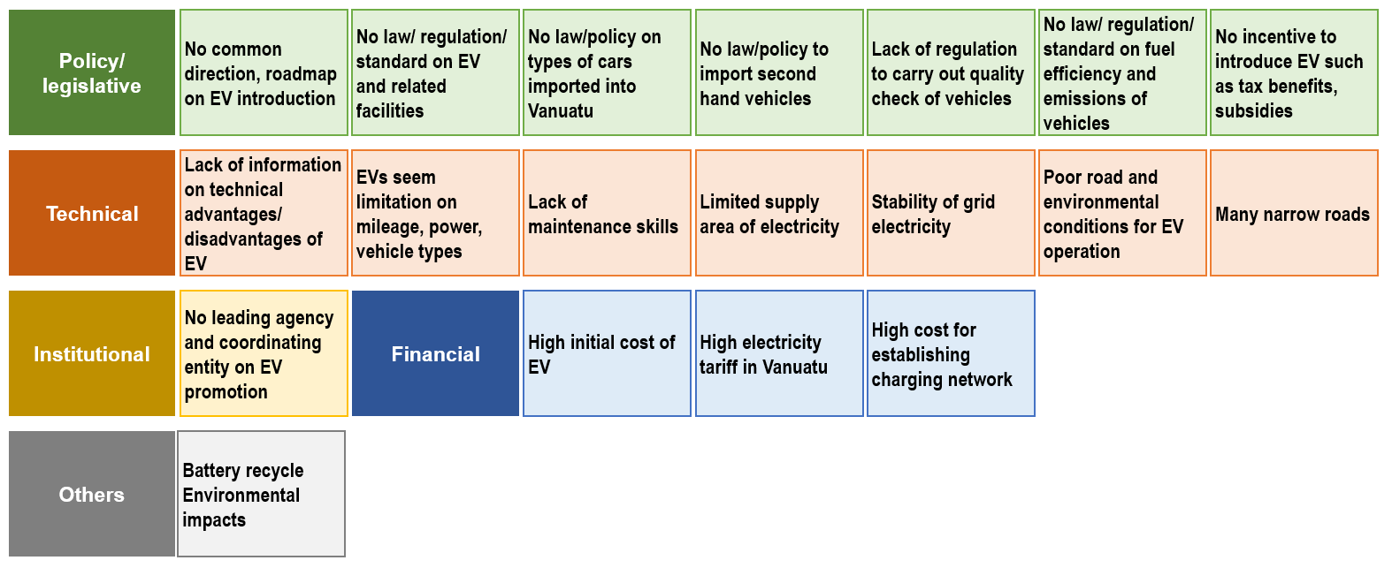

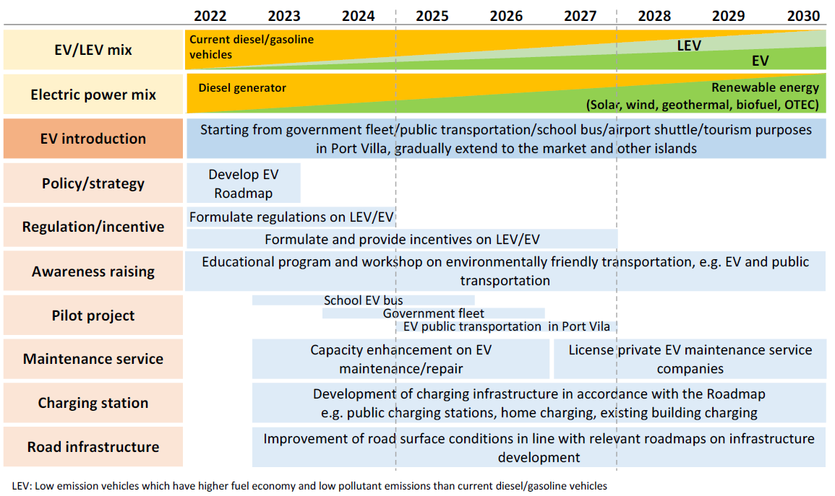
Annex3.2: An outline of proposed measures forwards the year 2030

Annex3.3: Targets and benefits
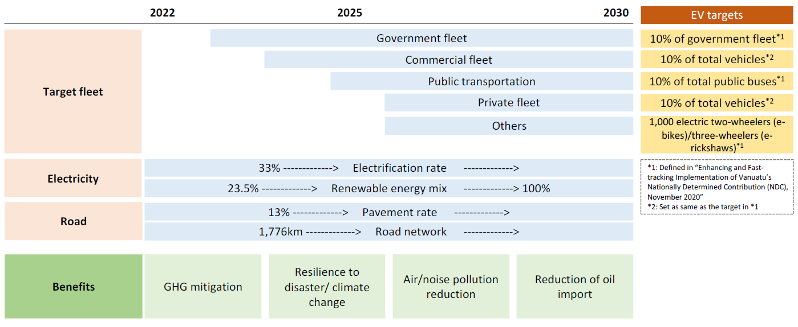

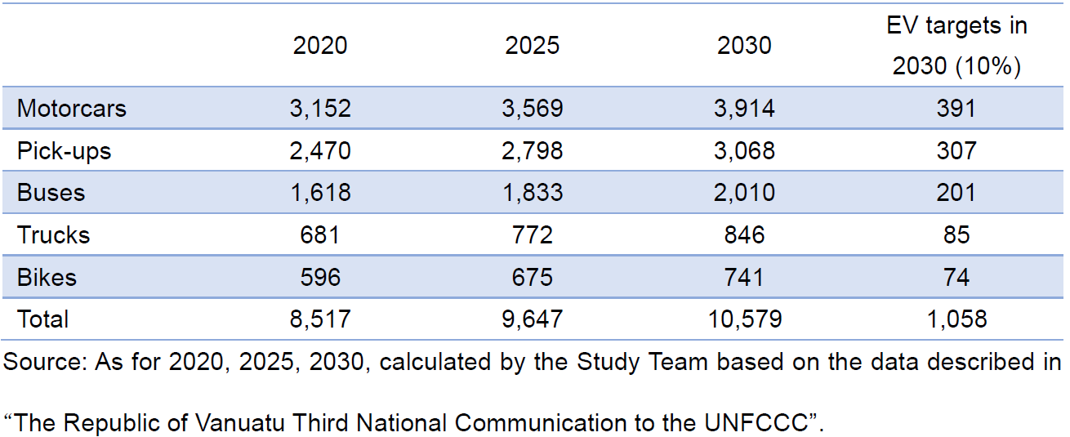
Annex3.4: Estimated number of motor vehicles in use and EV targets

Annex3.5: CO2 emissions of EV vans by types of electricity generation mix (gCO2/km)
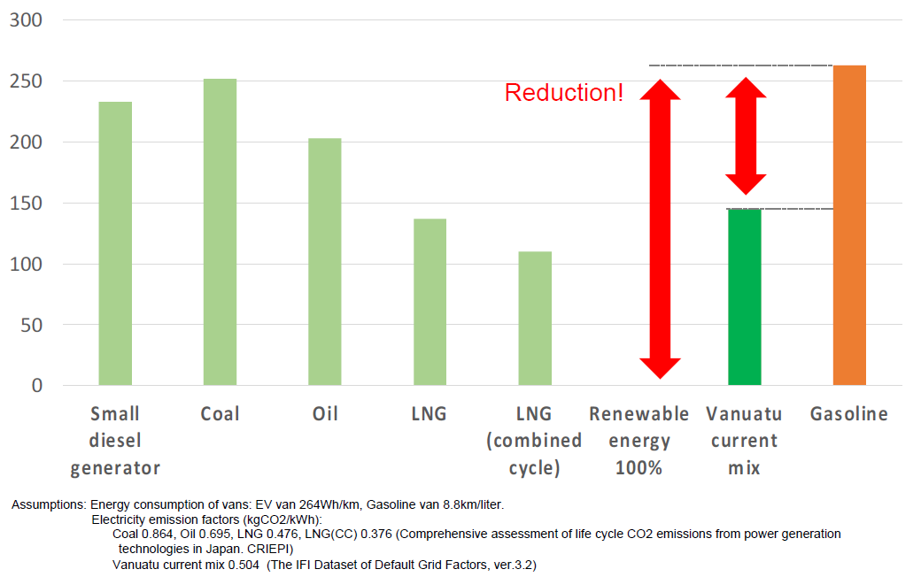

Annex3.6: Pillars of proposed measures

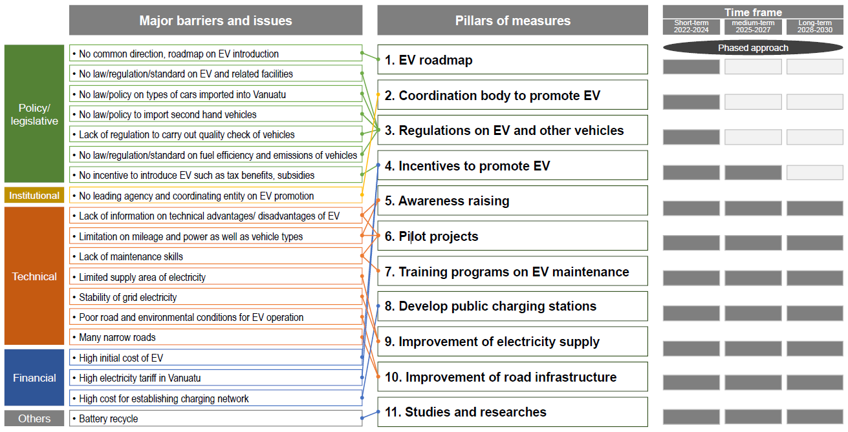

Annex3.7: Interlinkages of benefits/impacts relevant with sustainable development by introducing EVs in Vanuatu, other than GHG reduction

