Sustainable Land Transport Strategy and Proposed Actions for Nauru
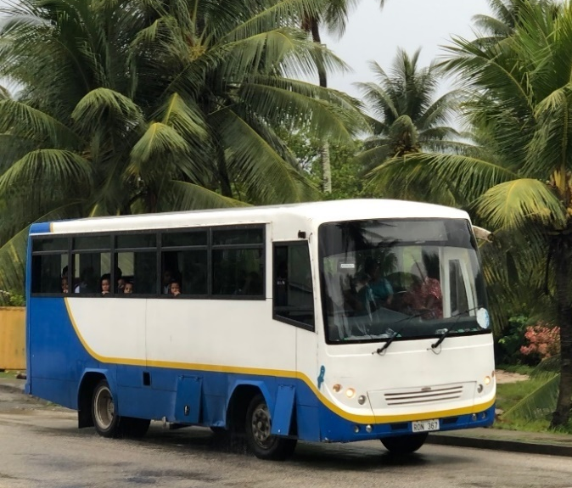 | 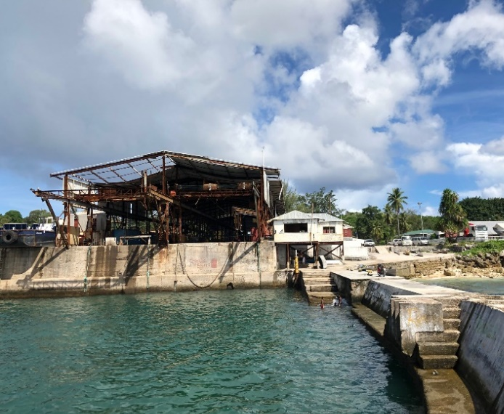
DRAFT
September 2020
Ministry of Commerce, Industry and Environment

Supported by:



Executive summary

To be completed for final version

Acknowledgments

This report was prepared by UNEP’s Sustainable Mobility Unit, and the Energy section of the Department of Commerce, Industry & Environment (CIE). Vehicle fleet analysis would not have been possible if not for the active cooperation of the Land Transport Regulatory Office. Information on fuel quality were provided by Vital Energy.

Table of contents
Executive summary 2
Acknowledgments 3
Abbreviations 5
About this strategy 6
About Nauru 7
Transportation in the island 10
Road safety issues 11
Vehicle fleet characteristics and fuel economy baseline 12
Fuel supply and quality 17
Policies and legal framework related to land transportation 17
Developing a vision for sustainable and low-emissions land transport in Nauru 18
Results of Sustainable Transport Policy Survey 18
Strategy and proposed actions 21
Integrate land-use planning and transportation 23
Encourage and improve walking and cycling facilities 24
Promote cleaner and more efficient fuels and vehicles 24
Pursue electrification of transport with renewable energy as main source 26
Provide a reliable and affordable public bus system 27
Carry out awareness-raising activities for sustainable land transport 28
References 30

Abbreviations

CTCN | Climate Technology Center and Network
DCIE | Department of Commerce, Industry, and Environment
HIES | Household, Income, and Expenditure Survey
Lge | Liters of gasoline equivalent
NEPF | National Energy Policy Framework of Nauru
NERM | Nauru Energy Road Map
NUC | Nauru Utilities Corporation
SUV | Sports Utility Vehicle
UNEP | United Nations Environment Programme

About this strategy

Nauru is one of the Small Island Developing States (SIDS) that are most vulnerable to the impacts of climate change, including an existential threat brought about by rising sea levels, increasing sea temperature leading to loss of biodiversity, and extreme weather events. Nauru has been active at the global stage in calling for more climate action and support for SIDS to address the climate crisis. At the national level Nauru is also committed to promote energy efficiency and the use of renewables, and in achieving the Sustainable Development Goals.
In early 2019, the Department of Commerce, Industry and Environment (DCIE) requested the Climate Technology and Center Network (CTCN) for a Feasibility Study for Sustainable Land Transport Strategy that includes a review and assessment of the current transportation situation, characterization and fuel economy analysis of the vehicle fleet, technology option analysis, and develop a roadmap for technological solutions for sustainable transport.
The Nauru Energy Road Map 2018-2020 has explicitly included the need to implement energy efficiency policies in the transport sector and investigate feasible replacements for petrol and diesel fuels, including LPG, hybrid, electric vehicles (powered by renewable energy), including buses.
CTCN worked with the United Nations Environment Programme (UNEP) to address this technical assistance request. UNEP’s Sustainable Mobility Unit has been supporting over 65 developing countries and countries in transition to promote and develop cleaner and efficient vehicle policies and as well as policies that promote cycling and walking. Recently, UNEP together with the International Energy Agency (IEA) is leading the Global Electric Mobility Programme supported by the Global Environment Facility (GEF) in cooperation with other UN agencies and development banks.
Together with the DCIE, UNEP has conducted a review of relevant reports and policies and conducted stakeholder consultations to help in developing the strategy. A survey on transport behavior and policy preference was conducted as part of this project. A total of 155 Nauruans from among the various districts were interviewed. The policy survey included questions on the acceptability of sustainable transport policies using a Likert-type rating scale. Key government officials were also interviewed regarding their views and insights on sustainable transport policies.
This report provides an overview of the land transportation system in Nauru and offers a strategy and proposed actions to adopt a more sustainable, energy-efficient, reliable, affordable, and low-emissions land transport system in the country.

About Nauru

Nauru is the smallest republic in the world with a total land area of about 21km². The central plateau, which rises to about 30m with the highest point at 65m, is where phosphate mining is widely conducted. Today the central plateau is a barren terrain of jagged coral pinnacles. On the other hand, the land along the coastline is relatively flat and fertile with vegetation and coconut trees and is where most of the population are concentrated.
Nauru is part of the Micronesian sub-regional grouping in the Pacific and is accessed mainly by air, mostly from Brisbane, Australia and Nadi, Fiji. There are also flights to its neighboring countries such as in Kiribati and the Marshall Islands.
Figure 1 shows an aerial view of the island showing the Nauru International Airport and Government offices at the forefront, and the settlements along the coastline. According to the latest household income, and expenditure survey (HIES) in 2013, Nauru has 1703 households and 10,294 individuals distributed among its 14 districts (see Table 1). Though, recent estimates show the population is about 13,000.
The most populated districts are in the Southwestern part of the island where most of the government offices and commercial areas are, namely, Denig, Aiwo, Boe, Yaren, and Meneng.
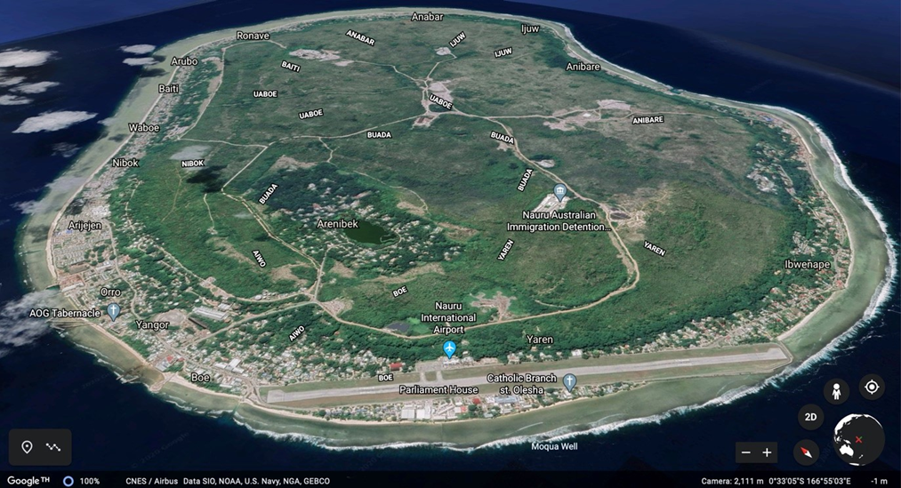
Figure 1. The Island Republic of Nauru
Source: Google Earth, accessed 1 June 2020.

Table 1. Overview of Districts, Households and Population in Nauru (2013)  *Location is a settlement within Denig that used to have expatriate communities from Tuvalu, I-Kiribati, and Chinese, working in Phosphate mining. Nauruans have since re-claimed the housing in this community.  Source: Republic of Nauru, Department of Finance, Bureau of Statistics. Nauru Household, Income and Expenditure Survey (HIES) 2012/2013 | 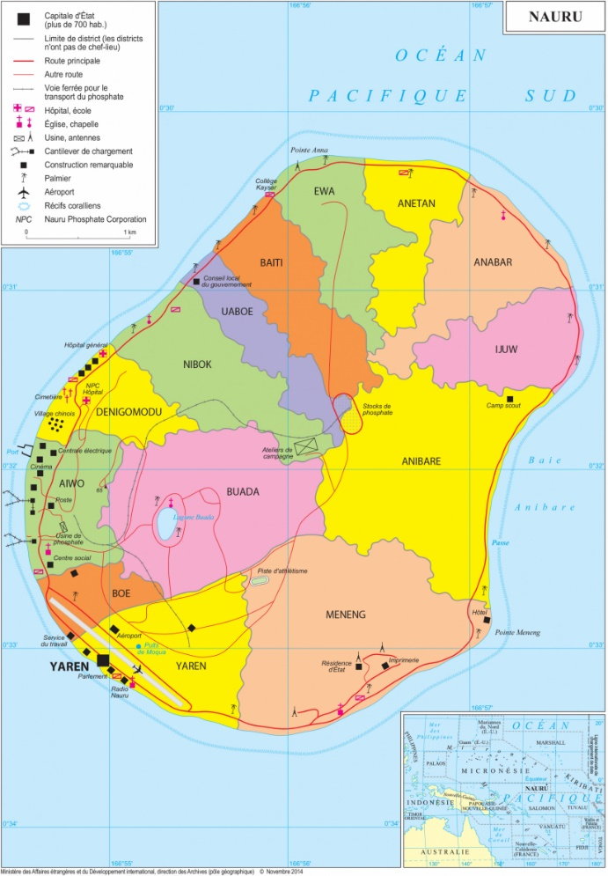  Figure 2. Geopolitical Map of Nauru  Source: Worldmaps. Accessed July 2020 https://www.worldmaps.info/Nauru/
  Districts | Households | Persons
  Yaren | 105 | 773
  Boe | 136 | 881
  Aiwo | 215 | 1263
  Buada | 137 | 765
  Denig | 57 | 318
  Nibok | 72 | 501
  Uaboe | 40 | 329
  Baitsi | 70 | 531
  Ewa | 63 | 462
  Anetan | 93 | 608
  Anabar | 65 | 468
  Ijuw | 29 | 184
  Anibare | 35 | 234
  Meneng | 249 | 1428
  Location* | 337 | 1549
  Total | 1703 | 10294

The transport behavior and policy preference survey conducted to support the development of this strategy included the participation of 155 Nauruans, randomly selected from the various districts as shown in Table 2. Majority of the responses came from females and included a relatively good distribution of responses from various age groups as shown in Figure 3.
Table 2. Survey Respondents by District disaggregated by Gender | Figure 3. Survey Respondents by Age Group
  Districts | F | M | Total
  Aiwo | 9 | 8 | 17
  Anabar | 3 | 4 | 7
  Anetan | 6 | 3 | 9
  Anibare | 5 | 4 | 9
  Baitsi | 7 | 4 | 11
  Boe | 2 | 5 | 7
  Buada | 10 | 3 | 13
  Denig | 2 | 7 | 9
  Ewa | 5 | 2 | 7
  Ijuw | 3 | 6 | 9
  Meneng | 21 | 10 | 31
  Nibok | 6 | 2 | 8
  Uaboe | 5 | 3 | 8
  Yaren | 8 | 2 | 10
  Grand Total | 92 | 63 | 155

Out of the 155 respondents, 11% indicated they have completed tertiary education; 37% completed or achieved secondary education; 25% completed or achieved elementary education; 6% had indicated diploma degrees and/or tertiary undergraduates and the remaining 21% did not indicate their level of education.
The 2020 GDP per capita for Nauru valued at USD 9,073 is higher than most of the countries in the Pacific except Fiji. However, living costs are quite high in Nauru because essential commodities like food and water are all imported. There is also no potable groundwater in the island. According to the HIES, most household expenses are associated with food and non-alcoholic beverages (43.4%) while transport is the next most significant group with 14.5%.
Electricity in the Island is supplied by diesel generators. According to the 2018 Nauru Utilities Corporation (NUC) Report, the total operational capacity is 9.8MW, while the maximum demand for the period is 5.3MW.
Electricity is heavily subsidized by the Government (NEPF). Households are charged 0.25AU$/kWh for 200kW monthly consumption and charged 0.50AU$ beyond 200kW. Commercial, industrial, and government establishments pay 0.70AU$/kWh. For comparison, the average household electricity consumption in the U.S. is 914kWh per month in 2018, and in Australia it is 456kWh per month in the same period.

Transportation in the island

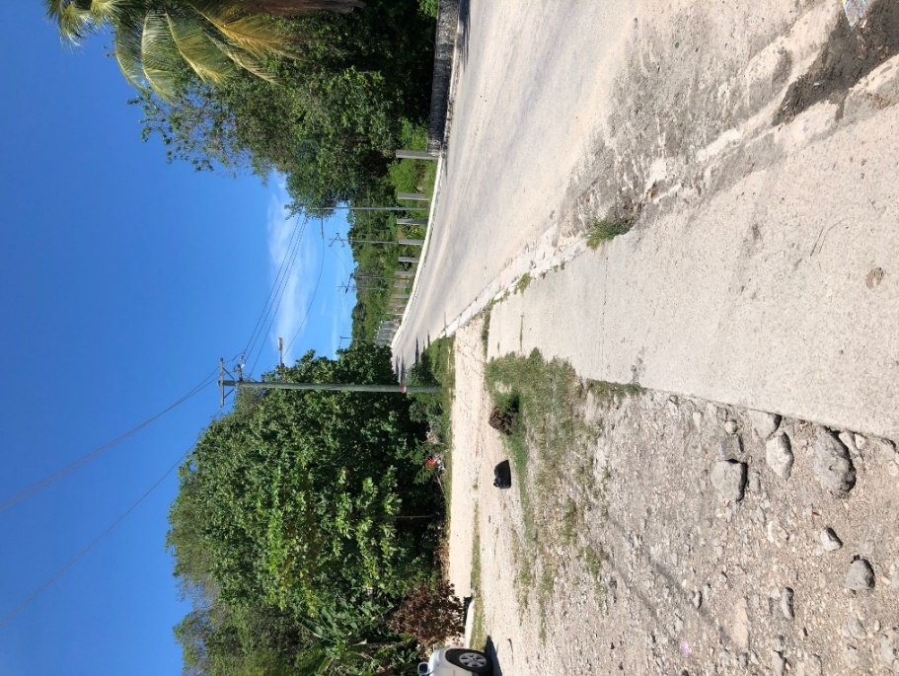
Figure 3. Typical roadway and sidewalk construction in Nauru
Nauru has about 30km of roads with 80% paved, running along the coastline. There is a road that leads to the inner central plateau, but a significant section of this road is on dirt tracks.
Figure 3 shows a typical road cross-section in the island, i.e. a 2-way 1.5 lane roadway with some paved, but often broken, sidewalks. Ingress and egress accesses to residential and commercial establishments are often unpaved as well.
In its Second National Telecommunication to the UNFCCC, the report indicated that 29% of households owned at least one car and 46% of households had at least one motorbike in 2011. It also mentioned that public transport has improved and benefiting schools and public sector employees. However, in 2019 only a few public buses are running on irregular service with fixed routes in the island. In 2005, it was highlighted that not having access to poor quality public transport hinders school children to regularly attend school.
As such, transportation around the island has been mainly by private cars and motorcycles. There are no taxi services in the island and tourists rely on for-hire car services. Water transport to go around the island is not available.
In the transport and policy preference survey, 81% indicated work trips as the primary reason for travel, 6% for commercial purposes, and the rest for school/gym/church and other leisure trips. Though, it is noted that 36% of respondents indicated mixed trips like going to work, dropping off children to school, going to commercial area, going to gym, etc. About 70% (112) of the respondents own cars and motorcycles. Out of 112 who own cars, 42 had more than 1 car in their household. Sixty-five respondents indicated their cars are personal/ private and 20 indicated its from Government. Out of the 42 people who owned more than one car, 25 had private and government issued vehicles. For those that owned motorcycles (104), 38 respondents had more than one, and 99 indicated they are privately-owned.

Figure 4. Car, motorcycle, and bicycle ownership in Nauru (survey of 155 people)
Not surprisingly, majority (58%) of the respondents indicated a preference for using cars for daily commute, followed by using motorcycles (30%), public transport (8%), and cycling (3%), as shown in Figure 5. The reasons provided, in order of priority, are – comfort, convenience, cheaper, no alternative, cheaper, cleanliness, and no shorter travel time.

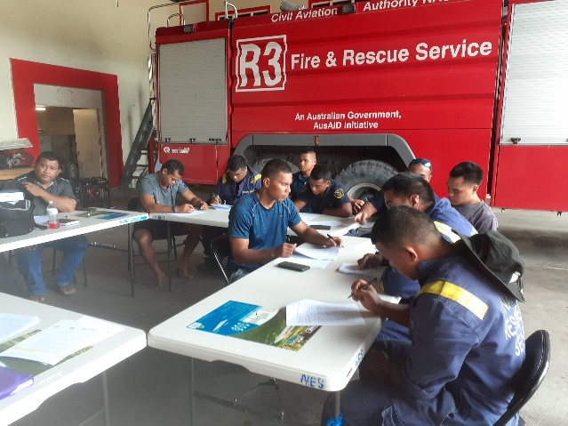
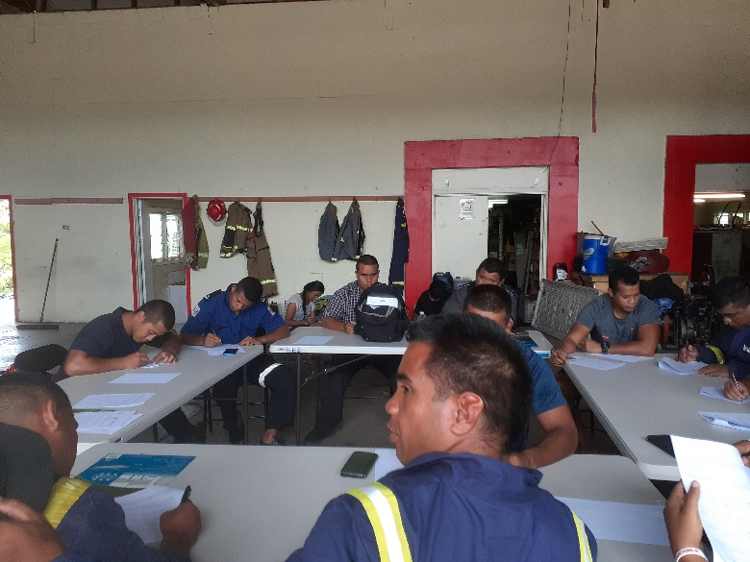
Figure 5. Transport mode preference for daily commute | Figure 6. Transport and policy preference survey at the Nauru Fire Brigade

Road safety issues

Road safety principles are comprehensively embodied in the Motor Traffic Act of 2014. The act includes regulations from obtaining drivers licenses to motor vehicle use and speed. The island effectively has a 50kph speed limit and 20kph when passing schools and church at a time when people are entering or leaving the establishments.
In the transport and policy preference survey, 54 out of the 155 people indicated that they have been involved in a traffic accident, and 23 people stating that they have been involved in an accident 1 year or less. However, the severity of the accident is not defined. Out of the 54 people involved in traffic accidents, 39 were with motorcycles and 14 with cars. Traffic accidents and deaths per capita in Nauru is not available.
The significant number of stray dogs roaming the coastal area and acting was highlighted as the second most important issue acting as a deterrent to walking and cycling around the island.

Vehicle fleet characteristics and fuel economy baseline

Data from the Nauru Land Transportation Regulatory Office shows that majority, if not all, of the vehicles in Nauru are imported second-hand vehicles from Australia and Japan. In 2019, the total number vehicles were 4,431 comprising 947 diesel vehicles and 3,484 petrol vehicles. Thirty percent (1,035) of the registered petrol vehicles are motorcycles. There are 537 government vehicles and 675 listed as commercial vehicles. The share of diesel vehicles has been increasing in Nauru since 2017 as shown in Figure 7. Figure 8 shows the average age of motor vehicles at the time of first registration from 2014 to 2019.
Figure 7. Share of petrol and diesel vehicles in the vehicle registration | Figure 8. Average age of vehicles at the time of first registration

In terms of the types of vehicles, Figure 9 below shows the increasing trend towards imports of SUVs, utility vehicles and vans since 2016, reflecting the increasing registration of diesel vehicles as well.
Figure 9. Vehicle type at the time of vehicle first registration from 2014 to 2019

Figure 10. Average engine displacement of motor vehicles registered in Nauru from 2014-2019
Consequentially, the average engine displacement of vehicles imported second-hand to Nauru has also been increasing since 2016. The import of vehicles with engine displacement in the categories 2400-2800 and 2800-3200 has been notably increasing as shown in Figure 10. The motor vehicles parked in the commercial area as shown Figure 11, shows SUVs and pick-up trucks with at least 2400cc engine displacements. The average engine displacement in Nauru in 2019 is 2643cc compared to 2288cc in 2014.
Motor vehicles with higher engine displacements tends to consume more fuel per kilometer, and such lead to higher emissions.
In order to find out the baseline and trends in fuel consumption in Nauru, a fuel economy baseline analysis was conducted using the vehicle registration data of Nauru following the Global Fuel Economy Initiative (GFEI) methodology. The GFEI has a target of 4.4Lge/100km for all new sales of vehicles by 2030 in order to help reduce emissions from road transport and contribute to achieving the goals of the Paris Agreement on Climate Change.
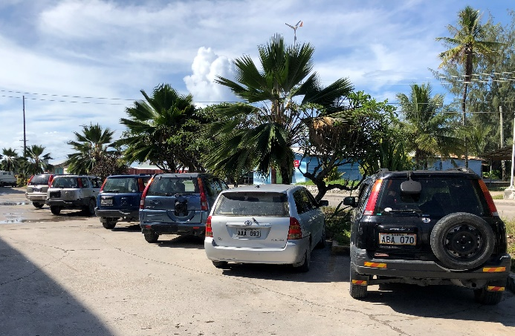 | 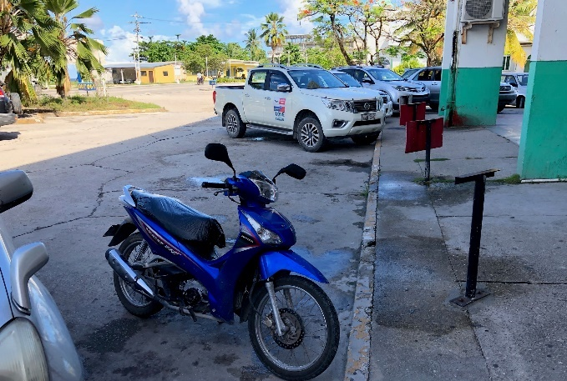
Figure 11. Vehicles parked in the commercial area

The minimum data required to calculate the average weighted fuel economy for newly registered Light-Duty Vehicles (LDVs) for at least one historic year are:
- Vehicle make (e.g. Brand)
- Vehicle model (e.g. Model)
- Model production year (e.g. 2005)
- Fuel type (e.g. gasoline, diesel, LPG, CNG, electricity)
- Engine displacement (e.g. 1600 cc or 1.6 l)
- Engine power (e.g. 80 kW)
- Rated fuel economy (Lge/100km) and specific carbon emissions per km (gCO₂ per km) and the respective test cycle basis (NEDC, CAFE (FTP), JC08)
In the absence of the rated fuel economy (Lge/100km) or specific carbon emissions per km (gCO₂ per km) data being available as a part of the national registration data, the GFEI recommends the use of the international literature and resources with appropriate conversions. The vehicle fleet data obtained from the Nauru Land Transport Regulatory Office under the Department of Transport included all information except the engine power and rated fuel economy. Information from Japanese, Australian, and American vehicles were used as the vehicles sold are of similar make and model.
The GFEI prescribes weighted average fuel economy of newly registered LDVs as the fleet-wide estimator to characterize the fuel economy of newly registered vehicles that enter the market at base year. The weighted average fuel economy and CO₂ emissions of newly registered LDVs could be calculated using the following equation:

Average Fuel Economy = $\frac{\sum_{i}^{n}{Number of registered LDV of model i in that year*Fuel economy of model type i}}{Total vehicle registered during that year}$
Average CO₂ Emission = $\frac{\sum_{i}^{n}{Number of registered LDV of model i in that year*CO2 Emission of model type i}}{Total vehicle registered during that year}$

The baseline-setting exercise includes the following steps:
- Establish the baseline year (e.g. the GFEI uses 2005 where data is available) – 2014 for Nauru
- Identify the data points to be collated to calculate a robust baseline
- Find and evaluate available new LDV vehicle registration data sources and their quality
- Calculate the base year average fuel economy and other characteristics for newly registered vehicles
- Repeat the same exercise using uniform methodology at regular intervals.
Figure 12 shows the fuel economy baseline in 2014 and subsequent trends up to 2019 and the equivalent CO₂ emissions in g/km. The International Energy Agency, one of the GFEI partners, has been monitoring the vehicle fuel economy of developed and developing countries. Figure 13 shows the fuel economy baseline of advanced and emerging countries, and as well as the global average in 2015 and the subsequent trends. Advanced countries with cheaper fuel costs have the highest baseline in 2005 at 11Lge/100km and improving to 8.6Lge/100km in 2017. Emerging countries were at 8.6Lge/100km in 2005 and improving to 7.5Lge/100km in 2017. Aside from relatively cheaper fuel costs, bigger vehicles with high engine displacements are the main reason why advanced countries with fuel costs less than 1USD per liter still has high fuel economy consumption in 2017. Advanced countries with fuel costs higher than 1 USD per liter are at 5.8Lge/100km. The GFEI has set a global target of 4.4Lge/100km for all new cars in 2030 in order to halve the emissions from light-duty vehicles in 2050.
In 2015, the average fuel economy of advanced countries with gasoline prices more than 1 USD was 5.8Lge/100km; for advanced countries with gasoline prices less than 1 USD, average fuel economy was 8.6Lge/100km; while for emerging countries, it was 7.8Lge/100km. Nauru was at 12Lge/100km in 2015, improving to 11.4Lge/100km in 2019. The average cost of gasoline per liter in Nauru was XX in 2019. For comparison, the average fuel economy consumption of vehicles in Fiji was 7.2Lge/100km in 2015 and 7.1Lge/100km in 2019. One liter of premium gasoline cost USD 1.01 per liter in December 2019.

Figure 12. Fuel economy baseline and trends in Nauru from 2014 to 2019 and equivalent gCO₂/km emissions
The high fuel economy baseline and trends in Nauru is reflective of the types and efficiency of the vehicles in the country. As shown in Figure 10, there is a high and growing share of cars with bigger engine displacements since 2016.
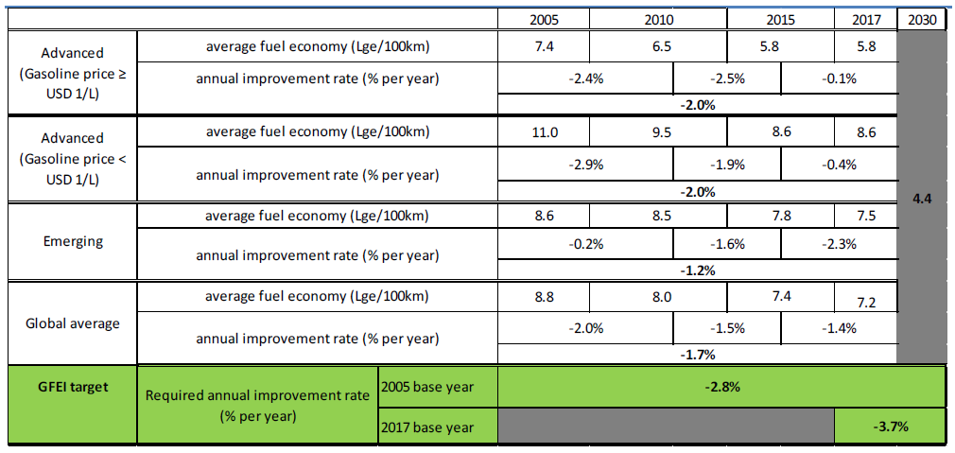
Figure 13. Progress in average fuel economy improvement in different regions and GFEI target for 2030
Source: IEA elaboration and enhancement for broader coverage of IHS Markit database (IHS Markit, 2018) in GFEI Working Paper 19: Fuel Economy in Major Car Markets: Technology and Policy Drivers 2005-2017

Figure 14. Average fuel economy baseline and trend and equivalent CO₂g/km of light-duty vehicles in Nauru relative to other countries
Figure 14 shows how the fuel economy baseline and equivalent CO2g/km emissions data of Nauru compare to other developing countries. This figure considers information from 65 developing countries that UNEP/GFEI has supported in improving the energy efficiency of their motor vehicles since 2009. Furthermore, in this UNEP/GFEI analysis, it showed that Nauru can save up to 20 million liters of fuel up to 2030 if it can reach the target of 4.4l/100km by 2030.
An analysis of the fuel economy of motorcycles was not conducted because of a significant number of registrations without the manufacturing year. However, the registration data shows newer motorcycles compared to light-duty vehicles. In 2019, 71% of the registered motorcycles were 3 years or younger. In 2014 and 2015, about 50% were 3 years or under. Motorcycles are inherently fuel efficient. The most popular make and model are the Yamaha Crypton and the Honda Trail with a total share of 26% and 12% in the whole motorcycle fleet. The Yamaha Crypton 110cc has a rated fuel consumption of 2.56l/100km (39km/l) while the Honda Trail 110cc has 1.67l/100km (60km/l).

Fuel supply and quality

The transport sector accounts for 35% of fuels imported to Nauru (NERM), about 3.5 million liters in 2012. Conventional gasoline and diesel are the only types of transport fuel in the country. The private company that imports the fuel to Nauru showed that the quality of imported gasoline and diesel are at least Euro 2 equivalent, with at least 500ppm sulfur. Actual importation quality certificate shows even lower levels of sulfur that can reach to 360ppm for diesel, and 150ppm for gasoline. There are no biofuels mixed in the fuel as shown in the quality import certificates. The Nauru Utilities Corporation (NUC) manages the importation of fuel. According to the Nauru 2018 Budget Papers, the NUC requires US$8million per year from the national government.

Policies and legal framework related to land transportation

At present there is no over-arching legal framework on transportation and urban planning in Nauru. There is also no land use plan to guide development decisions. The main legislation governing motor vehicles in Nauru is the Motor Traffic Regulations of 2014, amended in 2016, which includes issues licensing, insurance, registration fees relating to motor vehicles for private and business operations, e.g. taxi services.
There are also no fiscal and non-fiscal policies and programs to promote cleaner and more efficient vehicles in Nauru, including the relevant standards for vehicle emission and fuel quality.
The Department of Transport and the Land Transportation Regulatory Agency are the main government agencies overseeing the planning, implementation and enforcement of motor vehicle regulations. While the Department of Commerce, Industry, and Environment is the key government agency developing policies and regulations for energy and the environment.
The National Sustainable Development Strategy, revised in 2009, sets forth the countries’ priorities to achieve sustainable development. As part of the Infrastructure sectoral goals, the Strategy identified “Improve transport infrastructure and provide reliable and affordable public transport service” for transport infrastructure. It included key performance indicators like, public transport vehicles per capita; and included strategies for road maintenance, public transport, maintenance of government vehicles, improvement of port and cargo handling, and air transport. More information is available in Annex X.

Developing a vision for sustainable and low-emissions land transport in Nauru

It is important to have a vision for the land transport sector in line with the Sustainable Development Goals and the country’s own vision and goals. The NSDS (revised 2009) includes the people’s vision for development “A future where individual, community, business and government partnerships contribute to a sustainable quality of life for all Nauruans.” The Nauru Energy Road Map (NERM) of 2018 acknowledges that it supports the national vision adopted by the NSDS, which is: “Provide a reliable, affordable, secure and sustainable energy supply to meet the socio-economic development needs of Nauru.” The sectoral goal for transport is: “Improve transport infrastructure and provide reliable and affordable public transport service. “
It is proposed to amend or expand the vision for the transport sector in the NSDS to reflect a more sustainable and low-emissions land transport for Nauru, focusing on the movement of people and goods instead of vehicles.
Considering global trends on sustainable transport and the results of the transport and policy survey and assessment of transport in Nauru, a proposed amendment or expansion of the vision for the transport sector is: “Nauruans will enjoy sustainable and low-emissions transport with cleaner fuels and vehicles and maximizing the use of renewable energy for electric mobility, and with a reliable, affordable, and user-friendly public bus system integrated with walking and cycling facilities by 2030.”
The vision would:
- reduce fossil fuel dependency for transport ad national fossil fuel expenditures thereby improving energy security;
- reduce air pollution from vehicles and health impact from road-side exposure to motor vehicle emissions;
- reduce CO₂ emissions from the transport sector and support the Paris Agreement on Climate Change;
- support active transportation improving the over-all livability and quality of life in Nauru and reducing non-communicable diseases such as diabetes.
To achieve this vision, Nauru would have to enact policies and invest in the implementation of the sustainable land transport strategy.

Results of Sustainable Transport Policy Survey

The transport and policy survey were conducted primarily to provide inputs in developing the sustainable land transport strategy for Nauru. The survey showed the respondents’ overwhelming preference for cars and motorcycles (Figure 5) primarily because of the condition and unreliability of the current public bus system.
The survey included questions on parameters respondents would like to see improved for public transportation, walking, and cycling. The respondents identified road safety as the most important parameter, followed by removing stray dogs for walking and cycling.
The complete results are:
- Public bus – (1) road safety, (2) punctuality/ reliability, (3) cleanliness, (4) comfort, (5) travel time, (6) frequency, (7) information system, and (8) ease of transfer
- Walking to your destination – (1) road safety, (2) remove stray dogs, (3) road markings, (4) traffic signs, (5) bigger sidewalks/ pavement, and (6) more shade
- Cycling to your destination – (1) road safety, (2) remove stray dogs, (3) road markings, (4) bigger sidewalks/ pavement, (5) traffic signs, (6) bicycle parking, and (7) more shade
Figure 15 shows the results of a 5-point Likert scale of questions to assess the respondents’ level of agreement on sustainable transport policies and concepts.

Figure 15. Respondents’ level of agreement on sustainable transport policies and concept

The response on walking supports earlier reference to improve walkability in Nauru by removing stray dogs and providing better walking facilities. In terms of cycling as a good transport mode, 60% of respondents’ have agrees/ strongly agree, and less than 20% disagrees/ strongly disagrees. The responses on private cars as bad for the environment and relying on private cars for daily commute as not sustainable showed about 30% and 45% in agreement, and 40% of respondents showing neutrality on the issue.
For public transport, a question on having better public transport and public spaces as improving the livability of the community garnered 80% agreement and about 15% having a neutral position. In terms of public transportation being more affordable than owning and using cars for daily commute, 75% agree and strongly agree. The last two questions on public transport refers to its environmental impact, such as reducing the expenditure on fuels, and reduction of emissions, both air pollution and greenhouse gas. Both questions only obtained about 64% agreement or strong agreement. In both questions, about 25% replied neutral.
Another 5-point scale Likert survey transport policy specifically targeting policymakers and senior government officials was conducted. The answers from 12 respondents as shown in Figure 16 shows positive support for sustainable transport policies in Nauru.

Figure 16. Policymakers and senior government officials survey on transport policy

Statements 1-8 refers to promoting cleaner and more efficient vehicles including policies on importation of vehicles. The first statement is asking for a general sentiment for Nauru prioritizing cleaner and more efficient vehicles, of which most respondents generally agreed and strongly agreed. The second statement is on the choice of imported vehicle being purely based on the number of people it can carry. Only four people agreed and strongly agreed to this statement and six disagreed. The statement is ambiguous as it is not made clear how the number of people a vehicle can carry will influence the choice of vehicle.
The third statement is on the amendment of the import restriction for vehicles from 12 to 6. Only one strongly agreed, and two agreed, while there are five who remained neutral and three who disagreed and strongly disagreed. Only four agreed/ strongly agreed to the 4th statement asking for a ban on importing single fuel vehicles over hybrid, while four remained neutral and two disagreed/ strongly disagreed.
The fifth statement proposing an amendment to the registration requirements for vehicles to include year of manufacture, fuel type, and mileage was agreed/strongly agreed by 8 out of the 12 respondents. The sixth statement is on introducing a vehicle scrappage scheme based on a set of reasonable mileage and engine lifetime parameters. Six respondents agreed/strongly agreed to this statement while three disagreed/ strongly disagreed. The seventh statement is on the readiness of Nauru for electric mobility provided the necessary charging infrastructure is put in place. Nine of 12 respondents agreed/ strongly agreed to this statement while two remain neutral and one disagreed. The last statement focusing on vehicles was on agreeing whether gasoline and diesel cars will remain as the primary mode of transport in Nauru, seven agreed/strongly agreed while five remained neutral.
Statements 9-12 refer to public buses. Statement nine is on accepting a policy to deploy buses to and from work to conserve fuel and environment. Seven respondents agreed/ strongly agreed while one remained neutral and one disagreed. The next statement is on whether the respondents will still import private vehicles if a reliable public bus system in place. Seven agreed, three remained neutral and 2 disagreed/strongly disagreed.
Statement number 11 states in a negative way that public bus system will not work in Nauru. For this statement, all responses disagreed or strongly disagreed. However, statement 12 which asks whether Nauruans will prefer commuting by individual cars and motorcycles rather than buses, showed seven agreeing and strongly agreeing to this statement.
Statement 13 refers to cycling and walking facilities as not important for Nauru. Eleven strongly disagreed/ disagreed but one respondent agreed. The statement on the importance of urban and land use planning as important to achieving sustainable land transport but impossible to implement in Nauru, received seven strongly disagree/ disagree responses, and three agreements and one staying neutral.
The final statement refers to having an integrated transport system in Nauru anchored by public transport, walking, and cycling facilities as the backbone for a sustainable land transport strategy for Nauru. Eight respondents agreed/strongly agreed, while two remained neutral and two disagreed/ strongly disagreed.

Strategy and proposed actions

Nauru is a small island developing state with relatively low population density. The country imports all its fuel for energy and transport. There is a limited public bus system, and majority of work trips are done by car and motorcycle. It is important to note that Nauru has a big advantage in terms of distance from homes to commercial and office areas. There is also light vehicle traffic, and as such majority of trips are less than 30 minutes. In the transport and policy survey, the average travel time is 13 minutes, with the longest at 60 minutes covering 10kms.
However, majority of vehicles are more than 10 years old with bigger engines and low fuel economy. The average fuel economy of light-duty vehicles in Nauru is 11.4l/100km (8.8kms/l) of fuel in 2019. This fuel economy rating is reflective of the dominance of SUV vehicle types in the island. While air pollution is not (yet) a problem in the whole island, road-side exposure to air pollution can also be substantial due to high(er) emissions of motor vehicles and the proximity of residential areas along the major road. While the main roads are paved, there are limited sidewalks and pedestrian facilities along the main roads.
The strategy for sustainable land transport for Nauru is based on the Avoid-Shift-Improve approach, a widely adopted approach for developing strategies, policies, and measures to make transport sustainable.
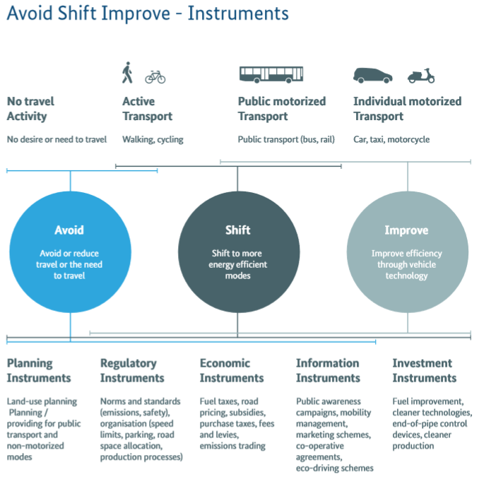
Figure 17. Avoid-Shift-Improve Approach
Source: GIZ-SUTP, TUMI

Avoid includes policies, strategies, measures that essentially avoids or reduces motorized travel, like promotion of compact and mixed-use development, work from home arrangements, and improving walking and cycling facilities. Shift includes promotion of public transport and shared transport. Improve focuses on improving vehicle and fuel technologies including electrification and use of renewable energy for transport.
Many countries have also adopted National Environmentally Sustainable Transport (EST) Policies in the region, the Philippines and Vietnam. The EST is spearheaded by the United Nations Centre for Regional Development (UNCRD) which convenes yearly EST forums with Asia Pacific governments to promote and share knowledge on sustainable transport. The integrated EST Strategy highlights the following elements.
- Public health
- Road safety and maintenance
- Traffic noise management
- Social equity and gender perspectives
- Public transport planning and transport demand management
- Non-motorized transport
- Environment and people-friendly infrastructure
- Cleaner fuels
- Strengthening roadside air quality monitoring and assessment
- Vehicle emissions control and standards, and inspection and maintenance
- Land-use planning
- Strengthening knowledge base, awareness, and public participation

Based on the current transport situation and capacity of the government in Nauru, concepts on promoting sustainable transport, and experience from other developing countries, the proposed strategy for sustainable land transport in Nauru will initially focus on:

Figure 18. Sustainable Land Transport Strategy for Nauru

Integrate land-use planning and transportation

Nauru’s Second National Communication to the United Nations Framework Convention on Climate Change (UNFCCC) identified land-use planning as critical to ensure future infrastructure investments are coherent with the visions and needs of all of Nauru’s communities. It also proposed to broaden the Master Land Use Plan for Topside to include Nauru’s coastal areas and integrate climate and disaster risks. In order to maximize the development potential of the Master Land Use Plan, it is also proposed to include transportation infrastructure and services to the Master Land Use Plan.
The improvement of Nauru’s seaport will undoubtedly increase demand for transport in the island. As stated in the project objective of the port project, the climate resilient port will allow reliable transport links for the import of food, goods, and fuel and potentially export of phosphate and products including fish, and limestone rock and aggregate. Transport activity in and around the port will increase as access and efficiency in the port increases. Deliberate planning for transport services and infrastructure in and around the port area and linked with the commercial and government facilities in Yaren is important to ensure that sustainable transport modes are provided. Traffic impact assessment studies can be required for the Seaport development and other planned development in the future.
It will also be important to conduct an origin-destination transport survey covering the wider community in Nauru and including all modes of road transport to plan for future improvements in transport infrastructure in the country.

Encourage and improve walking and cycling facilities

Road development and improvements should also take into more consideration facilities for pedestrians and cyclists. Providing such facilities will greatly improve road safety and access for people who walk and cycle to work. These guides and tools provided by the Institute of Transportation and Development Policy and UNEP can greatly assist policymakers in developing a non-motorized transport strategy or policy and putting more focus on pedestrians.
Implementation costs depend on the scale and quality of improvements. But improving sidewalks and providing bikeways in key areas where volume of commuters is high should not be substantial. Also, it will be important to make sure that the Port project will include such infrastructure provisions, and linked towards public transport access, e.g. walkways and sheds in loading and unloading bays of buses.
The transport and policy survey respondents highlighted the removal of stray dogs as a requirement in improving both walking and cycling facilities. Street lighting was not included in the transport and policy preference survey, but it is recommended to also be improved as it improves night-time road safety and encourages people to walk and cycle even at night especially in commercial and high-traffic areas.

Promote cleaner and more efficient fuels and vehicles

The Motor Traffic (Amendment) No.2 ACT of 2016 sets a 12 years age limit for imported second-hand vehicles to Nauru. However, there are no standards for vehicle emissions and fuel quality. According to data obtained from Vital Energy, the fuel quality imported to Nauru is at least 500ppm sulfur in fuel. The equivalent vehicle emission standards for fuel meeting 500ppm sulfur is Euro 2. This means that Nauru can put in place a policy mandating vehicle emission standard of at least Euro 2. A certificate of conformity could be required from importers selling vehicles to Nauru. New Zealand provides a comprehensive guide to meeting standards and requiring certificates of conformity. Vehicles coming from Japan with 6 years from age of manufacture would meet Euro 2 vehicle emission standards. Looking at companies importing second-hand vehicles to Nauru, requirements were found to be lax and does not comply with the current 12-year age limit. Road worthiness certificate should also be required.
It is also important for Nauru to also develop a roadmap to stricter vehicle emission standards and fuel quality, e.g. going to Euro 4/IV and Euro 6/VI vehicle emission standards and equivalent fuel quality by 2022 and 2024. The costs of Euro 4/IV and Euro 6/VI equivalent fuel quality, with 50ppm and 10ppm sulfur respectively, are now becoming competitive to lower quality of fuel, e.g. Euro 2 equivalent.
Figures 9 and 10 highlight the growing numbers of SUV-type and pick-up trucks imported to Nauru, having engine displacements of at least 2400cc. It is to be noted that going around Nauru, and even going once or twice to topside, considering good weather conditions, does not necessarily require the SUVs and pick-up trucks. However, this growing trend of having bigger and more powerful vehicles will provide a challenge for Nauru. The vehicles’ low fuel economy will lead to higher fuel consumption and rising fuel imports in the country. These vehicles also have higher air pollutant emissions affecting public health, and higher CO2 emissions. The popularity of SUVs and bigger, more powerful cars are not only evident in Nauru but also in other countries, notably the U.S. and other developed countries including Australia. As such, the number of SUVs and pick-up trucks available in the second-hand market and available to Nauru must have been also increasing with relatively cheaper prices.
According to the IEA-GFEI report (Working Paper 17) “A vehicle’s fuel consumption is based primarily on its powertrain technology and size. Majority of light-duty vehicles are equipped with gasoline-powered spark-ignition-engine powertrains, and they tend to have higher fuel consumption. Diesel engines consume 10-20% less fuel thanks to more efficient engine operations, whereas hybrid vehicles, usually powered by gasoline, have even lower fuel consumption because the engine almost always operates near peak efficiency and it accommodates some energy from regenerative braking. Electric vehicles have the lowest consumption (of course, pure battery EVs do not use liquid fuel at all) owing to the intrinsically higher efficiency of electric motors compared with ICEs. Vehicle size, which is usually based on vehicle weight, generally determines fuel consumption: larger vehicles such as SUVs consume more energy than smaller, lighter vehicles on average. Fuel consumption of hybrid and electric vehicle depends less on their weight because they are able to recover a portion of the energy lost when breaking.”
As such it is proposed to adopt a fiscal policy that increases the tax for bigger and older motor vehicles to encourage adoption of cleaner and more efficient vehicles. It is proposed to modify the fees in the registration or renewal of motor vehicles in the Motor Traffic Act and consider putting in place a vehicle excise tax system. The present categorization of vehicles as 0-2600cc and 2601cc and over in terms of fee differences, should also be revised. For example, categories – 1200cc below, 1201-1400cc, 1401-1800cc, 1801-2200cc, 2201-2600cc, 2601-3200cc, and 3200cc and over, could be adopted with different fee rates, and vehicle excise taxes. Even lower tax and fee rates for electric vehicles will encourage the adoption of cleaner and more efficient vehicles. This can also potentially provide higher revenues for the government coming from vehicles. Note that the opening of the Seaport could pave the way for more imported vehicles, as such it is important to put in place vehicle emission standards, fuel quality standards, and fiscal policies as soon as possible.
While LGP and CNG vehicles will reduce particulate matter emissions from transport, importing LPG and CNG vehicles may prove to be costly for Nauru considering economies of scale, and the need to set-up related facilities for importing and distribution of fuel and the maintenance of such vehicles.

Pursue electrification of transport with renewable energy as main source

Electrification of road transport can be transformative and ground-breaking for Nauru. The Asian Development Bank has an ongoing project Nauru Solar Power Development Project which aims to install a 6 MWh solar array with a 2.5 MWh/5.0 MW battery energy storage system (BESS). The development of this project will improve the electricity supply in the country and reduce diesel consumption, complementing the existing diesel-powered generators. It is also expected to improve the technical capacity in Nauru in dealing with solar PVs and BESS. It may also pave the way for more solar PV and BESS projects in the country in residential and commercial areas that can be used for charging electric vehicles. The World Energy Outlook 2020, IEA’s flagship publication released in September 2020.
Many small-island developing states are now considering the shift towards e-mobility. In the Global Electric Mobility Programme of UNEP and IEA supported by the Global Environment Facility, Maldives, Mauritius, Seychelles, Antigua and Barbuda, Saint Lucia, and Grenada are part of the program. These countries plan to establish national frameworks and policies to promote e-mobility, develop fiscal and non-fiscal policies, improve capacity in the countries in dealing with electric vehicles, and pilot specific e-vehicles e.g. e-buses, e-cars, e-motorcycles, and e-bicycles.
It is recommended to develop a national plan for shifting to electric mobility for 2-wheelers, 4-wheelers, and even heavy-duty vehicles in the long run. The plan should also include the deployment of charging stations and the integration of renewable energy like solar power. Establishing a capacity building program to improve the knowledge and technical capacity of Nauruans in dealing with electric mobility is also advised. This can be linked with ongoing efforts in solar power and BESS deployment in Nauru. Battery management will also be important. There are now many initiatives working on second-life batteries from electric vehicles used for BESS which could complement efforts in solar power deployment in Nauru.
The largest number of electric vehicles in the world are 2- and 3-wheelers. Asia has the most number, with China leading with at least 200 million electric 2-wheelers (bicycle and scooter type). Increasing numbers and models for sale in India and Southeast Asia has been observed as well. There are thousands of models and make and quality and range has been steadily improving with costs ranging from US$300 for a decent electric bicycle model, to more than US$3,000 for high-end electric motorcycle/scooter types.
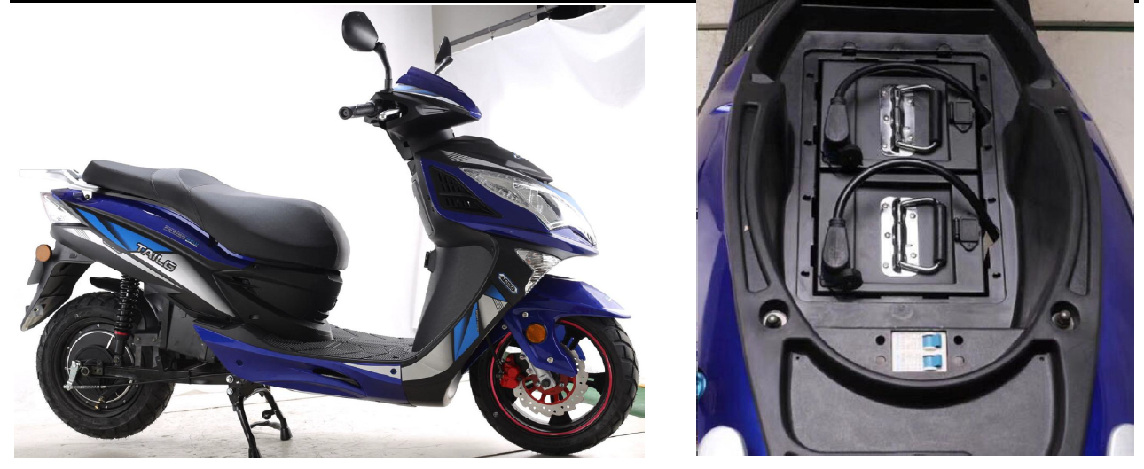 | 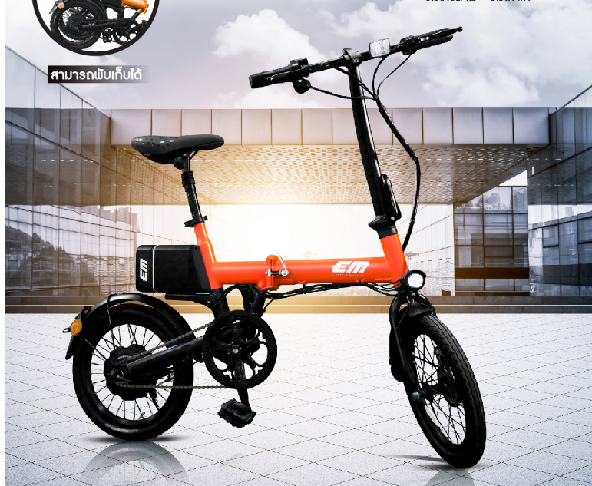
Figure 19. Chinese electric scooter with 3000w electric motor, with 2 swappable lithium-ion batteries | Figure 20. Electric folding bicycle in Thailand with 250w electric motor and lithium-ion batteries

Swappable batteries are now the trend for electric bicycles, scooters/motorcycles, and 3-wheelers. Taipei,China has the largest battery swapping platform for its Gogoro smartscooter network with over 200,000 battery swaps a day. An electric bicycle/scooter sharing or rent scheme for Nauru would be inexpensive considering a relatively small fleet to service the whole island. Electric 2-wheelers batteries can also be charged in normal household electrical outlets. Electric 2-wheelers would also benefit from direct charging from solar panels.
Electric 2-wheelers can also be used in commercial fleets especially for e-commerce deliveries. UNEP in cooperation with the EV Associations in Southeast Asia has prepared a Policy Guidelines for Electric 2&3 wheelers for Southeast Asia. The guidelines would also be useful for Nauru when developing standards and regulations for electric 2&3 wheelers.
Electric cars are also now widely available and issues on quality and range have significantly improved. In developing countries, countries like Sri Lanka have also increased the number of electric cars due to supportive fiscal and non-fiscal policies for imported new and second-hand vehicles. Imported second-hand electric cars available for Nauru with about 50,000km mileage with manufacturing year of 2012, sells for US$5,500 plus shipping and for a hybrid gasoline car with mileage of 55,000km and manufacturing year of 2010 sells for US$3,900. This shows the increasing competitiveness of second-hand electric cars. Establishing a vehicle charging facility or network is required for supporting electric cars. Costs of EV fast charging with 50kW and EV charging with 10kW-20kW is about US$50,000 and US$10,000. Home charging facilities based on an 11kW wall box will cost about US$1,000. Exact estimates will vary and may be even lower.
Electric buses are also increasingly becoming popular primarily because of its potential to help reduce air pollution in many big cities. Like electric cars, quality and range have also significantly improved, and many cities are going for complete electrification of the bus fleet. Many cities in China are now using majority electric buses in their fleet with strong support from national and local governments. However, the cost of electric buses can still be prohibitive compared to conventional diesel buses. The costs of electric buses can be as high US$450,000 for large 50+ seater buses, to US$180,000 smaller, 30-seater buses. The cost for a Euro IV compliant bus would be about US$150,000.

Provide a reliable and affordable public bus system

At present, there are 2-3 buses that serve Nauru with no fixed schedules. Establishing a reliable and affordable public bus system for Nauru will require an operational and management/business plan for the bus system. The operational plan involves an analysis of the demand, route identification, and frequency of service. The management/business plan involves the institutional set-up, daily administration, deployment of buses, maintenance and fuel requirements, and asset management. There are many resources that can be used to develop the public bus system for Nauru like the World Bank’s Urban Bus Toolkit and state-of-the-art management and operations of bus systems like those in Singapore.
Establishing a reliable and affordable bus system for Nauru need not be complex compared to situations in more dense and bigger cities in the region. It can be straightforward as the origin and destination of office, commercial, and residential areas are limited. For example, a bus system that operates 10 buses, even smaller 30-seater buses, may be enough to service the community during peak hours. However, the most efficient route servicing the whole community will need to be surveyed.
The challenge would be how to make the bus system sustainable. In many big cities, efficient and effective public transport systems like rail and buses are subsidized by governments. It is easier to organize and run the bus system if there are strong government regulations and support; and private sector is given the opportunity to implement the system with performance contracts. This means that the government pays the private operator for their service based on specific parameters that needs to be met, for example, number of kilometers driven per day, and/or number of trips made per day, number of bus breakdown, on-schedule deployment of buses, etc. It will be important to conduct and develop a management/business plan for the bus system.
In terms of technology, Euro II-compliant diesel buses should be the least technology for new buses, as diesel fuel complies with Euro II vehicle emission standards. However, there should be an effort to mandate soot-free technologies, or those meeting Euro VI vehicle emission standards in the over-all plan of Nauru. Soot-free technologies also include battery-electric-buses. Given the time required in over-hauling or improving the current bus system, it may be better for Nauru to consider going straight to battery-electric-buses. In 2023 or 2025, when Nauru purchase new buses, the cost of battery-electric-buses may be more price-competitive to diesel buses.

Carry out awareness-raising activities for sustainable land transport

Why develop awareness-raising activities?
To move seamlessly towards the implementation of the Sustainable Land Transport Strategy for Nauru, the development of a communications strategy is critical. This document is aimed at providing guidance for how the Nauruan Government can engage key stakeholders—including staff of government ministries, members of civil society and the private sector who are instrumental in driving the implementation the said Strategy.
Target audience
The target audience are citizens including civil societies and the Private Sector as their engagement and participation is vital.
Goals
In alignment of the vision statement of the Strategy, the desired goals of the awareness-raising activities are:
- Increased consideration and use of walking and cycling
- Increased consideration of public transport
- Increased consideration of cleaner fuels and vehicles
- Increased awareness of health and economic benefits of low-emissions land transport in the long term
Identifying effective channels
Mass and social media  These channels have broad reach and include television, radio, newspapers, magazines,  outdoor and transit advertising, direct mail and websites. | Radio, Nauru Media (& Facebook page)  Digicel text blast messages  Posters at waiting areas and notice boards (Suggested locations include airport arrivals, post offices, ATMs, Eigigu Supermarket, Meneng Hotel, and Capelle & Partner stores)  Instagram, Twitter or Tiktok
Organization and community.  These channels reach specific groups of individuals based on geography (for example, a specific village) or a common interest, such as occupational status. | School visits  Environment Day events  Independence Beauty pageant show  Church gatherings
Interpersonal.  These one-on-one discussions are often the most trusted channels for health information. | Teachers, counsellors, and faith leaders.

Forming key messages
Be brief: When addressing the public jargonistic phrases should be avoided. Think about the average level of knowledge and education among the Nauruan audience. The message to citizens should be kept simple and direct.
Present the end goal: Citizens care more about outcomes than processes. When forming messages always ask what they mean for an individual citizen. Health and economic benefits of sustainable mobility are easy to understand and should be of everyone’s concern.
Support the arguments: Speakers communicating key messages need to have back-up material including statistical data such as national fuel economy trends compared to the global average to support policy arguments.
Limit the number of key messages: The general rule is to limit key messages to three. Do not overwhelm the citizens with so many numbers and messages.
Suggested initial activities
A story to tell: Develop anecdotes about local air pollution and how it comes from the land transport sector. These anecdotes can be shared via local radio or Nauru Media Facebook Page and made into TikTok videos. Make sure at least one story is shared each month via each channel.
One champion is stronger than any group of teachers: Assign community leaders from churches and sports clubs to promote sustainable mobility practices. Booklets summarising key information points will be circulated amongst key community leaders of all age groups. It is an often most effective way to reach more people compared to any other campaign materials. Please avoid politicians as they tend to not work for everyone, as the audience would read their messages as political ones.
Use key community events: Big national events that everyone attends such as Independence Beauty Pageant is a good opportunity to promote sustainable mobility. Simple quiz questions about health impacts of negative mobility choices can be incorporated in the show to raise awareness.
Information session/briefing Information sessions: This can be a valuable way to engage community groups, especially where there is a local champion identified on the cause of sustainable mobility. The sessions usually involve an exchange of information, enabling the team to better understand local conditions, and the community group to learn more about the concept of sustainable mobility, possible ways to participate and contribute.
Suggested implementation timeline
Ideally, monitoring and evaluation should be embedded from the very start of planning as a core element when designing awareness-raising activities.
- January – March 2021: develop activities and key messages, identify community champions
- April – June 2021: disseminate stories and booklets,
- July 2021: Conduct mid-point review and assess outreach gaps in terms of target audience and media channels
- August – November 2021: disseminate stories and booklets, hold Information session/briefing Information sessions
- December 2021: Final review
The above timeline can be repeated for the subsequent years depending on progress and needs.

Table 3. Summary of strategies and proposed actions
Strategy | Proposed actions
Integrating land-use planning and transportation | - Integrate transport infrastructure and services in the Master Land Use Plan for Nauru  - Require traffic impact assessment of the Seaport and other planned developments  - Conduct origin-destination survey covering all road transport modes  - Integrate transport behavior questions in the national census
Improving walkways and cycling facilities | - Road development and improvements should integrate facilities for pedestrian and cyclists  - Develop plan to remove stray dogs  - Provide adequate street lighting
Promote cleaner and more efficient fuels and vehicles | Amend Motor Traffic Act to:  - Increase the age limit for imported second-hand vehicles from 12 years to at least 6 years.  - Set at least Euro 2 vehicle emission standards for imported second-hand vehicles  - Require certificate of conformity to emission standards and road worthiness certificates of vehicles  - Develop vehicle emission / fuel quality standards roadmap  - Update registration tax and establish vehicle excise tax for vehicles considering at least the engine size of vehicles
Pursue electrification of transport with renewable energy as main source | - Develop a national plan promoting electric mobility for 2-wheelrs, 4-wheelers, and heavy-duty vehicles  - Integrate development of charging network and use of solar power  - Establish capacity building program on e-mobility and solar power and BESS  - Develop battery management and disposal
Provide a reliable and affordable public bus system | - Assess the current public bus system  - Conduct an operational and management/business plan for a new public bus system  - Explore the use of battery-electric-buses for the new system
Carry out awareness-raising activities to support the implementation of sustainable land transport | - Develop and share personal stories to be shared on various social and traditional media channels  - Assign community leaders from churches and sports clubs to promote sustainable mobility practices. Booklets summarising key information points to be developed.  - Big national events that everyone attends such as Independence Beauty Pageant is a good opportunity to promote sustainable mobility.

References

Ministry of Commerce, Industry and Environment (MCIE). 2009. Nauru National Energy Policy Framework.
Ministry of Finance and Economic Planning (MFEP). 2009. Nauru National Sustainable Development Strategy 2005-2025.
Ministry of Commerce, Industry and Environment (MCIE). 2018. Nauru National Energy Roadmap 2018-2020.
Ministry of Commerce, Industry and Environment (MCIE). 2014. Nauru Second National Communication to the United Nations Framework Convention for Climate Change.
European Union Pacific Technical and Vocational Education And Training Project: Nauru Training Needs and Gap Analysis 92015) Accessed at http://prdrse4all.spc.int/sites/default/files/nauru_0.pdf
Moustafa, Ahmed. 2014. UNDP Nauru Hardship and Poverty Report: Analysis of the 2012/13Household Income and Expenditure Survey. Accessed https://nauru-data.sprep.org/system/files/Nauru_UNDP_Hardship%20and%20Poverty%20Report_2012_2013.PDF

ANNEX I

Transport
Goal: Improve transport infrastructure and provide reliable and affordable public transport service
Key Performance Indicators: Public transport vehicles per capita
Value of Public expenditure on roads
Frequency of international air and sea links

Strategies | Short-term Milestones (2012) | Medium-term Milestones (2015) | Long-term Milestones (2025) | Responsibility
Contract out road  maintenance comprising:  cleaning of blocked drainage;  rehabilitation of road side  protection; resealing of  damaged roads; maintenance  and rehabilitation of street  lights | - Contract awarded and works carried out.  - Contract performance reports prepared. | Road works and regular maintenance  carried out | Well maintained road network throughout  Nauru | Chief Secretary
Establish private sector  mechanism to provide regular,  reliable, low cost public road  transport | - Private sector provides public transport | Private sector provides regular, reliable,  low cost public road transport service |  | Transport
Maintain Government vehicles | - Government vehicles maintained in accordance with specified maintenance schedule  - Provision of increased number of school buses for growing student population | Government vehicles in good running  condition |  | Transport
Refurbish and develop port  infrastructure for vessel  handling | - Procurement of barges, raft, mooring certification and repairs.  - Construction of an interim Ports building  - Long term wharf and port infrastructure plan approved | Wharf and port infrastructure completed  and effective vessel and cargo handling  operations established | Efficient transport infrastructure  operating. | Ports
Develop regular sea freight  Service | - Affordable, reliable shipping service negotiated and available through Sub regional Shipping arrangements | Reliable and regular sea freight service  Available | Efficient, regular and sustainable sea  freight service. | Transport
Maintain safe, reliable and  economically sustainable air  services | - Increased frequency of air services available  - Airport safety and security standards meet minimum international requirements  - Refurbished civil aviation infrastructure  - Runway resurfaced | Airport security standards maintained |  | Civil Aviation

https://www.earth.northwestern.edu/people/emile/nauru.html
World Bank, 2017 in ADB report on Solar Power Feasibility
https://www.imf.org/external/pubs/ft/weo/2019/02/weodata/
This tariff applies to pre-paid customers that do not have a private solar PV system
https://www.eia.gov/tools/faqs/faq.php?id=97&t=3
https://www.ausgrid.com.au/Industry/Our-Research/Data-to-share/Average-electricity-use
https://www.nationsencyclopedia.com/economies/Asia-and-the-Pacific/Nauru-INFRASTRUCTURE-POWER-AND-COMMUNICATIONS.html
Situation Analysis of Children in Nauru (2017). Available: https://www.unicef.org/pacificislands/media/1161/file/Situation-Analysis-of-Children-Nauru.pdf
Motor Traffic Act of 2014. http://ronlaw.gov.nr/nauru_lpms/files/acts/41753d3263a559b3a9d40d499c093935.pdf
The Global Fuel Economy Initiative (GFEI) was established in 2009 by the United Nations Environment Programme, FIA Foundation, International Energy Agency, International Transport Forum, UC Davis, and the International Council for Clean Transportation with the aim to improve fuel economy of all road vehicles worldwide across all energy types, including internal combustion engines, hybrid engines and electric vehicles.
https://www.exchange-rates.org/Rate/FJD/USD/12-31-2019
Yamaha Crypton 110cc https://www.spritmonitor.de/en/detail/513868.html and Honda Trail 110cc https://en.wikipedia.org/wiki/Honda_CT_series#1980-2008_CT110_%22Trail_110%22
https://www.transformative-mobility.org/assets/publications/ASI_TUMI_SUTP_iNUA_No-9_April-2019.pdf
https://www.uncrd.or.jp/index.php?menu=376
ADB. 2017. Safeguards Due Diligence Report. Sustainable and Climate Resilient Connectivity in Nauru – PPTA Consultants https://www.adb.org/sites/default/files/project-documents/48480/48480-001-tacr-en_8.pdf
ITDP NMT Toolkit - https://nmttoolkit.itdp.org/guide/nmt-casestudies/759-2/ ; Pedestrians First: Tools for a Walkable city https://pedestriansfirst.itdp.org/ ; and UNEP: How to prioritize walking and cycling https://www.unenvironment.org/explore-topics/transport/what-we-do/share-road/why-does-share-road-matter/how-prioritize-walking
https://www.nzta.govt.nz/vehicles/importing-a-vehicle/step-2-evidence/used-vehicles-from-japan/#overall
https://www.jinjidosha.com/nauru/
The use of Arabic numerals, e.g. 1-6, for Euro-based emission standards indicate the standards are for light-duty vehicles, and the use of Roman numerals, e.g. I-VI, indicate that the standards are for heavy-duty vehicles.
https://www.theguardian.com/us-news/2020/sep/01/suv-conquered-america-climate-change-emissions?CMP=share_btn_tw
https://www.iea.org/reports/fuel-consumption-of-cars-and-vans
https://www.thegef.org/project/global-programme-support-countries-shift-electric-mobility
https://www.gogoro.com/
Policy Guidelines for Electric 2&3 Wheelers for Southeast Asia - https://cleanairsolutions.asia/asean-e2-e3vs-policy-guidelines/
https://www.jinjidosha.com/stock/?MakeId=3&ClientId=1
https://www.ifc.org/wps/wcm/connect/a2571c4c-9fd9-433c-9a87-5d0076380a1d/IFC-TransportNotes-WhyNow-final.pdf?MOD=AJPERES&CVID=m-Lof6I
https://ppiaf.org/sites/ppiaf.org/files/documents/toolkits/UrbanBusToolkit/assets/home.html
https://www.lta.gov.sg/content/ltagov/en/who_we_are/our_work/public_transport_system/bus.html
WHO Strategic Communications Framework for effective communications (2017)
CIVITAS Toolkit on Effective Communications and Marketing (CIVITAS, 2011)
Communicating Environmentally Sustainable Transport - The Role of Soft Measures (OECD, 2002)
WHO Strategic Communications Framework for effective communications (2017)

