Technical Assistance Closure Report Template

Objective of the technical assistance (TA) Closure Report:
- To communicate publicly in one document a summary of progress made and lessons learned during the TA towards the anticipated impact (sections 1-4).
- To document qualitative and quantitative data collected during TA, for use in donor and UN reporting (Annex 1).

Steps for completing the TA Closure report:
- The lead TA implementer submits the closure report at the end of the technical assistance as a final deliverable. The TA closure report will capture outputs, outcomes and impacts of all activities conducted under the TA. Please copy and summarise relevant material from previous TA outputs/deliverables and the Response Plan, as relevant.
- A CTCN Manager will review and revise the closure report before final approval by the CTCN Deputy Director.

Important note on public and internal use of the closure report:
Once approved by the CTCN Deputy Director, the TA closure report will be a public document available on the CTCN website www.ctc-n.org. Selected content will be used for targeted communication activities. Annex 2 is for internal use only and will not be publicly available.

Closure Report for CTCN Technical Assistance

- Basic information
Title of response plan | Development of low-emission mobility policies and financing proposals for Cambodia
Technical assistance reference number | 2019000003
Country / countries | Cambodia
NDE focal point and organisation | Dr. Hak Mao,  Director of Department of Climate Change, The general secretariat of the National Council for Sustainable Development, the Ministry of Environment
Proponent focal point and organisation | Mr. Doeun Dara, Vice Chief of Office of Policy and Coordination,  Department of Climate Change, General Secretariat of National Council for Sustainable Development, Ministry of Environment
Designer of the response plan | The general secretariat of the National Council for Sustainable Development, the Ministry of Environment
Implementer(s) of technical assistance | ENVELOPS Co., LTD.
Beneficiaries | Ministry of Environment  Ministry of Public Works and Transport
Sector(s) addressed | Transportation
Technologies supported | Land Transport  - More efficient light duty vehicles  Vehicle and fuel technologies  - Electric Vehicles
Implementation period and total duration in months | 28 November 2019 ~ 27 November 2021
Total budget for implementation | USD 141,775
Description of delivered outputs and products as well as the activities undertaken to achieve them. In doing so, review the log frame of the original response plan and refer to it as appropriate | The specific objective for this TA is: to facilitate the Royal Government of Cambodia to map out the most effective and feasible action to introduce E-Mobility, as a viable means to contribute to the country’s achievement of its GHG emission reduction target in the transport sector under the country’s NDC targets and to devise a suitable financing instrument to fund the implementation of E-Mobility in Cambodia.  Deliverables  - A policy action plan for low-emission mobility in Cambodia  - Draft proposal for Green Climate Fund on clean and efficient mobility in Cambodia
Methodologies applied to produce outputs and products | Communication with stakeholders to i) create a common understanding and support of the project, ii) exchange knowledge and experiences on climate project in terms of financial strategy and local context, iii) develop a shared vision of the broader opportunities and benefits emerging, and iv) receive suggestions from participants for a successful implementation of the project.  Produce and cross check the policy action plan with Ministry of Environment by using advisory of external professionals  Consult on the project concept and to develop concept note for Green Climate Fund to be reviewed by Government stakeholders of Cambodia
Deviations | This technical assistance (TA) was originally designed before the COVID-19 crisis. During the execution of the TA, COVID-19 arise, which prevented the implementor to visit Cambodia. All the works for the TA was done remotely and the meetings were held on-line.
Anticipated follow-up activities and next steps | With the COVID-19 situation improving, interested Accredited Entity (AE) of GCF and Delivery Partner (DP) will be organized to proceed the Concept Note to the Funding proposal stage.

- Lessons learned
 | Lessons learned | Recommendations
Lessons learned from the CTCN TA process | 1. the TA program is not designed for working remotely without visiting the site (Limited access on-site due to COVID-19 Situation)  2. The current situation for implementation of developing of policy action plan was too early. Other enabling conditions must proceed before the implementation of detailed E-Mobility policy action plan. | 1. Hiring of a suitable local consultant is critical that meets the requirements of the TA. Also, the conditions for on-line communication of the beneficiary country should be identified to proceed with the work.  2.Before the finalization of the Response Plan (RP), current situation and progress of the suggested TA should be identified to maximize the benefits of the TA
Lessons learned related to climate technology transfer | 1. Further improvement of the knowledge and capacities of the participating country/personnel is necessary, especially when applying their knowledge and skills in real situations.  2. Multiple projects with same objective can proceed at the same time (sponsored by different international organization) for climate change/technology. | 1. Expand the TA program from focusing on the general technical assistance to an actual implementation of the action plan and projects that each participant can stand alone.  2. When the project is linked to other national projects, it should be indicated before the response plan establishment. It will be more efficient to focus the effort on the goal together rather than to work separately.

3. Illustration of the TA and photos
For communication purposes, please provide 2-4 Power Point slides, including illustrations or charts, describing barriers, opportunities, methodology, activities, outputs and achieved results. The illustrations must be copied into the TA Closure report but must also be delivered as power point files. Also, please provide at least five high-resolution pictures in jpg format, capturing technical assistance. The pictures should illustrate how the TA has impacted the lives of the beneficiaries in particular and the communities in general.

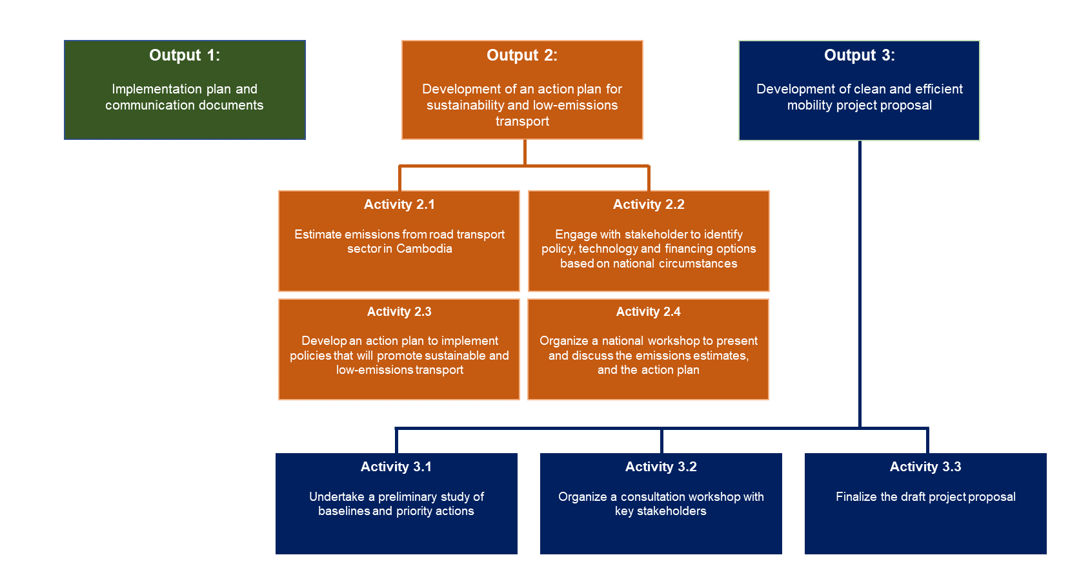

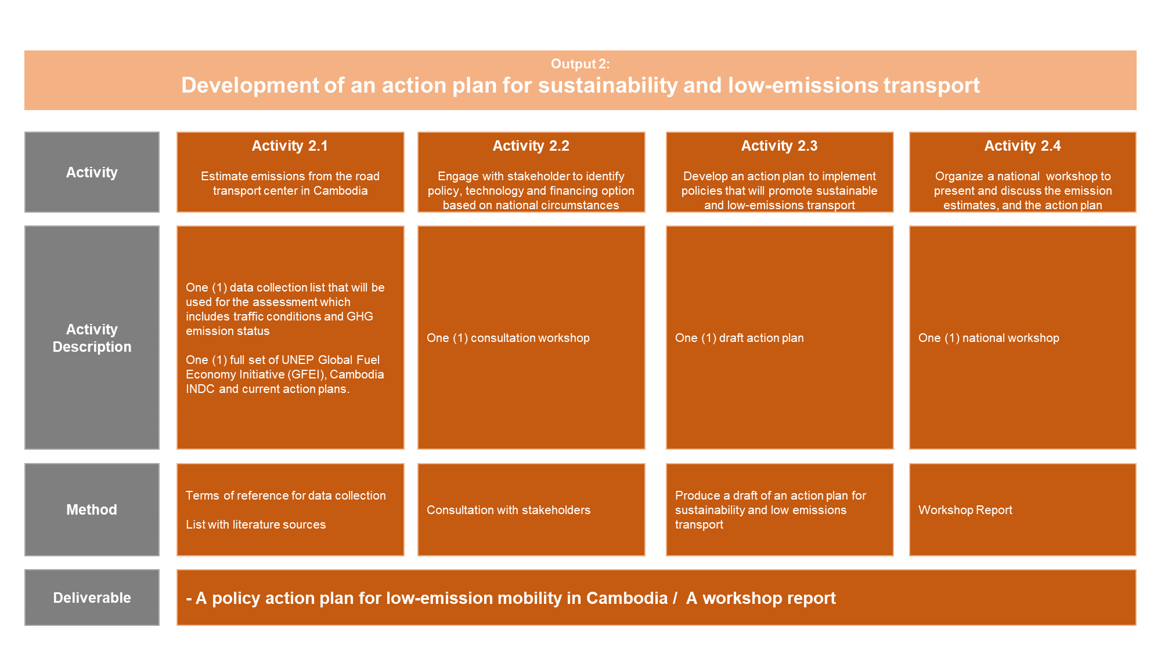

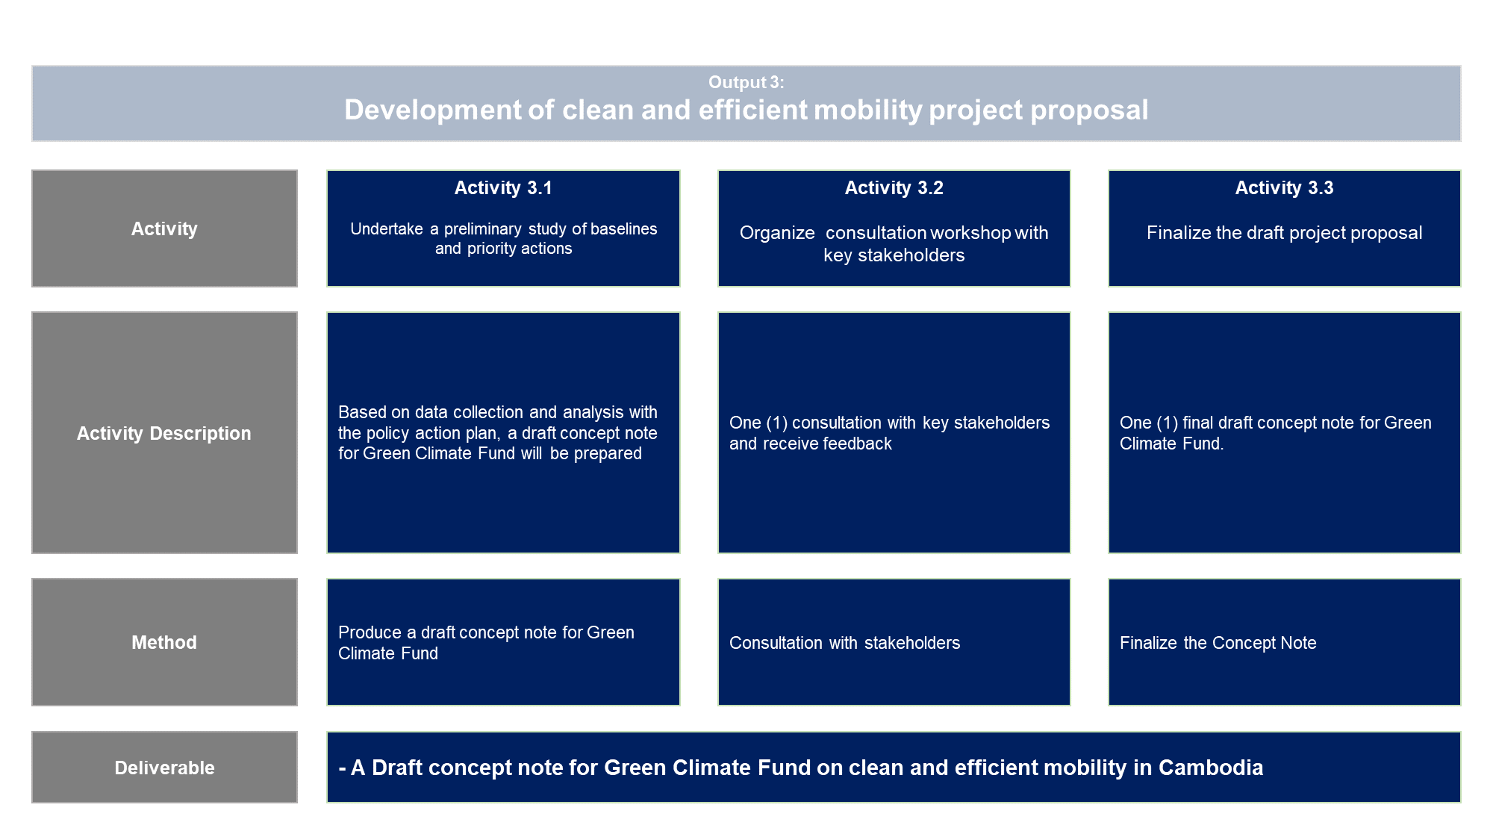

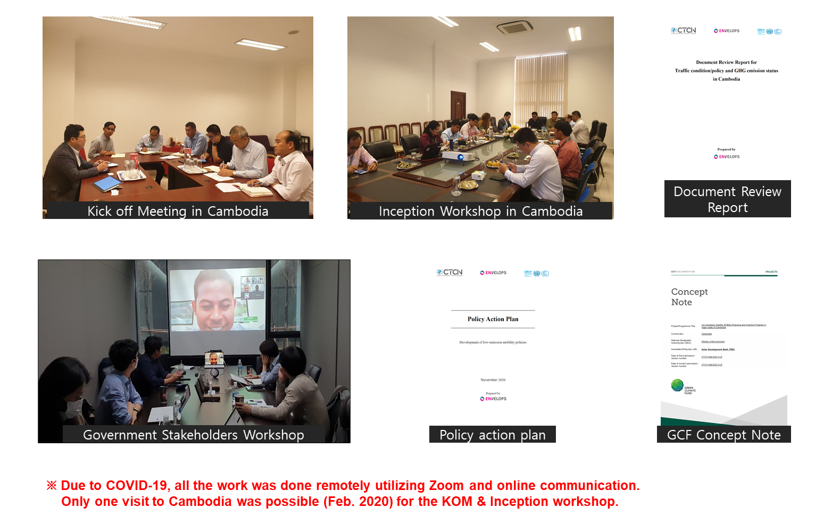

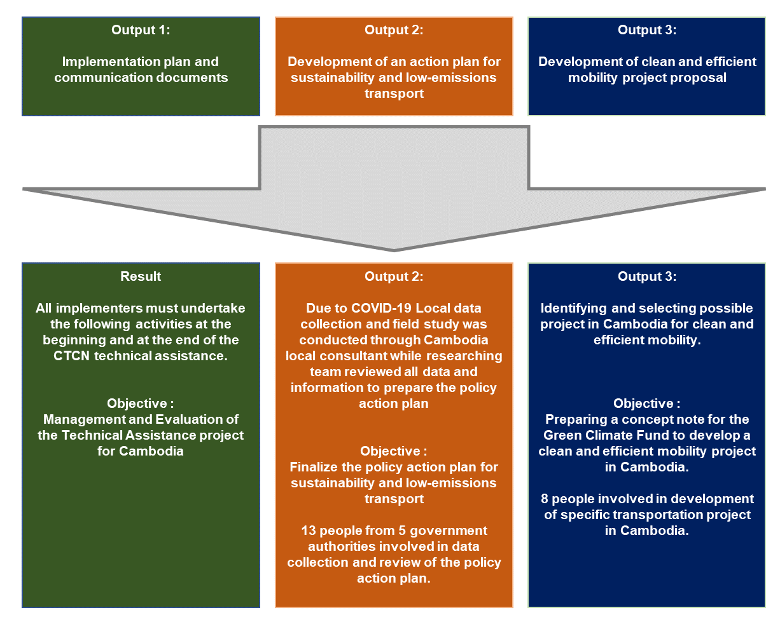

4. Impact Statement
The information in the table below will be used to communicate results and anticipated impacts of this technical assistance publicly. Please copy information from impact statement developed in the M&E Plan and update as relevant.

Challenge | The Royal Government of Cambodia recognized that the high level of dependence on imported fossil fuel poses a number of challenges in their transition to a sustainable development pathway and reducing GHG emissions and air pollution in the country. However, in order to make a successful transition into a low-emission pathway, Cambodia must address a number of barriers including  - Data and information gap  - Policy and planning gap  - Institutional gap  - Technical capacity gap  - Financial gap  - Market and infrastructure gap
CTCN Assistance | - Implementer conducted stakeholders engagement through inception workshop, to ensure a mutual understanding of proposed activities and expected outputs from TA  - Implementer conducted the assessment of current transport situation, policy and GHG emission and review of the previous E-Mobility plans and projects to collect all relevant data which will be used for the basis of an action plan  - Implementer provided of an action plan for sustainability and low-emissions transport including an implementation plan for cleaner and efficient vehicle policies  - Implementer provided a clean and efficient mobility project proposal for Green climate fund
Anticipated Impact | - Provide total of 26,000 solar charged E-Bikes to people in Siem Reap and Phnom Pehn  - GHG mitigation by replacing conventional internal combustion bikes to E-Bikes.  - Alleviating health risk by replacing heavy-emitting transportation modality to lowering the level of air pollution
Co-benefits: Achieved or anticipated co-benefits from the TA | Transport networks are one of the most important elements of a country’s infrastructure, and they are key to reducing poverty and promoting gender equality. In low-income countries, gender differences in mobility needs are very pronounced, requiring gender sensitive policy responses. The TA will drive the changes to cleaner and more efficient vehicles which presents an opportunity to address this unequal distribution by increasing women’s participation in the transport sector and provide socio-economic opportunities in new businesses and business models as drivers, charging solution providers, fleets operators etc.
Gender aspects of the TA | Output 2, a review of national mobility policies, can help Cambodia to understand gender disparities in Cambodia’s mobility policies and can serve as a guidance for future policy developments.  Output 3 by fostering the uptake of electric vehicles, will contribute to lower costs of transportation in the longer term. Women, particularly in rural Cambodia, who suffer from significantly lower income then men with poor access to labour market, will thus in particular benefit from lower mobility cost in terms of increased access to employment, markets, education and health services, but also to the caretaking and household responsibility that the majority of women hold.
Anticipated contribution to NDC | The policy action plan will be helpful to achieve 3% of targeted emission reduction in transportation sector in Cambodia INDC. (The updated NDC has been submitted and the next project should reflect the updated NDC)
The narrative story | Cambodia’s reliance on road transport has increased throughout the country’s economic development. Cambodia mainly relies on fossil fuel vehicles. The transportation sector is expected to account for an increasingly larger share of greenhouse gas emissions in Cambodia. In 2000, the transportation sector, accounted for 709Gg of CO2eq in 2000 rising to 4,752.35 GgCO2eq in 2016. With the rise in the number of vehicles on the road, Phnom Penh’s air pollution is growing concern as most vehicles are imported used with no age limits or emission standards.  The objective of this TA is  1) to provide Cambodia with a policy action plan for low-emission vehicle policy options to reduce emissions and energy use from the road transport sector, and  2) to assist Cambodia in accessing global environment funds to promote sustainable and low-emissions transport
Contribution to SDGs  A complete list of SDGs and their targets is available here: 43 | - SDG 7. Ensure access to affordable, reliable, sustainable and modern energy for all  by 2030, double the global rate of improvement in energy efficiency: increased awareness and understanding of efficient vehicle technologies is a direct result of this TA.  - SDG11. Make cities and human settlements inclusive, safe, resilient and sustainable  The long-term impacts of this TA will bring the urban population in Cambodia both economic and health benefits.  - SDG 13. Take urgent action to combat climate change and its impacts  This TA will assist Cambodia in tackling their high dependence on imported fossil fuel through suggestion and proposing a project that will support the implementation of E-bikes.
Annex 1 Technical assistance data collection

Please add quantitative and qualitative values for the indicators selected in the M&E plan and monitored throughout the technical assistance in the tables below. Indicators which have been monitored in addition to the proposed indicators below may be added at the end of table A. Non-relevant indicators should be left blank.

- Output and outcome indicators

Indicator  Please note indicators below highlighted as anticipated | Quantitative value  Value and unit | Qualitative description  List the various elements corresponding to the quantitative value as well as timelines and responsible institutions
Number of communication and outreach activities conducted by proponents and implementing partners to showcase CTCN support | 2  2 | Events (titles):  - Inception Workshop  - Stakeholder Workshop  News release: -  Newsletter: -  Articles: -  Presentations on the results of the TA:  - CTCN Advisory board meeting  - Korea CTCN TA case Study  Social media postings:  Etc.
Number of participants in the events above | 11  11 | Inception Workshop  (2 from Envelops, 1 from GGGI, 8 from Cambodia ministries)  Stakeholder Workshop  (3 from Envelops, 2 external transport and gender expert, 6 from Cambodia government stakeholders)
- Number of men | 8  9 | Inception Workshop  Stakeholder Workshop
- Number of women | 3  2 | Inception Workshop  Stakeholder Workshop
Number of training sessions and capacity strengthening activities
Number of people who received the training
- Number of men
- Number of women
Total number of institutions trained
- Number of research organisations, laboratories and universities
- Number of private companies
- Number of cities and local government
- Number of communities
- Number of ministries
- Number of specialised governmental institutions
- Number of non-profit organisations
Percentage of participants reporting satisfaction with CTCN training (from CTCN training feedback form)
Percentage of participants reporting increased knowledge, capacity and/or understanding as a result of CTCN training (from CTCN training feedback form)
- Number of men
- Number of women
Total number of deliverables produced during the assistance (excluding mission, progress and internal reports) | 4 | - A Document Review report for Cambodia transportation policies and projects  - A policy action plan for Development of low-emission mobility policies  - A concept note for GCF (Low-emission mobility (E-Bike) financing and incentive Program in major cities of Cambodia  - A final report
- Number of tools and technical documents strengthened, revised or developed | 2 | - A policy action plan for Development of low-emission mobility policies  - A concept note for GCF (Low-emission mobility (E-Bike)
- Number of other information materials strengthened, revised or created (For example training and workshop reports, Power Points, exercise docs etc.) | 2 | - A Document Review report for Cambodia transportation policies and projects  - A final report
Total number of policies, strategies, plans, laws, agreements or regulations supported by the assistance | 1
- Adaptation related
- Mitigation related | 1 | - A policy action plan for Development of low-emission mobility policies
- Both adaptation- and mitigation related
Anticipated number of policies, strategies, plans, laws, agreements or regulations proposed, adopted or implemented as a result of the TA | 1
- Adaptation related
- Mitigation related | 1 | - A policy action plan for Development of low-emission mobility policies
- Both adaptation- and mitigation related
Anticipated number of technologies transferred or deployed as a result of CTCN support |  | - More efficient light duty vehicles  - Electric Vehicles
Number of South-South collaborations enabled during or through CTCN TA support
Number of climate technology RD&D related outreach activities
Number of participants in climate technology RD&D related workshops and events |  | Disaggregate by country
- Number of men
- Number of women
Anticipated number of cooperative research, development, and demonstration programmes facilitated as a result of CTCN TA
Number of countries with strengthened National System of Innovation as a result of CTCN support
Number of organisations engaged through CTCN support |  | Disaggregate by type of organisations
Insert any additional indicators here

- Core impact indicators

Please fill in the tables for anticipated impacts of the CTCN assistance. Every technical assistance should contribute to at least one of the indicators below. For guidance on how to report on core indicators see the ‘M&E Guidance Document for TA Implementers’.

Core indicator 1 | Anticipated metric tons of CO₂ equivalent (CO₂e) emissions reduced or avoided as a result of CTCN TA
 | Anticipated metric tons of CO₂ , equivalent emissions reduced or avoided as a result of the TA on annual basis | Anticipated metric tons of CO₂ , equivalent emissions reduced or avoided as a result of the TA in total
Quantitative value |  | By Year 2050:  Alternative Scenario #1: Introducing E-Motor Cycle: 2,813,410  Alternative Scenario #2: Introducing electric cars and buses: 482,280
Unit |  | Metric tons of CO₂
Methodology  Explain the method or process of verifying the indicator and how data was gathered |  | the fuel efficiency of vehicles in km/kWh is applied to the emission factor for Cambodia, 0.3839 kg/kWh (national average grid emission factor in Cambodia). As a result, the emission rates are calculated as follows.  - E-car: 77.0 g/km (note that 273.32 g/km is used for gasoline cars)  - E-minibus: 157.8 g/km (note that 442.424 g/km is used for diesel minibuses)  - E-bus: 402.6 g/km (note that 1,159.689 g/km is used for diesel buses)  (Refer to Policy Action plan for detailed methodology)
GHG assessment boundary  Identify expected post-TA activities, associated effects and assess boundary for quantification of GHG emission reductions |  | - Implementation of the E-Mobility registration program  E-Mobility Incentive Programs  - Implementation of the GCF Concept Note
Baseline candidates  Define alternative technologies or practises used in baseline calculation to represent possible alternatives to the project activities |  | - Implementation of E-Public Transportation which will reduce the number of operation of the personalized vehicles
Baseline emissions  Describe baseline scenario and emissions calculated |  | Refer to the Policy Action Plan for detailed Baseline emissions (BAU Scenario)
Assumptions  Describe assumptions made during calculation and quantification of GHG reductions |  | Refer to the Policy Action Plan for detailed Assumptions

Core indicator 2 | Anticipated increased economic, health, well-being, infrastructure and built environment, and ecosystems resilience to climate change impacts as a result of technical assistance  Please provide a qualitative description of the anticipated impacts on the categories below
Infrastructure and built environment
Anticipated increased infrastructure resilience (avoided/mitigated climate induced damages and strengthened physical assets)
Ecosystems and biodiversity
Anticipated increased ecosystem resilience (areas with increased resistance to climate-induced disturbances and with improved recovery rates)
Economic
Anticipated increased economic resilience (e.g. less reliance on vulnerable economic sectors or diversification of livelihood)
Health and wellbeing
Anticipated increased health and wellbeing of target group (e.g. improved basic health, water and food security)

Core indicator 3 | Anticipated number of direct and indirect beneficiaries as a result of the TA
 | Direct beneficiaries | Indirect beneficiaries | Means of verification
Adaptation related |  |  | Describe calculation methods and assumptions made
Mitigation related |  |  | Describe calculation methods and assumptions made
Both adaptation-and mitigation related |  |  | Describe calculation methods and assumptions made

Core indicator 4 | Amount of funding/investment leveraged (USD) as a result of TA (disaggregated by public, private, national, and international sources, as well as between anticipated/confirmed funding)
 | Quantitative value  Value and currency | Qualitative description  List the various elements corresponding to the quantitative value as well as expected timelines and responsible institutions | Methods  Describe method use for quantification of funds leveraged including assumptions made and attention paid to causality, attribution and avoidance of double-counting
Total anticipated amount of funding/investment mobilised or leveraged (USD) as a result of the TA | 10.1M USD | Low-emissions mobility (E-Bike) financing and incentive Program in major cities of Cambodia (The main objective of this project is to enable and assist the people of Cambodia to purchase solar charged E-bike) will be proposed to the AEs of GCF.
Anticipated amount of public funding mobilised from national sources (USD)
Anticipated amount of public funding mobilised from international and regional sources as a result of the TA | 10.1M USD | E-Mobility Financing Program (6.1M USD)  E-Mobility Incentive Program (3.0M USD)  Raising awareness of E-Mobility (0.5M USD)  Capacity Building for E-Mobility (0.5M USD) | Project concept paper included all the contents of funding amount and its detail description.
Anticipated amount of private investment mobilised (in USD) from national sources as a result of the TA
Anticipated amount of private investment mobilised (in USD) from international and regional sources as a result of the TA

Annex 2 (for internal use – to be filled in by the CTCN)
CTCN evaluation
This section will be completed by the relevant CTCN Technology Manager.

- Evaluation of the timeliness of the TA implementation as measured against the timeline included in the response plan;
- Evaluation of TA quality as defined in the response plan;
- Overall performance of the Implementers;
- Overall engagement of the NDE and Proponent;
- Lessons learned on the CTCN process and steps taken by the CTCN to improve.

