Technical Assistance Closure Report Template

Objective of the technical assistance (TA) Closure Report:
- To communicate publicly in one document a summary of progress made and lessons learned during the TA towards the anticipated impact (sections 1-4).
- To document qualitative and quantitative data collected during TA, for use in donor and UN reporting (Annex 1).

Steps for completing the TA Closure report:
- The lead TA implementer submits the closure report at the end of the technical assistance as a final deliverable. The TA closure report will capture outputs, outcomes and impacts of all activities conducted under the TA. Please copy and summarise relevant material from previous TA outputs/deliverables and the Response Plan, as relevant.
- A CTCN Manager will review and revise the closure report before final approval by the CTCN Deputy Director.

Important note on public and internal use of the closure report:
Once approved by the CTCN Deputy Director, the TA closure report will be a public document available on the CTCN website www.ctc-n.org. Selected content will be used for targeted communication activities. Annex 2 is for internal use only and will not be publicly available.

Closure Report for CTCN Technical Assistance

- Basic information
Title of response plan | Technical Assistance for the Development of a Climate Smart City in Kurunegala, Sri Lanka (Mitigation elements)
Technical assistance reference number | 2019000048
Country / countries | Sri Lanka
NDE focal point and organisation | K.N. Kumudini Vidyalankara, Director  Climate Change Secretariat, Ministry of Environment  Tel: +94112034193  Fax: +94 (0) 112879978  Email: climatesec@gmail.com, kumudiniimex@gmail.com  Address: Climate Change Secretariat Ministry of Environment, 416/1/C, Robert Gunawardena Mawatha, Battaramulla, Sri Lanka
Proponent focal point and organisation | Mr. Pradeep Thilakarathne, Municipal Commissioner  Municipal Council Building, Kurunegala, Sri Lanka  mohmck0@gmail.com  Tel: +94717139660
Designer of the response plan
Implementer(s) of technical assistance | - Econetwork Inc. (Project Implementer)  - National Cleaner Production Centre Sri Lanka  (Local Partner)
Beneficiaries | Kurunegala Municipal Council (KMC) and approx. 40,000 residents living in the city boundary
Sector(s) addressed | Mitigation in energy, transport, and waste sectors
Technologies supported | 1. Identification of baseline GHG emissions and current state of Kurunegala city  2. Identification of sector specific low emission climate technologies  3. Establishing a sectoral roadmap and action plans for transition to a low-carbon city  4. Build the capacity of city planners and policy makers in order to guide on how to transform Kurunegala City into a low emission city
Implementation period and total duration in months | November 2019 – January 2021 (14 months)
Total budget for implementation | USD 170,000
Description of delivered outputs and products as well as the activities undertaken to achieve them. In doing so, review the log frame of the original response plan and refer to it as appropriate | To contribute to the development of a pathway for the transition to a low emission municipality in Kurunegala, Econetwork performed project activities at each stage based on the collaboration with local partner, NCPC, and has successfully delivered the outputs and deliverables per response plan.  At the beginning of the TA, Econetwork provided detailed work plan, monitoring and evaluation plan, and CTCN Impact description to develop the implementation planning and communication documents for project management.  In order to officially launch the TA, there was supposed to be a project inception workshop in the place, however, due to the physical limitation caused from COVID-19, Econetwork delivered inception report to replace the actual inception workshop report. With the official launch of the TA, Econetwork had worked on the analysing of the current state of Kurunegala city in energy, transport, and waste sectors then based on this analysis, Econetwork had conducted feasibility survey to identify the sector specific climate technologies in the priority. During this activity, there were two different stakeholder meetings to let the stakeholders be involved in the actual activities and to involve in the process of evaluating the technologies.  After finalizing the prioritized climate technologies, Eco has drafted KOICA Project Concept Paper (PCP) for the waste sector and developed the sectoral roadmap for KMC.  Finally, Econetwork, as a project implementer, has delivered capacity building workshop with guidance for Greenhouse gas Inventory for KMC and institutional framework for the data collecting and sharing mechanisms among the institutions to fully develop the GHG inventory.  All the forms of workshops were processed face-to-face in Kurunegala and Econetwork took a part through virtual platform, Zoom call, since there was physical limitation of travelling due to COVID-19.  The Climate Change Secretariat was the facilitator for the programme and reviewed all the reports. The KMC provided support by organizing all the stakeholder consultations, providing letters to obtain data and were the main contributors at stakeholder consultations.
Methodologies applied to produce outputs and products | Local expert evaluation on the technology, On-site interview and survey through local partners with key stakeholders, face-to-face discussions with stakeholders, On-line AHP (Analytic Hierarchy Process) survey for the final climate technology, Regular conference call with local partners for the quality control of the deliverables
Deviations | Due to the sudden upsurge of COVID-19 worldwide, basically Econetwork was not able to physically come to Sri Lanka for conducting the TA. Therefore, all the workshops and stakeholder meetings were organized by KMC, facilitated by CCS, presented by NCPC and Econetwork participated through virtual meeting platform. Econetwork also provided several presentations which were presented at the sakeholder consultations.  While implementing the analysis for the feasible financial options for the climate technology to be introduced, we have found out that it is more plausible to draft the PCP(Project Concept Paper) for KOICA(Korea International Cooperation Agency), rather than the concept note for GCF. Therefore, there was a change of deliverable 4.3 from GCF draft concept note to KOICA PCP draft.  And some of the activities were delayed and adjusted accordingly, however, Econetwork has managed all the activities to deliver the expected outputs
Anticipated follow-up activities and next steps | After completion of this technical assistance, KMC will discuss with local experts to actually incorporate the sectoral roadmap into their policy and planning.  Also, KMC will prepare for the application of the in-depth technical feasibility survey for the waste sector in Kurunegala.  At the last half of the year, KMC will develop the long-term funding project for the waste management since Kurunegala's administrative area is planned to be expanded as Greater Kurunegala, which will induce more severe waste issues and GHG emission in the future.

- Lessons learned
 | Lessons learned | Recommendations
Lessons learned from the CTCN TA process | The submission process of deliverables, approval authority for the decision making, and the project implementer's intervention on the response plan were challenging due to the nature of the first experience of TA implementation. | Recommendations include  - Finalization of the response plan before project implementation  - Provision of guidance on each process or certain situation to the project implementer at the beginning of the project process.
Lessons learned related to climate technology transfer | Due to the COVID-19, Econetwork could not physically come to Sri Lanka for site survey and supporting the workshop on-site. Therefore, it also caused the delay of data collecting and inefficient communication which have led to the overall delay of the project management schedule. In this context, it was crucial to have good partnership with local consultants for carrying out the on-site technical support for KMC. | Recommendations include  - Provision of the pool for the local consultants or supportive agency who understand well on the local context situation analysis and provide decent facilitation among the local stakeholders.

3. Illustration of the TA and photos
For communication purposes, please provide 2-4 Power Point slides, including illustrations or charts, describing barriers, opportunities, methodology, activities, outputs and achieved results. The illustrations must be copied into the TA Closure report but must also be delivered as power point files. Also, please provide at least five high-resolution pictures in jpg format, capturing technical assistance. The pictures should illustrate how the TA has impacted the lives of the beneficiaries in particular and the communities in general.

3-1. Illustration of the TA

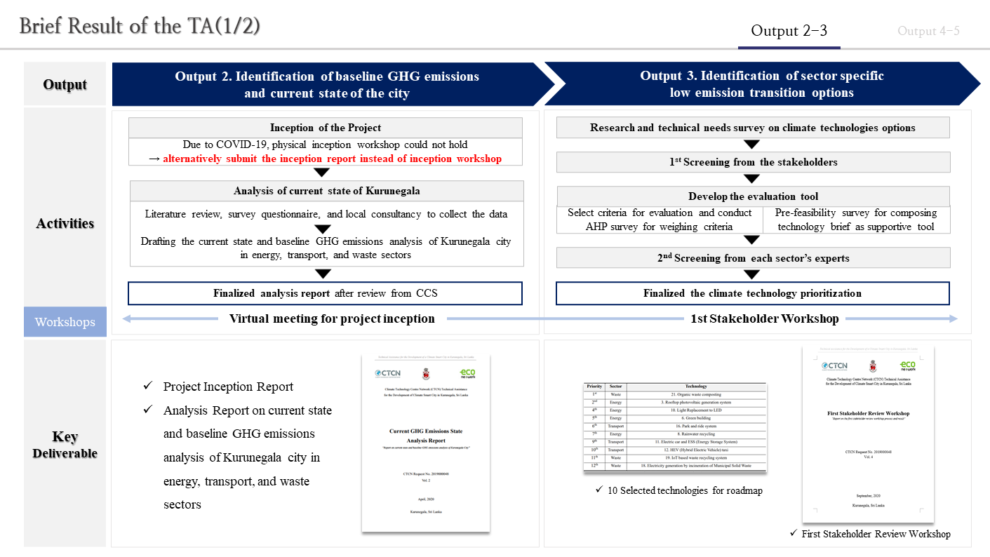

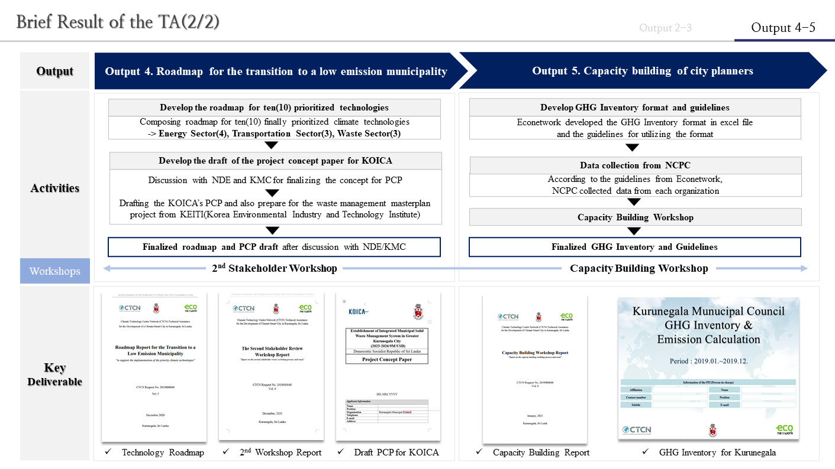

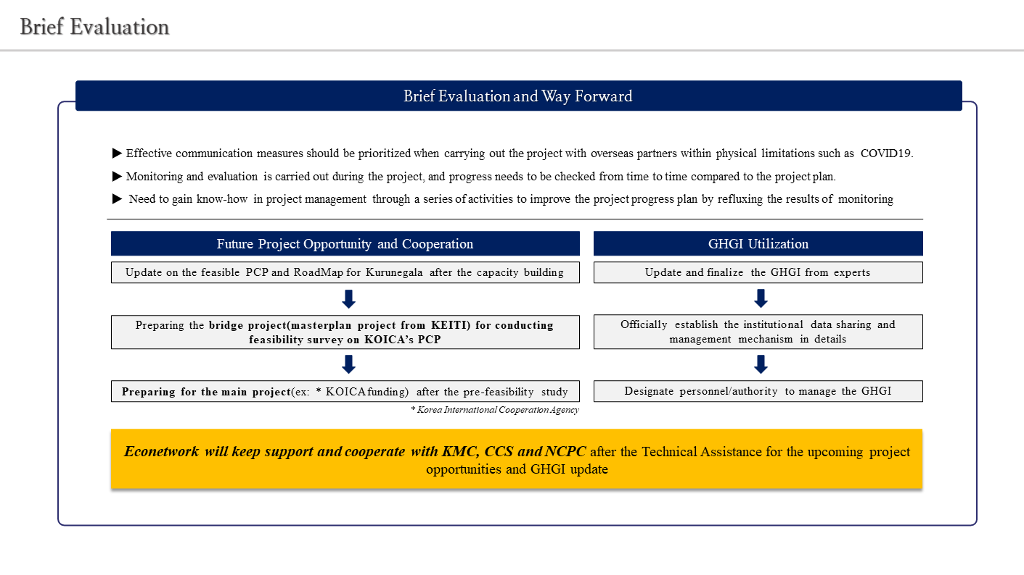

3-2. Photos of the TA

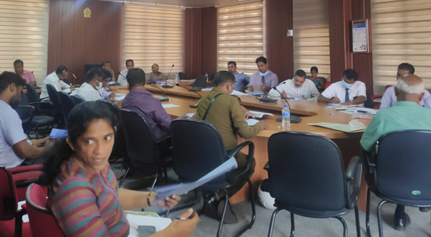
[Discussion session on the 1st screened technologies at 1st Stakeholder Review Workshop]
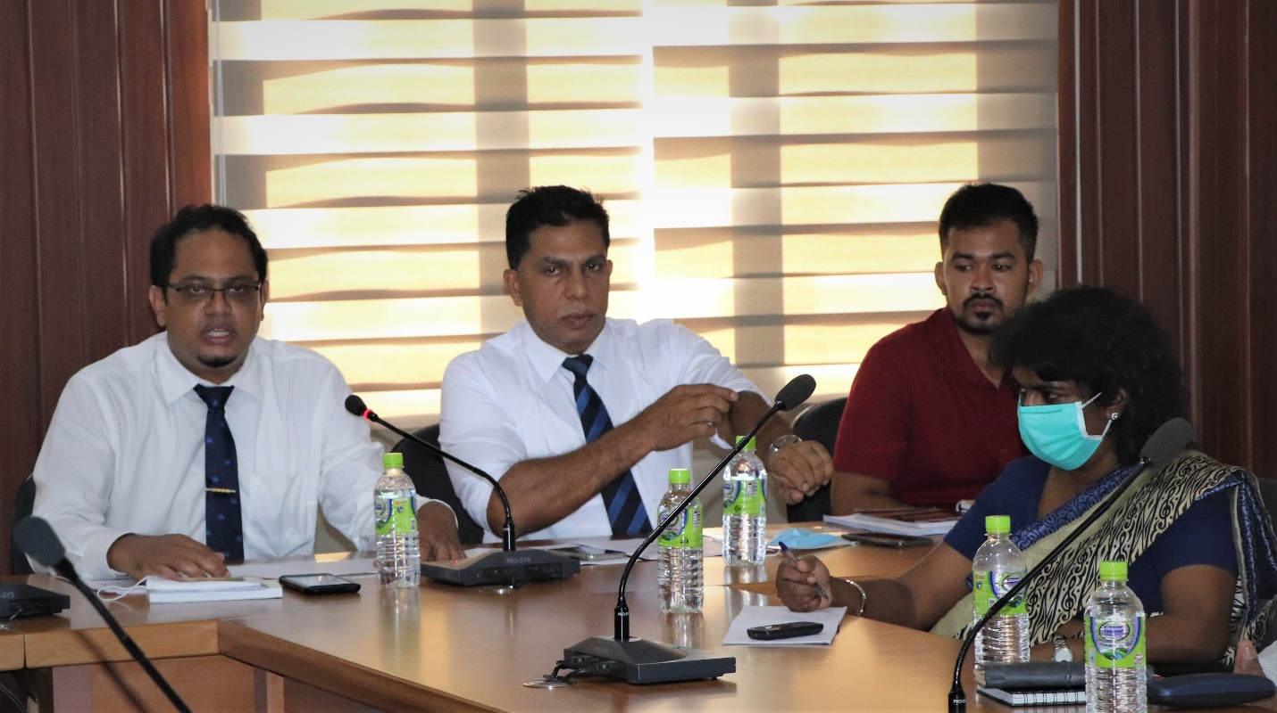
[Deputy Commissioner of KMC's welcome speech at 2nd stakeholder review workshop]
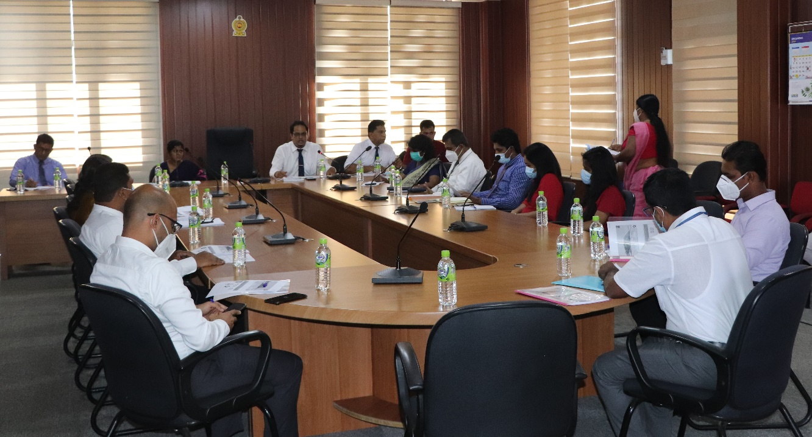
[Discussion session on GHG data gap at capacity building workshop]
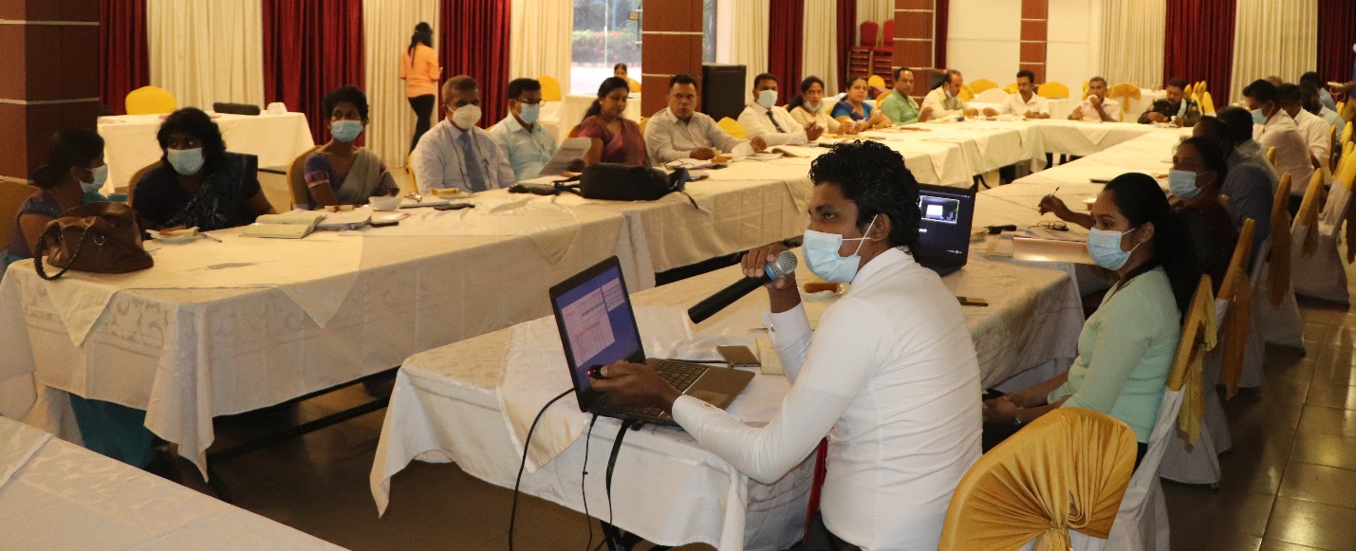
[Finalized GHG Inventory Introduction at capacity building workshop]
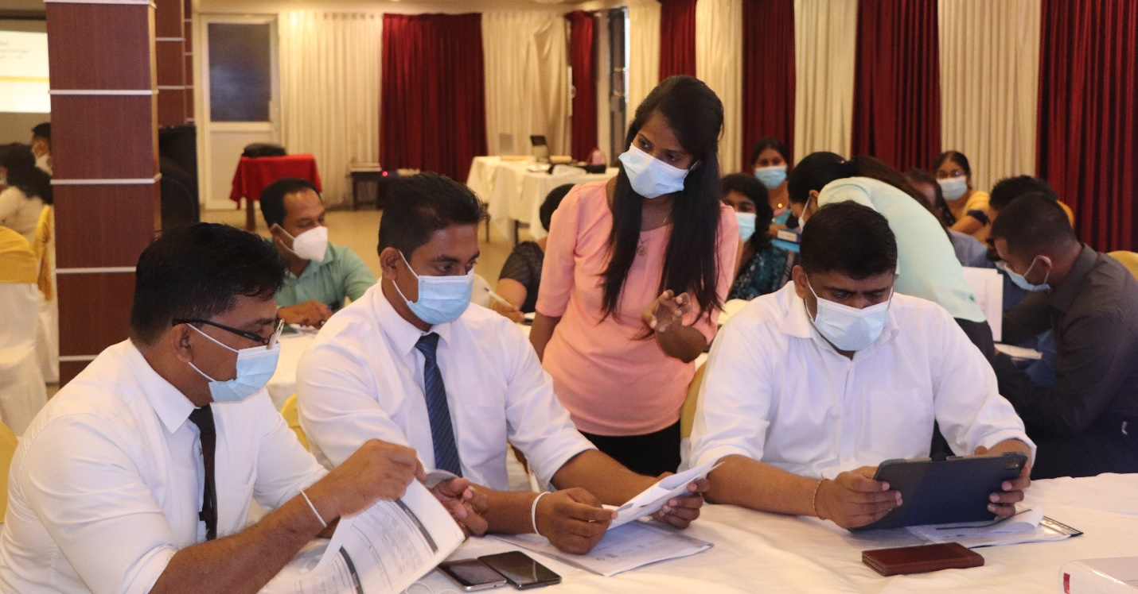
[Capacity building session for waste sector at capacity building workshop]

4. Impact Statement
The information in the table below will be used to communicate results and anticipated impacts of this technical assistance publicly. Please copy information from impact statement developed in the M&E Plan and update as relevant.

Challenge | Kurunegala City located in the North Western Province of Sri Lanka, is one of the most intensively developing economic and administrative capitals. The main highways pass through a centre of city and it is connected to main cities. The geographical characteristic of the city and the condition of the road cause severe traffic congestion and the growing population leads the increase of energy consumption and generation of waste.  The project develops a roadmap to transform Kurunegala city to climate smart city with mitigating greenhouse gases in energy, transport and waste sectors.
CTCN Assistance | - Analysing current state and baseline GHG emissions of Kurunegala city in energy, transport and waste sectors (hereinafter the sectors considered are specified in energy, transport and waste area),  - Identifying list of low emission technologies for 3 sectors  - Developing the roadmap including a low emission technology for each sector  - Building the capacity of city planners and policy makers in order to guide on how to transform Kurunegala city into a low GHG emission city  - Developing GHG Inventory for Kurunegala
Anticipated impact | - Incorporating climate resilient aspects and low carbon technologies into city development plans  - Beneficiaries are people living within the KMC boundary  - Guiding policy makers and urban planners to make critical decisions on investing and implementing projects to cope with climate change
Co-benefits: Achieved or anticipated  co-benefits from the TA | Community Benefits  - Enhancing resilient capability of the city for climate change  - Mainstreaming climate change aspects into provincial agenda  Environmental Benefits  - Improvement of air quality  - Reduction of GHG emissions  Financial Benefits  - Development of the concept note of climate project supported by international financial organization  - Increase of job opening to carry out the climate project
Gender aspects of the TA | Gender expert has involved in the design of the survey and incorporating the survey result into the final roadmap. The survey was focused on the female human resources working on environment and training opportunities in the key stakeholder organization.  After the result of the survey and literature review, the project implementer has recommended to train and employ certain percentage of female officials/employee as mandatory so that gender aspects to be mainstreamed in the further project and policy making.
Anticipated contribution to NDC | This assistance supports Sri Lanka’s Nationally Determined Contribution to;  - Accomplish the Sri Lanka’s objectives of advancing mitigation in energy, transport and waste sectors by establishing a roadmap to reduce GHG emissions in Kurunegala city  - Strengthen the capability of city planners and policy makers for coping with the climate change
The narrative story | As an intersection of the south and the north districts of Sri Lanka, Kurunegala city (capital city of Kurunegala district with a population of more than 40 thousand) has a potential to become a major city (Greater Kurunegala). The annual average population growth rate of 4 per cent and an increasing demand for skilled labor and transportation facilities display the dynamic economic activities of the city. The increasing economic activities together with the high population density (3,000/km²), on the other hand, have caused social and environmental problems such as air pollution and issues with water management. Against this context, the city established the Development Plan for Urban Development Area of Kurunegala Town Development Plan 2019-2030.  Therefore, the Kurunegala Municipal Council (KMC) has the responsibility to develop and implement an appropriate urban action plan focusing on climate mitigation. For this purpose, the KMC requested CTCN to provide technical assistance in developing the pathway for the transition to a low-emission municipality.  Therefore, the project implementer has contributed to draw out the short-list of plausible climate technologies in energy, transport, and waste sectors for KMC and roadmap, inventory development. After the technical consulting, KMC, CCS, NCPC(the local consultancy), and the project implementer have identified that the most plausible technology to be introduced in KMC is waste management(composting, WtE, and waste collection and segregation).
Contribution to SDGs | - SDG 11  The CTCN TA will develop an urban low emission transition plan for Kurunegala city.  - SDG 13.2  The purpose of this CTCN TA is to integrate the result of the assessment into the local urban development plan.  - SDG 13.b  Identified result from the assessment will encourage the local government to establish an urban action plan with consideration for gender issues.

Annex 1 Technical assistance data collection

Please add quantitative and qualitative values for the indicators selected in the M&E plan and monitored throughout the technical assistance in the tables below. Indicators which have been monitored in addition to the proposed indicators below may be added at the end of table A. Non-relevant indicators should be left blank.

- Output and outcome indicators

Indicator  Please note indicators below highlighted as anticipated | Quantitative value  Value and unit | Qualitative description  List the various elements corresponding to the quantitative value as well as timelines and responsible institutions
Number of communication and outreach activities conducted by proponents and implementing partners to showcase CTCN support | 12 | Events (titles): Stakeholder review workshop(2), Capacity building workshop(1)  News release: 0  Newsletter: Local agency(NCPC) Newsletter(1)  Articles:0  Presentations on the results of the TA: 0  Social media postings: NCPC Facebook(3)  NCPC Linked-in(3)  Etc.
Number of participants in the events above | 95
- Number of men | 74
- Number of women | 21
Number of training sessions and capacity strengthening activities | 1 | Capacity building workshop on how to maintain the GHG inventory and implement climate technologies for Kurunegala
Number of people who received the training | 35
- Number of men | 26
- Number of women | 9
Total number of institutions trained | 16
- Number of research organisations, laboratories and universities
- Number of private companies
- Number of cities and local government | 1 | Kurunegala Municipal Council
- Number of communities
- Number of ministries | 2 | ▪ Ministry of Health  ▪ Climate Change Secretariat of Ministry of Environment
- Number of specialised governmental institutions | 12 | ▪ Central Environment Authority  ▪ Provincial Environment Authority  ▪ Road Department Authority  ▪ Urban Department Authority  ▪ Greater Kurunegala-Water  ▪ Supply Survey Department  ▪ Plantation company  ▪ Road Passenger Transport Authority  ▪ Department of Motor Traffic  ▪ Department of Railway  ▪ Ceypetco  ▪ Department of Agriculture
- Number of non-profit organisations | 1 | NCPC Sri Lanka
Percentage of participants reporting satisfaction with CTCN training (from CTCN training feedback form)
Percentage of participants reporting increased knowledge, capacity and/or understanding as a result of CTCN training (from CTCN training feedback form)
- Number of men
- Number of women
Total number of deliverables produced during the assistance (excluding mission, progress and internal reports) | 2
- Number of tools and technical documents strengthened, revised or developed | 1 | GHG Inventory Sheet for Kurunegala
- Number of other information materials strengthened, revised or created (For example training and workshop reports, Power Points, exercise docs etc.) | 1 | Guidelines for GHG Inventory of Kurunegala
Total number of policies, strategies, plans, laws, agreements or regulations supported by the assistance
- Adaptation related
- Mitigation related
- Both adaptation- and mitigation related
Anticipated number of policies, strategies, plans, laws, agreements or regulations proposed, adopted or implemented as a result of the TA | 2 | KMC level waste management , solar power bylaws and regulation, incorporating the results into city development plan
- Adaptation related
- Mitigation related | 2 | KMC level waste management bylaws and regulation, incorporating the results into city development plan; solar street lighting programmes
- Both adaptation- and mitigation related
Anticipated number of technologies transferred or deployed as a result of CTCN support | 1 | Solid Waste Sector, Municipal solid waste (The project implementer resulted Project Concept Paper for KOICA as a deliverable)
Number of South-South collaborations enabled during or through CTCN TA support
Number of climate technology RD&D related outreach activities
Number of participants in climate technology RD&D related workshops and events
- Number of men
- Number of women
Anticipated number of cooperative research, development, and demonstration programmes facilitated as a result of CTCN TA
Number of countries with strengthened National System of Innovation as a result of CTCN support | 1 | Sri Lanka
Number of organisations engaged through CTCN support | 3 | Climate Change Secretariat of Ministry of Environment  (Sri Lanka),  National Cleaner Production Centre Sri Lanka(Local Consultancy), Kurunegala Municipal Council
Insert any additional indicators here

- Core impact indicators

Core indicator 2 | Anticipated increased economic, health, well-being, infrastructure and built environment, and ecosystems resilience to climate change impacts as a result of technical assistance  Please provide a qualitative description of the anticipated impacts on the categories below
Infrastructure and built environment  Anticipated increased infrastructure resilience (avoided/mitigated climate induced damages and strengthened physical assets) | It is expected to build piloted waste management facility (not decided yet) in Kurunegala after the submission of the Project Concept Paper for KOICA in this November to efficiently manage the waste generation and collection to mitigate the greenhouse gas generation from the waste sector.  Also, KMC will review the most plausible climate technologies' current status of infrastructure readiness to cope with the population and economic growth in line with Kurunegala Town Development Plan (2019-2030).
Economic  Anticipated increased economic resilience (e.g. less reliance on vulnerable economic sectors or diversification of livelihood) | Once the KMC adopts the feasible climate technology based on the roadmap, this will contribute to the job creation and improvement of access to energy or transport sector by engaging more citizens to the basic infrastructure.
Health and wellbeing  Anticipated increased health and wellbeing of target group (e.g. improved basic health, water and food security) | As a result of technical assistance, it will bring the improvement of public health and wellbeing in terms of mitigating the greenhouse gas, air pollution and decent waste management which can reduce the possibility of epidemics or disease from the open dumping, open burning, water and soil pollution poorly controlled waste collection and management.

Core indicator 3 | Anticipated number of direct and indirect beneficiaries as a result of the TA
 | Direct beneficiaries | Indirect beneficiaries | Means of verification
Adaptation related | - | -
Mitigation related | 25,987 | 180,399 | As a result of the TA, roadmap for the plausible climate technology has been made, and the training, and workshops were conducted to enhance the understanding of the stakeholders. Therefore, from the direct impact of the TA, it is expected to benefit 25,987 population within the administrative area of Kurunegala Municipal Council, and including indirect beneficiaries, it is expected to impact on total 180,399 population, residents in Kurunegala District boundary.
Both adaptation-and mitigation related | - | -

Annex 2 (for internal use – to be filled in by the CTCN)
CTCN evaluation
This section will be completed by the relevant CTCN Technology Manager.

- Evaluation of the timeliness of the TA implementation as measured against the timeline included in the response plan;
- Evaluation of TA quality as defined in the response plan;
- Overall performance of the Implementers;
- Overall engagement of the NDE and Proponent;
- Lessons learned on the CTCN process and steps taken by the CTCN to improve.

