

Cost-benefit Assessment of Mitigation Options in
Rice Production: Data compilation, tools and training
within the Vietnamese context
(IRRI Ref. No.A-2018-162)

First Progress Report

submitted to the

United Nations Industrial Development Organization - Vietnam

January 2020

Contact:
Alvin Poncin
Head, Portfolio Management Office
Telephone: +63 (2) 8580-5600; Fax: +63 (2) 8580-5699
E-mail address: ipmo@irri.org Mailing address: DAPO Box 7777, Metro Manila, Philippines
Courier address: 10th Floor, Suite 1009, Security Bank Center, 6776 Ayala Avenue, Makati City 1226



First Progress Report of TA:
Cost-benefit Assessment of Mitigation Options in Rice Production: Data compilation, tools and training within the Vietnamese context (CBA-Rice)
CTCN ref. 2016000061

Submitted by
R. Wassmann, International Rice Research Institute
With contributions by UNIQUE

Jan, 2019

Deliverables due in the First Progress Report (Jan. 2019):

LIST OF ATTACHMENTS:
#1 Program of inception and consultation workshop
#2 Minutes, List of Participants and Photos of inception and consultation workshop
#3 (as separate PDF) : User Manual: Cost-Benefit Assessment of GHG Mitigation in Rice Production based on Suitability Mapping of Alternate Wetting and Drying

D 2.1 / D 3.1
Inception and consultation workshop for at least 50 national participants

The inception and consultation workshop has been held in Hanoi on 26 Sept. 2019 with the program shown in Attachment #1. The workshop was organized by IRRI and the requesting Vietnamese Institution (Institute of Policy and Strategy for Agriculture and Rural Development (IPSARD). Support from (CTCN) has been acknowledged including the reading out of a welcome message submitted by Ms. Webbe. As can be seen in the attached list of participants (Attachment #2), the workshop was attended by more than 50 participants from the 23 relevant sectors attended the workshop, such as officials from the Minister of Agriculture and Rural Development (MARD) and attached agencies, experts from international and local research institutes, representatives from various local governments, universities and a private company. The project team was presented by staff members from IRRI (R. Wassmann, B.O. Sander, B. Yen) and UNIQUE (P. Kadgi) as well as national consultants (V.M. Trinh, N.L.D. Tran).
The principal messages coming out of this workshop have been reported in the minutes (Attachment #2) and have been synthetized in a press release that is shown as screen shot in Figure 1. Thus, we limit this report on individual aspects of the workshop outcome that are of direct relevance for the forthcoming activities in the TA. After initial presentations on the policy and technology background of the TA. the audience split into two groups that discussed the following guiding questions:
1. What are key mitigation options identified in the NDC/Planning frame work of crop production sector -- specifically in rice production?
2. Are there any CBAs on mitigation in rice production that have been conducted already?
3. What are challenges/gaps for planning and implementation of mitigation from the perspectives of end-users?
4. What need to be included in the online CBA tool being developed by TA in order to best address problems faced in selecting and implementing mitigation options?
5. What do you consider as the preferred scale for CBA – commune, district, province or country?
6. How can this tool contribute to better selection of mitigation options being included in NDC?
This format of group meeting has been chosen to allow feedback from a broad range of participants – and has served very well given this purpose. By the same token, the availability of simultaneous translation also facilitated very interactive discussions throughout the workshop. The two groups had very vivid discussions on these issues and presented these outputs to the audience in the wrap-up meeting (see details in the minutes).
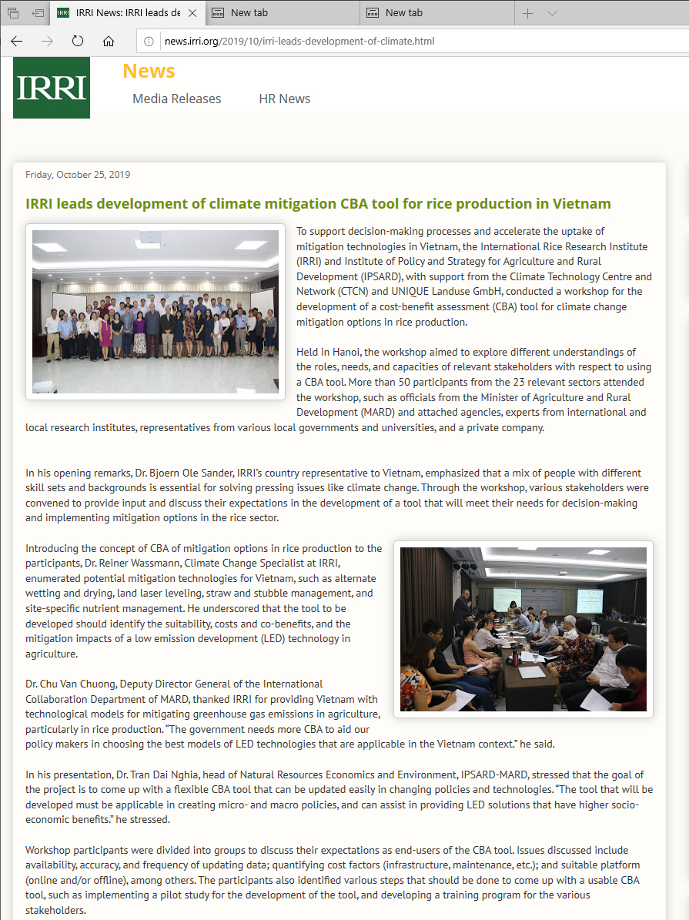
Figure 1: Press release on the inception workshop

Both working groups have stressed the need for providing a user-friendly tool with clearly defined target groups and scales. Thus, it was concluded that the development of the cost-benefit tool should be conducted in a bottom-up approach, i.e. targeting one of the main rice growing provinces in one case study, instead of an abstract consideration of the country as a whole. It should be noted, however, that this specification in the tool development does not divert from the objectives of the TA. Irrespective of the selected case study for the development, the tool as such will be generic in nature – at least within the national context of Vietnam -- and can be applied in other provinces as well.
The participants arrived at a broad consensus that the tool development should focus on a province in the Mekong Delta, namely An Giang province. This also implies that the target group for the 2nd workshop (validation workshop, Del. 2.4/ 3.2) will consist of stakeholders from the Mekong Delta and that the venue will be also be in this region.
UNIQUE has reviewed existing CBA tools in terms of their applicability for rice mitigation in Vietnam. There are many excellent tools available, however, none that fits the specifications of this particular project in terms of linking economic outcomes with carbon effectiveness, and simulataneously being easily accessible for non-experts. The full report is provided in Annex 1.

D 2.2. List and descriptions of mitigation options to be included in the tool

Online resources used:
http://ricestat.irri.org/fhsd/php/survey.php#
http://www.knowledgebank.irri.org/decision-tools

Literature used:
- Ryan R.Romasanta Bjoern OleSander Yam Kanta Gaihrea Ma. Carmelita Alberto Martin Gummert James Quilty Van Hung Nguyen Angeli Grace Castalone Carlito Balingbing Joseph Sandro Teodoro Correa Jr Reiner Wassmann How does burning of rice straw affect CH4 and N2O emissions? A comparative experiment of different on-field straw management practices International Rice Research Institute (IRRI), Los Baños, Philippines Karlsruhe Institute of Technology, Institute for Meteorology and Climate Research, Garmisch-Partenkirchen, Germany International Fertilizer Development Center, Dhaka, Bangladesh1 Received 12 August 2016, Revised 28 December 2016, Accepted 30 December 2016, Available online 24 January 2017. Agriculture, Ecosystems & Environment Volume 239, 15 February 2017, Pages 143-153
- Chivenge, Pauline & Rubianes, Francis & Chin, Duong & Thach, Tran & Khang, Vu & Romasanta, Ryan & Nguyen, V Hung & Van Trinh, Mai. (2020). Rice Straw Incorporation Influences Nutrient Cycling and Soil Organic Matter. 10.1007/978-3-030-32373-8_8.
- Arai, Hironori & hongvan, nguyen & nga, truong & hosen, yasukazu & chiem, nguyen & inubushi, kazuyuki. (2014). Rice Straw Management by Farmers in a Triple Rice Production System in the Mekong Delta, Viet Nam. Tropical agriculture and development. 58. 155-162. The Impact of AWD on rice productivity and profitability in ZIS, Hubei, China (2000) Wuhan University
- R. Wassmann, R. Pasco, J. Zerrudo, D. M. Ngo, T. B. T. Vo & B. O. Sander Introducing a new tool for greenhouse gas calculation tailored for cropland: rationale, operational framework and potential application 2019
- Reiner Wasserman, Bjoern Ole Sander, Sudhir Yadav. Alternate Wetting and Drying information paper -
- Allen JM, Sander BO. 2019. The Diverse Benefits of Alternate Wetting and Drying (AWD). Los Baños, Philippines: International Rice Research Institute. Available online at: www.ccafs.cgiar.org.
- Bui Tan Yen, Reiner Wassmann and Bjoern Ole Sander Information note elaborating on a study of the International Rice Research Institute (IRRI) conducted by Vo et al. (2018)
- Bordey FH, Moya PF, Beltran JC, Dawe DC, editors. 2016. Competitiveness of Philippine Rice in Asia. Science City of Muñoz (Philippines): Philippine Rice Research Institute and Manila (Philippines): International Rice Research Institute. 172 p.
- Escobar Carbonari D, Grosjean G, Läderach P, Nghia TD, Sander BO, McKinley J, Sebastian L and Tapasco J (2019) Reviewing Vietnam’s Nationally Determined Contribution: A New Perspective Using the Marginal Cost of Abatement. Front. Sustain. Food Syst. 3:14. doi: 10.3389/fsufs.2019.00014
- Climate change mitigation potential of agricultural practices supported by IFAD investments An ex ante analysis by Meryl Richards Aslihan Arslan Romina Cavatassi Todd Rosenstock FAO 2019
- Practise Brief Climate Smart Agriculture: Alternate wetting and drying in irrigated rice Implementation guidance for policymakers and investors Meryl Richards, B. Ole Sander April 2014

Mitigation options to be included in the tool
The potential mitigation options from Vietnamese rice cultivation have been previously presented and discussed in several documents including published literature. The selection of the four mitigation options shown below (and already mentioned in our offer) only reflects the broad consensus among international and national experts. While our web-site on GHG mitigation in rice (GHGmitigation.irri.org) lists a total of 13 technologies, the other nine mitigation technologies have not explicitly been mentioned in this report because
- Technical overlaps with the four technologies mentioned (e.g. the ‘1 Must Do – 5 Reduction’ technology encompasses Alternate Wetting and Drying as well as Site-specific Nutrient Management
- Lack of available machinery at present, e.g. for Land Laser Leveling
- Only low relevance in the context of CBA, e.g. reducing emissions from mills and drying facilities will require high investments that are outside of the scope of this TA
- Irrelevance for the Vietnamese NDC which in its tentative version only includes AWD, mid-season drainage, residue and fertilizer management.
Thus, the focus on these four technologies stems from pragmatic reasons regarding the size of the TA and is also efficiency-oriented to maximize outputs under given resources.

Alternate Wetting and Drying has originally been developed as water saving technology. While irrigation can be reduced by 30%, this technology also reduces emissions of the GHG methane by 30-70% (nitrous oxide emissions may be higher, but do not trade-off methane savings). From a farmers’ perspective, water saving may in some cases be an incentive for AWD adoption whereas in other cases, mainly when irrigation water is free, this incentive is rather negligible. Moreover, the suitability of AWD largely varies in space and time, so that suitability of this technology can best be assessed through GIS technology.
Mid season drainage is similar to Alternate Wetting and Drying however it only involves one mid season drainage of the rice field as opposed to multiple drainages over the course of a season. Savings from water use can be as high as 10%, although there is an increased risk of crop issues and there may also be increased monitoring costs associated with this method of production. GHG emissions are expected to be reduced by up to 30% from using this technique.
Site-specific Nutrient Management is based on splitting fertilizer applications to meet their actual demand by the rice plant. This approach can reduce fertilizer rates by 10 -30% without affecting yields. In turn, this form of management entails on-site and off-site mitigation, namely lower nitrous oxide emissions from the rice field as well as avoided carbon dioxide emissions for fertilizer production.
Straw management in Vietnam typically consists of open field burning. While the burning process creates considerable air pollution, it also emits the GHGs methane and nitrous oxide due to incomplete combustion. On the other hand, methane emissions are even higher when straw is incorporated into flooded soils. Alternatively, straw can be removed and used for energy or other options, by the hurdle for this is the laborious collection of the straw. Ongoing mechanization trends may in the future lead to baling of straw that will accelerate alternative uses and GHG mitigation.

D 2.3
List and descriptions of use cases for the tool

Through stakeholder consultations, several types of users and use cases were defined. The main users will be agencies acting at the national level, namely under the Ministry of Agriculture and Rural Development. The Department of Science, Technology and Environment (DoSTE) and the Institute of Policy and Strategy for Agriculture and Rural Development under MARD lead the development and formulation of Vietnam’s NDC in the agriculture sector. Both institutions are directly involved in the development of the tool and have necessary capacity for effective use. On subnational level, provincial agencies in the Mekong Delta the main rice-growing region of Vietnam, are the intended users. In most cases this will be the Department of Agriculture and Rural Development (DARD) who are also under the administrative umbrella of MARD.
A real world use case scenario is defined below to demonstrate the roles of the different users throughout the process of data input, maintenance, and output. This shows the intended contributions and uses of the tool as defined by the user groups to highlight the logical flow of the tool use in action.

Use case scenario: CBA tool
Actors:
- MARD (budget allocation and oversight)
  - IPSARD (strategy and policy)
  - DoSTE (NDC)
- DARD (budget allocation for technical capacity)
- IRRI technical assistance
Logical Flow:
- The user (at province level this is DARD and at national level IPSARD) will input production cost data (or may use default settings) under different production scenarios with a target project area defined. The project scenarios can include any of the 4 individual emission practices or combinations representing local ag improvement packages that have been defined according to the Vietnamese context by stakeholders. These include AWD, mid-season drainage, straw management, and fertilizer management, in addition to local ag improvement packages such as ‘1Must Do, 5 Reductions’; SRP; SRI.
- Landscape scale estimations are produced by the CBA tool and organized on a regional or national scale as appropriate.
- DoSTE receives GHG information and landscape scale cost-benefit analysis (CBA) for use in making decisions on NDC’s and reporting progress.
- Regional goals are defined by provincial DARD units and monitored through local reporting structure and area-based defined project focus for maximum economic efficiency and mitigation benefit.
- GIS database connected to provincial level data reporting is maintained at the province level by DARD and across provinces at the national level with input from IPSARD and DoSTE.
- Suitability maps and landscape scale CBA used to define capacity needs for mobilizing monetary and technical resources at provincial level.
- MARD allocates resources to DARD on a needs-basis identified through the tool.
- DARD allocates financial resources for capacity building (e.g., training, irrigation service provider, farmer decision-support tools, and infrastructure).
- GHG estimations are calculated and reported through DoSTE for NDCs.
Basic capacity in terms of hardware and software exists. The IRRI office is currently strengthening the GIS capacity of several provincial DARD’s in the Mekong delta and pilots an MRV system.

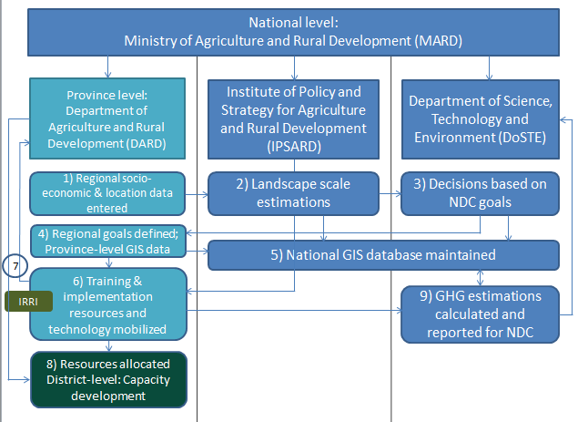

The discussion with stakeholders during the kick-off workshop made it clear that the CBA tool initially represented a rather abstract concept to the national partners. Thus, the TA-team and the national partners agreed that the tool should first be developed and piloted through one regional study, namely one province in the Mekong Delta, An Giang. This will allow intensive interaction with local stakeholders and thus, ensure the future usability of the tool at province scale. A point person from the DARD in An Giang has been identified and will collate feedback from province officials. At the province level the basic capacity in terms of hardware and software exists and experts from IRRI are providing training and strengthening the GIS capacity of several provincial DARD’s in the Mekong delta.

The drafted tool that has been submitted takes into account the local country context through the addition of individual mitigation practices that align with the NDC actions for agriculture. Additional contextualization takes into account local agriculture improvement packages that are promoted by the Vietnamese government. These packages include ‘1 Must Do, 5 Reductions’ which is a recommendation of good agricultural practices including the use of certified seeds, and the reduction of seed rate, water, fertilizer, pesticide, and post-harvest losses. This package has been adapted into ‘1 Must Do, 6 Reductions’ to highlight GHG emissions with the inclusion of the 6th reduction being greenhouse gas emissions. This brings into focus that the GHG mitigation is a direct result of practicing the ‘1 Must Do, 5 Reductions’ recommendations and also shows the government commitment to reducing GHG emissions in rice production. The other packages for local good agricultural practices that the tool has been customized to include are the System of Rice Intensification (SRI) and the Sustainable Rice Platform (SRP) standard which has a more holistic approach to sustainability including agronomic, economic, and ethical standards.

This Cost Benefit Analysis Tool is designed to assist with understanding the implications of different mitigation options and identify suitable rice production areas for select climate mitigation options. The targeted users of this tool are Ministry officials looking to define investment portfolios and policies. The tool is designed to show the economic and GHG implications of different planning decisions to assist with designing optimal investment strategies. Intended users have access to and understanding of Microsoft Excel and basic GIS technology; advanced knowledge is not required for either technology.

D 2.4./ D 3.2
Validation workshop, including documentation for at least 50 national participants

The validation workshop has been prepared by the TA-team in Jan./ Febr. 2020 in line with a workshop date right after Tet-holidays at the end of February. Following-up on the agreement reached at the inception workshop, An Giang province in the Mekong Delta was identified as the venue of the validation workshop. By the end of February, however, Vietnam, had already imposed country-wide travel restrictions due to the Corona-crisis. As the TA team is based in Hanoi (and Germany), the implementation of the validation workshop had to be postponed. We are in close contact with our Vietnamese partners to re-schedule the validation workshop and have tentatively set the date to early May. It is understood, however, that the volatile situation in terms of travel conditions will require a re-assessment of this schedule in due time (April).
As specified in the detailed work plan, this workshop was scheduled to be held in February. As the target group comprises stakeholders from the Mekong Delta, the venue will also be in that region. At this point, the preparations are ongoing and the user manual to be used in the workshop is already available in a draft version (Attachment #3). Thus, the project group is in the time line of the activities listed in the detailed workplan (due in Dec. 2019: Act. 3.2. Development of training materials & documentation for the GIS maps & capacity building)
1st (draft) version of training manual will be presented and used at 1st regional training workshop

Attachment #1)
Program of the inception and consultation workshop

Attachment #2)
Minutes, List of Participants and Photos of inception and consultation workshop
of a new Technical Assistance funded by Climate Technology Centre and Network
“Cost-benefit Assessment of Mitigation Options in Rice Production of Vietnam”
Date: 26 Sept
Venue: Adonis Hotel, 55 Quang Trung, Hanoi.
Organizers: Institute of Policy and Strategy for Agriculture and Rural Development and International Rice Research Institute

Welcome speech by Bjoern Ole Sander (IRRI)
- Climate change as a global issue
- Need multi-disciplinary efforts with different skill sets/background to solve pressing issues like climate change
- IRRI-MARD work on profitability, increased resilience and sustainability, work on LED/low emission pathways, mitigation and agriculture
- NDC implementation plan of Vietnam opens opportunities for investment

Opening speech by Dr. Chu Van Chuong (ICD- MARD)
- On behalf of MARD, thanks for supports from CTCN and IRRI
- Vietnam has been very proactive in the global climate actions
- Vietnam committed to reduce 8% of GHG with national effort and 25% of GHG with international support.
- To submit the final NDC and implement the Paris agreement starting from 2020, the government and the private sector need to fulfill the commitments in the agriculture sector
- Rice sector is being transformed towards adaptation and mitigation
- More detailed CBA tool that is applicable for Vietnam context is needed
- IRRI support in the review of the current policy, policy development and implementation
- Highly appreciated IRRI contributions to MARD in over 40 years, especially IRRI support in poverty reduction and rice production. As the result, Vietnam become one of the leading rice exporters in the world
- Rice remains to be the leading crop in Vietnam.
- This is important workshop. The finding and the recommendations from local participants and national/international experts will be helpful to MARD’s policy development, implementation, and realization of NDC targets

Message from CTCN submitted J. Webbe read out by by R. Wassmann

Presentations:
- Rationale of Technical Assistance on CostBenefit Analysis for Mitigation Options in Vietnamese Rice Production by Tran Dai Nghia (IPSARD)
- Introducing the concept of CBA of Mitigation Options in Rice Production by Reiner Wassmann (IRRI)
- Basic outline of a CBA tool by Prashant Kadgi (UNIQUE)
Question and answer:
Tran Dai Nghia (IPSARD)
- There are number of CBA tools developed and applied in different sectors
- What we really need here is the CBA for mitigation options.
- The tool need to be able to estimate marginal values
- The tool is less technical/simple enough so that many people can use
- We expect to have an online tool that can be used by a wide range and different levels of user, e.g. ministry, province and district officials, and public and private sectors.
Tran Thu Ha (SNV)
- Including all 4 practices in the tool is too optimistic
- integrated farm management approach is more effective
- Need to consider who are the users of the CBA: national or local officials

Leocadio Sebastian (CCAFS)
- An important point is that who are the intended users of the CBA tool;
- The is the need to harmonize assumptions and inputs
Nguyen Dieu Trinh (MPI)
- Who are users of the tool? Should not target farmer as a user, even the tool is simplified
- MPI would need to know if different management levels (Ministry, province, district) can use the same platform?
- How to apply rice CBA tool to other crops and commodities, especially in the implementation of NDC; in the identification for the Green Growth program; for comparison with other crops in the NDC?
Phan Sy Hieu (Center of statistics and information, MARD)
- Statistic data of rice production (i.e. rice area by season) is not consistent among sources. Sometime the different was up to 30%, which may lead to poor GHG estimations.
- Need to ensure quality of input data in calculations
Tran Van The (IAE)
- Can’t expect to collect all cost and benefit of a mitigation option. Collecting those data is not viable, especially social benefit, long-term environmental benefit.
- The presentation of Unique mainly focuses on financial aspect.
- If a new mitigation practice is not yet adopted anywhere, how to estimate its cost and benefit?
- How the tool looks at the incremental cost and added benefits of the technology?

Group discussion:
After presentations on The audience has
Guiding questions for group discussions
1. What are key mitigation options identified in the NDC/Planning frame work of crop production sector -- specifically in rice production?
2. Are there any CBAs on mitigation in rice production that have been conducted already?
3. What are challenges/gaps for planning and implementation of mitigation from the perspectives of end-users?
4. What need to be included in the online CBA tool being developed by TA in order to best address problems faced in selecting and implementing mitigation options?
5. What do you consider as the preferred scale for CBA – commune, district, province or country?
6. How can this tool contribute to better selection of mitigation options being included in NDC?

Group 1- summarized by Bui Tan Yen
- GHG options:
- Key mitigation options have been identified in the NDC and the decision 7020 of the government (including 1M5R, AWD, straw management, nitrogen efficiency)
These mitigation options basically correspond to a re-phrasing of the technical concept of the TA. AWD and straw management are explicitly mentioned in the TA offer while achieving ‘nitrogen efficiency’ can best be done SSNM. The acronym 1M5R refers to a Vietnamese technology campaign titled 1 Mus Do – 5 Reductions that encompasses both Alternate Wetting and Drying and Site-specific Nutrient Management
- In the revised NDC document (not approved yet), there are more practices included.
- Existing tool:
- Mostly use MS excel-based and SPSS tool for CBA
- In existing tool, the difficulty is to quantify cost factors (infrastructure, maintenance)
- Hard to estimate social cost, infrastructure (e.g. irrigation, transportation)
- Often estimate cost and benefit for an individual crop but lack of consideration of other crops in the crop-rotation or in a land use type
- Comment: need to break cost and benefit into 2 cases: existing and not-existing infrastructure
- Challenges/gaps:
- Much depend on the decision of policy makers, not only based on output of CBA tool
- Depends also on implementation requirements
- Not applicable to smallholder farmers because small /not significant change in benefits in small scale is not attractive to farmers.
- Online vs offline CBA:
- Not many people need this tool because GHG mitigation is narrow field. So that online tool is not necessary. Offline tool is more useful. However, both online and off-line tool should be developed.
- Need to determine: which management levels/ agencies need an online tool
- There are many places that internet access is still limited. Offline tool is still a solution
- Data/Input considerations: Following input data need to be included:
  - Bio-physical conditions of the field
  - Social condition of farming
- Take into account both quantitative and qualitative indicators (i.e., farming techniques)
- Need to develop guideline for data collection and data preparation
- Specify how much of data as minimum requirement
- Input data should be harmonized at all levels
- Issue on NDC use:
- Provide training for users
- Need to push mechanism, require CBA in any planning process or project development process Regulation for the planning process
- UNIQUE: Aiming at hybrid of online and offline tool; should always be updated all the time

Group 2- summarized by Reiner Wassmann
- Technologies are already identified in the NDC, mentioned in PPT of Dr. Nghia
No need to focus at this point
- Existing experience with CBA tools:
- AgResult, IPSARD have done several CBA
- Few on mitigation
- Difficulty is inaccurate data from farmers
- Data inaccuracy (from farmers)
- Lack of representative samples
- Regional diversity of Vietnam (north, central, south)
- Challenges/gaps
- Rice is not prioritized within NAMA (compared to energy sector)
- Social and environmental impacts; changes in an old practice
- Quantify shadow price
- Data availability (look into existing databases/too; data mining activities); work on existing data
- What should be included:
- Work with different levels/users; different CBA tools
- Focus on 3 levels: Enterprise, Provincial officials, Central government
- Scale of CBA:
- Focus on pilot study;
- Smaller scale to develop a generic tool
- Ranking of 1st criteria of 4 (cost effectiveness) in the NDC; to feed in in future formulation/implementation of NDC

Final list of participants Attachment #1) Program of the inception and consultation workshop
(29 males and 25 females)
# | Gender | Name | Organization | Email
1 | Mr. | Leocadio Sebastian | Regional Program Leader for CCAFS Southeast Asia | l.sebastian@irri.org
2 | Mr. | Eisen Bernardo | CCAFS Communication Specialist | e.bernardo@irri.org
3 | Mr. | Sridhar Gummadi | CCAFS Science officer | sridhar.gummadi@irri.org
4 | Ms. | Đinh Kim Dung | CCAFS, SEA | d.dinh@irri.org
5 | Mr. | Nguyen Chi Kien | CCAFS, SEA
6 | Mr. | Vũ Thanh Biển | Vietnam National University of Agriculture | vtbienqldd@gmail.com
7 | Ms. | Nguyen Phuong Ha | Vietnam National University of Agriculture
8 | Ms. | Trieu Hong Lua | Vietnam National University of Agriculture
9 | Ms. | Ngo Thi Phuong Nga | GIZ
10 | Ms. | Le Bach Yen | GIZ
11 | Ms. | Tran Thu Ha | Team Leader, Ag Results Vietnam Emissions Reduction Pilot – AVERP, SNV Netherlands Development Organisation | htranthu@snv.org
12 | Mr. | Ole Sander | Climate change Specialist, IRRI | b.sander@irri.org
13 | Mr. | Bùi Tân Yên | IRRI-Vietnam office | y.bui@irri.org
14 | Mr. | Reiner Wassman | IRRI-HQ | R.Wassmann@irri.org
15 | Ms. | Katie Nelson | IRRI-Vietnam office | k.nelson@irri.org
16 | Ms. | Vũ Thanh Hà | IRRI-Vietnam office
17 | Ms. | Nguyễn Thị Diệu Trinh | Department of science, education, nature and environment. Ministry of Planning and Investment | trinh4mpi@gmail.com
18 | Mr. | Trịnh Hoàng Dương | Center for Agricultural Meteorology. IMHEN. MONRE | hoangduongktnn@gmail.com
19 | Ms. | Lê Hoàng Anh | Department of Science, Technology and Environment. MARD | lehoanganh06@gmail.com
20 | Ms. | Bùi Mỹ Bình | International Cooperation Dept. MARD | binhbm.htqt@mard.gov.vn
21 | Mr. | Chu Văn Chuông | International Cooperation Dept. MARD | chuonghoa2002@gmail.com
22 | Ms. | Tạ Kim Cúc | Center for Informatics and Statistics - MARD
23 | Mr. | Phan Sỹ Hiếu | Center for Informatics and Statistics - MARD | phansyhieu1975@gmail.com
24 | Ms. | Nguyễn Việt Khoa | National Agriculture Extension Center | vietkhoanaec@gmail.com
25 | Mr. | Trần Đại Nghĩa | Institute for Policy and Strategy for Agriculture and Rural Development | tran.nghiadai99@gmail.com
26 | Ms. | Nguyễn Thị Ánh Tuyết | Institute for Policy and Strategy for Agriculture and Rural Development
27 | Mr. | Đỗ Quang Huy | Institute for Policy and Strategy for Agriculture and Rural Development
28 | Mr. | Phạm Đức Thụ | Soil and fertilizer research institute | phamducthu1978@gmail.com
29 | Mr. | Nguyễn Toàn Thắng | Soil and fertilizer research institute | toanthang3899@gmail.com
30 | Mr. | Đỗ Trọng Thăng | Soil and fertilizer research institute | ddthang86@gmail.com
31 | Ms. | Hoàng Thu Hường | Soil and fertilizer research institute | hoanghuong2609@gmail.com
32 | Ms. | Phùng Thị Mỹ Hạnh | Soil and fertilizer research institute | hanh.mta@gmail.com
33 | Mr. | Lưu Ngọc Quyến | Northern Mountainous Agriculture and Forestry Science Institute | quyengret@yahoo.com
34 | Ms. | Phạm Thị Sến | Northern Mountainous Agriculture and Forestry Science Institute | phamthisenprc@gmail.com
35 | Mr. | Trần Ngọc Thạch | Cuu Long Rice Research Institute | thach69@gmail.com
36 | Mr. | Mai Văn Trịnh | Agricultural Environment Institute | maivantrinh@gmail.com
37 | Mr. | Trần Văn Thể | Agricultural Environment Institute | thevasi02@gmail.com
38 | Ms. | Vũ Thị Hằng | Agricultural Environment Institute | vuhang2288@gmail.com
39 | Mr. | Vũ Dương Quỳnh | Agricultural Environment Institute | vuduongquynh2002@yahoo.com
40 | Mr. | Đỗ Minh Phương | Institute of Planning and Agricultural Design (NIAAP) | dphuong@gmail.com
41 | Mr. | Vũ Công Lân | Center for Sustainable Rural Development (SRD) | vuconglan1306@gmail.com
42 | Mr. | Alex Russel | Center for Sustainable Rural Development (SRD) | alex.russell.au@outlook.com
43 | Ms. | Trần Nhật Lam Duyên | Vietnam National University | trannhatlamduyen@gmail.com
44 | Ms. | Nguyễn Thị Oanh | Vietnam National University | oanhgeo@gmail.com
45 | Ms. | Nông Nguyễn Khánh Ngọc | Vietnam National University | ngocnongnguyen@gmail.com
46 | Mr. | Nguyễn Trọng Vân | Vietnam National University | trongvangeo@gmail.com
47 | Mr. | Max De Antoni Migliorati | QUT University, Autralia | max.deantoni@qut.edu.au
48 | Ms. | Natalie Doran-Browne | QUT University, Autralia | n.doran-browne@unimelb.edu.au
49 | Ms. | Nguyễn Lê Trang | Agricultural Genetics Institute | nguyenletrang87@gmail.com
50 | Ms. | Ngô Hà Châu | Center for International Forestry Research (CIFOR) | hachaungo271@gmail.com
51 | Ms. | Nozomi Kawarazuka | International Potato Center (CIP) | N.Kawarazuka@cgiar.org
52 | Mr. | Eoin O'Dwyer | International Potato Center (CIP) (internship) | eo3650od-s@student.lu.se
53 | Mr. | Nguyen Thai Son | Agri Project Management Board. MARD
54 | Mr. | Prashant Kadgi | Consultant UNIQUR Forestry & Land use | Prashant.Kadgi@unique-landuse.de
Photos:
1) Welcome Message given by Dr. Chu Van Chuong (director of International Cooperation Department- MARD)  2)Photo taken during the presentation by R. Wassmann | 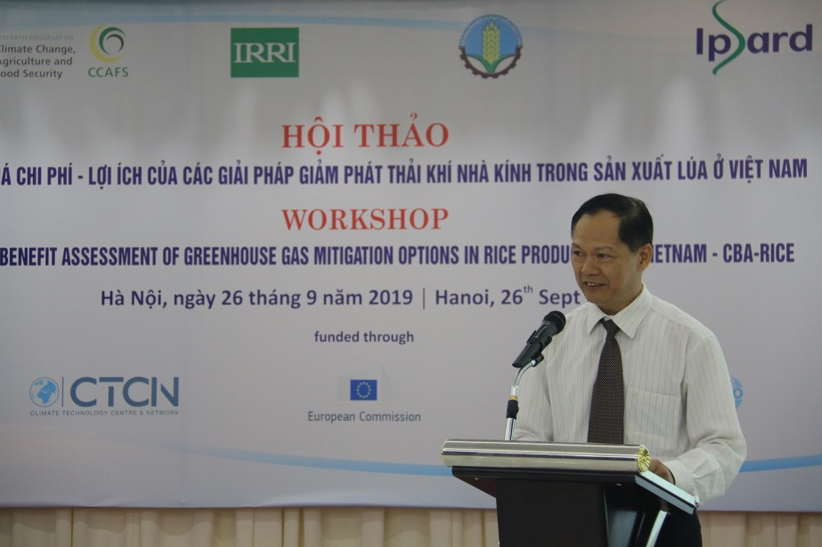

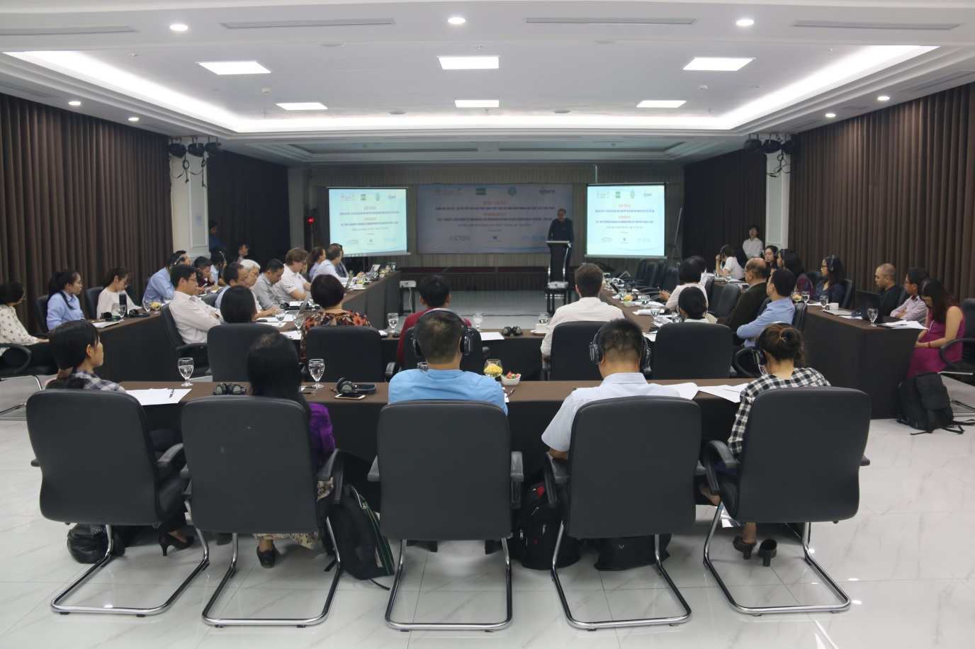

Annex 1: Review of Carbon Calculators

This paper reviews current carbon calculation tools and their suitability for use in the cost benefit analysis of mitigation options for rice production in Vietnam. The models focus mainly on farm level production as opposed to taking a regional perspective. Most of the models reviewed are also specifically designed to calculate GHG emissions and do no generate economic indicators for the costs and benefits of land use change. This paper will review some of the more prominent tools individually including Cool Farm Tool, EX-ACT and CCAFS-MOT. The final section will look at other available tools. Each tool is assessed in terms of usability, data requirements and methodologies.

Cool-Farm Tool
https://coolfarmtool.org

Developed by University of Aberdeen and Cool Farm Alliance members, the Cool Farm Tool (CFT) helps farmers to choose crop and livestock-related management options that will improve their environmental performance in terms of biodiversity, water use and Greenhouse Gases. The CFT can calculate emissions for more than 20 crops and different livestock types around the world, including rice. CFT GHG analysis is generally used for on-farm measures but can be extended to include transport (MacSween, 2018).
A ranking assessment of carbon accounting tools conducted in 2013 found that the Cool Farm Tool was the best tool then available in the public domain (Whittaker, 2013) and the tool continues to be among the most popular tools. The Cool Farm Tool aims to measure GHG emissions from various cropping regimes. It is not region or crop specific, and is aimed at the farm-scale. It is informed by global surveys on current practice and mitigation potential. The aim is to provide decision-making support to farmers: “Cool farm Tool is generally used to the farm gate and not beyond”.
The focus is on GHG mitigation as opposed to assessing the economic impacts at a landscape level. The tool requires around 10-15 minutes of data entry to produce general results, and a further 30-60 minutes to produce a more detailed analysis.
Suitability: This tool has low level resolution for physical parameters and does not produce landscape level economic results. It also does not account for different rice production practices.

EX-ACT Tool
http://www.fao.org/tc/exact/ex-act-home/en/

The Ex-Ante Carbon-balance Tool is an Excel-based appraisal system developed by FAO providing ex-ante estimates of the impact of agriculture, forestry and fishery development projects, programmes and policies on the carbon-balance. It estimates C stock changes and GHG emissions per unit of land. The carbon-balance is defined as the net balance of all greenhouse gasses (GHGs), expressed in carbon dioxide (CO2) equivalents that were emitted or sequestered due to project implementation as compared to a business as-usual scenario.
EX-ACT can be used to examine which project activities will have the greatest benefits economically as well as in terms of climate mitigation. While, it is generally used at project level it can also be scaled up to sector level for policy analysis. The EX-ACT tool uses IPCC Tier 1 default values and/or region specific coefficients (Tier 2). The tool publishes the results in the form of maps, tables and FAO statistical data. There is also space at the end of the spreadsheet that allows the user to undertake additional calculations if required.
The EAXCT tool may be difficult for non-experts with little experience using greenhouse gas accounting tools. Training courses are offered to learn how to use the Tool.
Suitability: This tool can be difficult to use for non experts and does not produce economic indicators at landscape level.

CCAFS Mitigation Options Tool (CCAFS-MOT)
https://ccafs.cgiar.org/mitigation-option-tool-agriculture
The CCAFS-MOT tool estimates greenhouse gas emissions from multiple crops (e.g. barley, maize, sugar cane), crop groups (e.g. vegetables, legumes) and livestock based on data specific to different regions by bringing together several empirical models to estimate GHG emissions. CCAFS-MOT provides policymakers across the globe with the fast, accessible, and reliable information needed to make informed decisions about emissions reductions within agriculture.
The Tool is excel based and can be used on a per-hectare or a regional basis, with low data requirements in comparison to the other tools reviewed here. This tool does not provide economic information and is not easily adaptible for specific local contexts. The model can be set to reflect country and climatic conditions, but not regionally specific conditions (such as rainfall or temperature). The model has a number of basic land use options for rice production but does not offer the ability to adapt these models.
Suitability: This tool does not provide region specific results and does not produce economic indicators at landscape level.

Agriculture and Land Use Greenhouse Gas Inventory (ALU) Software
https://www.nrel.colostate.edu/projects/alusoftware/home/

The ALU software reports GHG emissions from agriculture and other land uses in line with the UNFCCC. The software allows users to estimate GHG levels associated with agricultural and forestry activities, and to identify potential reductions in GHG emissions.
Usability: The ALU download page contains an FAQ section on software use and installation and a 20-minute instructional video. The tool itself is not adjustable by the user and generates an excel printout of the results from the online software. The software aims to to simplify the reporting of GHG emissions to the UNFCCC. Hence, it is not possible for the user to adjust the software for individual projects or specific regional contexts. The aim is not to produce financial results but rather to report GHG emissions in line with UNFCCC standards for areas of different sizes.
The inventory has been divided into three modules, which are accessible from a single page: Module 1: Specify Activity Data (Primary and Secondary Data Specification), Module 2: Specify Emissions/Stock Change Factors, and Module 3: Inventory Calculations. Default IPCC emission factors are provided for use in Module 2, although country specific emission factors can be used if available. This tool is somewhat difficult to access, requiring registration (takes 2-3 days) and the tool is requires significant user input (MacSween, 2018).
Suitability: This tool has little scope for customizing regional environmental conditions and rice production methods. It is not designed to produce economic indicators at the landscape level and there is a cumbersome registration period before it can be used.

Small-Holder Agriculture Monitoring and Baseline Assessment (SHAMBA)
https://shambatool.wordpress.com/outputs/

The SHAMBA is a carbon accounting tool focused on tropical areas. The tool identifies changes in carbon stocks in soil and woody biomass as well as GHG emissions that result from changes in agricultural practices and tree planting. Results can be calculated either annually or over a specific accounting period. The tool creates a baseline scenario based on current land management activities and compares this to an intervention scenario that considers climate smart agriculture (CSA) practices (MacSween, 2018).
Usability: A user guide explains how to install and use the tool. The aim of the tool is to make agricultural and forestry carbon offsetting understandable and profitable for communities. Data requirements include plot location, plot area, tree stocking density, growth rate, and tree mortality. Once this data has been entered, it is combined with existing data in the SHAMBA tool to provide a more detailed and accurate account of a project’s carbon benefits. The user does not require a scientific background or access to scientific literature to use SHAMBA, as the tool contains databases of emission factors, tree allometry, and soil and climate information.
SHAMBA uses the Roth C model for estimating changes in soil carbon stocks resulting from implementation of CSA practices, and IPCC modules for non-CO2 greenhouse gases. The Tool can produce outputs in Excel, R or Python and allows users to model different scenarios at per hectare or at regional levels.
This tool works with several GHG pools, including emissions from burning, organic nitrogen emissions, and nitrogen fertilizer emissions and users are able to enter the data by themselves instead of having to employ specialist consultants. This encourages communities to start their own projects. At present, the tool is not yet suitable for worldwide use and exists as a computer code with a basic user interface (MacSween, 2018).
Suitability: This tool has potential for use in the Vietnamese context but is not currently available in a final format that is suitable for use.

Carbon Benefits Project: Modelling, Measurement and Monitoring (CPB)
http://www.carbonbenefitsproject.org

The CBP tool is an online modelling tool that measures, monitors, models, and forecasts GHG emissions and changes in carbon stocks. The tool produces a standardized system that can be used by the Global Environment Facility (GEF) and other sustainable land management (SLM) projects. The online tool offers three types of assessment: the ‘Simple Assessment’, the ‘Detailed Assessment’, and provides Socio-Economic Tools. In both forms of assessment, results are spatially explicit and can be broken down by land use, land management, soil type, and climate.
The Simple Assessment provides a tool to assess the impact of land management activities on carbon stocks and GHG emissions. This tool is aimed at land management projects involving relatively few changes on a small area or on relatively few combinations of soil type and climate. The Detailed Assessment provides similar outcomes, however it is suitable for detailed reporting where there is a reasonable focus on climate change mitigation and/or multiple land management changes on areas with several combinations of soil type and climate.
The CBP socio-economic component consists of an online Driver-Impact-Response Analysis and the Cost Benefit Analysis. Once the analysis has been completed, the user has the option of generating a report in the form of a graph/chart that is based on the UNFCCC GHG source categories, a summary report, or a detailed report. Both reports can be used to assist CBP tool users, the GEF, and implementing agencies (e.g. World Bank, IFAD, etc.).
Suitability: This tool does not produce economic indicators suitable for Cost Benefit Analysis and does not allow for specification of rice production methods.

Carbon Calculator
The Carbon Calculator is designed for individuals and businesses to calculate their carbon footprint for the purposes of obtaining carbon certification and improving the public image of the firm. This tool is not aimed at agricultural users. https://www.carbonfootprint.com/calculator.aspx

SECTOR tool
http://climatechange.irri.org/sector
SECTOR is a shorthand for “Source-selective and Emission-adjusted GHG CalculaTOR for Cropland”. The tool was developed by IRRI. The current development version is in the form of an Excel spreadsheet file that is fitted with generic formulas and templates that are automatically managed and tailored according to the user's data input specifications.
Suitability: This tool is not designed to generate economic indicators but rather focuses on GHG emissions. The tool can develop scenarios that reflect the rice production scenarios and regional context in Vietnam however it is not designed to produce economic indicators. The carbon savings generated in the current version of the model (16.6.2020), were developed using the SECTOR Tool.

CALM
The CALM Carbon Calculator is no longer in commission – the Country, and Business Association (CLA) recommends the Cool Farm Tool and the Farm Carbon Cutting Toolkit.

Other Tools
There are a number of different Carbon Calculator tools available in the public domain (e.g. the Carbon Footprint Calculator (Carbon footprint.com), WWF carbon Footprint Calculator, Carbon Calculator by Climate Care, Carbon Farming Calculator (Carbon Farming Group) etc. The aim of these tools is to allow people and businesses to determine the amount of carbon that they are currently emitting. They are not designed to assess the GHG or economic implications of land use change.
Finally, the Farm Carbon Calculator, offered by Agritech, is a tool to calculate carbon at the farm level. The tool allows farmers to model different farming techniques or inputs and see the impact on carbon output. This is not a landscape level tool and cannot account for different types of land use over a landscape. Further, the tool does not provide economic results. The tool can be accessed at https://calculator.farmcarbontoolkit.org.uk/.

Other assessments
According to the seminal review of GHG calculators conducted by FAO in 2012, the results provided by the GHG calculators available at that time only included the following:
- GHG/ha
- GHG/product
- GHG/project
- GHG total for farm/territory
Figure 1 Time and knowledge requirements for GHG calculators (2012)
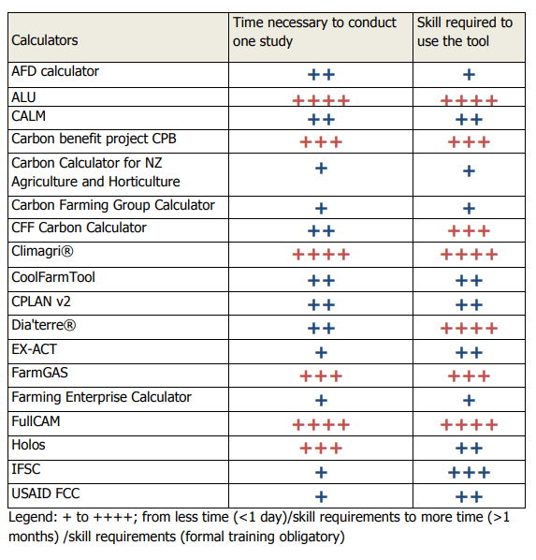
Source: (FAO, 2012)

Figure 2: Data levels
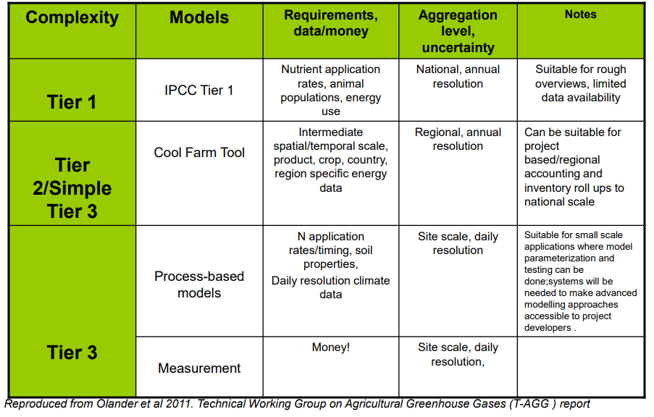

https://www.sciencedirect.com/science/article/abs/pii/S1364815211000892?via%3Dihub
https://coolfarmtool.org/coolfarmtool/frequently-asked-questions/
http://www.fao.org/3/a-i8075e.pdf
https://www.cla.org.uk/site-search?s=CALM Accessed 10.6.2020
https://www.carbonfootprint.com/calculator.aspx

