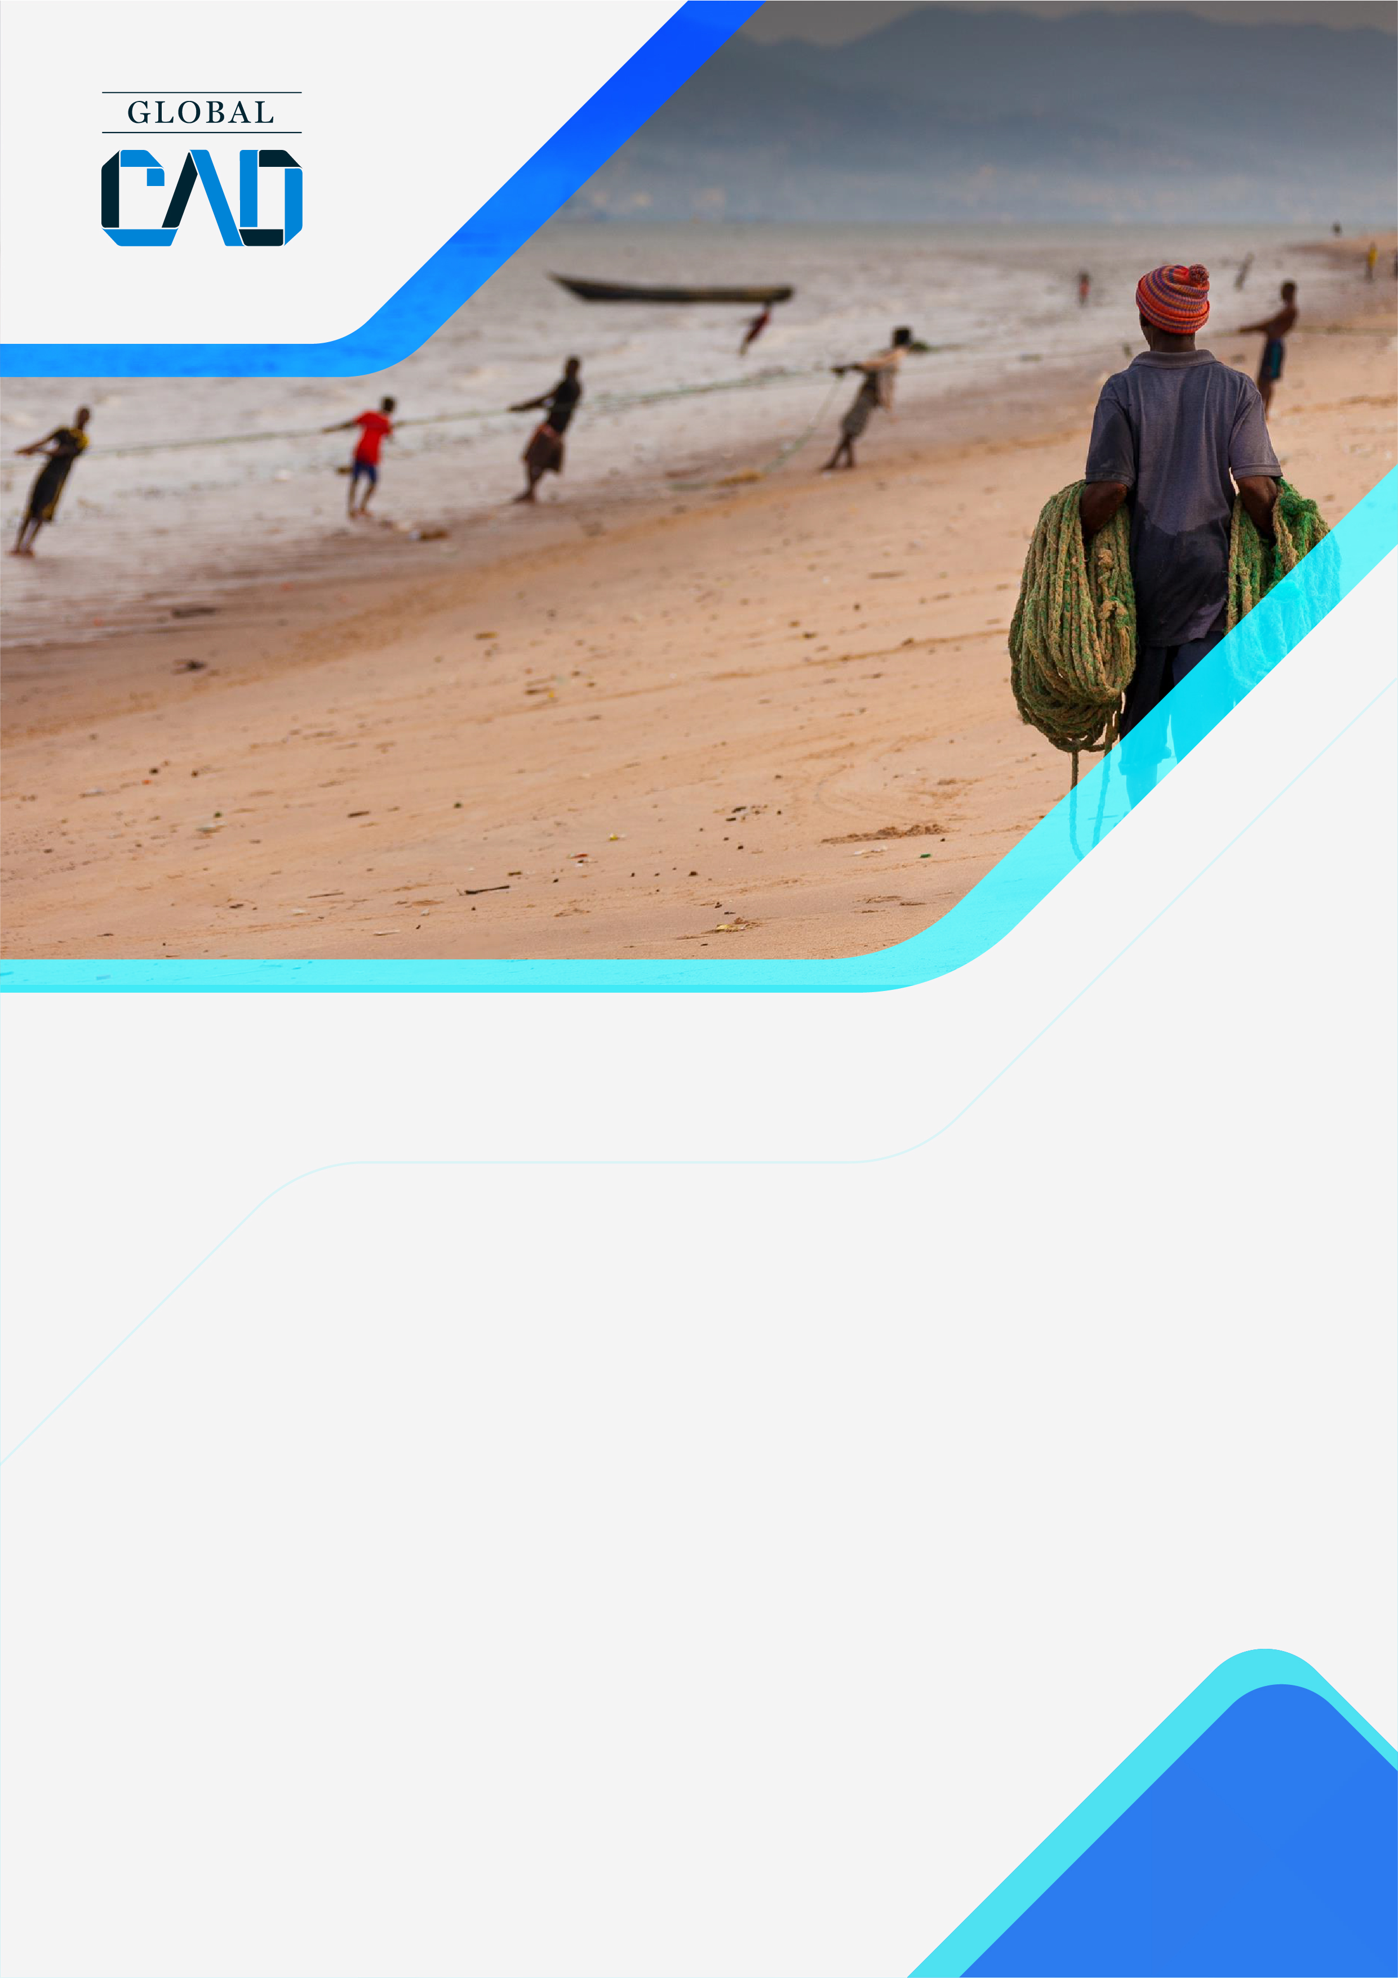
  - 
  - United Nations Industrial Development Organization

06/02/2019

CONTACT:
  - Fernando Casado Cañeque
Director
Fcasado@globalcad.org

Deliverable 1.4.
  - Assessment of Coastal Hazards and Climate Change Adaptation Technologies for the Coastal Region of West Africa and Cameroon Using the Coastal Hazard Wheel (CHW)
globalcad.org
Activity 1.4. Workplan for closure and data collection report (Deliverable D 1.4.)
Based on the monitoring framework elaborated during the inception phase (activity 1.2) the team of consultant will provide a final report presenting the results of the TA. This will be based on a continuous work of monitoring during the project implementation presenting progress from the established baseline. The closure report will provide an assessment of progress and specific recommendations for the future implementation of the CHW in West Africa by the National Antenna of WACOM and Cameroon.

(A) Outputs and Activities as described in the Response Plan |  | (E) Value for Output/Activity produced using the indicator in column C | (F) Difference btw targeted and delivered Output and activity values
Output 1: The consultancy implementation is well planned and it is ensured that all relevant stakeholders are engaged and well informed throughout the different stages of the implementation. | A.1.1: Development of planning and communication documents | 4 reports delivered | 28th February
Output 2: Update with the CHW the National and WACOM Coordination Unit's databases | A2.1 Comprehensive collection, evaluation and analysis of available national and regional data | 2 reports delivered | 30th April
 |  | 1 database delivered | 30th April
 | A2.2. Organize a regional training session for the focal points of the national antennas | 2 Regional Workshops + 11 experts trained | 24th April
 | A2.3. Train the experts of the national antennas and the regional coordination unit of WACOM | 2 Regional Workshops + 135 experts trained | 15h^{th} July
 | A2.4. Update the classification and mapping of coastal risks and adaptation options | 2 reports delivered, 5 coastal mapping updates | 20th September
Output 3: Identify and promote specific adaptation options and technologies most appropriate for coastal risks | A.3.1: Identify, evaluate and formulate a series of recommendations for technological options to be implemented for the sustainable management of the main identified coastal risks | 1 report delivered, 5 to 10 technologies proposed | 20th September
 | A.3.2: Formulate recommendations for a better optimization of the future application of the CHW tool in the context of MOLOA and Cameroon | 1 report delivered | 30th September
 | A.3.3: Organize a final regional workshop for sharing and capitalizing technical assistance | 1 final report and 1 workshop delivered | 15th December

