Regional Disaster Vulnerability Reduction Project, Grenada

Acquisition of Lidar Topography and Aerial Photography Data

Deliverable # 3 – Technical Specifications

Version 1.0

For | Government of Grenada  RDVRP Project Coordination Unit
Author | Stephan Landtwing  Stephan.landtwing@bsf-swissphoto.com  +41 79 585 69 02
Date | November 15, 2016

List of contents

1 Management Summary 3
2 Project Overview 4
2.1 Project Brief 4
2.2 Project Area 5
2.3 Product Summary of Key Deliverables 8
2.4 Project Timeframe 9
2.5 General Project Requirements 10
2.6 Presentation of results 10
3 Data provided by the Government of Grenada 11
4 Specifications for Data Collection 12
4.1 Topographic Lidar 12
4.2 Aerial Imagery 14
4.3 GNSS Base Stations 15
5 Specifications for Deliverables 17
5.1 Lidar Point Cloud 17
5.2 Aerial Imagery 18
5.3 GNSS base station data 19
5.4 Topographic Lidar Derived Data 19
5.5 Combined Lidar/Bathymetry Derived Data 21
5.6 Orthophoto Derived Data 22
5.7 Various Data Supply Specification 24
6 Project Planning and Reporting Specification 25
7 Quality Assurance Specifications and Acceptance Criteria 27
7.1 Topographic Lidar 27
7.2 Aerial Photography and Orthophoto 28
Appendix A – File Naming Conventions 30
Appendix B – Project Area 32
Appendix C - UKHO Bathymetry Project Information 33

Management Summary
The Caribbean Island state of Grenada seeks to update its national geospatial data by procuring Lidar elevation models and color/infrared aerial imagery for the entirety of its 380 km² territory. This document describes the technical specifications for the data capture mission and data deliverables. It outlines the detailed requirements for the expected data quality (accuracy, resolution, completeness, classification etc.), acceptance criteria and reporting standards.
The key requirements are:
- Area of Interest
  - Land mass of the islands of Grenada, Carriacou and Petite Martinique as well as the smaller islands; Total area of 380 km².
- Main products:
  - Topographic Lidar data
  - Aerial color (RGB) photography
  - Aerial near infrared (NIR) photography
- Resolution and accuracy
  - Topographic Lidar: min. 8 points per m², 10 cm vertical RMSE, 20 cm horizontal RMSE
  - Orthophotos: 20 cm GSD, 3 pixel horizontal RMSE
- Deliverables
  - Classified point cloud
  - Interpolated topographic digital surface model (DSM) as 0.5 m grid
  - Interpolated topographic digital terrain model (DTM) as 0.5 m grid
  - DTM contours, 0.5 m interval
  - RGB orthophoto mosaic with 0.2 m resolution
  - Color infrared orthophoto mosaic with 0.2 m resolution
  - DTM adjusted and combined with bathymetry data provided by the Contracting Authority
- Reference systems
  - Delivery system 1: WGS84 datum, ITRF2008 reference frame, UTM Zone 20 North projection, orthometric heights over EGM2008
  - Delivery system 2: Grenada 1953 datum (Clarke 1880 ellipsoid), British West Indies Grid projection (EPSG 2003), orthometric heights over EGM2008.
Precise datum transformation parameters and a detailed geoid model are in the process of being established under a parallel project and will be made available to the Contractor in due time.
  - Measurement unit = meters

Project Overview

Project Brief
The impacts of climate change are already being felt in the Caribbean. The small island economies are highly vulnerable to natural hazards because of their size, geography, and location. Climate shocks represent a dominant factor driving output fluctuations in the region, thus severely affecting development prospects. In the Eastern Caribbean, natural disasters account on average for almost 20 percent of the variance of real GDP growth and the evidence shows that an adverse natural event in one country has a statistically significant spillover effect on neighboring countries in the region.
Given the effects of climate change, exposure to natural hazards is likely to increase in the years to come. If current trends continue, US$350-870 million will likely be lost in the subregion annually between 2015 and 2050 through declining fish catches, reduced tourism, and loss of shoreline protection associated with sea level rise, storm surge, and coral reef degradation. It is therefore of critical importance for the Eastern Caribbean to find ways to achieve economic and social development that is more resilient to the climate they live in.
The World Bank is currently supporting Caribbean-led efforts to increase climate resilience and decrease vulnerability to natural disasters. A concerted effort in this regard is taking place under the Caribbean Regional Pilot Program for Climate Resilience (PPCR), which proceeds along two closely linked and complementary tracks: (i) country-based investments in six CARICOM members states (Haiti, Jamaica, Dominica, Grenada, St. Lucia, and St. Vincent and the Grenadines); and (ii) region-wide activities including data management and monitoring for improving understanding of climate risks and potential impacts, as necessary to take actions to enhance climate resilience, coupled with activities to tackle risks and vulnerabilities common to all Caribbean countries.
The PPCR Disaster Vulnerability Reduction Project aims at measurably reducing vulnerability to natural hazards and climate change impacts in the Eastern Caribbean sub-region. There are four components to the project.
- Prevention and adaptation investments
Under this component the participating countries will implement and test a broad spectrum of interventions aimed at reducing vulnerability in public buildings and infrastructure.
- Regional platforms for hazard and risk evaluation, and applications for improved decision making.
Under this component the project will support building the regional capacity for assessment of natural risks and integration of such assessment into policy and decision making process for the development of investments, disaster risk mitigation, and disaster response across sectors.
- Natural disaster response investments.
This component will finance emergency recovery and reconstruction subprojects under an agreed action plan of activities designed as a mechanism to implement the recipient's rapid response to an emergency.
- Project management and implementation support.
Activities under this component will support strengthening and developing the institutional capacity for project management.
The project will strengthen the provision of climate and other relevant data and information on Grenada. It includes activities to increase public awareness of climate change issues and to improve the availability and use of geospatial data for risk analysis, hazard mapping and knowledge sharing.

Proposed Lidar and aerial imagery collection in Grenada
This component of the project involves the acquisition and processing of both topographic Lidar and aerial imagery data for Grenada. The development of Digital Elevation Models (DEMs) and other derived products are critical to the subsequent components of the project. The purpose of this technical specification is to detail the requirements that need to be satisfied by the Lidar provider in undertaking this work. This document is provided for use in developing a financial proposal for the work.
Bathymetric Lidar data collection by the United Kingdom Hydrographic Office
In parallel, the United Kingdom Hydrographic Office (UKHO) will conduct a campaign for seabed mapping for improved charting and environmental management for St. Vincent and the Grenadines and Grenada under the Commonwealth Marine Economies Program (http://www.cmeprogramme.org/). The project comprises two major measures to improve the quality of the seabed mapping data around Grenada:
- Multi-beam sonar sounding surveys to IHO Order 1a of the areas “Point Salines to Moliniere Point” (33 km²) and “Tyrrel Bay, Carriacou” (5 km²). These surveys were carried out in September 2016.
- Bathymetric Lidar survey to IHO Order 1B standard of a 3’500 km² area, which roughly corresponds to the shallow water areas down to 50 m of depth around the islands (including Grenada). The UKHO’s contractor is due to commence work in November 2016. As well as order 1b Lidar down to 50m where possible, the contractor will also gather topographic Lidar of the coast, but only the first 100m.
The UKHO will make this data available to the Government of Grenada in WGS84 datum (GRS80 ellipsoid, ITRF2008), UTM Zone 20 North projection and local vertical chart datum. The integration of the bathymetric and topographic data into one seamless, adjusted elevation model covering sea floor and land topography is part of these technical specifications and need to be offered in this bid (see chapter 5.5).

Project Area
Grenada is a small island nation in the Eastern Caribbean, towards the south end of the Windward Islands. The area of interest for which topographic Lidar and aerial imagery data is to be collected under this project includes the land mass of all the islands making up the national territory of Grenada. This includes the three larger, inhabited island of Grenada, Carriacou and Petite Martinique as well as the smaller uninhabited islands Ronde Island, Caille Island, Diamond Island, Large Island, Saline Island, Frigate Island and others. The total surface of the area of interest is 380 km².
The exact outline of the project area is depicted in Figure 2 and provided as an ESRI shape file as part of the bidding documents.
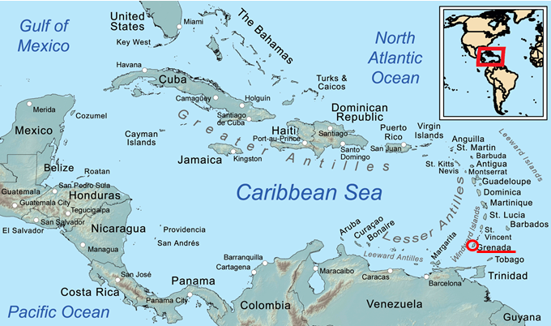
Figure 1: Location of Grenada in the south-east of the Caribbean Sea (Map Source: Wikipedia)
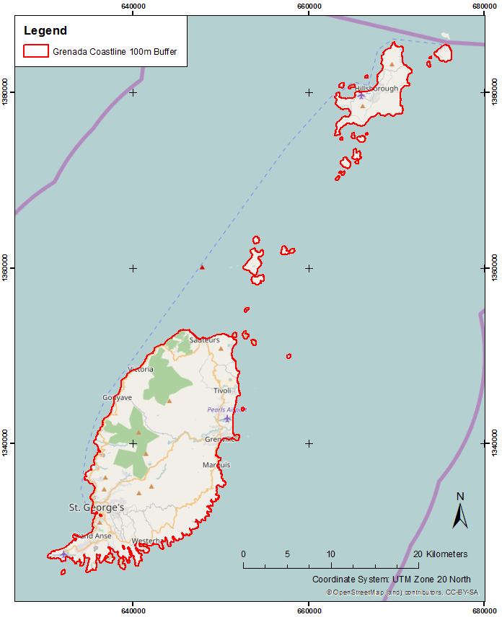
Figure 2: Map of the project area of interest
The topography of the islands is challenging with steep rises and valleys. The highest point is Mount St. Catherine on Grenada at a height of 840 m above sea level. The inland portion of the island of Grenada is covered in dense tropical, indeciduous vegetation (see Figure 3).
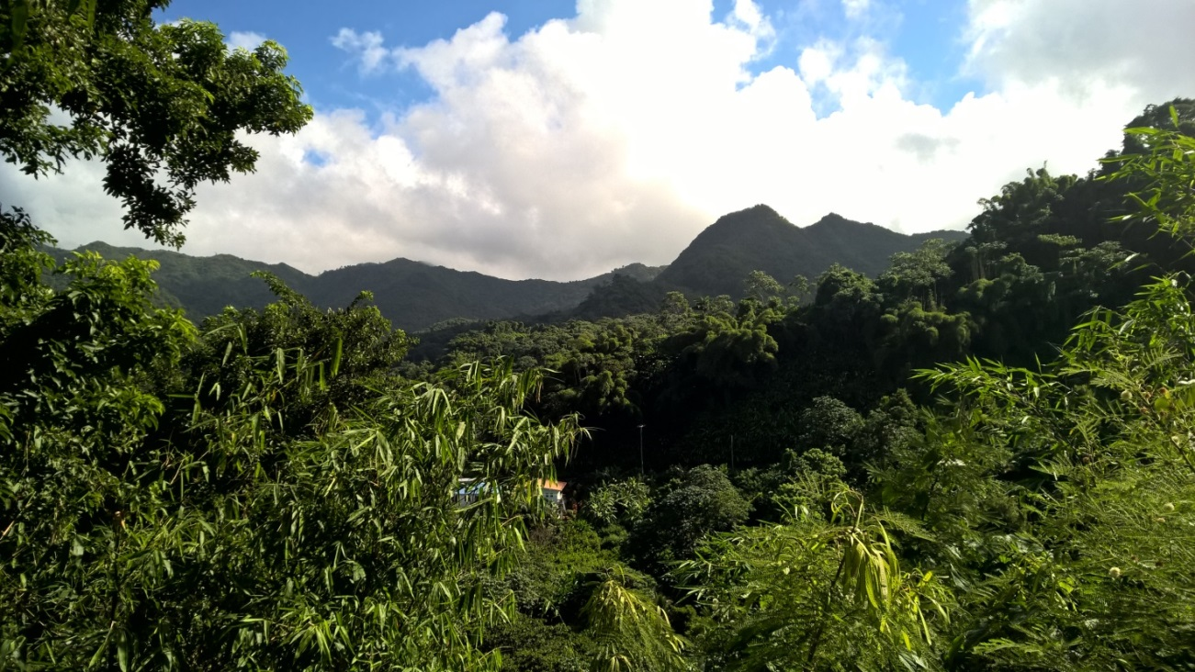
Figure 3: Typical terrain and vegetation in central Grenada
Grenada has a tropical climate with year-round high temperatures around 25° to 30° C. The majority of its precipitation falls in the rainy season from June to November, which can also see the occasional tropical storm or even hurricane. The best season for airborne data capture missions is the dry season with prevailing easterly Trade Winds in the months February through April. See Figure 4 for details.
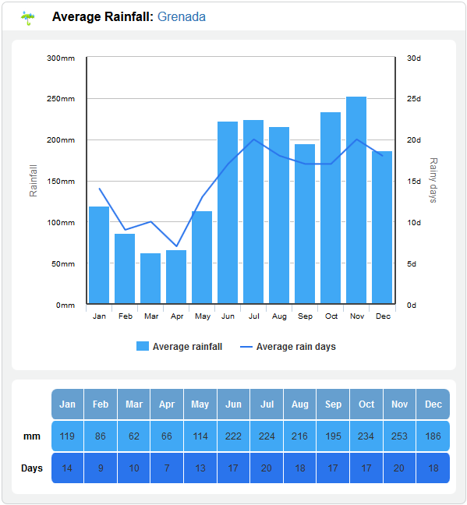
Figure 4: Rainfall statistics for Grenada. Source: http://www.holiday-weather.com

Product Summary of Key Deliverables
The following table gives a high-level summary of the key products to be delivered by the contractor under this project. The detailed requirements for the data collection, individual products, reporting and quality assurance/quality control documentation will be described in chapters 4 to 7.
Product Types | Product Specification | Deliverables | Format(s) | Resolution
Topographic Lidar | - Delivery coordinate system 1: WGS84, UTM Zone 20 N, orthometric heights using the EGM2008 geoid model  - Delivery coordinate system 2: Grenada Datum 1953, British West Indies Grid projection, local orthometric heights  - Vertical accuracy 20 cm @ 95% CI, horizontal accuracy 40 cm @ 95% CI | - Classified Lidar point cloud  - Lidar intensity images  - Digital Surface Model (DSM)  - Digital Terrain Model (DTM)  - Contours | - LAS  - TIFF + TFW  - TIFF + TFW  - TIFF + TFW  - ESRI Shape | - Min. 8 points/m²  - 0.50 m  - 0.50 m  - 0.50 m  - 1 m
Aerial imagery RGB + NIR | - Delivery coordinate system 1: WGS84, UTM Zone 20 N, orthometric heights using the EGM2008 geoid model  - Delivery coordinate system 2: Grenada Datum 1953, British West Indies Grid projection, local orthometric heights  - Horizontal accuracy of the Orthophoto product 60 cm @ 95 % CI | - Single aerial images RGB + NIR  - Adjusted image centers and orientation parameters (result of aerotriangulation)  - Orthophoto mosaic RGB + NIR | - 3 x 8 bit TIFF  - ESRI Shape  - 3 x 8 bit TIFF + TFW | - GSD max. 0.20 m  - n/a  - 0.20 m
Combined Topographic/Bathymetric Elevation | - Height differences between ground DTMs  - Complete seamless DTM and contours including both bathymetry (provided by UKHO) and topography (collected under this contract) | - Topo-Bathy difference model  - Seamless DTM mosaic  - Seamless contours | - TIFF + TFW  - TIFF + TFW  - ESRI Shape | - 1 m  - 1 m  - 1 m
Ancillary Information | - Deliver all additional technical data gathered to support the project | - Flight line trajectories  - Lidar strip difference images  - GNSS base station raw data  - GNSS base station survey protocols and photo documentation  - GNSS base station post processing protocols (long baseline to IGS stations)  - Ground control point coordinates, measurement protocols and photo documentation  - Project report | - ESRI Shape  - TIFF + TFW  - RINEX  - PDF, JPG  - PDF  - ESRI Shapefile, PDF, JPG  - MS Word DOC, PDF

During the course of the project, the following reports have to be submitted by the contractor:
Delivery Dates | Deliverables | Format(s)
- Ten days post quote acceptance  - Before survey commencement  - Before product generation  - Weekly throughout the survey  - Attached to every delivery  At conclusion of project | - Project work plan  - Pre-survey QC plan  - Flight plan  - Post-survey SA report  - Progress report  - Data delivery report  - Final project report incl. maps and images | - MS Word DOC  - MS Word DOC  - ESRI Shape  - MS Word DOC  - MS Word DOC  - MS Word DOC  - MS Word DOC

Project Timeframe
Due to the weather conditions experienced in Grenada, Lidar data capture will be performed in the dry season in spring 2017. The preferred timeline for the project is as follows:
Milestone | Latest/end date | Responsible
Deadline for bid submission | 03.02.2017 | Bidders
Bid evaluation, selection of winning bid | 17.02.2017 | GoG PCU
Approval of contract award decision by World Bank | 28.02.2017 | PCU/World Bank
Execution of contract with Lidar contractor | 17.03.2017 | PCU/Contractor
Kick-off session on Grenada; Scouting trip for ground survey | 31.03.2017 | Contractor
Dry season: Data collection campaign | 30.04.2017 | Contractor
Intermediate deliveries shall be made for  - Ground control data: 2 weeks after the survey campaign  - Trajectories and swath coverage: 7 days after each flight mission  - Unclassified Lidar point cloud: 4 weeks after the last flight mission  - Aerial images and aerotriangulation results: 4 weeks after the last flight mission  - Test area of all derived deliverables: 6 weeks after the last flight mission  - Difference documentation to bathymetry model: 8 weeks after the last flight mission |  | Contractor
Data processing by contractor. Delivery and presentation of final deliverables | 31.08.2017 | Contractor
QC of final deliverables and final acceptance review report | 31.10.2017 | PCU

General Project Requirements
The successful tenderer is expected to bring all necessary equipment and carry out all necessary activities to successfully conduct an airborne data acquisition campaign. This includes ground survey equipment for the measurement of control points. As there is currently no reliable continuously operating GNSS base station (CORS) available on Grenada, the bidder shall present in his offer a detailed concept for accurately georeferencing the Lidar and imagery data in a global reference frame, preferably by setting up dedicated GNSS base stations on the island(s) and calculating their exact positions in the IGS network.
Assistance to any field mobilizations can be provided by the Land Use Division in the Ministry of Agriculture, Lands, Forestry & Fisheries, located in St. George’s. This also includes local support in the areas where field crews might be deployed. Contact details will be communicated to the successful tenderer once confirmed.
The successful capture of Lidar and imagery data will depend primarily on optimal weather conditions at the time of flying. Detailed weather conditions and forecasts can be obtained from the Meteorological Services, MBIA at Point Salines, St. George, Grenada. Foreign air operators need a permit from the Ministry of Tourism, Civil Aviation, Culture and Performing Arts to perform aerial survey work in Grenada. This permit can be obtained via a simple application letter addressed to Mr. Earl P. Charles at the Ministry of Tourism, Civil Aviation, Culture and the Performing Arts of Grenada at the Ministerial Complex, Botanical Gardens, St. George, Grenada (Tel. +1 473 440 0366 9, Fax +1 473 440 0443). An existing AOC certificate will help expedite the process. There are no foreseen security concerns in Grenada. The onus will be on the successful tenderer to confirm any of the above details prior to the mobilization for the survey. The contractor is also required to provide detailed project planning, quality assurance and reporting.
In parallel to the Lidar and imagery data capture efforts, a project aimed at renewing Grenada’s National Geodetic Network is underway. A measurement campaign will be conducted to establish refined datum transformation parameters and geoid model corrections to tie the local coordinate frame to the WGS84 datum with cm precision. These updated transformation parameters will be made available during the course of the project in spring/summer 2017 and shall be used by the Lidar/imagery service provider for producing a set of deliverables in Grenada national coordinates after delivery, review and acceptance of all deliverable products in the WGS84 UTM Zone 20 North coordinate system and EGM2008 orthometric heights.

Presentation of results
At the end of the project, the contractor will carry out a one-day presentation of the work carried out under this project and of the resulting data sets at the Government of Grenada offices in St. George’s. He shall outline the work plan, equipment used, work carried out, challenges and solutions, tools used and results and accuracies achieved. The delivered products shall be presented in detail and their quality discussed. Examples for “best practice” usage and applications will be given and questions by the local stakeholders answered.

Data provided by the Government of Grenada
The following data will be provided to the contractor by the Government of Grenada during the course of the project
Data set | Format | Date of availability
Area of interest polygon | ESRI Shape file in UTM Zone 20 N | Included in bidding documents, Appendix B
Existing 25 m DEM of Grenada | GeoTIFF in UTM Zone 20N | Included in bidding documents, Appendix B
Horizontal and Vertical Datum Transformation Parameters | Datum shift parameters  Orthometric height correction or geoid model | To be confirmed – presumably May 2017
UKHO Bathymetry Data | Specifications (UKHO Lidar Survey Specification, May 2016; Hydrographic Instruction “Grenada and St Vincent and the Grenadines – Lidar”, HI 1530, Version 1, 2nd August 2016)  Classified ASPRS LAS 1.2 in UTM Zone 20 N with elevations referenced to local chart datum | Included in bidding documents, Appendix C  To be confirmed – presumably June 2017

Specifications for Data Collection

Topographic Lidar
Description |  | Specifications
1 | Topographic Coverage | The extent of the topographic Lidar capture will be the land mass of all the islands making up the national territory of Grenada. The exact outline of the project area is depicted in Figure 1 and provided as an ESRI shape file as part of the bidding documents.  The topographic Lidar survey area is as per Appendix B – Project Area:  - Grenada_Coastline_UTM20N_100mBuffer.shp  Data must be supplied for the full extent of capture and not clipped to the project boundaries supplied as part of this RFT
2 | Date of Capture | - Lidar: Completed by 30th April 2017. Timing for flying is the responsibility of the contractor and needs to coincide with suitable weather.  - Ground Control Data: Completed by 30th April 2017.
3 | Delivery Dates | See chapter 2.4
4 | Topographic Collection Requirements | - The survey design must guarantee:  - recording a minimum Aggregate Nominal Pulse Density (ANPD) of ≥ eight (8) outbound pulses per square meter  - achieving an Aggregate Nominal Pulse Spacing (NPS) of ≤ 0.35 m  - a scan angle not exceeding 60° total FOV (+/- 30° from nadir)  - generating a uniform and regular point pattern with an across/along track point spacing ratio not exceeding 2/3 in any part of the swath.  - that 95% of all 0.5 m cells in the final DSM grid contain at least one valid Lidar point (last and only returns) outside of acceptable, unavoidable data voids.  - Flight line overlap must be 20% or greater, as required to ensure there are no data gaps between the usable portions of the swaths. Collections in high relief terrain are expected to require greater overlap. Any data with gaps between the geometrically usable portions of the swaths will be rejected.  - The relative vertical accuracy of adjacent flight lines must be within ± 5cm @ 95% confidence interval.  - Data Voids (areas ≥ 4 x NPS), measured using 1st-returns only within a single swath are not acceptable, except:  - where caused by water bodies  - where caused by areas of low near infra-red (NIR) reflectivity such asphalt or composition roofing  - where appropriately filled-in by another swath  - Environmental conditions for data capture.  - Cloud and fog free between the aircraft and the ground.  - Floodplain/wetland data must be captured during times of base-flow and outside of significant surface inundation due to natural events and /or regulated environmental flows. If this condition occurs consultation is required with the contracting authority at least 12 hours before the planned start of the survey.  - There is no tidal restriction on data acquisition.  - Flights should not be undertaken during periods of heavy smoke and haze.
5 | Sensor Requirements | The sensor must be capable of:  - detecting multiple discrete returns, with a minimum of 4 potential returns for each outbound laser pulse.  - recording the intensity of each return.
6 | Fundamental Topographic Spatial Accuracy Requirements | Fundamental spatial accuracy of the Lidar survey must conform to the following USGS Lidar Base Specification Quality Level 1 (QL1) standard:  - Absolute non-vegetated Vertical Accuracy (NVA) ≤ 20 cm at 95% confidence interval (1.96 x RMSE_{Z})  - Fundamental Horizontal Accuracy (FHA) ≤ 40cm at 95% confidence interval (1.73 x RMSE_{XY})  Absolute vertical accuracy of the Lidar data and the derived DTM is to be assessed and reported in accordance with the ASPRS Positional Accuracy Standards for Digital Geospatial Data (American Society for Photogrammetry and Remote Sensing, 2014).
7 | Geodetic Datum and Coordinate System | All data is to be georeferenced in a hypothesis-free global reference system (delivery system 1). As refined transformation parameters into the national coordinate system become available, the final deliverables are to be transformed into the Grenada national grid and elevation system (delivery system 2).
7a | Horizontal Datum | Delivery System 1  - WGS84 | Delivery System 2  - Grenada 1953
7b | Map Projection | Delivery System 1  - UTM Zone 20 North (EPSG 32620) | Delivery System 2  - British West Indies Grid (EPSG 2003)
  Projection | Universal Transverse Mercator (UTM) Zone 20 North
  Datum | WGS84, ITRF2008
  Spheroid | GRS80
  Longitude of Origin | Central Meridian= 63° West
  Latitude of Origin | Equator (0º)
  Central Scale Factor | 0.9996
  Measurement unit | Meter
  False Easting | 500‘000 meters
  False Northing | 0 meters
  Projection | British West Indies Grid
  Datum | Grenada 1953
  Spheroid | Clarke 1880
  Longitude of Origin | Central meridian = 62° West
  Latitude of Origin | Equator (0º)
  Central Scale Factor | 0.9995
  Measurement unit | Meter
  False Easting | 400’000 metres
  False Northing | 0 metres
7c | Vertical Datum | Delivery System 1  - Orthometric heights  - Earth Gravitational Model 2008 (EGM2008) shall be used to derive orthometric heights from ellipsoidal data. | Delivery System 2  - Orthometric heights  - Earth Gravitational Model 2008 (EGM2008) plus local correction shall be used to derive orthometric heights from ellipsoidal data. These corrections will be made available during the course of the project.
8 | Survey Control | - The supplier shall independently measure a sufficient number of control points across the islands to adequately and reliably document that the accuracy requirements according to 4.1.6 are met.  - The quantity and location of check points shall meet the requirements set forth by the USGS Lidar Base Specification Version 1.2 and the ASPRS Positional Accuracy Standards for Digital Geospatial Data Version 1.0.  - The primary control points shall be measured in the WGS84 system using GNSS technology.  - Secondary control shall be established in the national geodetic network once final adjusted coordinates become available from the ongoing measurement campaign.  - As per ASRPS guidelines, control point measurement accuracy shall be three times more accurate than the required accuracy of the elevation data set being tested. In this case, the following requirements apply:  - Absolute Vertical Accuracy of control points ≤ 6.5 cm at 95% confidence interval  - Absolute Horizontal Accuracy ≤ 13.3 cm at 95% confidence interval  - All survey control data used or derived from this contract must be supplied to ensure independent Quality Assurance (QA) of the survey operations, and for possible inclusion in the country’s survey control infrastructure. It is therefore essential that all primary ground stations are permanently marked.

Aerial Imagery
Description |  | Specifications
1 | Topographic Coverage | The extent of the aerial imagery capture is identical to the extent of the Lidar data collection as per 2.1.1. above
2 | Date of Capture | The aerial imagery capture should be conducted simultaneously or as close in time as possible to the Lidar data collection.  - Completed by 30 April 2017. Timing for flying is the responsibility of the contractor and needs to coincide with suitable weather.
3 | Delivery Dates | See chapter 2.4
4 | Aerial Imagery Collection Requirements | - The survey design must guarantee:  - recording of aerial images with a maximum ground sampling distance (GSD) of 20 cm even at the lowest terrain point. The flight plan shall take the terrain into account. The provider shall document in his flight plan that the GSD requirement is met for the entire project area.  - achieving along-track overlap of at least 70% and across-track overlap of at least 40% in the final images even at the highest terrain point.  - Simultaneous registration of red, green, blue and near infrared channels.  - Environmental conditions for data capture.  - Cloud and fog free between the aircraft and the ground.  - A minimum of 15% of the total project area may be affected by cloud shadows. Sufficient contrast for feature detection must still be available in shadow areas.  - Minimum sun elevation angle of 50°.  - Floodplain/wetland data must be captured during times of base-flow and outside of significant surface inundation due to natural events and /or regulated environmental flows. If this condition occurs consultation is required with the contracting authority before survey proceeds.  - There is no tidal restriction on data acquisition.  - Flights should not be undertaken during periods of heavy smoke and haze.
5 | Sensor Requirements | The sensor must be of photogrammetric quality and capable of:  - simultaneously registering red, green, blue and near infrared channels.  - registering each channel with a radiometric resolution of 8 bit or more.  - being geometrically stable in the climatic conditions encountered on Grenada.
6 | Fundamental Spatial Accuracy Requirements | The acquired imagery shall be adequate to derive digital orthophotos with an absolute horizontal accuracy of 3 pixels (= 0.60 m) at 95% confidence interval.
7 | Geodetic Datum and Coordinate System | According to 4.1.7
8 | Survey Control | - The supplier shall independently measure control points across the islands to adequately and reliably document that the accuracy requirements according to 4.2.6 are met.  - The quantity and location of check points shall meet the requirements set forth by the ASPRS Positional Accuracy Standards for Digital Geospatial Data Version 1.0.  - The primary control points shall be measured in the WGS84 system using GNSS technology.  - Secondary control shall be established in the national geodetic network once final adjusted coordinates become available from the ongoing measurement campaign.  - As per ASRPS guidelines, control point measurement accuracy shall be three times more accurate than the required accuracy of the imagery data set being tested. In this case, the following requirements apply:  - Absolute Horizontal Accuracy ≤ 20 cm at 95% confidence interval  - All survey control data used or derived from this contract must be supplied to ensure independent Quality Assurance (QA) of the survey operations, and for possible inclusion in the country’s survey control infrastructure. It is therefore essential that all primary ground stations are permanently marked.

GNSS Base Stations
If the contractor chooses to set up dedicated GNSS base stations on Grenada in order to reliably georeference the airborne data, the following specifications apply. If the contractor proposes a different method, he must provide a detailed description in his offer.
Description |  | Specifications
1 | Coverage | At least two GNSS base stations shall be set up and operated simultaneously. The location and distribution of the stations shall be such that the base line to the survey aircraft never exceeds 25 km. The stations shall be set up on a point monument of the national geodetic network.
2 | Date of Capture | The exact WGS84 coordinates of the base stations shall be determined ahead of the aerial survey by a fixed static measurement campaign of at least two times 12 hours using different receivers.  During the survey flights, the base stations shall continuously record measurements at 1 s intervals for a time frame from one hour prior to take-off to one hour after landing.
3 | Delivery Dates | The documentation of the static base station measurement and processing shall be submitted at the latest two (2) weeks after its completion and before commencing the georeferencing calculation of the Lidar and imagery data.  The raw RINEX data for each base station occupation during productive survey flights shall be provided within two (2) weeks of each survey flight.
4 | GNSS Base Station Processing Requirements | The raw static measurements shall be processed into WGS84 coordinates using at least 3 Caribbean IGS network stations. The final adjusted coordinates of the stations shall be computed as the mean value of the two 12 hours measurement sessions.  A detailed report describing the methodology and achieved accuracy and reliability figures shall be submitted as part of the delivery.
5 | Sensor Requirements | The GNSS antennas and receivers shall be capable of recording dual-frequency L1/L2 GPS and GLONASS signals at a measurement rate of 1 s or higher.
6 | Fundamental Spatial Accuracy Requirements | The final adjusted coordinates shall meet  - an Absolute Vertical Accuracy ≤ 2 cm at 95% confidence interval  - an Absolute Horizontal Accuracy ≤ 4cm at 95% confidence interval
7 | Geodetic Datum and Coordinate System | The base station coordinates shall be computed in the ITRF2008 reference frame.

Specifications for Deliverables

Lidar Point Cloud
Deliverables |  | Specifications
1 | Flight trajectory and swath coverage | - One ESRI 3D point Shape file containing all trajectories from start to landing  - Measurement interval 1 s  - Attributes per point: Date, flight mission/sortie, adjusted GPS time, local civil time (hh:mm:ss), Easting, Northing, Elevation, Roll, Pitch, Heading  - One ESRI 3D line Shape file containing all usable flight lines from “laser on” to “laser off”, one polyline per flight line  - Attributes per line: Date, flight mission/sortie, start time (GPS), end time (GPS), start time (local civil time hh:mm:ss), end time (local civil time hh:mm:ss), flight line number according to flight plan, flight line number (LAS point source ID)  - One ESRI 2D polygon Shape file containing the approximate achieved swath coverage per flight line  - Attributes per swath: Date, flight mission/sortie, start time (GPS), end time (GPS), start time (local civil time hh:mm:ss), end time (local civil time hh:mm:ss), flight line number according to flight plan, flight line number (LAS point source ID)  - Trajectories are to be provided in the both coordinate systems as per 4.1.7:  - Delivery system 1 (UTM Zone 20 N, EGM2008 orthometric heights)  - Delivery system 2 (Grenada National Grid and local vertical datum)
2 | Unclassified Point Cloud | - All returns, all collected points, fully calibrated and adjusted to specified vertical datum, by swath. 1 file per swath, 1 swath per file.  - To be delivered as fully compliant LAS v1.2, point record format 3 with all standard attributes including:  - Georeferencing information in all LAS file headers  - Intensity values (native radiometric resolution)  - Return number and number of returns per pulse  - Scan direction, edge of flight line flags and scan angle rank  - Flight line number (Point Source ID)  - GPS times recorded as adjusted GPS time, at a precision sufficient to allow unique timestamps for each pulse.  - RGB values derived from the oriented aerial images  - Data is to be provided in the following coordinate system as per 4.1.7:  - Delivery system 1 (UTM Zone 20 N, EGM2008 orthometric heights)  - Complete swaths are to be provided as they were recorded. No culling of the data shall be performed on the project boundary.  - File naming as per Appendix A.
3 | Classified Point Cloud | - All returns, all collected points, fully calibrated and adjusted to specified vertical datum, and classified as specified below.  - To be delivered as fully compliant LAS v1.2, point record format 3 with all standard attributes including:  - Georeferencing information in all LAS file headers  - Intensity values (native radiometric resolution)  - Return number and number of returns per pulse  - Scan direction, edge of flight line flags and scan angle rank  - Classification code per class list in below. ALL points not identified as “Withheld” are to be classified.  - Flight line number (Point Source ID)  - GPS times recorded as adjusted GPS time, at a precision sufficient to allow unique timestamps for each pulse.  - RGB values derived from the oriented aerial images  - Data is to be provided in the following coordinate systems as per 4.1.7:  - Delivery system 1 (UTM Zone 20 N, EGM2008 orthometric heights)  - Delivery system 2 (Grenada National Grid and local vertical datum)  - Tiled delivery, as per Data Supply Specifications 5.7 below.  - File naming as per Appendix A.
4 | Lidar Point Cloud Classification Scheme | - All classified point cloud data must adhere to the following modified ASPRS classification scheme.
  Number | Point Class | Description
  1 | Default | Unclassified and other objects: Cars, ships, boats, cranes, containers, stockpiles, power and telephone lines and other temporary objects
  2 | Ground | Bare ground
  3 | Low vegetation | 0 – 0.3 m above ground
  4 | Medium vegetation | 0.3 – 2 m above ground
  5 | High vegetation | > 2 m above ground
  6 | Buildings, structures | Buildings, houses, sheds, silos etc. Roofs and walls to be classified in this class.
  7 | Low/high points | Spurious high/low point returns (unusable)
  9 | Water surface | Water surface returns (sea, lakes, rivers)
  10 | Bridges | Bridges, overpasses, jetties including pylons and pillars
5 | Topographic Lidar Point Cloud Classification Level | - The classification shall be conducted using automated and manual routines. The quality level expected includes significant manual interaction to reach a high level of detail and reliability among all classes.  - Errors of omission and errors of commission must not exceed 2% of all points per class and 1 x 1 km tile. E.g. out of 100 buildings in one tile, a maximum of 2 may be erroneously classified in any other point class than 6. And out of 20’000 points classified as “bridges”, a maximum of 400 points may be located on any other object than bridges.  - Large (>2m) anomalies (errors) within all classification levels must not exist. If clear errors are identified in the QA/QC process, the classification result will be rejected.  - The contractor shall utilize the simultaneously captured aerial imagery to support and enhance the point cloud classification.

Aerial Imagery
Deliverables |  | Specifications
1 | Single Aerial Images - RGBI | - Delivered as 4 channel TIFFs (R, G, B, NIR), 8 bit per channel, uncompressed  - Color balancing and color matching between frames shall be performed to achieve a homogeneous image pool. Contrast and brightness of each image should be adjusted to minimize the color variation between photos and photo runs.  - For all image products, ensure the data values are set to the range 1-254 (not 0-255). The purpose of this is to reserve the value 0 or 255 for null image data. This is useful when reprojecting data and setting the transparency value to a value which is not within the image data range.  - File naming as per Appendix A.
2 | Image positions orientations | - The image blocks are to be georeferenced using the post-processed GNSS-INS solution and an additional aerotriangulation process, taking into account a sufficient number of ground control points.  - The achieved accuracy shall be adequate to derive digital orthophotos with an absolute horizontal accuracy of 3 pixels (= 0.60 m) at 95% confidence interval.  - A detailed summary of the aerotriangulation results including the residual RMS values at the ground control and check points shall be included in the technical report.  - Delivery of the image positions and orientations as one ESRI 3D point Shape file containing one point record per image center  - Attributes: Date, flight mission/sortie, adjusted GPS time, local civil time (hh:mm:ss), Image Number, Easting, Northing, Height, Omega, Phi, Kappa  - A point (.) is to be used as decimal separator  - Time stamps to be recorded as adjusted GPS time, at a precision sufficient to allow unique timestamps for each image.  - Orientation angles are to be stored in decimal degrees (0° - 359.9999°)

GNSS base station data
Deliverables |  | Specifications
1 | Base station data | - Raw GNSS data for all base station occupations during productive survey flights is to be provided in RINEX V1.2 format (Receiver Independent Exchange Format).  - GNSS observation log sheets which include the following details:  - Survey mark ID  - Occupation time & date  - Antenna height measurements including situation photo or sketch  - Instrument /antenna types & serial numbers  - The GNSS observation log sheets should be provided in pdf format or Excel spreadsheet if data is captured digitally.

Topographic Lidar Derived Data
Deliverables |  | Specifications
1 | Intensity Image | - 0.5 m grid intensity image  - Homogeneous mosaic generated using all laser return intensity values  - 8 bit 1 channel TIFF + TFW  - Data is to be provided in the following coordinate systems as per 4.1.7:  - Delivery system 1 (UTM Zone 20 N, EGM2008 orthometric heights)  - Delivery system 2 (Grenada National Grid and local vertical datum)  - Tiled delivery, as per Data Supply Specifications 5.7 below.  - The intensity images shall contain all collected data, not cut to the project boundary.  - File naming as per Appendix A.
2 | Digital Surface Model (DSM) | - 0.5 m grid Digital Surface Model (DSM)  - The DSM shall be generated from the “first return” Lidar mass point data. This will include ground and non-ground points classified in the following classes:  - 2: Ground  - 3 – 5: Low, medium and high vegetation  - 6: Buildings, structures  - 9: Water surface  - 10: Bridges  - The DSM generation should employ a Point to TIN and TIN to Raster process with Natural Nearest Neighbor interpolation. Data gaps caused by inland water bodies are to be closed using Delauney triangulation in the TINning process.  - Void areas (i.e., areas outside the project boundary but within any tiling scheme) shall be coded using a unique “NODATA” value.  - Tiled delivery as 32bit floating point 1 channel TIFF + TFW, as per Data Supply Specifications 5.7 below.  - Mosaic of all tiles as ECW file using 5:1 compression.  - Data is to be provided in the following coordinate systems as per 4.1.7:  - Delivery system 1 (UTM Zone 20 N, EGM2008 orthometric heights)  - Delivery system 2 (Grenada National Grid and local vertical datum)  - File naming as per Appendix A.
3 | Digital Terrain Model (DTM) | - 0.5 m grid bare earth Digital Terrain Model (DTM)  - The DTM shall be generated from the Lidar mass point data. This will include bare earth ground points classified in the following classes:  - 2: Ground  - The DTM generation should employ a Point to TIN and TIN to Raster process with Natural Nearest Neighbor interpolation. Data gaps caused by inland water bodies and buildings are to be closed using Delauney triangulation in the TINning process.  - Void areas (i.e., areas outside the project boundary but within any tiling scheme) shall be coded using a unique “NODATA” value.  - Tiled delivery as 32bit floating point 1 channel TIFF + TFW, as per Data Supply Specifications 5.7 below.  - Mosaic of all tiles as ECW file using 5:1 compression.  - Data is to be provided in the following coordinate systems as per 4.1.7:  - Delivery system 1 (UTM Zone 20 N, EGM2008 orthometric heights)  - Delivery system 2 (Grenada National Grid and local vertical datum)  - File naming as per Appendix A.
4 | Contours | - The contour interval is to be 0.5m, with every 5m contour interval being assigned as a major contour line.  - The contours are to be supplied as a single file ESRI Shape file.  - Each Contour file should retain the attribute “ALTITUDE” that carries the elevation value to MSL for each contour.  - The contour data set should adhere to the following Topology Rules:  - Contours must not intersect.  - Contours must not have dangles unless at the edge of the data set.  - Contours are to be visually cartographic type contours.  - A minimal number of vertices are to be used in defining the contour line, but without destroying the “natural look” into a computer generated set of unnatural contour lines. Smoothing may be applied.  - Distance between adjoining vertices would generally not be less than 15 meters, unless depicting a sharp change in direction. The contour data should have a smooth look when displayed/printed at a scale of 1:250.  - Contour lines are to be long continuous line strings, rather than separate lengths.  - As per the DTM, all non-ground objects such as vegetation and man-made structures shall be removed from the contour data, so that contours define the “bald earth” ground surface.  - Contours must have an accuracy such that 95% of “well defined” points along the contour line are to have a value that must not differ to the “true” ground surface by any more than half the contour interval.
5 | Hillshade models | - Hillshaded terrain relief representations of DSM and DTM as 0.5 m grid  - The hillshades shall be generated from the DSM and DTM grids using a sun elevation angle of 45° and an azimuth of 315°.  - Void areas (i.e., areas outside the project boundary but within any tiling scheme) shall be coded using a unique “NODATA” value.  - Tiled delivery as 32bit grayscale TIFF + TFW, as per Data Supply Specifications 5.7 below.  - Mosaic of all tiles as ECW file using 5:1 compression.  - Data is to be provided in the following coordinate systems as per 4.1.7:  - Delivery system 1 (UTM Zone 20 N, EGM2008 orthometric heights)  - Delivery system 2 (Grenada National Grid and local vertical datum)  - File naming as per Appendix A.

Combined Lidar/Bathymetry Derived Data
Deliverables |  | Specifications
1 | Difference image | - 1 m grid elevation difference image between the UKHO bathymetry dataset provided by the GoG and the topographic Lidar dataset processed by the contractor  - Homogeneous difference image mosaic generated by subtracting the topo grid from the bathymetry grid.  - 8 bit 1 channel TIFF + TFW  - Data is to be provided in the following coordinate systems as per 4.1.7:  - Delivery system 1 (UTM Zone 20 N, EGM2008 orthometric heights)  - Delivery system 2 (Grenada National Grid and local vertical datum)  - Tiled delivery, as per Data Supply Specifications below.  - The difference image shall cover the entire extent of all combined data, not cut to the project boundary.  - File naming as per Appendix A.
2 | Adjustment process | - The contractor shall analyze the elevation differences along the borders of the two datasets using both large-area difference images and single-point control measurements using the ground control points. He shall then propose a data adjustment method to optimally merge the two datasets into a homogeneous DTM.  - The GoG will review the proposed method and give its approval to proceed.  - The contractor will then proceed to adjust and merge the two data sets. He shall check and document the results and provide a detailed report describing the methodology and results.
3 | Seamless Combined Digital Terrain and Seafloor Model | - 1 m grid Seamless Combined Digital Terrain and Seafloor Model  - The Combined Digital Terrain and Seafloor Model shall be generated from the Lidar and UKHO Bathymetry data, adjusted according to 5.5.2, using “ground” and “sea floor” data only.  - No further editing of the bathymetric data set apart from the adjustment has to be performed. The data is used “as is”. Observations by the contractor regarding the quality of the bathymetric data shall be documented in the technical report.  - Void areas (i.e., areas outside the project boundary but within any tiling scheme) shall be coded using a unique “NODATA” value.  - Tiled delivery as 32bit floating point 1 channel TIFF + TFW, as per Data Supply Specifications 5.7 below.  - Mosaic of all tiles as ECW file using 5:1 compression.  - Data is to be provided in the following coordinate systems as per 4.1.7:  - Delivery system 1 (UTM Zone 20 N, EGM2008 orthometric heights)  - Delivery system 2 (Grenada National Grid and local vertical datum)  - The Seamless Combined Digital Terrain and Seafloor Model shall contain all collected data, not cut to the project boundary.  - File naming as per Appendix A.
4 | Seamless Combined Contours | - Contour lines derived from the 1m Seamless Combined Digital Terrain and Seafloor Model grid  - The contour interval is to be 1 m, with every 10m contour interval being assigned as a major contour line.  - The contours are to be supplied as a single file ESRI Shape file.  - Each Contour file should retain the attribute “ALTITUDE” that carries the elevation value to MSL for each contour.  - The contour data set should adhere to the following Topology Rules:  - Contours must not intersect.  - Contours must not have dangles unless at the edge of the data set.  - Contours are to be visually cartographic type contours.  - A minimal number of vertices are to be used in defining the contour line, but without destroying the “natural look” into a computer generated set of unnatural contour lines. Smoothing may be applied.  - Distance between adjoining vertices would generally not be less than 15 meters, unless depicting a sharp change in direction. The contour data should have a smooth look when displayed/printed at a scale of 1:1’000.  - Contour lines are to be long continuous line strings, rather than separate lengths.  - As per the DTM, all non-ground objects such as vegetation and man-made structures shall be removed from the contour data, so that contours define the “bald earth” ground surface.  - Contours must have an accuracy such that 95% of “well defined” points along the contour line are to have a value that must not differ to the “true” ground surface by any more than half the contour interval.  - The Seamless Combined Contours shall contain all collected data, not cut to the project boundary.  - File naming as per Appendix A.
6 | Combined Hillshade Model | - Hillshaded terrain relief representations of the 1m Seamless Combined Digital Terrain and Seafloor Model grid as 1 m grid  - The hillshades shall be generated from the DSM and DTM grids using a sun elevation angle of 45° and an azimuth of 315°.  - Void areas (i.e., areas outside the project boundary but within any tiling scheme) shall be coded using a unique “NODATA” value.  - Tiled delivery as 32bit grayscale TIFF + TFW, as per Data Supply Specifications 5.7 below.  - Mosaic of all tiles as ECW file using 5:1 compression.  - Data is to be provided in the following coordinate systems as per 4.1.7:  - Delivery system 1 (UTM Zone 20 N, EGM2008 orthometric heights)  - Delivery system 2 (Grenada National Grid and local vertical datum)  - The Combined Hillshade Model shall contain all collected data, not cut to the project boundary  - File naming as per Appendix A.

Orthophoto Derived Data
Deliverables |  | Specifications
1 | RGB Orthophoto Mosaic | - 0.2 m resolution color orthophoto mosaic  - Calculated from the collected aerial imagery, using the aerotriangulation results and the Lidar DTM  - The spectral range of the orthophoto shall be three band, 8 bit each: R(ed), G(reen), B(lue)  - Absolute horizontal accuracy shall be 3 pixels (= 0.60 m) at 95% confidence interval  - Color balance across the whole mosaic must be optimized to allow quality color discrimination whilst still providing the best possible tonal match across the mosaic.  - Frame selection should minimize noticeable exposure patches, vertical height displacement and seam lines between ground features.  - Where necessary, manual corrections shall be made to ensure geometrically correct and visually attractive representation of ground and surface features. The stated horizontal accuracy must be met throughout the product coverage and will be tested against random sample check points.  - For all image products, ensure the data values are set to the range 1-254 (not 0-255). The purpose of this is to reserve the value 0 or 255 for null image data.This is useful when reprojecting data and setting the transparency value to a value which is not within the image data range.  - Tiled delivery as 3 x 8 bit TIFF + TFW, as per Data Supply Specifications 5.7 below.  - Mosaic of all tiles as ECW file using 5:1 compression.  - Data is to be provided in the following coordinate systems as per 4.1.7:  - Delivery system 1 (UTM Zone 20 N, EGM2008 orthometric heights)  - Delivery system 2 (Grenada National Grid and local vertical datum)  - Tiled delivery, as per Data Supply Specifications below.  - File naming as per Appendix A.
2 | Infrared Orthophoto Mosaic | - 0.2 m resolution color infrared orthophoto mosaic  - Calculated from the collected aerial imagery, using the aerotriangulation results and the Lidar DTM  - The spectral range of the orthophoto shall be three band, 8 bit each: R(ed), G(reen), Near Infrared  - Absolute horizontal accuracy shall be 4 pixels (= 0.80 m) at 95% confidence interval. The Infrared mosaic must be geometrically identical to the RGB mosaic.  - Color balance across the whole mosaic must be optimized to allow quality color discrimination whilst still providing the best possible tonal match across the mosaic.  - Frame selection should minimize noticeable exposure patches, vertical height displacement and seam lines between ground features.  - Where necessary, manual corrections shall be made to ensure geometrically correct and visually attractive representation of ground and surface features. The Infrared mosaic must be geometrically identical to the RGB mosaic. The stated horizontal accuracy must be met throughout the product coverage and will be tested against random sample check points.  - For all image products, ensure the data values are set to the range 1-254 (not 0-255). The purpose of this is to reserve the value 0 or 255 for null image data.This is useful when reprojecting data and setting the transparency value to a value which is not within the image data range.  - Tiled delivery as 3 x 8 bit TIFF + TFW, as per Data Supply Specifications 5.7 below.  - Mosaic of all tiles as ECW file using 5:1 compression.  - Data is to be provided in the following coordinate systems as per 4.1.7:  - Delivery system 1 (UTM Zone 20 N, EGM2008 orthometric heights)  - Delivery system 2 (Grenada National Grid and local vertical datum)  - Tiled delivery, as per Data Supply Specifications below.  - File naming as per Appendix A.

Various Data Supply Specification
Deliverables |  | Specifications
1 | File naming | See Appendix A for file naming conventions.
2 | Coordinate Origins for Gridded Data | The origin of all gridded data must be placed on a whole meter coordinate value that will align with the zero (0) origin map projection for each Delivery System.
3 | Data Tiling | - All standard data sets should be supplied as single files where possible and tiled to manageable file sizes if necessary as below:  - 1km x 1km tiles based on map projection coordinates with origins that align with the zero (0) origin of the map projection.  - Larger tile sizes which maximize workflow efficiency will be considered.  - The origin of the tile must be placed on a whole meter coordinate value of the south west corner of each tile. e.g. 426000mE_7243000mN  - A Tile Index is to be provided by the contractor in ESRI shape file format. The tile name as specified above must be included as an attribute in the Tile Index file.  - File naming as per Appendix A.
4 | Project Boundary Clipping | Unless otherwise stated above, deliverables shall be clipped to the project boundary/area of interest polygon (Appendix B).
5 | Data Delivery Reports | A delivery report describing the contents of the data supplied with every data delivery (interim, staged, final).
6 | Delivery Media | - Two copies of the data should be delivered on External Hard Drives with USB 3 functionality. External hard drives will be retained by the Contract Authority.  - Data deliveries should be clearly labelled with name of Service Provider, date of supply and list of contents.
7 | Report Formats | All reports are to be provided in Microsoft Word (.docx) or PDF format, Excel spreadsheet (.xlsx) or appropriate digital format approved by the Contract Authority.

Project Planning and Reporting Specification
Deliverables |  | Specifications
1 | Project Plan | Project plan detailing work breakdown structure, agreed data capture plans, project milestones, data delivery formats, delivery schedules and progress reporting schedules etc.  To be included in the bidder’s offer. Upon project startup, the Contracting Authority will provide comments and feedback. The Contractor is then expected to submit a revised version of the Project Plan within 10 calendar days.
2 | Pre-Survey Quality Assurance Plan | The contractor shall prepare and submit to the Contracting Authority a Quality Assurance Plan for the topographic Lidar and aerial imagery survey that conforms to an identified management system and generally complies with ISO 9001.  The plan must address the organization and management of the project, work procedures, environmental considerations, safety and risk control and test procedures.  The plan must also include:  - The procedures and methodologies to be used to verify that the deliverables meet the required specifications.  - Details of proposed calibration checks and methodology to be used to establish both reference stations and ground test sites.  - Proposed flight plans  - Any other details that the contractor deems relevant or are requested within these specifications.  To be included in the bidder’s offer. Upon project startup, the Contracting Authority will provide comments and feedback. The Contractor is then expected to submit a revised version of the Pre-Survey Quality Assurance Plan within 20 calendar days.
3 | Post-Survey Spatial Accuracy Report | Acceptance of the Post-Survey Spatial Accuracy Report and related information is required before point classification and other product derivation is to proceed.  The absolute and relative accuracy of the data, both horizontal and vertical, and relative to known control, shall be verified prior to classification and subsequent product development.  This validation is limited to the Fundamental Spatial Accuracy (defined below), measured in clear, open areas for the topographic Lidar and at ground control points for the aerial imagery/aerotriangulation. A detailed report of this validation is a required deliverable.  The report for the topographic Lidar and aerial imagery surveys will include the following:  - Flight trajectories as specified in 5.1.1 above.  - Details of system calibration checks.  - Results of relative (flight line) matching and details of any adjustments made. This specifically includes a strip difference image as a 1 m grid showing the vertical differences between overlapping flight lines per grid cell.  - Results of vertical and horizontal accuracy validation for Lidar and imagery.  - All survey control coordinates, site ID and check point comparisons in both Excel spreadsheet and ESRI shape file formats.  - Digital photographs of all survey and check sites, with the site ID included in the filename. The bearing of the photo direction should also be included.  - Report on the differences between the collected topographic Lidar data and the UKHO bathymetry data as per 5.5.  - Other related information.
4 | Progress Reports | The contractor will report by email weekly during the data acquisition, and fortnightly during non-capture.  The report should contain a summary of progress, delivery and implementation, and details of any problems encountered and remedial action taken. It should give a current estimate on further project milestones, i.e. if the planned delivery dates can be complied with.  The report should also address the planned activities for the two weeks ahead, regardless of whether successful capture has been achieved.  A template of the progress report shall be included in the project plan.
5 | Project Report | The Project Report should comprise a technical discussion addressing how each of the contract specifications has been met, a brief description of the project areas, a statement of consistency with any specified standards, results of independent accuracy and validation tests, metadata statements and extra-ordinary issues that may have affected the nature or delivery of the project.  All aspects of the project operations must be adequately reported.

Quality Assurance Specifications and Acceptance Criteria

Topographic Lidar
Description |  | Specifications
1 | Lidar Fundamental Spatial Accuracy Validation | - The onus for reaching the required accuracy lies with the data supplier. Independent accuracy assessments may also be carried out by the Contracting Authority.  Vertical Accuracy Validation  - The fundamental vertical accuracy of the point cloud dataset must be determined with check points located only in open, relatively flat terrain, where there is a very high probability that the sensor will have detected the ground surface.  - The vertical accuracy of the point cloud dataset is to be tested using a TIN surface constructed from bare-earth Lidar points compared against ground survey check points.  - The number of check points (locations) is dependent on the extent of the survey. The following strategy should be used as a guide:  - Check points must be established to adequately cover the full extent of the survey area, and be representative of the project area landscape.  - A minimum of 20 check points (locations). When 20 points are tested, the 95 percent confidence interval would generally allow 1 point to fail the threshold given in product specifications  - The proposed check point survey design must be submitted with the quotation, and approved by the Contract Authority prior to implementation. Acceptance of the post-survey spatial accuracy report discussed above is dependent on the quality, number and distribution of these check points.  - If additional independent validation is required, data should be assessed in accordance with ASPRS Accuracy Reporting Guidelines.  - The Contracting Authority will conduct independent vertical accuracy validation. The data set will be accepted if 95% of these checks fall inside the required 20 cm confidence interval.  Horizontal Accuracy Validation  - The contractor shall demonstrate compliance with the requirements for horizontal accuracy set forth in chapter 4.1 through analysis of distinct features which are identifiable in the elevation data (e.g. fences) or intensity images with other data sources such as high resolution imagery with known horizontal accuracy. The contractor shall specify this method in his Pre-Survey Quality Assurance Plan.  - The Contracting Authority will conduct independent horizontal accuracy validation. The data set will be accepted if 95% of these checks fall inside the required 40 cm confidence interval.
2 | Classification Accuracy Validation | - It is expected that due diligence in the classification process will produce datasets that meet the required classification accuracies according to 5.1.4. The data set will be accepted if it meets the following tests within any 1km x 1km tile:  - No gross errors that significantly reduce the usability of the resulting DTM and DSM are present in the data.  - Errors of omission must not exceed 2% of all points per class  - errors of commission must not exceed 2% of all points per class  - Classification accuracy tests shall be presented in the form of an error matrix for each specified class reporting errors of omission and commission generated from randomly selected points.
3 | Classification Consistency Validation | - Point classification is to be consistent across the entire project.  - Noticeable variations in the character, texture, or quality of the classification between tiles, swaths, flight missions, or other non-natural divisions will be cause for rejection of the entire deliverable.
4 | Spatial Distribution of Points Validation | In order to ensure uniform densities throughout the data set:  - A regular grid, with 0.5 m cell size will be laid over the data.  - At least 95% of the cells in the grid shall contain at least 1 Lidar point.  - Assessment to be made against single swath, first return data located within the geometrically usable center portion (typically ~90%) of each swath.  - Acceptable data voids identified previously in this specification are excluded.
5 | Interpolation Consistency Validation | All products derived from the Lidar mass point data as tiles will show no edge artefacts or mismatch. A quilted appearance in the overall project surfaces, whether caused by differences in processing quality or character between tiles, swaths, flight missions, or other non-natural divisions, will be cause for rejection of the entire deliverable.

Aerial Photography and Orthophoto
Description |  | Specifications
1 | Orthophoto Fundamental Spatial Accuracy Validation | - The onus for reaching the required accuracy lies with the data supplier. Independent accuracy assessments may also be carried out by the Contracting Authority.  Orthophoto Horizontal Accuracy Validation  - The fundamental horizontal accuracy of the orthophoto must be determined with marked or unmarked check points that are clearly visible in the orthophoto.  - The horizontal accuracy of the orthophoto is to be tested by measuring the horizontal distance between the location of these points in the orthophoto and their true location determined by ground survey.  - A minimum of 20 check points (locations) is required, evenly distributed over the islands. When 20 points are tested, the 95 percent confidence interval would generally allow 1 point to fail the threshold given in product specifications  - The proposed check point survey design must be submitted with the quotation, and approved by the Contract Authority prior to implementation. Acceptance of the post-survey spatial accuracy report discussed above is dependent on the quality, number and distribution of these check points.  - If additional independent validation is required, data should be assessed in accordance with ASPRS Accuracy Reporting Guidelines.  - The Contracting Authority will conduct independent vertical accuracy validation. The data set will be accepted if 95% of all check point measurements fall inside the required 60 cm confidence interval. This may include checks on bridges, retaining walls and other geometrically challenging features.
2 | Orthophoto Geometry | - In addition to the absolute horizontal accuracy requirements, no geometry discontinuities of more than 2 pixels along mosaic seamlines may be present in the final product.  - Non-DTM objects such as bridges and buildings may not be cut by seam lines and need to be adequately corrected to retain a maximum of geometric correctness and visual appeal.
3 | Orthophoto Consistency Validation | - Orthophoto appearance in color balance and contrast is to be consistent across the entire project.  - Noticeable variations in the character, texture, or quality of the classification between tiles, swaths, flight missions, or other non-natural divisions will be cause for rejection of the entire deliverable.

Appendix A – File Naming Conventions
The following file naming conventions shall be adhered to for all georeferenced datasets delivered under this specification.
Orthorectified IMAGERY (orthophoto, intensity images)
ProjectName | GrenadaLidar | A meaningful description of the total survey area of interest. Do not use “_” as part of the Project Name
YYYY | 2017 | Year of survey
TYPE | -INT | Image type  - INT for Lidar intensity images  - RGB for 3 band natural color imagery  - RGI for 3 band false color infrared imagery  - RGBI for 4 band imagery including infrared
GSD | -20cm | Ground sampling distance or resolution of image in cm.
xxxyyyy | _4806558 (480,000mE  6558,000mN) | Easting and northing value (whole kilometer) of the south- west corner of the tile.  A single “_” must be used to separate the remaining file name components.
zz | _20 | Coordinate system  - UTM zone of the file  - BG for British West Indies Grid
wwww | _0020 | Width of the dataset or tile in whole kilometers
hhhh | _0050 | Height of dataset or tile in whole kilometers
For example: ProjectNameYYYY-TYPE-GSD_xxxyyyy_zz_wwww_hhhh.ecw
= GrenadaLidar2017-INT-100cm_4806558_20_0001_0001.tif

Lidar UNCLASSIFIED POINT CLOUD (LAS)

All Lidar point cloud data are to be delivered fully compliant LAS v1.2, Point Record Format 3.
ProjectName | GrenadaLidar | A meaningful description of the total survey area of interest. Do not use “_” as part of the Project Name
YYYY | 2017 | Year of survey
UNC | -UNC | Unclassified point cloud. Fully calibrated and adjusted to specified datum
SWT | - 1...n | Swath number (1 file per swath). Must be consistent with trajectory documentation and Point Source ID attribute in the LAS files.
xxxyyyy | _4806558 (480,000mE  6558,000mN) | Easting and northing value (whole kilometer) of the south- west corner of the tile.  A single “_” must be used to separate the remaining file name components.
zz | _20 | Coordinate system  - UTM zone of the file  - BG for British West Indies Grid
wwww | _0020 | Width of the dataset or tile in whole kilometers
hhhh | _0050 | Height of dataset or tile in whole kilometers
For example: ProjectNameYYYY-UNC-SWT_xxxyyyy_zz_wwww_hhhh.ecw
= GrenadaLidar2017-UNC-01235_4806558_20_0005_0002.tif

Lidar CLASSIFIED POINT CLOUD (LAS)

All Lidar point cloud data are to be delivered fully compliant LAS v1.2, Point Record Format 3.
ProjectName | GrenadaLidar | A meaningful description of the total survey area of interest. Do not use “_” as part of the Project Name
YYYY | 2017 | Year of survey
CL | -CL | Classified point cloud. Fully calibrated and adjusted to specified datum
xxxyyyy | _4806558 (480,000mE  6558,000mN) | Easting and northing value (whole kilometer) of the south- west corner of the tile.  A single “_” must be used to separate the remaining file name components.
zz | _20 | Coordinate system  - UTM zone of the file  - BG for British West Indies Grid
wwww | _0020 | Width of the dataset or tile in whole kilometers
hhhh | _0050 | Height of dataset or tile in whole kilometers
For example: ProjectNameYYYY-CL_xxxyyyy_zz_wwww_hhhh.ecw
= GrenadaLidar2017-CL_4806558_20_0005_0002.tif

All OTHER GEOREFERENCED FILES

For other file types and formats that may be specified as deliverables
ProjectName | GrenadaLidar | A meaningful description of the total survey area of interest. Do not use “_” as part of the Project Name
YYYY | 2017 | Year of survey
SSSS-PPPP | -DTM-GRID | Surface type.  - DSM  - DTM  - Mixed (MIX). Bathymetry and terrain elevations  - TTT (Other terrain variables e.g. slope (SLP). Add as necessary.  Product type  - GRID (GRID)  - Contours (CON)  - Other  Use additional field width and more characters if required.
GSD | -20cm | Ground sampling distance or resolution of image in cm.
xxxyyyy | _4806558 (480,000mE  6558,000mN) | Easting and northing value (whole kilometer) of the south- west corner of the tile.  A single “_” must be used to separate the remaining file name components.
zz | _20 | Coordinate system  - UTM zone of the file  - BG for British West Indies Grid
wwww | _0001 | Width of the dataset or tile in whole kilometers
hhhh | _0001 | Height of dataset or tile in whole kilometers
.ext |  | File extension according to format conventions  - LAS  - shp  - dxf  - others as needed
For example: ProjectNameYYYY-SSSS-PPPP-GSD_xxxyyyy_zz_wwww_hhhh.ext
= GrenadaLidar2017-DTM-CON_4806558_20_0001_0001.shp

Appendix B – Project Area
- Project Area: Grenada_coastline_UTM20N_100mBuffer.shp
  - WGS84, UTM 20 N projection
Figure 5: Map of the project area of interest.
- Existing 25 m DEM: Grenada_25m_DEM.tif
  - British West Indies Grid
  - Orthometric Heights
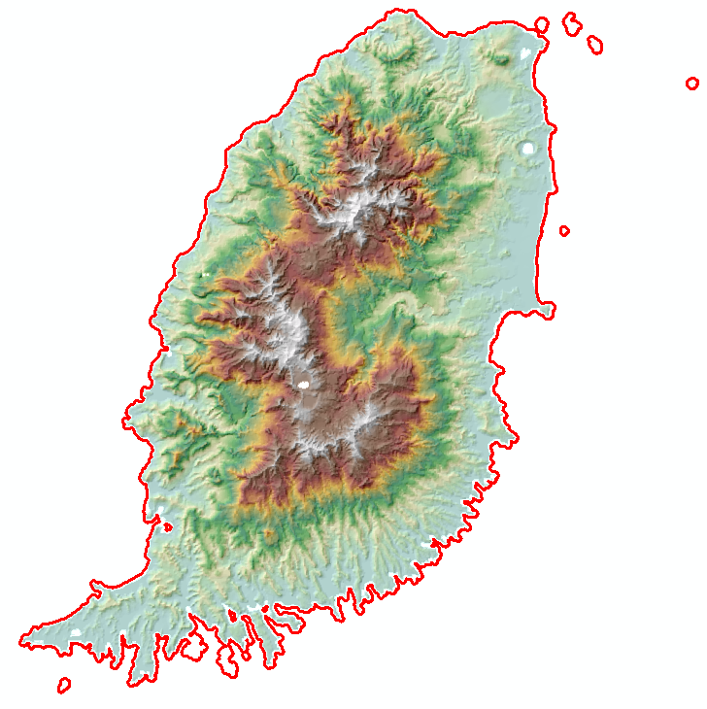
Figure 6: 25 m resolution DEM of the island of Grenada provided as part of the bidding documents.

Appendix C - UKHO Bathymetry Project Information
- UKHO Lidar Survey Specification, May 2016: Survey Specification V1.1 - Lidar.pdf
- Hydrographic Instruction “Grenada and St Vincent and the Grenadines – Lidar”, HI 1530, Version 1, 2nd August 2016: HI_1530_CMEP_GRD_SVG_Lidar_PJP.pdf

https://pubs.usgs.gov/tm/11b4/pdf/tm11-B4.pdf Version 1.2, November 2014
https://www.asprs.org/pad-division/asprs-positional-accuracy-standards-for-digital-geospatial-data.html, Version 1.0, November 2014

