CTCN assistance in Thailand
Strengthening Bangkok’s Early Warning System to respond to climate induced flooding
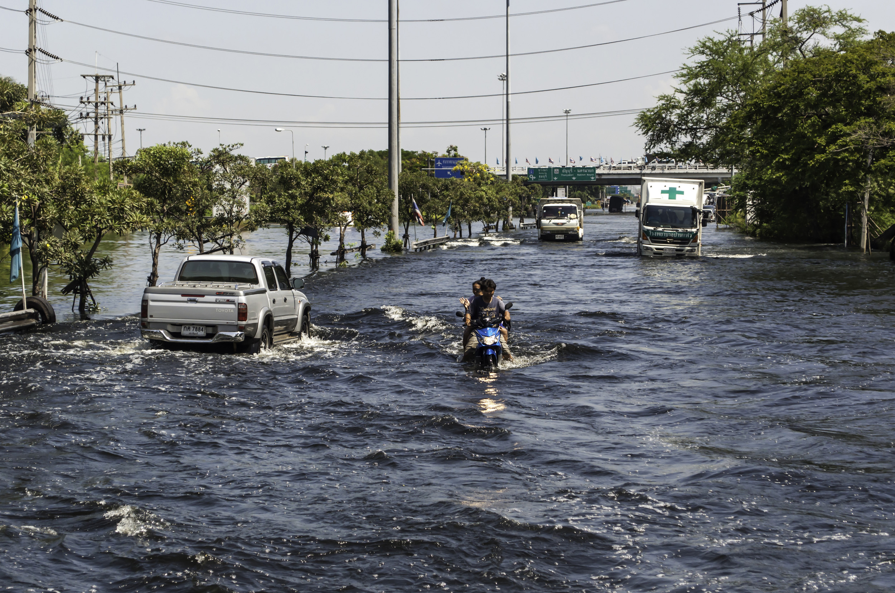
Deliverable 9 - Activity 3-1 On-the-job training

Draft final 13th November 2017

This report has been prepared under the DHI Business Management System
certified by Bureau Veritas to comply with ISO 9001 (Quality Management)

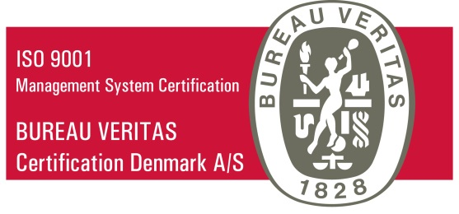

Approved by

Contents
1 Topics and areas covered 4
2 Hydraulic modelling 4
3 Data flow configuration 4
4 MIKE Operations web-interface configuration 5

Topics and areas covered
This report briefly summarises the activities related to the “on-the-job training”.
The activities stretch over the full duration of the project implementation period, with special emphasis on the hydraulic modelling, data flow configuration and web adaptation tasks.

Hydraulic modelling
The hydraulic models play a core role in the early warning system. The models have been build and refined during November 2016-April 2017. Selected BMA staff were trained during a formal one-week training period in December 2016, and the skills were further enhanced through active use of the models under supervision by DHI.
A range of different scenarios was prepared during the calibration period, adjusting the hydraulic model to provide overall satisfying results compared with measurements from the SCADA system.
With the calibrated models, analysis of flood patterns for a number of historical events helped the process of stabilising and optimizing the model. Also, theoretical effects of changes in pipes/pumps and drainage conditions were mapped on basis of a number of simulations.
The BMA staff were actively engaged, both in the planning of the simulations as well as in the actual execution and result interpretation. Because of the modelling work, the key staff have acquired basic flood modelling skills, enabling them to continue the flood analysis work – also on other catchments.

Data flow configuration
The data retrieved from SCADA, radars and hydraulic model follows a complex path. This data flow was designed in close collaboration between BMA and DHI, where BMA openly shared knowledge and information about their internal data structures. During a 3 days’ workshop in Bangkok in February 2017, the BMA staff were trained in setting up the DIMS.CORE system, and introduced to the MIKE Operations including the web-interface.
The competences acquired include ability to configure DIMS.CORE and link the system with external data sources.

MIKE Operations web-interface configuration
MIKE Operations works as a control centre for the early warning system. It controls and monitors the data flow and execute simulations, following a pre-configured schedule. Two senior staff members from BMA was trained in configuration of the system at one-week workshop executed in Denmark in August 2017. The engineers participated actively in the design, adaptation and configuration of the web pages displaying flood risk maps.
The competences acquired by the BMA staff include ability to configure the MIKE Operations web interface. This web component includes different display functionality, and with the trained skills, the BMA staff may alter and reconfigure the functionality depending on specific needs and desires.

