Workshop Report
“Technology development for climate resilience and efficient use of resources in the agricultural sector in Thailand”
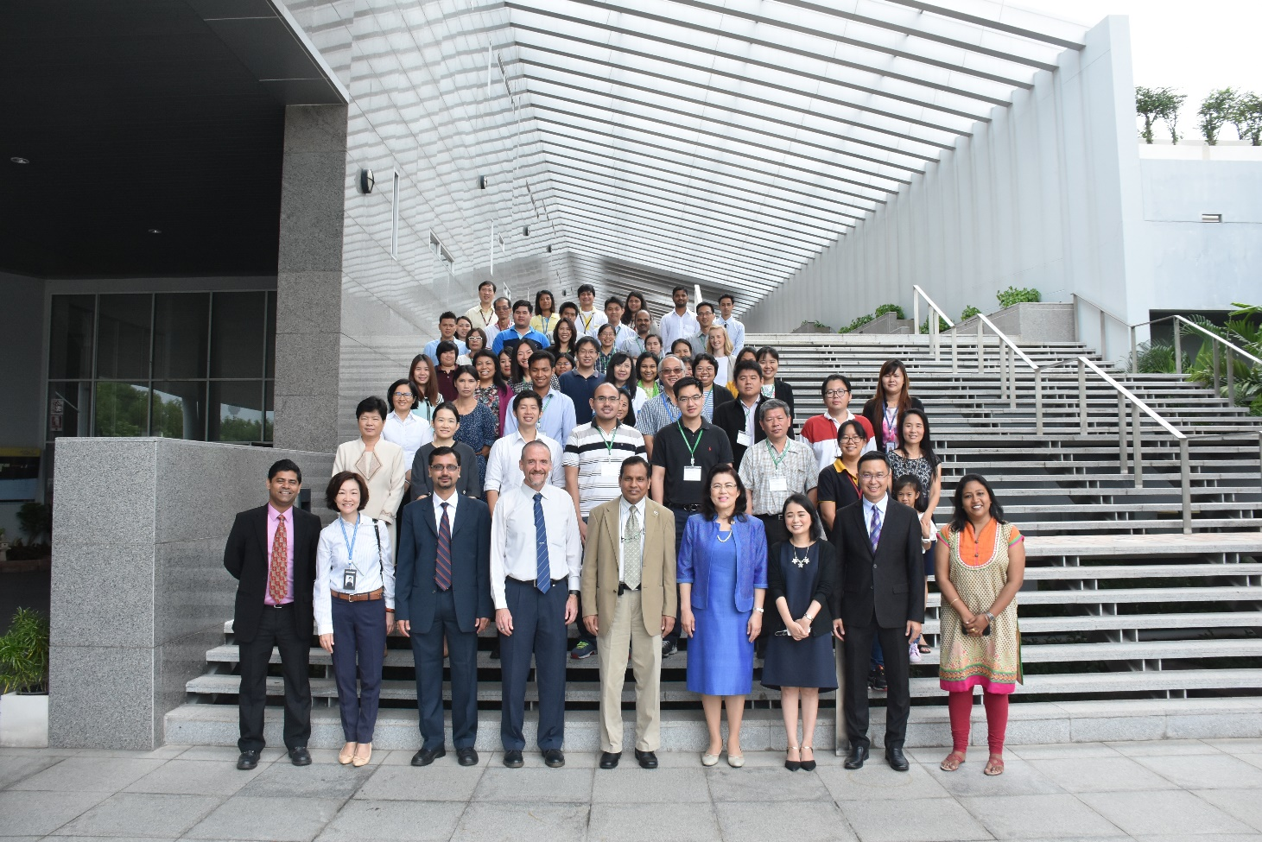

26-30 September, 2016
The Sirinthorn Science Home (Lecture Hall – 2)
National Science and Technology Development Agency (NSTDA)

CONTENTS

- Background……………………………………………………………3

- Workshop Objectives and Structure………………………………..4

- Workshop Proceedings………………………………………………6

- Key Outputs and Discussions……………………………………...17

Annex A: Workshop Program………………………………………….18

Annex B: Brief CVs of Resource Persons……………………………20

Annex C: List of Participants…………………………………………..26

Annex D: Participants’ Evaluation of the Workshop…………………28

Annex E: Gallery………………………………………………………..29

- BACKGROUND

Agriculture plays an important role in Thailand. More than 40% of the labor force is engaged in the agricultural sector, which is heavily impacted by climate change. In the future the agricultural sector will further be impacted by extreme weather, resource scarcity and environmental degradation. Existing applied technologies may not be robust enough to cope up with the anticipate changes. Thus, technology development and technology transfer on the efficient use of resources are necessary to for the agricultural sector to address climate change, to increase productivity, as well as to meet the sustainable productivity goal of the country.
On 30th November 2015, the National Designated Entity (NDE) of Thailand submitted a request to CTCN entitled “Technology development for climate resilience and efficient use of resources in the agricultural sector in Thailand”. The request was made by the National Science and Technology Development Agency (NSTDA) of Thailand, which was routed through the Thai NDE.
The request for technical assistance centered on seeking support for enhancing skill & knowledge of Thai stakeholders in precision farming, considering both theoretical and practical implications. An element of the support requested was in the form of training that would be suitable for a diverse group of stakeholders—including academic, research institutes, and private sector—which would not only have classroom lectures, but also field practices on the application of technologies & tools.
In response to the request made, as one of the activities, the CTCN, Thai NDE’s office, NSTDA and the Asian Institute of Technology organized a workshop from 26-30 September, 2016. The workshop focused on precision farming and on-site specific agricultural management can offer great advantages and optimize input of resources and overall farming practices. The technology is still in a formative stage in Thailand. Hence, the workshop was expected to further the case for widespread use and application of such technologies in various settings.

- WORKSHOP OBJECTIVES AND STRUCTURE

2.1 Objectives
The overall objective of the workshop was to enhance the capacities of Thai stakeholders in the knowledge and application of technologies that would help in the efficient use of resources. More specifically, the workshop endeavored to:
- Boost the participants’ knowledge on the various precision farming technologies that are in practice to manage use of resources judiciously.
- Provide hands-on experience to the participants in the application of precision farming technological components
- Provide an avenue for participants to brainstorm about potential project ideas and how these can be implemented.

2.2 Workshop modality:
The workshop had four kinds of sessions
- Classroom lectures
- Computer-based modeling practice exercises
- Technological demonstrations
- Field trip

2.3 Workshop topics:
The workshop covered FIVE major areas of knowledge:

Knowledge Area-1: Plant phenotyping, density mapping and yield estimation: This session focused on the conceptual background related to Object Based Image Analysis (OBIA) and how this technique could be used to classify high resolution remote sensing images. It also covered aspects of segmentation of image into similar image objects (or segment), followed by classification of image objects based on threshold attributes and relationship between segment objects.

Knowledge Area-2: Hyper/Multi-spectral and thermal imaging: This session set the background for different satellite imagery (both commercially and freely accessible), looking at distinct features as well as limitations in terms of their temporal and spatial resolutions. It then delved into potential applications of those images in precision agriculture, through empirical models/indices to analyze hyper/multi-spectral satellite images.

Knowledge Area-3: Geoinformatics: This session emphasized on geodatabases and web-GIS, and the innovative and potential applications of these geoinformatics tools in creation of Decision Support System (DSS) in precision agriculture. Web-GIS empowers the use of simple handheld devices, such as smartphones, to upload

geo-tagged images, process and to inquire into its geospatial characteristics – at a remotely located server. Applications of Web-GIS enables even unskilled farmers to create and use these database online, and to receive expert advisory from remotely located offices. This DSS eventually helps improving resources use efficiency in the crop production with timely and appropriate applications of agricultural inputs.

Knowledge Area-4: Smart irrigation and fertigation: This session provided insights into the conceptual background of wireless sensor network (WSN) for precise scheduling of homestead irrigation. Drastically reduced prices of computers and electronics, and wide accessibility of internet have opened innovative opportunities of its application in agriculture. Appropriate sensors can be placed at desired locations to collect real-time status of different indicators, which can eventually be used to operate a smart irrigation and fertigation facility.

Knowledge Area-5: Sensor technology: This session sought to elucidate the underlying concepts in different handheld devices such as cameras (RGB, NIR), SPAD sensor, spectrometer, IR filters, and other laser reflectance sensors. The session also compared different sensors/devices for their in-field performance – and provided guidance on selecting most suited ones to specific intended applications.

Annex A provides details of the day-to-day workshop sessions.

2.4 Resource persons for the workshop
Five core resource persons were engaged for the workshop:

- Dr. Peeyush Soni (Associate Professor), AIT
- Dr. Mathew Dailey (Associate Professor), AIT
- Dr. Kiyoshi Honda (Professor), Chubu University, Japan
- Dr. Juthasinee Thanyapraneedkul (Lecturer), Thamassat University
- Dr. Sarawut Ninsawat (Assistant Professor), AIT

In addition to the five resource persons, a special keynote address was made by Dr. Donghui Ma (VSN China/Biosci Thailand).

See Annex B for short bios of the core resource persons.

2.4 Workshop participants:
20 core participants from universities, government agencies, and private sector
30-40 non-core participants who attended the morning sessions only.

See Annex C for the detailed participant listing.

3. WORKSHOP PROCEEDINGS

DAY 1 (26 SEPT, 2016)
Venue: The Sirinthorn Science Home (Lecture Hall-2), NSTDA

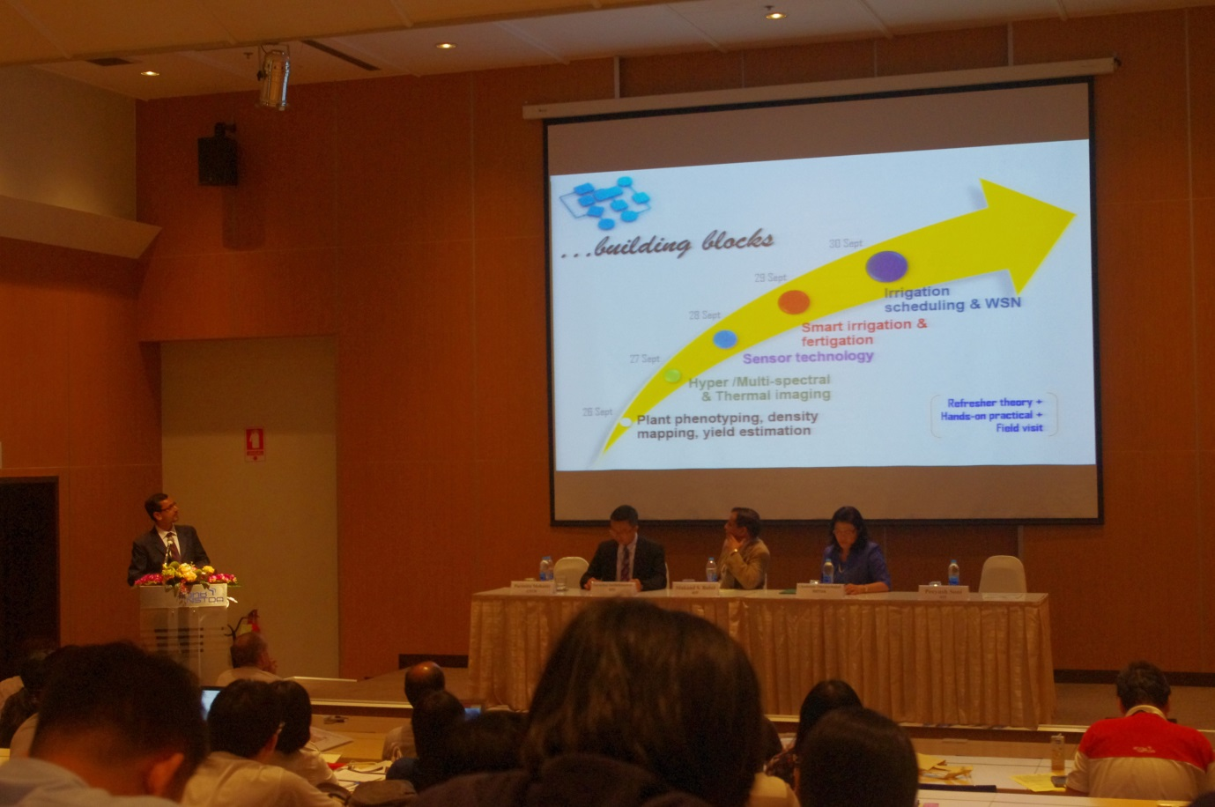

Opening session:
The opening session was facilitated by Dr. Victor Shinde (AIT). Opening remarks were made by opening remarks by Mr. Jukka Uosakainen (Director CTCN); Dr. Surachai Sathitkunarat (STI); Dr. Chadamas Thuvasethakul (NSTDA); and Prof. Mukand Singh Babel (AIT).

Mr. Jukka Uosakainen welcomed the participants (through a video message), and acknowledged the importance of such interactive platforms for raising awareness on changing climate, and also emphasized on the need for collective action to devise technological solutions. He also appreciated the Thai NDE’s vision of preparing a pertinent request for CTCN assistance. Dr. Surachai Sathitkunarat described the background that led to the development of this request, and lauded the partnership between NSTDA and AIT to jointly develop this workshop. He invited the participants to make the best use of this platform. In her welcome remarks, Dr. Chadamas Thuvasethakul advocated the importance of this workshop in context of climate change and Thai agriculture. She encouraged the participants to actively engage in networking with each other and with the resource persons. Prof. Mukand S. Babel welcomed the participants and briefly described the range of climate-change related activities at AIT – underpinning their interdisciplinary nature. He acknowledged the relevance of the workshop on precision agriculture and mentioned that this was wonderful example of a “no regrets” technology, whose benefits are evident with or without climate change.

Dr. Peeyush Soni (AIT) presented the workshop agenda and summarized the course objectives. He noted that 20 participants were carefully selected by NSTDA – representing government agencies, private sector, universities, and research institutions; yet other interested individuals were welcome to attend the morning sessions. Dr. Parimitha Mohanthy (CTCN) welcomed the participants on behalf of the CTCN. She briefed the audience with the mission and mandate of CTCN, and its relevance to strengthen the region’s capacity to address climate-change related issues.

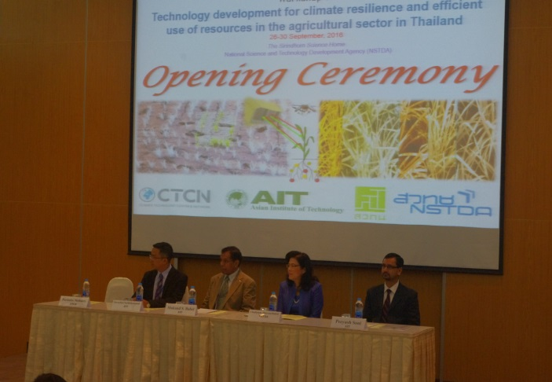 | 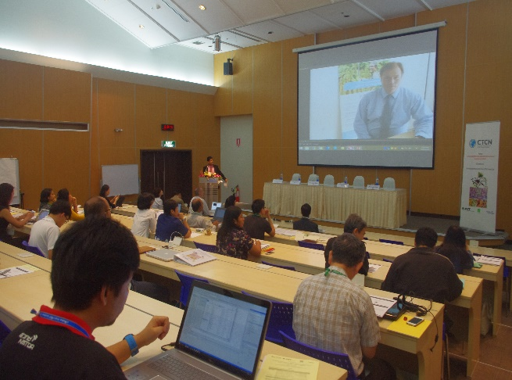
Left: Opening session speakers from left to right: Dr Surachai Sathitkunarat (STI); Prof. Mukand Babel (AIT); Dr. Chadamas Thuvasethakul (NSTDA); Dr. Peeyush Soni (AIT)
Right: Video message by CTCN Director Mr. Jukka Uosakainen

Morning session:
Theory: “Plant phenotyping, density mapping and yield estimation” – by Dr. Matthew N. Dailey (AIT)

Dr. Dailey discussed the conceptual basis of machine vision in precision agriculture. After discussing the preliminaries on pattern recognition and machine learning, he introduced the participants with 3-D computer vision. His discussion also included the texture modeling with SIFT, classification with SVMs, agricultural crop mapping and high-throughput plant phenotyping. The participants were apprised of how the object based image analysis (OBIA) technique can be used to classify images. His presentation concluded with the following take-home messages:

- Most precision agriculture applications based on computer vision involve extraction of 3D or 2D structure and/or appearance.
- Automatic extraction of structure is increasingly practical and well understood in the computer vision community.
- Appearance extraction is more application specific.
- In industrial environments, conditions can be controlled so that appearance is easy to measure.
- In outdoor environments, simple problems such as illumination create uncertainity.

Afternoon session:
Practice: “Plant phenotyping, density mapping and yield estimation” – by Dr. Matthew N. Dailey et al. (AIT)

The afternoon session included practice with Python programming for segmentation of image into similar image objects (or segment), followed by classification of image objects based on threshold attributes. The participants were provided with raw data from field, and were guided to segment the images of pineapples, gourds and melons by using open source codes.

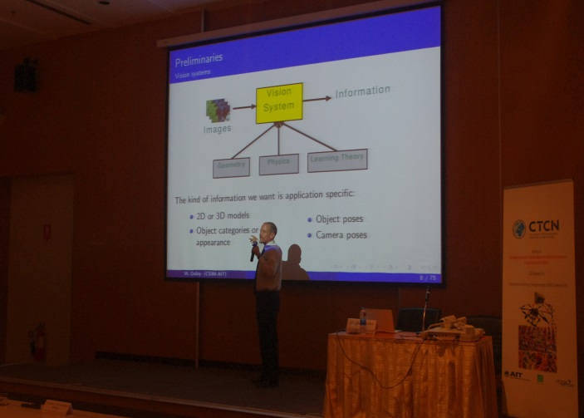 | 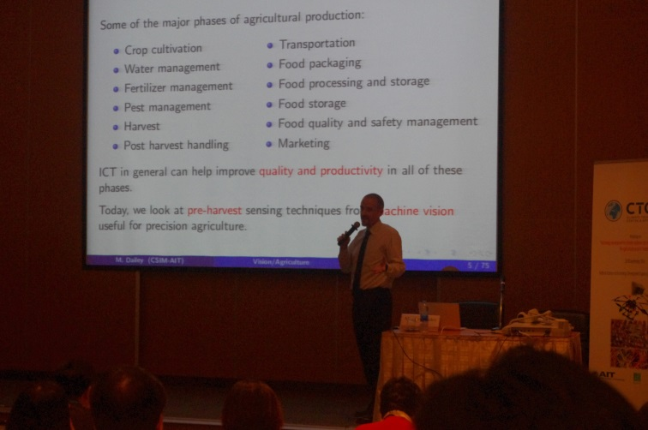

Left and Right: Dr. Mathew Dailey conducting his session on plant phenotyping density mapping and yield estimation

DAY 2 (27 SEPT, 2016)
Venue: The Sirinthorn Science Home (Lecture Hall-2), NSTDA

Morning session:
Dr. Peeyush Soni presented the recap of the Day-1, and summarized how image analysis and machine vision were demonstrated to be useful in precision agriculture.

Theory: “Hyper/Multi-spectral and thermal imaging” – by Dr. Juthasinee Thanyapraneedkul (Thammasat University)

In this session, Dr. Juthasinee presented the fundamentals of remote sensing and its potential applications in precision agriculture. Spectral signatures of different agricultural products were shown to be different than that of soil and water surrounding it. Spectral characteristics of energy sources and sensing systems were then described, including the generic classification of different bands. Satellite remote sensing systems were discussed for their spectral, temporal spatial and radiometric resolutions. Participants were provided with a refresher background on different satellite imagery. Distinct features as well as limitations of those satellites were compared in terms of their temporal and spatial resolutions. Hyperspectral remote sensing and its supporting platforms (satellites) were shown to be potentially useful in precision agriculture; e.g. crop yield estimation, detection of nutrient deficiencies, disease infestation, NPK mapping etc. Thermal imaging concepts were also discussed with the participants. Use of vegetative index was discussed with introduction to some popularly used VIs, e.g. NDVI.

Practice: “Hyper/Multi-spectral and thermal imaging” – by Dr. Juthasinee Thanyapraneedkul et al. (Thammasat University)

Participants were guided to use QGIS with open layers, semi-automatic classification plugins. Google Earth Pro was also used to overlay the GIS maps after image analysis. Raw data was downloaded from USGS website, on Landsat sentinel-2 satellite image repository. The images were used to demonstrate field estimation of biomass, primary production, and the plant evapotranspiration.

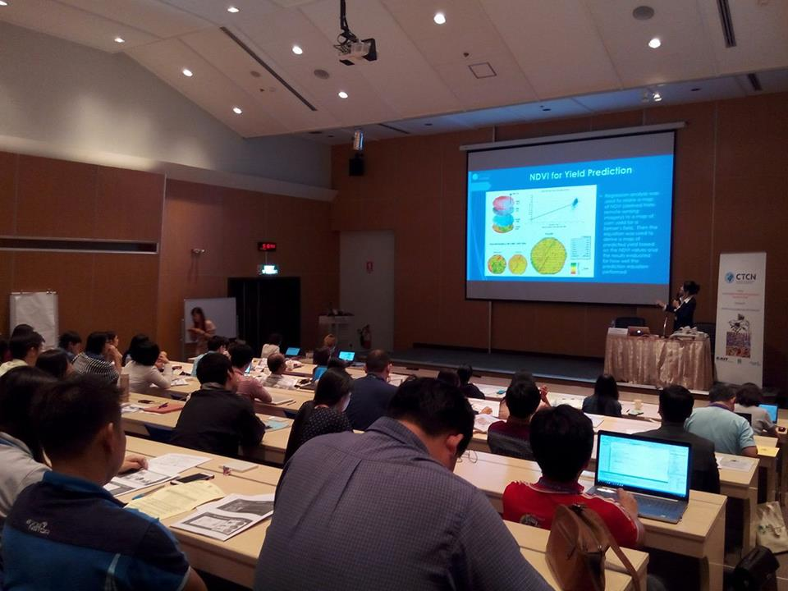 | 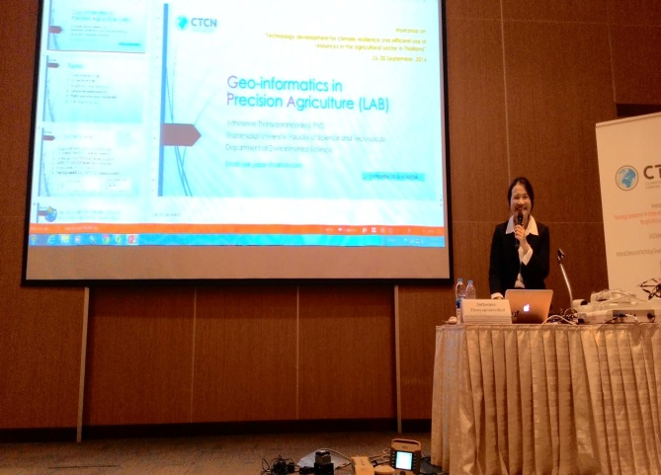
Left and Right: Dr. Juthasinee Thanyapraneedkul conducting her session on hyper/multi spectral thermal imaging

Afternoon session:
Theory: “Sensor technology” – by Dr. Peeyush Soni (AIT)

The afternoon session was dedicated to sensor technology. Dr. Soni provided the participants with a critical review of underlying concepts in different handheld devices. Generic classification of sensors was presented with their distinct features and underlying working principles. Several empirical indices shown to be conveniently computed using existing sensor technologies. Some innovative applications of these indices in estimation of plants’ nutritional status were also discussed. Relative performances of different sensors under different working conditions (e.g. illumination) were also discussed. Integration of sensors and disseminating data over wireless sensor network was also shown. It was also reminded that sensors come with their own limitations, hence, careful selection of appropriate sensor remains the key to a good measurement. Emphasis was given on the ground-based or near ground-based/handheld sensors. Examples were cited from spectral vegetation indices to assess and monitor biophysical properties, pests and diseases and macronutrients in both soil as well as in plants. Working principles of some commercially available sensors were discussed, including Cropspec, SPAD, Spectrometer, Greenseekers, Cropcircle, and LAI meter. Participants were provided with an example of Integrated Coffee Pests and Disease Management System (ICPDMS) as a case study on deploying and using sensors in farm management.

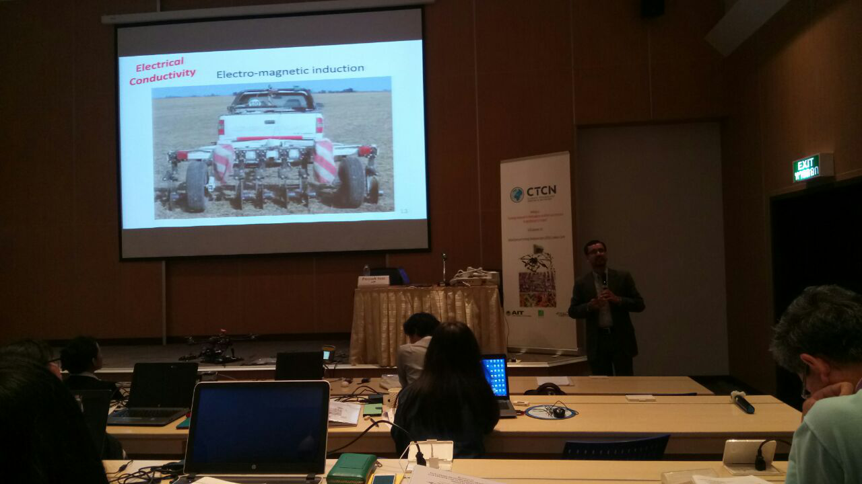 | 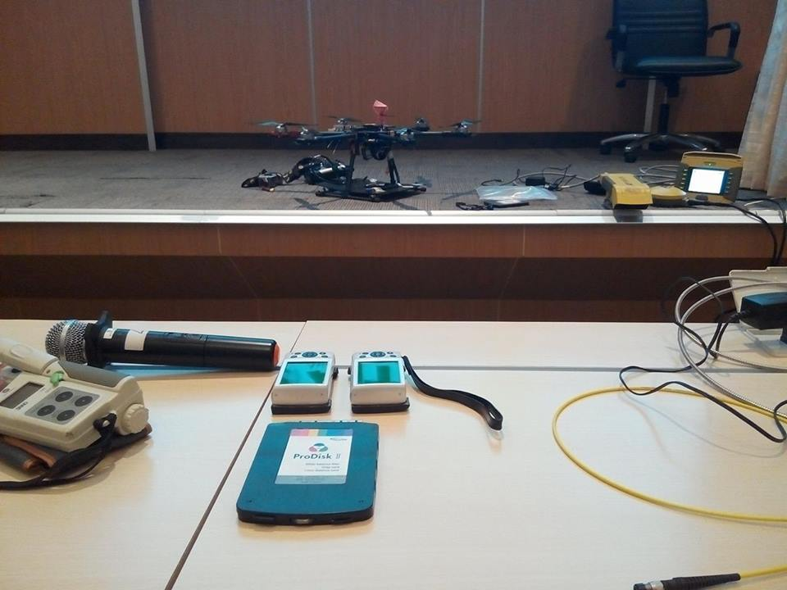
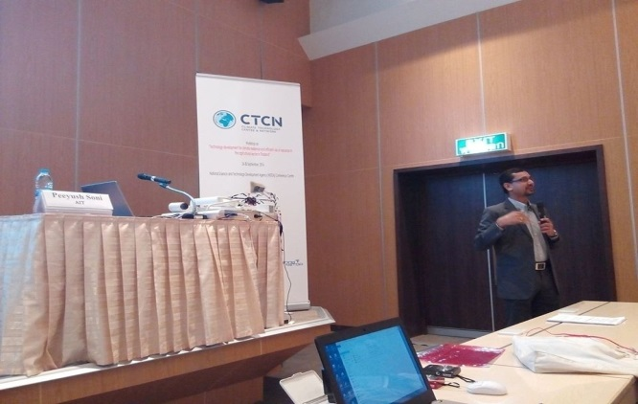 | 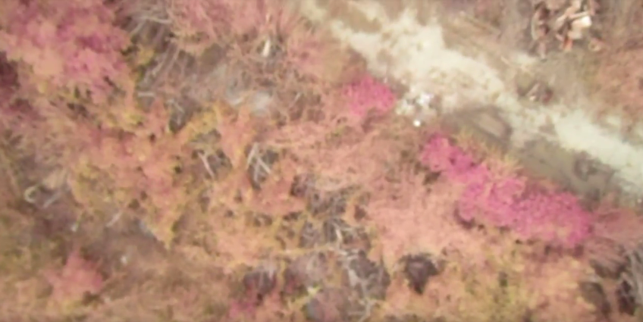
Top Left and Bottom Left: Dr. Peeyush Soni conducting his session on sensor technology
Top Right and Bottom Right: Field exercises conducted during the session

Practice: “Sensor technology” – by Dr. Peeyush Soni et al. (AIT)

Participants were provided with practical session on computing Vegetation Indices using images acquired from field. Different sensors were demonstrated to estimate plant Nitrogen content, including CropSpec, RGB camera, NIR camera, Spectrometer. Image acquisition using remote-controlled drone was also practically shown to the participants. The acquired images were then analyzed for VIs computation and for Nitrogen estimation. Following summarizes the practical session activities:
- Use Spectrometer, SPAD, CROPSPEC
- Use CAMERA with different filters and different platforms (Handheld and DRONE) and extract RGB from images.
- Apply appropriate VIs (provided a list of more than 100 VIs)
- Statistical Analysis (SPECTROMETER, SPAD, or CROPSPEC as dependent variable), and
- CAMERA data as Independent variable

Day 3 (29 Sept, 2016)
Venue: The Sirinthorn Science Home (Lecture Hall-2), NSTDA

Morning session:
Dr. Peeyush Soni presented the recap of the Day-2, and summarized how sensor technology could be useful in precision agricultural applications.

Theory: “Smart irrigation and fertigation” – by Prof. Kiyoshi Honda (Chubu University)

Prof. Honda provided the participants with a conceptual background of wireless sensor network (WSN) for precise scheduling of irrigation. They realized how conveniently computers and electronics can be integrated using internet technology for conserving precious agricultural inputs by improving their application efficiencies. Prof. Honda’s presentation on “ICT Agriculture for Climate Change Adaptation and Precision Farming” had the following specific sections: a) Modeling and simulation for climate change adaptation and precision farming, and b) Data driven agriculture on interoperable web services. He also introduced the participants with Auto Navigation and Guidance System, where he demonstrated by video (i) Kubota's auto-pilot technology, and (ii) Low Cost - Retrofit GPS Guidance System, Agri Info Design Ltd. In the later part of his presentation, Prof. Honda discussed the Sensor service platform and agriculture services in Japan, with cloudSense and agricultural APIs for preparing data to perform crop modeling. He discussed the agricultural applications, including (i) FieldTouch by IHI and (ii) e-kakashi by PS Solutions. Eventually, he told some success stories of Japanese farmers using ICT in agriculture.

Afternoon session:

Prof. Honda and his colleagues demonstrated the interoperable web services and its applications:

- CloudSense field sensor network infrastructure by ListenField
- Agro-Environmental Data Interoperability Voluntary WG
- e-Cropping Calendar by iBunya InterAct Project
- Soil API - Swagger
- NARO 1-km Gridded Climate Data via SOS - Swagger
- Visualizing Pest & Disease History in Japan from text based warnings
- Seasonal Forecast at IRI, Columbia University
- Weather Generator on Web
- DSSAT
- Tomorrow’s RICE - Rice Growth Simulation on Web DSSAT
Practice: “Mini Ideathon” – by Prof. Kiyoshi Honda et al. (Chubu University)
Mini Ideathon: “Implementing Precision Farming to Thailand” was introduced to the participants. The participants were divided into five groups. Each group was asked to categorize their ideas into High/Low in terms of impact to farm management; and then into High/Low in terms of feasibility. Then they was asked to select an idea from the High impact and High feasibility sub-class. The groups presented the selected idea and discussed the key stakeholders and their role, and the technology required to realize that idea.
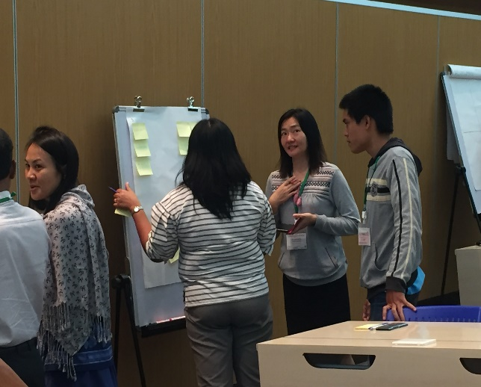
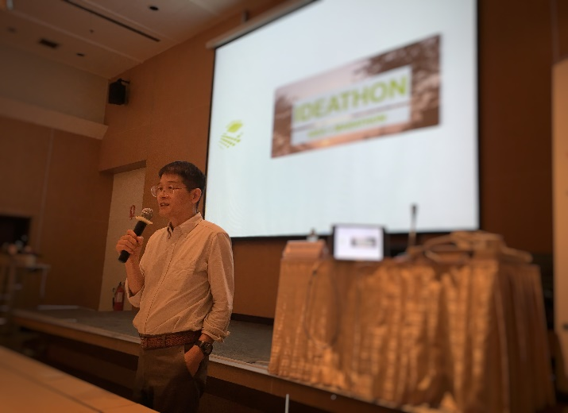
Left: Dr. Kiyoshi Honda conducting his session on smart irrigation and fertigation
Right: Participants implementing the mini ideathon

Day 4 (30 Sept, 2016)
Venue: The Sirinthorn Science Home (Lecture Hall-2), NSTDA

Morning session:

Dr. Peeyush Soni presented the recap of the Day-3, and summarized how the advancements in ICT and electronics could be useful in irrigation applications.

Theory: “Geoinformatics” – by Dr. Sarawut Ninsawat (AIT)

Dr. Sarawut introduced the participants with the concepts in geodatabase and web-GIS as decision support system for precision agriculture. He highlighted the transformation of Data to Information, and then to Knowledge. A database was defined as a collection of data, typically describing the activities of one or more related organizations. He then described a database management system, with particular application of sharing and accessing it over common web interface. Spatial database were shown to be more handy in agricultural applications; however, there were also some limitations e.g. high cost, lack of compatibilities with some free GIS software. He shared some spatial database offerings, e.g. ESRI ArcSDE; Oracle Spatial; IBMDB2 Spatial Extender; Informix Spatial Data Blade; MSSQL Server (with ESRISDE); Geomediaon MS Access; SpatialLite; PostGIS/ PostgreSQL. Later on when talking about spatial indexing, he described R-Tree Indexing.

Afternoon session:

Practice: “Geoinformatics” – by Dr. Sarawut Ninsawat et al. (AIT)

Through the practice session, Dr. Sarawut introduced WebGIS. He also demonstrated how the Extensible Mapping Application tools help developer to easily perform a common task (layer control, zoom-to-extent, query etc.) and allow them to customize the functionalities as well. Some of such tools introduced were: ESRI WebADF/JavaScript API; Google Maps API /ArcGIS JS Extension; Google Earth API; Bing Maps API /ArcGIS JS Extension; Bing Maps Silverlight API (Microsoft); Flex (Adobe) / ArcGIS Extension; Yahoo Maps API; OpenLayersAPI; and ArcGIS for iPhoneAPI. Later on, Dr. Sarawut discussed the applications of OGC web services.

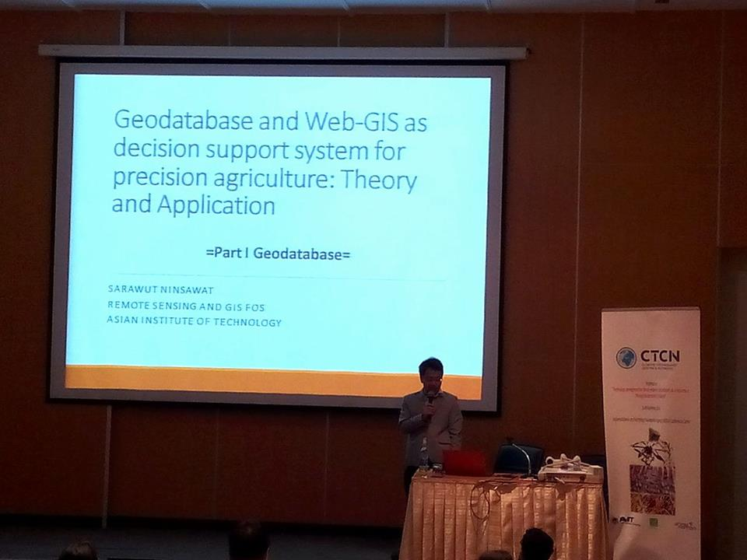 | 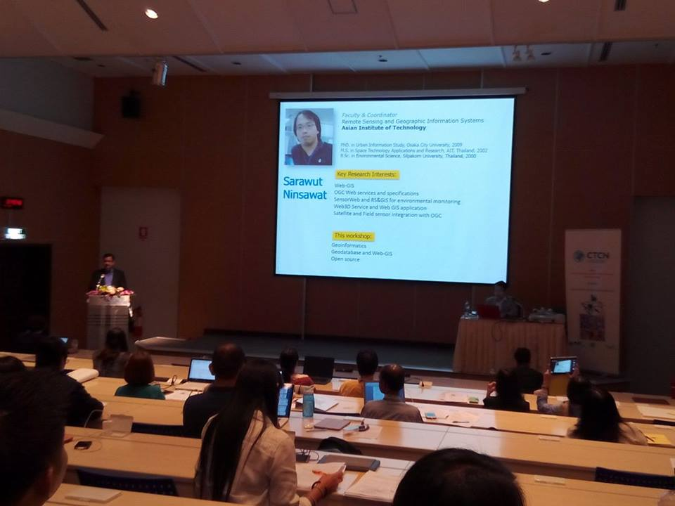
Left and Right: Dr. Sarawut Ninsawat conducting his session on Geoinformatics

Closing session:

A formal closing session was organized, which was presided over by Prof. Mukand S. Babel. Certificates of Attendance were distributed to all participants. Prof. Babel thanked the participants, organizers- AIT, NSTDA, and partners-STI and CTCN for their roles in making this workshop successful. Participants were invited to share their experiences. The workshop was formally closed, and the participants were provided with Workshop Evaluation forms, and were reminded of logistics for the field trip.

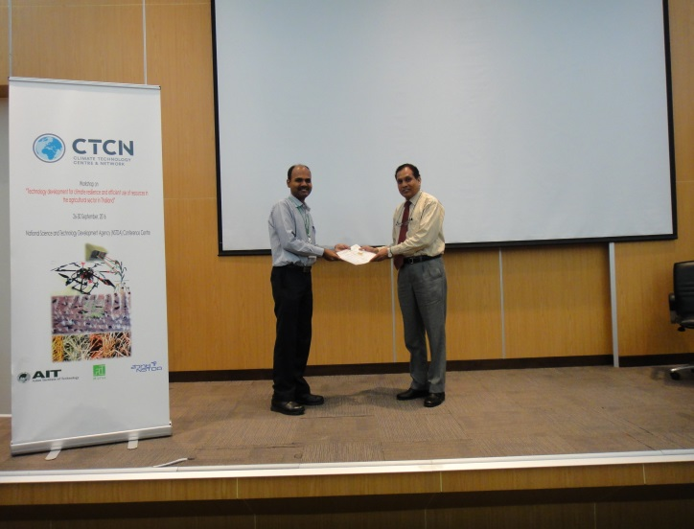 | 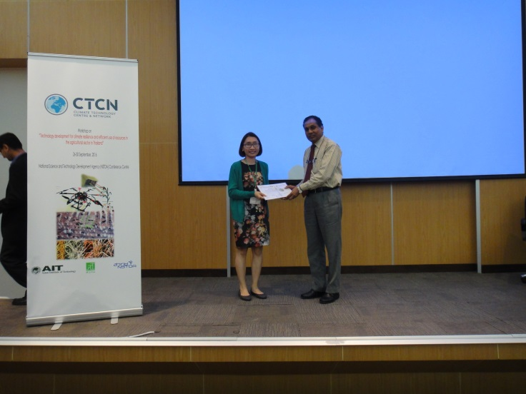
Left and Right: Prof. Mukand Babel awarding certificates to the participants

Day 5 (30 Sept, 2016)
Venue: Suranaree University of Technology, Nakhonratchasima

Dr. Sodchol Wonprasaid presented drip Irrigation and fertigation concepts. His specific focus was on economic crops in the Northeast. He also discussed the irrigation scheduling for sugarcane and cassava. Late on, Dr. Arthit Srikaew demonstrated an irrigation scheduling software for automatic planning and control of field irrigation. Dr. Thitiporn Machikowa and Dr. Prayouth Kumsawat presented the applications of wireless sensors for managing the field irrigation systems. Eventually, an automatic control system with application of solar-powered water pump was demonstrated on field, by Dr. Prayouth Kumsawat and Dr. Kongpol Areerak.

Dr. Peeyush Soni thanked the colleagues from Suranaree University of Technology for their efforts in showcasing the automatic micro-irrigation system. This concluded the five-day workshop.

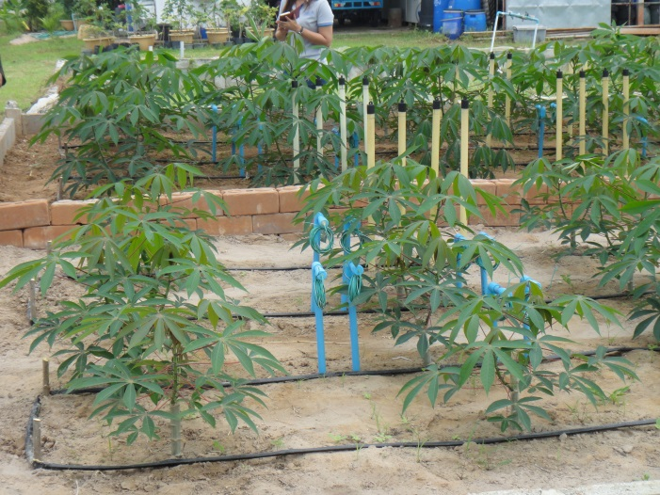 | 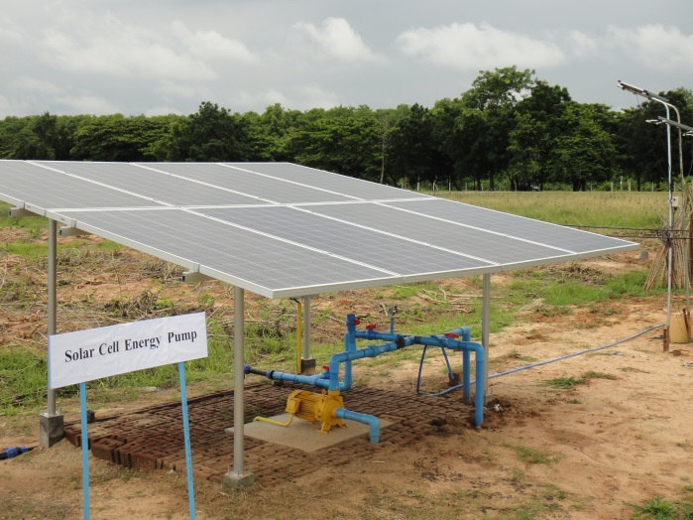
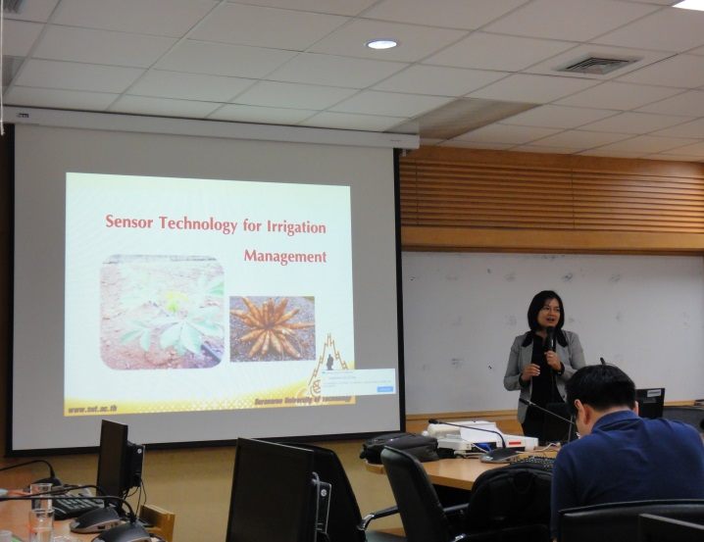 | 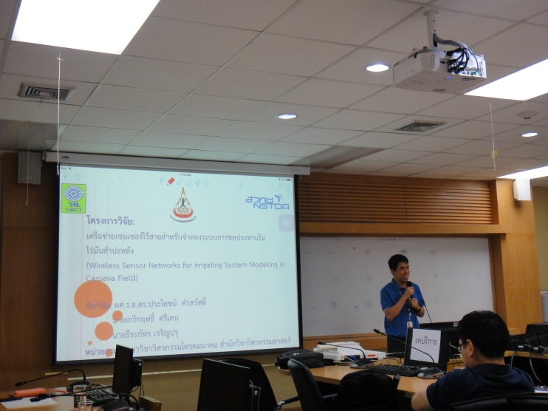

4. KEY OUTPUTS AND DISCUSSIONS

Below is a summary of key discussion points deliberated by participants during the workshop sessions.
- “Technologies for measuring soil nutrients (NPK) with non-destructive and rapid methods.”
Participants discussed if there were non-destructive methods to measure macro nutrients (NPK) in a soil sample. Discussions went along the line of in-situ measurement with rapid methods. Though the laboratory measurements are still regarded as the most accurate methods, yet it was felt necessary to explore different tools in remote-sensing for indirect estimation. Resource persons referred to using NIR Spectroscopy, but also argued that their field use is limited due to excessive cost and operating-skill requirements. More indirect estimation techniques are therefore popularly used. However, there is still a great deal of research required to calibrate/validate those models.
- “Costs of different sensors v/s their accuracies and performance.”
Participants raised the issue of selection of sensors for agricultural (field)use. Although there exists a variety of sensors to select from, yet, some important features (including their operating cost, operating range, accuracy and durability) play crucial role in their selection. It was discussed at length and concluded that the cost of sensors has been a major limitation in Thailand for vast adoption of precision agriculture technologies. Resource persons presented some low-cost methods/concept; however, it was felt necessary to validate those methods under local field/environmental conditions.
- “Smartphone- or web-based control of irrigation systems.”
Irrigation is regarded as a single most important (and challenging) activity in the farm production, which determines profitability (as well as sustainability) of farming system when supply of other factors remain sufficient. Access to irrigation and timeliness in irrigation were considered to be two major concern of Thai farmers. The Participants discussed that automatic (and remote) monitoring of plant water stress could be the ‘impact-making’ intervention to realize irrigation-efficiencies. Resource persons showed several success stories from the region, where implementation of smartphone- or web-based control of irrigation and fertilization system (a.k.a. Smart Fertigation) has resulted in higher benefits to farmers while saving precious resources. Those systems could be easily handled by farmers, and upon linked to a locally-adopted decision-support-system it also adds value to the decision making. Some participants (from industry) also shared their experiences with such automated systems, while other participants expressed their interest in exploring it for further considerations.
- “Smartphone- or web-based monitoring of plant health.”
Participants contemplated smartphone- or web-based monitoring of plant health, which could include integrated applications of GIS, sensors, cloud computing, remote sensing and local wisdom. Plant growth indicators, of particular interest, discussed were: disease monitoring, insect/pests infestation, plant nutrients, plant water stress, and yield estimation. Out of these, plant Nitrogen content estimation got special attention – as this could be taken as a resultant effect of several other processes. Resource persons demonstrated some indirect methods of plant Nitrogen content estimation, including NIR cameras, Spectormeters, several Vegetation Indices, and low altitude remote sensing platforms (i.e. UAVs or cranes). Low-cost, yet with acceptable results of some of these methods drew good deal of attention from the Participants.
- “Automated Irrigation”: A web-based smart irrigation system. Integrating soil moisture and weather sensors with IoT and data analytics; which can be managed at cloud server and interfaced with mobile applications.
- “Shouting Frog”: To improve the current situation of planting, where planting dates rely on farmers’ own experience, a soil-water-plant-atmosphere continuum is envisaged. With the help of weather station, remote sensing, automatic sensors, data analytics (Big data) and crop models, the farmers can be alerted through mobile phone on the critical dates of planting.
- “Cassava Yield Improvement”: Currently soil analysis for cassava fields is done by traditional lab-based methods. There is an urgent need for effective warning system for the events affecting yield loss. A sensor network could monitor the health of cassava crop over the entire growing period.
- “Intelligent Pest Control System”: Over application of pesticides can be avoided by using sensors mounted on UAVs (drones). The drones can help, through on-board sensors, in forecasting, monitoring, warning, and managing the insects and pests for field crops.
As a part of the group work, four group of Participants deliberated on possible technological adoption in precision agriculture. They classified those ideas in a matrix of feasibility and impact. They presented their selected application which fell under the quadrant of High-impact and High-feasibility. Items (e)-(h) above summarizes those ideas.

ANNEX A: WORKSHOP PROGRAM

Master of Ceremony for Opening Session: Dr. Victor Shinde
DAY 1, 26th September, 2016 (Monday)
0800-0830h | Registration
0830-0915h | Welcome address by CTCN (5 min)…………………… Parimita Mohanty  Welcome address by CTCN Director (Video).…………..Jukka Uosakainen  Welcome address by STI (5 min)………………… Surachai Sathitkunarat  Welcome address by NSTDA (5 min)……… Chadamas Thuvasethakul  Welcome address by AIT (5 min)………………………… Mukand S. Babel  Introduction of coreparticipants (5min)……………….…………………..…….All  Workshop objective and agenda (10 min)………………… Peeyush Soni  Group picture (10 minutes)…………………………………..………………..……..All
0915-1030h | Topic 1: Plant phenotyping, density mapping and yield estimation (Lecture)……………………………….………………….………… Matthew Dailey
1030-1045h | Coffee break
1045-1200h | Topic 1: Plant phenotyping, density mapping and yield estimation (Lecture continued)…………..……………………….………. Matthew Dailey
1200-1300h | Lunch break
1300-1430h | Topic 1: Plant phenotyping, density mapping and yield estimation (Practice)…………..……………………………………..…………… Matthew Dailey
1430-1445h | Coffee break
1445-1700h | Topic 1: Plant phenotyping, density mapping and yield estimation (Practice)…………..……………………………………..…………… Matthew Dailey
DAY 2, 27th September, 2016 (Tuesday)
0800-0815h | Recap of Day-1…………………………………………………..……… PeeyushSoni
0815-0915h | Topic 2: Hyper/Multi-spectral and thermal imaging(Lecture)……………………………… Juthasinee Thanyapraneedkul
0915-0930 | Coffee break
0930-1200h | Topic 2: Hyper/Multi-spectral and thermal imaging (Practice)…………………………………..…… Juthasinee Thanyapraneedkul
1200-1300h | Lunch break
1300-1400h | Topic 3: Sensor technology (Lecture)……………………... Peeyush Soni
1400-1515h | Topic 3: Sensor technology (Practice)……..……………… Peeyush Soni
1515-1530h | Coffee break
1530-1700h | Topic 3: Sensor technology (Practice)……..……………… Peeyush Soni

DAY 3, 28th September, 2016 (Wednesday)
0800-0815h | Recap of Day-2………………………………………………………. Peeyush Soni
0815-1000h | Topic4: Smart irrigation and fertigation (Lecture).…... Kiyoshi Honda
1000-1015h | Coffee break
1015-1115h | Topic4: Smart irrigation and fertigation (Lecture).….… Kiyoshi Honda
1115-1200h | Topic4: Smart irrigation and fertigation (Practice).…. Kiyoshi Honda
1200-1300h | Lunch break
1300-1430h | Topic4: Smart irrigation and fertigation (Practice).…… Kiyoshi Honda
1430-1445h | Coffee break
1445-1700h | Topic4: Smart irrigation and fertigation (Practice).…… Kiyoshi Honda
DAY 4, 29th September, 2016 (Thursday)
0800-0815h | Recap of Day-3…………………………………………………..………Peeyush Soni
0815-0845h | Special keynote address…………………………………………….. Donghui Ma
0815-1015h | Topic 5: Geoinformatics(Lecture)…………………..…. SarawutNinsawat
1015-1030 | Coffee break
1030-1200h | Topic 5: Geoinformatics(Practice)……….………..…… Sarawut Ninsawat
1200-1300h | Lunch break
1300-1515h | Topic 5: Geoinformatics(Practice)……….………..…… SarawutNinsawat
1515-1530h | Coffee break
1530-1600h | Certificate Distribution……..…………………………………….AIT Representative
1600h - | Departure for field trip

DAY 5, 30th September, 2016 (Friday) (Suranaree University of Technology, Nakhonratchasima)
09.00 - 10.00 h | Lecture  Drip Irrigation and fertigation for economic crops in the Northeast  and Irrigation scheduling for sugar cane and cassava  By Sodchol Wonprasaid  Irrigation scheduling software  By Arthit Srikaew
10.00 - 10.15 h | Coffee break
10.15 - 12.00 h | Practice  Drip Irrigation and fertigation for sugar cane and cassava.  By Sodchol Wonprasaid  Irrigation scheduling software  By Arthit Srikaew  Wireless sensor for irrigation management  By Thitiporn Machikowa and Prayouth Kumsawat  Automatic controlled and solar energy water pump By Prayouth Kumsawat, Kongpol Areerak, Kongpan Areerak
12.00 - 13.00 h | Lunch break
13.00 - 14.00 h | Discussion

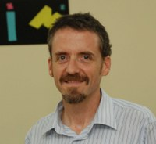
ANNEX B: SHORT CVs OF RESOURCE PERSONS
Dr. Mathew Dailey
Affiliation: Associate Professor, Computer Science and Information Management, Asian Institute of Technology, Thailand.
Expertise: Machine vision, machine learning, robotics, intelligent systems, cloud computing
Peer reviewed publications (2014 onwards only):
Noor, W., Dailey, M.N., and Haddawy, P. (2014), learning predictive choice publicationsmodels for decision optimization. IEEE Transactions on Knowledge and Data Engineering, 26(8): 1932{1935.
Basit, A., Qureshi, W.S., Dailey, M.N., and Krajnik, T. Joint localization of pursuit quadcopters and target using monocular cues. Journal of Intelligent and Robotic Systems, in press.
Chaivivatrakul, S. and Dailey, M.N. Texture-based fruit detection. Precision Agriculture, in press.
Chaivivatrakul, S., Tang, L., Dailey, M.N., and Nakarmi, A.D. (2014), Automatic morphological trait characterization for corn plants via 3D holographic reconstruction. Computers and Electronics in Agriculture, 109:109-123.
Baber, J., Dailey, M.N., Satoh, S., Afzulpurkar, N.V, and Bakhtyar, M. (2014), BIG-OH: Binarization of gradient orientation histograms. Image and Vision Computing, 32(11): 940-953.
Mak, C.W., Afzulpurkar, N.V., Dailey, M.N., and Saram, P.B. (2014), A Bayesian Approach to Automated Optical Inspection for Solder Jet Ball Joint Defects in the Head Gimbal Assembly Process. IEEE Transactions on Automation Science and Engineering, 11(4): 1155-1162.
Teeravech, K., Nagai, M., Honda, K., and Dailey, M.N. (2014), Discovering repetitive patterns in facade images using a RANSAC-style algorithm. ISPRS Journal of Photogrammetry and Remote Sensing 92: 38-53.

Synergestic activities (selected)
Professional Reviewer, Thailand Research Fund grant programs, 2012-2014.
Program committee (area chair for Signal Processing section), ECTI-CON 2010 and 2011; program committee member, ECTI-CON 2009.
Technical Program Committee Co-Chair, 2008 and 2009 IEEE International Symposium on Intelligent Signal Processing and Communication Systems (ISPACS 2008, ISPACS 2009).
Program committee, 2008, 2009, 2010 Mahasarakham International Work-shop on Artificial Intelligence (MIWAI 2008, MIWAI 2009, MIWAI 2010).
Fulbright scholarhip committee, Thailand-U.S. Educational Foundation, 2005.
Senior Member of IEEE. Member of the IEEE Computer Society, the IEEE Robotics and Automation Society (RAS), the American Association for Artificial Intelligence (AAAI), and the Thai Robotics Society (TRS).
Dr. Kiyoshi Honda
Affiliation: Professor, International Digital Earth Applied Science Research Center (IDEAS),Chubu Institute for Advanced Studies, Chubu University, Japan.

Expertise: Field sensor networks; Web-based agricultural information processing service; Remote sensing data assimilation for crop model calibration; IT agriculture platform development

Publications (related to IT and Agriculture):
Sensor Observation Service API for Providing Gridded Climate Data to Agricultural Applications: Rassarin Chinnachodteeranun, Kiyoshi HONDA: Future Internet 2016, 8(3), 40; doi:10.3390/fi8030040, 2016
Sensor Observation Service (SOS) and Multi-Layered API for Constructing Applications in Farm Management: HONDA Kiyoshi, Rassarin Chinnachodteeranun: Joint Session with SIP & ALFAE:
Standard in Agriculture, Asia Pacific Advanced Network 39th Conference, 4th March, Fukuoka, Japan, 2015
IT-Agriculture supported by interoperable information platforms (Invited): HONDA Kiyoshi: SRII (Service Research & Innovation Institute) Japan Summit, March 1-2, University of Tokyo, “Innovating Digital Economy for Japan” , http://www.thesrii.org/, 2015
Agriculture Information Service Based on Crop Modeling(Invited): HONDA Kiyoshi, A. Ines, A. YUI, A. Witayangkurn, R. Chinnachodteeranun, K. Teeravech: Proc. Of International Conference on Weather/Climate Models and Remote Sensing Applications for Sustainable Agriculture and Food Security Community, pp.86, 25-28 November, Jeju, Republic of Korea, 2014
Agriculture Information Service Built on Geospatial Data Infrastructure and Crop Modeling: K. Honda, A.V. M. Ines, A. Yui, A. Witayangkurn, R. Chinnachodteeranun, K. Teeravech: Proc. Of the 2014 Int’l Workshop on Web Intelligence and Smart Sensing, IWWISS '14, Sep 01-02 2014, Saint Etienne, France, ACM 978-1-4503-2747-3/14/09, doi:10.1145/2637064.2637094, 2014
Agricultural decision support system by multi-scale sensing and modeling: K. HONDA, A. YUI, A. Ines, R. Chinnachodteeranun, A.Witayangkurn: WG5: AGRICULTURE AND FOOD
A Crop Simulation System for Integrating Remote Sensing and Climate Information to Reduce Model Uncertainty in Crop Yield Assessments: A.Ines, K.Honda, A.Yui: American Geophysical Union(AGU)’s 2012 Fall Meeting, 2012
Data Assimilation based on the Integration of Satellite Data and Field Sensor Data for Drought Monitoring: K.HONDA: Joint CCAFS-JRC Workshop; Data assimilation for crop yield forecasting: Concepts, applications and challenges for heterogeneous, smallholder environments, June, JRC, Ispra, Italy, 2012
For full publication listing, access http://www.hondalab.net , or researchgate.net

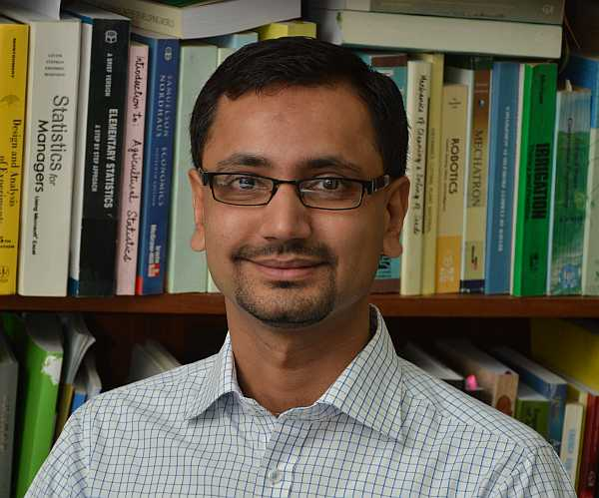
Dr. Peeyush Soni
Affiliation: Associate Professor, Agricultural Systems and Engineering, Asian Institute of Technology, Thailand.
Expertise: Precision agriculture, agricultural instrumentation, agricultural mechanization and automation, sensor network in agriculture, DSS for irrigation
Publications (2015 onwards only)
Hena Imtiyaz and Peeyush Soni (2016). Value Chain Analysis of Guava: Producer, Retailer and Consumer Perspectives 7(4): 17-42. Publisher: International Association of Engineering and Management Education (IAEME). ISSN 0976-6502 http://www.iaeme.com/Ijm.asp [IF: 0.76] http://isithomsonreuters.org/journal
Peeyush Soni (2016). “Agricultural Mechanization in Thailand : Current Status and Future Outlook” Agricultural Mechanization in Asia, Africa and Latin America (AMA), 47(2) : 58-66. Publisher: Farm Machinery Industrial Research Corp., Japan. ISSN: 0084-5841.
Robertoes Koekoeh K. Wibowo and Peeyush Soni (2016). “Farmers’ Injuries, Discomfort and Its Use in Design of Agricultural Hand Tools: A Case Study from East Java, Indonesia.” Agriculture and Agricultural Science Procedia 9:323-327, Publisher: Elsevier. ISSN: 2210-7843 http://www.journals.elsevier.com/agriculture-and-agricultural-science-procedia
Mohammad Badrul Masud, Peeyush Soni, Sangam Shrestha and Nitin K. Tripathi (2016). “Changes in Climate Extremes Over North Thailand During 1960-2099”. Journal of Climatology. Publisher: Hindawi Publishing Corporation. Article ID. 234504
Peeyush Soni, and May New Soe (2016). “Energy Balance and Energy Economic Analyses in Myanmar: Is Irrigated Rice Production System of Ayeyarwaddy Region More Efficient than Rain-fed?” Energy Efficiency, 9(1) : 223-237. Publisher: Springer. ISSN: 1570-6478. [IF: 0.961]
Abbadi Girmay Reda, Nitin K. Tripathi, Peeyush Soni, and Taravudh Tipdecho (2015). “Rain Fed Rice under Climate Variability in Southeast Asia: The Case of Thailand”. Journal of Earth Science and Climate Change, 6(8) : 1-9. Publisher: OMICS Group. [IF: 2.089]. ISSN: 2157-7617 doi: 10.4172/2157-7617.1000297
Asmat Ullah, Sylvain R. Perret, Shabbir H. Gheewala, and Peeyush Soni (2015). ‘Eco-efficiency of Cotton-Cropping Systems in Pakistan: An Integrated Approach of Life Cycle Assessment and Data Envelopment Analysis’. Journal of Cleaner Production. Publisher: Elsevier. ISSN : 0959-6526 [IF : 3.844]
Achievements:
ScienceDirect Top 25 (2013). Ranked 9th on the Top 25 for Journal of Terramechanics – January- March 2013. ScienceDirect Top 25 List of Most Downloaded Paper, by Elsevier B.V., Amsterdam, The Netherlands.
ScienceDirect Top 25 (2013). Ranked 24th on the Top 25 for Agricultural Systems – January- March 2013. ScienceDirect Top 25 List of Most Downloaded Paper, by Elsevier B.V., Amsterdam, The Netherlands
AMA-ShinNorinsha-AAAE Young Researcher Award Sept 2010. In recognition of his outstanding contributions to the advancement of Agricultural Engineering profession; Asian Association for Agricultural Engineering (AAAE); conferred in 20 Sept, 2010 at 11th IAEC, Shanghai (China) http://www.ait.ac.th/news-and-events/2010/news/ase-faculty-receives-the-young-researcher-award/view

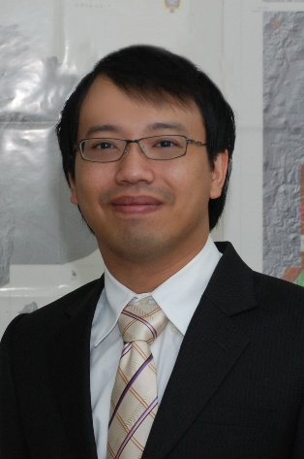
Dr. Sarawut Ninsawat
Affiliation: Assistant Professor, Remote Sensing and Geographic Information Systems FoS, Asian Institute of Technology, Thailand.

Expertise: WebGIS; OGC web services and specifications; sensorWeb and remote sensing; and GIS for environment monitoring.

Publications (selected only)
L. Chudech, M. Nagai, S. Ninsawat and R. P. Shrestha (2016). Modeling urban expansion in Bangkok Metropolitan region using demographic-economic data through cellular automata-markov chain and multi-layer perceptron-markov chain models. Sustainability, 8(7), 23 pages (ISSN:2071-1050)
M. D. Hossain, S. Ninsawat, S. Sharma, T. Koottatep and Y. Sarathai (2016). GIS oriented service optimization for fecal sludge collection. Spatial Information Research, 9 pages. (ISSN:236-3286)
D. Pinto, S. Shrestha, M. S. Babel, and S. Ninsawat (2015). Delineation of groundwater potential zones in the Comoro watershed, Timor Leste using GIS, remote sensing and analytic hierarchy process (AHP) technique. Applied Water Science, 17 pages. (ISSN: 2190-5495)
R. B. Reyes, M. Nagai, Y. Kamiya, T. Tipdecho and S. Ninsawat (2015). Effect of sea level rise in the validation of geopotential/geoid models in Metro Manila, Philippines. Survey Review, 47(342). pp. 211-219. (ISSN: 0039-6265)
S. Bhagabati, A. Kawasaki, M. Babel, P. Rogers and S. Ninsawat (2014). A Cooperative Game Analysis of Transboundary Hydropower Development in the Lower Mekong: Case of the 3S Subbasins. Water Resource Management, 22 pages. (ISSN: 1573-1650)
R. Samphutthanon, N. Kumar Tripathi, S. Ninsawat, R. Duboz (2013). Spatio-Temporal Distribution and Hotspots of Hand, Foot and Mouth Disease (HFMD) in Northern Thailand. Int. J. Environ. Res. Public Health, 11(1). pp. 312-336. (ISSN: 1660-4601)

Notable project carried out
Smart PWA mobile application: GIS Mobile Application on iOS and Android device for supporting Thai Provincial Waterworks Authority
SmartSurvey Mobile application supporting Sugar Cane survey (Mitrphol Research and Development)
Developing GIS plugins for estimating sugar cane yield Identifying Specific Diseases and Pests on Sugarcane Leaves and Trunks using Image Processing.
Prototype Development of Remote Sensing Image Map Server in Thailand and GMS countries (http://mapserver.hondalab.star.ait.ac.th/gms/)
AIT Tsunami team: Sub team “Detailed Mapping of the Damage in the Affected Areas”. Construct a Web Map Service of Tsunami geospatial information sharing system (http://www.tsunami.ait.ac.th)
Satellite and Field sensor Integration system based on OGC standards

Dr. Juthasinee Thanyapraneedkul
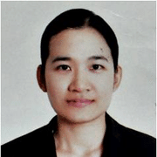
Affiliation: Lecturer, Department of Environmental Science, Thamassat University, Thailand.

Expertise: Vegetation ecology, satellite remote sensing, biomass and NPP estimation, hyper/multi spectral imaging.

Notable projects:
A survey of satisfaction, needs, expectation, attitude of stakeholders to Industrial Estate Authority of Thailand’s operations year 2013 , Industrial Estate Authority of Thailand (Geoinformatic expert)
Low Carbon Tourism perception of tourist who stay in cooperated hotels, Designated Areas for Sustainable Tourism Administration (GIS and Environmental Expert)
Multiplier effects from tourism in special area for sustainable tourism, Designated Areas for Sustainable Tourism Administration (Data researcher)
Research development of statistics and indicators of the criminal justice system and public and expert survey about the value and performance of the criminal justice system, Thailand Institute of Justice (Database expert)
Development of low-cost digital camera system to find crop health index (Nitrogen deficiency) for precision agriculture; (PhotoCrop). Case study : paddy field, Thammasat university young researcher research fund

Publications (selected)
Mineshita Y.; Muramatu K.; Soyama N,; Thanyapraneedkul J.; Motomasa D. An algorithm for the estimation of global gross primary production capacity focusing on shrubs. The Journal of the Remote Sensing Society of Japan, (submitted)
Thanyapraneedkul, J.; Samphutthanon R.; Tarkulwaranont P. Application of Google Earth for Disaster Monitoring, Case Example: Lad Krabang Industrial Estate Flood of the Year 2011. Thai Science and Technology Journal, 2015, 23(3), 398-417 (in Thai)
Thanyapraneedkul, J.; Muramatsu, K.; Daigo, M.; Furumi, S.; Soyama, N.; Nasahara, K.; Muraoka, H.; Noda, H.; Nagai, S.; Maeda, T.; Mano, M.; Mizoguchi, Y. A Vegetation Index to Estimate Terrestrial Gross Primary Production Capacity for the Global Change Observation Mission-Climate (GCOM-C)/Second-Generation Global Imager (SGLI) Satellite Sensor. Remote Sens. 2012, 4(12), 3689-3720
Thanyapraneedkul, J., Ikegami, K., Muramatsu, K., Soyama, N., Daigo, M., Kajiwara, K., Honda, Y., 2011, An improved tree-height measurement method for calculating net primary production in a larch forest on Mt. Yatsugatake, Japan, Nara Women’s University Journal, Vol 26, pp.261-274
Thanyapraneedkul, J., Muramatsu, K., Susaki, J., Daigo, M., 2008, Parameterization of the 3PGS model for above-ground biomass estimation in Eucalyptus camaldulensis and Acacia mangium plantations, Doshisha University worldwide business review Vol.10. No.1, pp.144-160
Thanyapraneedkul, J. and Susaki, J., 2006, Estimation of Forest Plantation Productivity Using a Physiologically Based Model Driven with Meteorological Data and Satellite-derived Estimates of Canopy Photosynthetic Capacity. University of Tokyo, Seisan-kenkyu, Vol 58, No.3

ANNEX C: LIST OF PARTICIPANTS

Core participants:

No | Institute Name: | Name (English):
1 | THAUS Co.,Ltd. | Thanach Songmethakrit
2 | Nakhon Prathom Rajabhat University | Dr. Nitthita Chirdchoo
3 | Department of Fisheries | Dr. Putth Songsangjinda
4 | Mitr Phol Sugarcane Research Centre | Saravanan Rethinam
5 | Thailand Institute of Scientific and Technological Research | Dr. Rochana Tangkoonboribun
6 | NANOTEC | Dr.Khoonsake Segkhoonthod
7 | Khon Kaen University | Dr. Wanwipa Kaewpradit Polpinit
8 | KhaoHin Son Research Station, Kasetsart University | Mrs Kingkan Panitnok
9 | NECTEC | Dr. Teera Phatrapornnant
10 | Royal Irrigation Department | Mrs. Mantana Sucharit
11 | King Mongkut’s Institute of Technology Ladkrabang | SukunyaYampracha
12 | Suranaree University of Technology | Mr. Paramat Kueakkaew
13 | Department of Agriculture | Sainam Udpuay
14 | Irrigation Development Institute of Technology | Mr. Chawakorn Rewtrakulpaibul
15 | Suranaree University of Technology | Mr. Thirasak Thong-ob
16 | BIOTEC | Dr. Udom Sae-Ueng
17 | KMUTT | Asst. Prof. Dr. TreenutSaithong
18 | KMUTT | Asst. Prof. Dr. Saowalak  Kalapanulak
19 | KMUTT | Rardchawadee Silapunt
20 | UbonRatchathani University | Supawadee Chaivivatrakul

General participants

No | Institute Name: | Name (English):
1 | Horticultural Research Institute | Ms. Lawan Chan-amporn
2 | Chiang Mai Royal Agricultural Research Center | MS.Chatnapa Khomarwut
3 | NECTEC | Mr. Amares Kaewpunya
4 | NECTEC | Mr. Panithi Sira-uksorn
5 | NECTEC | Mr. Sirichai Parittotakapron
6 | Suratthani Oil Palm Research Center | Miss Pensiri Jumradshine
7 | NECTEC | Theewit Wongtawee
8 | Land Development Department | Dr. Ratchanok Sangpenchan (Ms)
9 | A.I.T. | Dr. Sanyogita Andriyas
10 | BIOTEC | MR. SUMAID KONGPUGDEE
11 | BIOTEC | MR. KAMPOL SAKULLEERUNGROJ
12 | CPMO/ NSTDA | Ms. Kularb Sutapukdee
13 | CPMO/ NSTDA | Ms. Pimchanok Yodklaew
14 | MTEC/ NSTDA | Dr. Sasawat Mahabunphachai
15 | NECTEC/ NSTDA | Prachumpong Dangsakul
16 | NECTEC/ NSTDA | Mrs.Thanika Duangtanoo
17 | KMUTT | Rardchawadee Silapunt
18 | CS Tapioca Research and Innovation Co., Ltd. | Ms.Supaporn Kaewnum
19 | KMUTT | Asst. Prof.Annop Ruangwiset
20 | Kasetsart University | Ratchatee  Techapiesancharoenkij
21 | NECTEC/ NSTDA | Khongpan Rungprateepthaworn

ANNEX D: PARTICIPANTS’ EVALUATION OF THE WORKSHOP

NSTDA carried out an independent evaluation of the workshop sessions by reaching out to the participants through questionnaires. 18 participants (out of 20) submitted their evaluation forms, the results of which are summarized below.

Session | Excellent (5) | Good (4) | Fair (3) | Poor (2) | Very poor (1) | Total | Average
Session | จำนวน | จำนวน | จำนวน | จำนวน | จำนวน | Total | Average
Plant phenotyping, density mapping and yield estimation | 7 | 8 | 2 | 1 | 0 | 18 | 4.17
Hyper/Multi-spectral and thermal imaging | 3 | 12 | 3 | 0 | 0 | 18 | 4.00
Sensor technology | 2 | 13 | 1 | 2 | 0 | 18 | 3.83
Smart irrigation and fertigation | 7 | 8 | 2 | 1 | 0 | 18 | 4.17
Geoinformatics | 4 | 12 | 2 | 0 | 0 | 18 | 4.11
AVERAGE SCORE |  |  |  |  |  |  | 4.06

ANNEX E: GALLERY

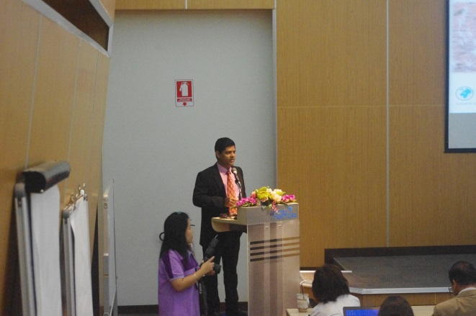 | 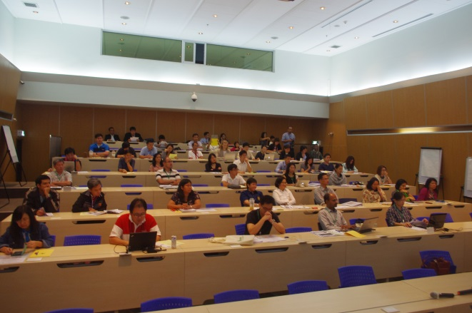
Left-Right: Opening session; Practical class

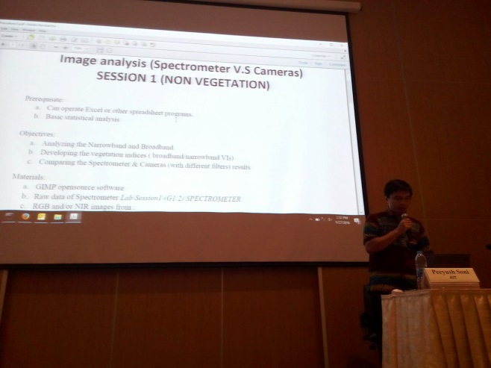 | 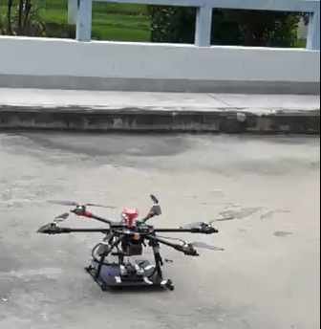
Left-Right:Practical class in Sensor Technology; Practical using Drone

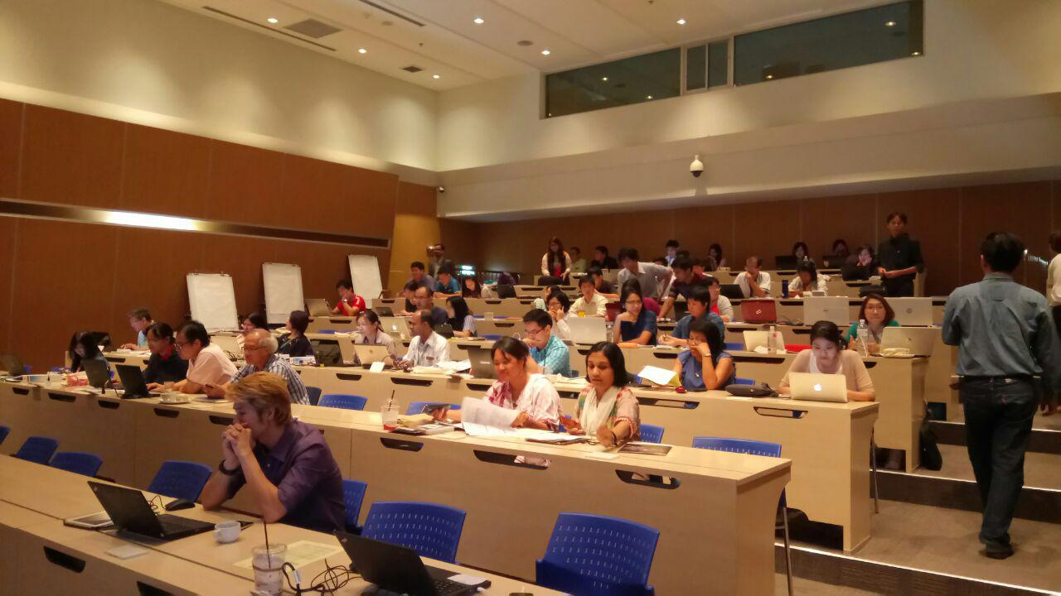 | 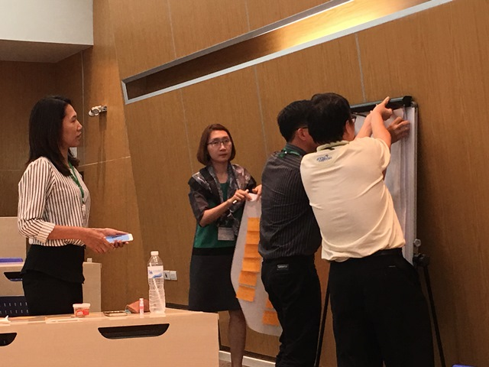
Left-Right: Practical Class; Interactive discussions during the Geoinformatics session
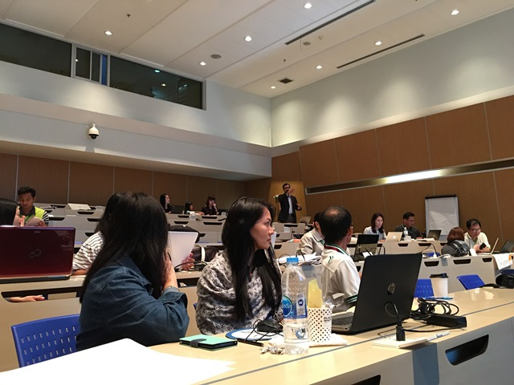 | 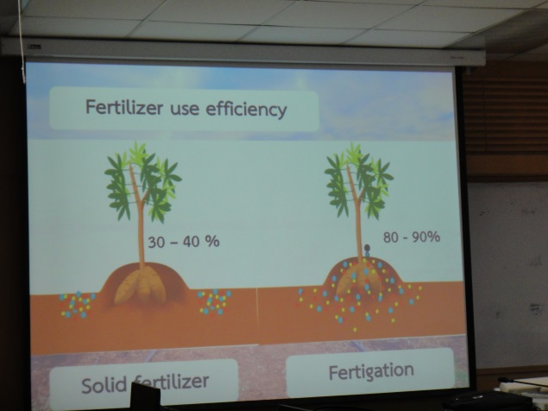
Left-Right:Practical session; Presentation in field session

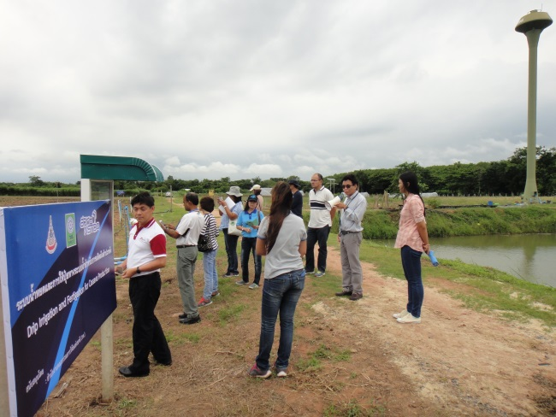 | 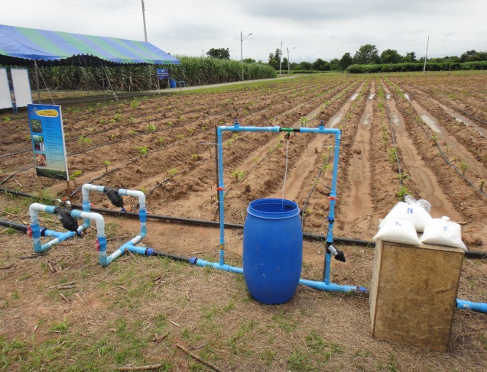
Left-Right:Observing the technology of Irrigation technology; Irrigation Deployment

