CTCN Deliverable 4.A Report informing a GCF proposal and the Pacific Resilience Programme

The original design of CTCN project No. 7000003466 - Capacity Development to Address Risks in the Coastal Zones Associated with Climate Change included a 5-day workshop where a session was planned to discuss upscaling the results of the project to inform GCF proposal focussed on coastal resilience. Because this session was not possible there has been no in-depth discussion of national priorities. Therefor this report makes some general suggestions, but these would need to be workshopped with local experts to develop an agreed design concept. All project participants are enthusiastic about a GCF project and hope that there will be an opportunity in the future to meet and discuss.
Building coastal resilience is an urgent national priority for many Pacific Islands. The project has provided data and information that can be used to assess coastal vulnerability. The four project partners Kiribati, Solomon Islands, Palau, and Republic of Marshall Islands (RMI) face varying levels of coastal inundation and erosion as a result of predicted sea level rise and storm surge. Large areas of the coastal zones in the four islands are in a relatively natural undisturbed state and thus offer opportunities for improved coastal management to ensure that any natural resilience is understood, protected and promoted.
The Pacific Climate Change Science and Adaptation Program predicts the following:
 | Sea level rise by 2030 | Wave height, storm surge, and coastal flooding
Kiribati | Medium emission scenario 7-17 cm | Decreased wave height Dec-March; more directed from the south in October; slight increase in wave height in the Line islands. Sea level rise will increase storm surge and coastal flooding.
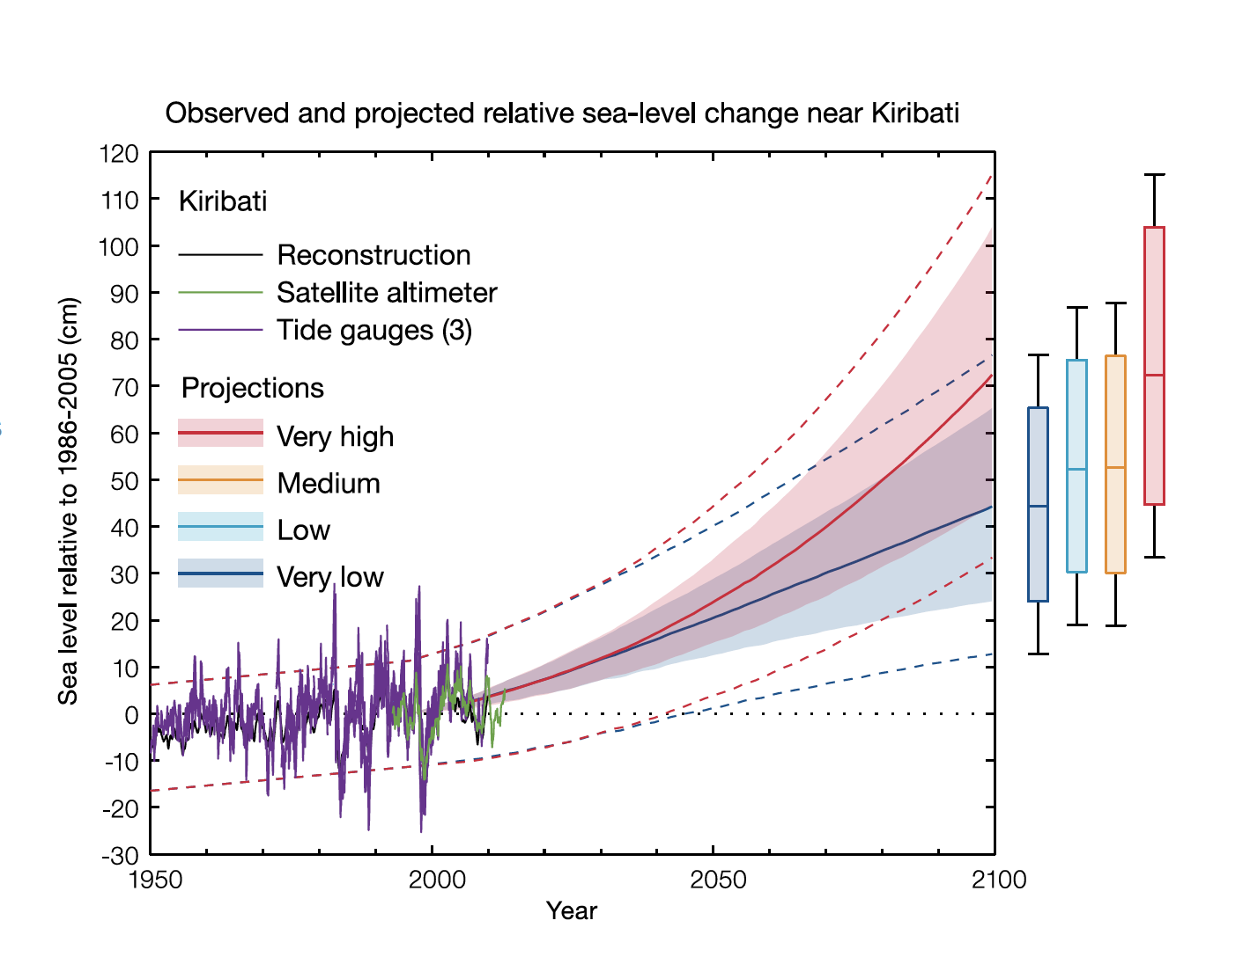

 | Sea level rise by 2030 | Wave height, storm surge, and coastal flooding
Solomon Islands | Medium emission scenario 7-17 cm | Decrease in frequency of cyclones but likely increase in the average maximum wind speed by between 2% and 11% and an increase in rainfall intensity.  Sea level rise will increase storm surge and coastal flooding.
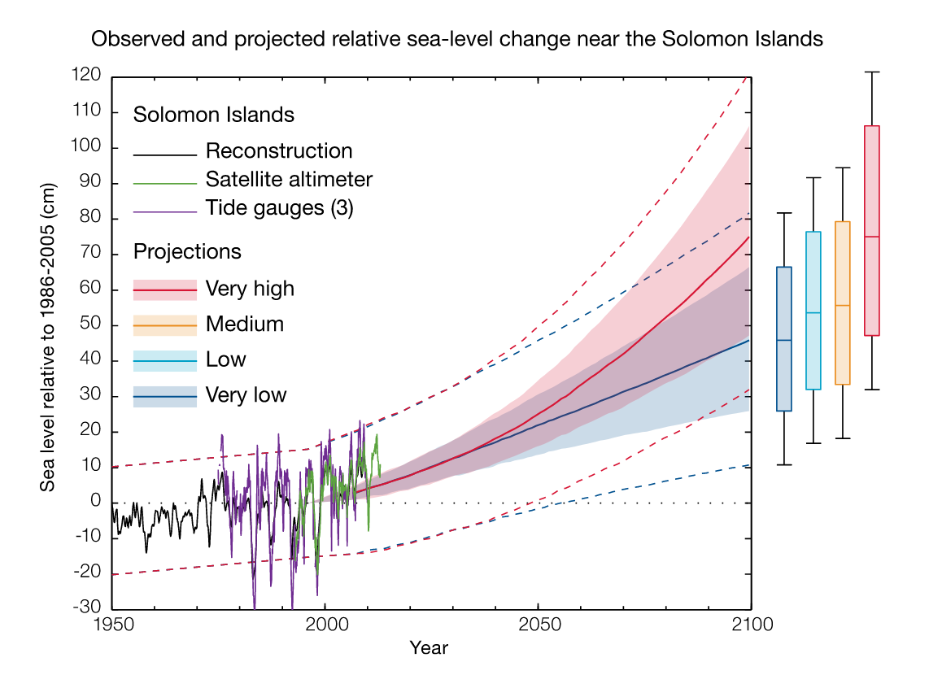

 | Sea level rise by 2030 | Wave height, storm surge, and coastal flooding
Palau | Medium emission scenario 8-17 cm | Decrease in frequency of typhoons but likely increase in the average maximum wind speed by between 2% and 11% and an increase in rainfall intensity.  Sea level rise will increase storm surge and coastal flooding.
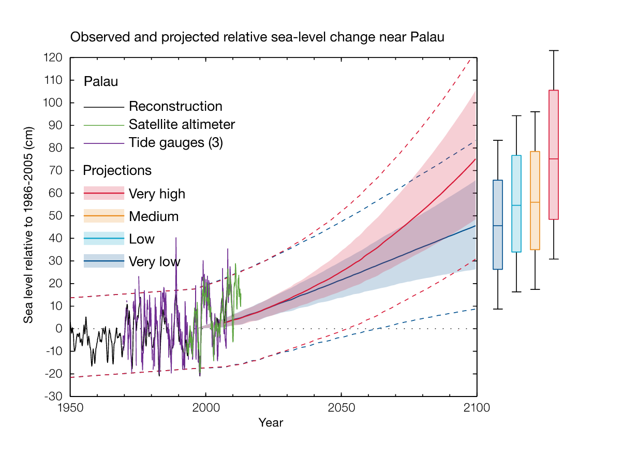

 | Sea level rise by 2030 | Wave height, storm surge, and coastal flooding
RMI | Medium emission scenario 8-17 cm | Decrease in frequency of typhoons but likely increase in the average maximum wind speed by between 2% and 11% and an increase in rainfall intensity.  Sea level rise will increase storm surge and coastal flooding.
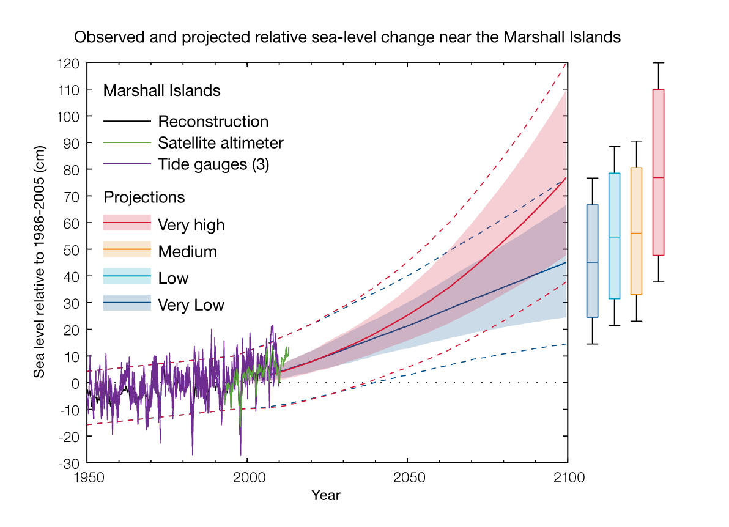

Potential outputs from a GCF could include:
- Early Warning Systems that provide localised and tailored impact-based warning to support coastal communities and emergency responses to take relevant on-the-ground life-saving actions.
- Ocean monitoring and prediction services to support improved navigational safety and search and rescue operations
- Development of a regional strategy to support ship-based ocean monitoring, including developing partnerships between National Meteorology services and the shipping sector
- Reduction of CO₂ emissions in the shipping sector through the provision of energy efficient navigational routes based on high resolution ocean prediction tool
- Increased SIDS capacity to monitor and assess coastal risk
- Strengthened coastal risk management to inform coastal development and investment
- Strengthened technical and institutional capacity to make risk informed decision
- Innovative, tailored, and scalable adaptation solutions that preserve the environment, cultural practices and enable social and economic growth
- Strengthened regional partnerships and cooperation through the development of a community of practice around coastal risk management that strengthens the sustainability of national expertise and promotes country to country knowledge sharing.

