Instructions to lead Implementers for drafting the

Technical Assistance Closure and Data Collection Report

Objective of the technical assistance (TA) Closure Report and Data Collection Report:
- To communicate publicly in one synthesis document a summary of progress made and lessons learned under the technical assistance (TA) towards the anticipated impact (main template).
- Compile TA-specific information required for internal use in donor and UN reporting (annex 1).

Steps for completing the TA Closure report:
- The lead TA implementer drafts the report at the end of the assignment as a final deliverable /product. The TA Closure report will capture all activities conducted under the TA hence it is expected that duplication of information will occur from earlier documents. Please copy and summarise relevant material from previous TA outputs/deliverables and the Response Plan, as relevant.
- A CTCN Manager will review and revise the report before final approval by the CTCN Director.

Important note on public and internal use of the closure report:
Once approved by the CTCN Director, the TA Closure and Data Collection Report will be a public document available on the CTCN website. Annex 1 is for internal use only and will not be publicly available.

Closure and Data Collection Report for CTCN Technical Assistance

- Basic information
Title of response plan | Design of an ecological post-fire restoration platform for the adaptation to climate change of the forestry and forestry sector in Chile.
Country / countries | Chile
NDE focal point and organisation | Paulina Ulloa Villalobos  Agency for Sustainability and Climate Change
Proponent focal point and organisation | Daniel Álvarez Latorre  Responsible for Restoration Unit  Ministry of Environment
Sector(s) addressed | Agriculture and Forestry
Technologies supported | - Sector: Forestry / Technology group: Sustainable forest Management.  - Sector: Agriculture / Technology group: Cropland/ Technology: Restoration of degraded lands.  - Sector: Agriculture and Forestry / Technology group: Land management training/ Technology: Community-based agricultural extension , forest user groups  - Sector: Water / Technology group: Adaptation planning/ Technology: Stakeholder consultation
Implementation period and total duration | 5 months
Total budget for implementation | 49,880
Designer of the response plan | CATIE
Implementer of response plan | CATIE

2. Summary of all activities, outputs and products that contribute to the expected impact of the technical assistance.
Description of delivered outputs and products as well as the activities undertaken to achieve them. In doing so, review the log frame of the original response plan and refer to it as appropriate | Output 1: Working Plan and related documents (CTCN formats)  Output 2: Experiences and stakeholders diagnosis in the TA intervention field. Includes:  - Stakeholders and field exploration: Meetings with key-informant stakeholders (Ministry of Environment). Preliminary identification of stakeholders and relevant experiences for the platform objectives.  - Diagnosis: Interview to potential users of the platform (26 stakeholders of national level and both regions). Characterization of stakeholders, interrelationship dynamic, previous experiences, lessons learnt and potentialities.  - Political and Institutional environment : Base on interviews and complementary literature review  - Pre-agreements identification  Output 3: Diagnosis of other experiences in climate similar zones.  - Literature review and analysis.  Output 4:Methodological Proposal of governance platform  - Proposal design: Analysis of outputs 2 and 3. And proposal design.  - Presentation workshop: one national workshop (presentation) and two workshops in each one of both regions (validation and presentation with regional stakeholders).  Output 5: Leassons learnt  - Interchange resources (two website notes)  - List of opportunities of agreements and commitments.  - Technical document of the methodological proposal, diagrammed for its dissemination and implementation
Partners organisations | Ministry of Environment of Chile  Centro Agronómico Tropical de Investigación y Enseñanza-CATIE
Beneficiaries | State institutions: Ministry of Environment, CONAF, INFOR, INIA and regional offices (SEREMI), regional governments . Others: Environmental NGO , private forest companies, local organizations (civil society), academic institutions, etc.
Methodologies applied to produce outputs and products | - Participatory diagnosis by interviews and meetings with stakeholders.  - Literature review and experiences systematization  - Methodological proposal based on local information.  - Participatory workshop
Deviations | During meetings with the counterpart of the Ministry of the Environment and its work team, the following agreements were established:  - To participate and present the partial results of the TA in a national workshop.  - Focus the methodological proposal on the design of a governance platform that integrates the national, regional and local scale to face the restoration of the landscape  - Define the product N ° 5 (Resources for the exchange) as a practical manual for the management of the platform, so it can be disseminated among the key actors participating in the platform.
Achieved or anticipated gender benefits from the TA | Achieved: Gender aspects identified, related to participation dynamic Governance strategies proposed to enhance the equality in the participation of women in decision making processes regarding landscape restoration.  Anticipated: Opportunities and agreements identified and proposed .
Achieved or anticipated co-benefits from the TA | The platform will promote the development of more resilient landscapes with stakeholders in better conditions for the new productive systems management and restoration as well as generation of ecosystem services.
Anticipated follow up activities and next steps | Activities to be followed up by the Ministry of Environment:  - Boosting the implementation of the proposal at the national and regional level, and its incorporation on the agenda of the National Committee for Ecological Restoration.  - Promotion and diffusion of the platform proposal and agreements to be taken between the stakeholders.  - Monitoring of the restoration agreements to be taken by the stakeholders during the TA.  - New agreements making in the context of an operative platforms.

- Lessons learnt
 | Lessons learnt | Recommendations
Lessons learnt for this TA.  Describe essential factors contributing to successful implementation, as well as specific challenges. Recommendations include considerations on what would need to be in place for increasing success of similar efforts (i.e. regulatory, legal, stakeholders, communication, etc.) | - The interest of different actors in participating was very positive  - The relevance of the problem of fires creates willingness to seek solutions from the actors  - It is a challenge for Chile to develop a culture of participatory governance and internalize it in the institutions  - Although technical assistance was initiated with a focus on post-forest fire restoration, it became evident that landscape restoration is a relevant activity beyond the particular effect of fire  - At some point there was an expectation that a governance platform not only designed but already active, would be the result of timely technical assistance, but in the current Chilean context such platforms require institutional support at least in the medium term | - It is important that the applicant clarifies from the beginning the specific objective of each stage, in order to clearly understand the desired contribution of the technical assistance and to design adequately the contents and presentation of each product.  - Having a person with knowledge of the local environment in the work team was very positive for this Technical Assistance, and facilitated contact with the institutions
Lessons learnt related to climate technology transfer  Describe opportunities, challenges and barriers for the use and deployment of the technology or technologies supported by the TA. The objective is to identify specific success factors for technology transfer | - It is a challenge for Chile to develop a culture of participatory governance and internalize it in the institutions  - It is somewhat complex to promote governance spaces at the local level from the Ministry of the Environment, since it only has officials in the field up to the regional level,  - Although Chile has many capacities and institutions for forest and fire issues, there is a considerable lack of coordination between institutions and projects | - If the Ministry of the Environment wishes these governance platforms to begin to function effectively, it must establish a process of convocation and accompaniment led by the same ministry or jointly with strategic partners.  - In the two territories where the proposed governance platform was validated, pilot restoration initiatives are being carried out that would greatly facilitate the implementation of local governance structures
Lessons learnt related the CTCN process for TA | - CTCN is an interesting platform to promote South-South collaboration, or between developing countries | - Although the philosophy of CTCN is to provide the requesting country with external technical assistance, this principle is not necessarily affected if local facilitators are incorporated into the work team to help optimize communication and information gathering

4. Illustration of the TA and photos

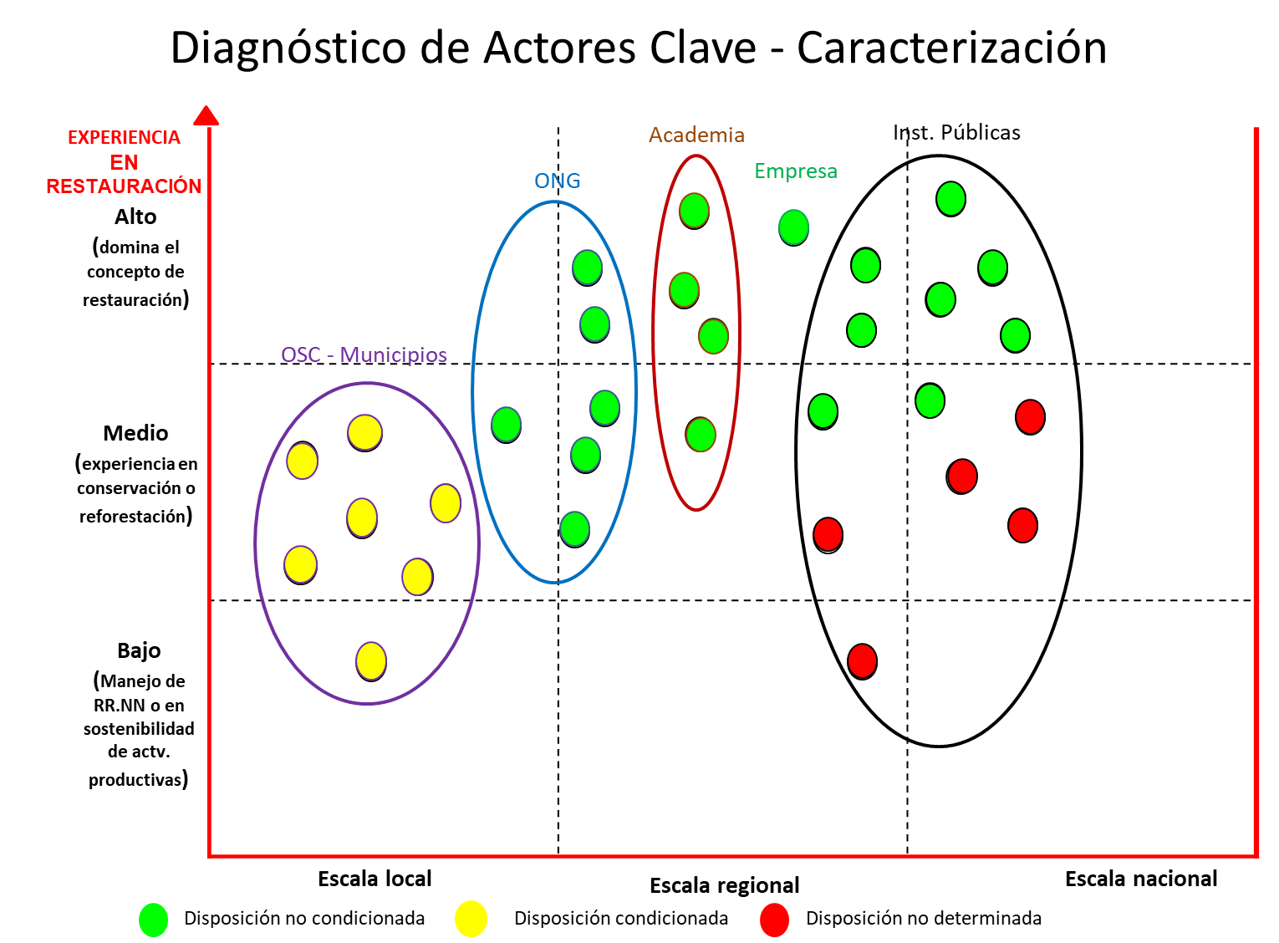

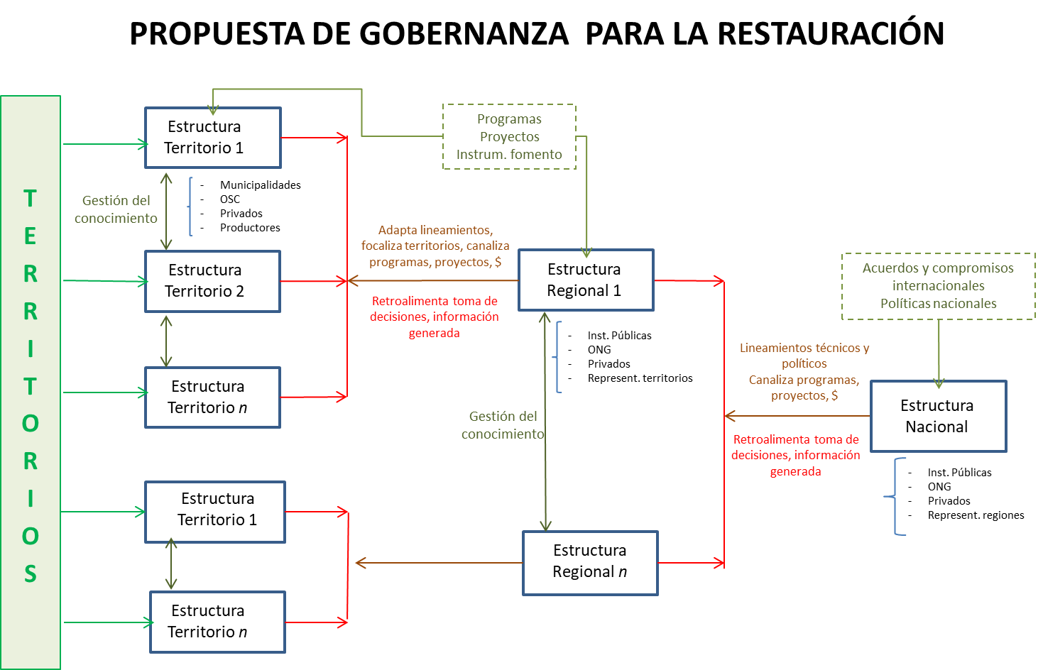

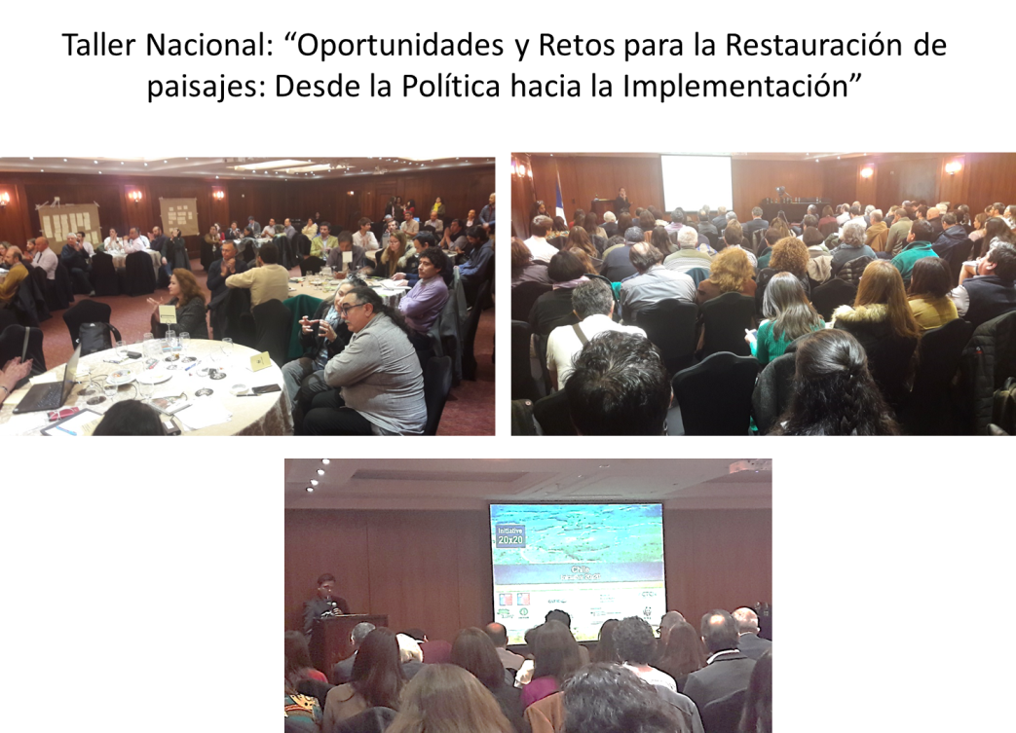

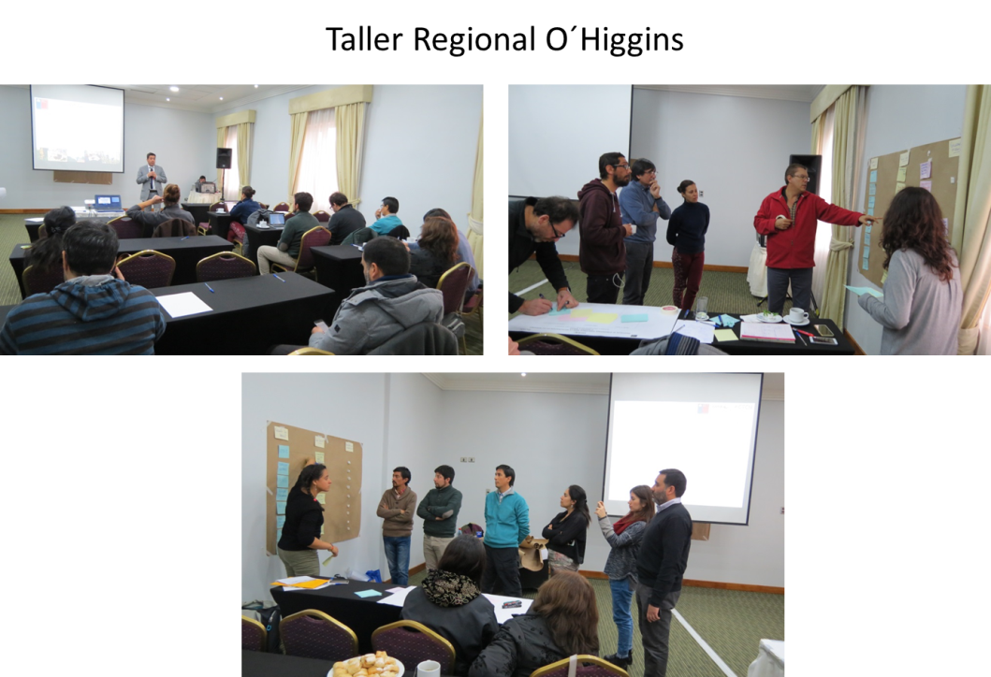

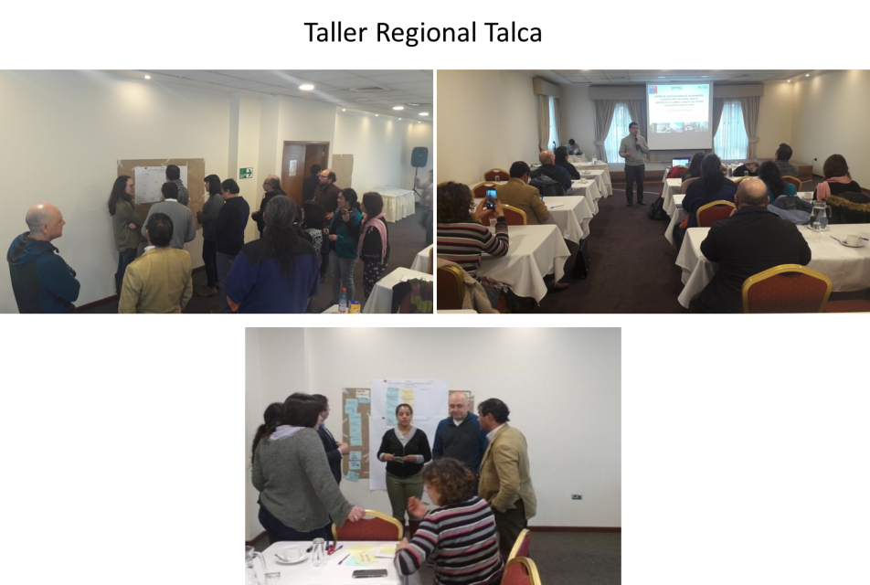

5. Information for TA impact description

Challenge: Approx. 500 characters with spaces | Due to climate change, the Mediterranean zone of Chile suffers higher temperatures and intense droughts that facilitate forest fires with enormous socioeconomic impact and land degradation. CTCN will support the State in the systematization of experiences and the design of an agreed platform of management of knowledge and opportunities, to strengthen capacities to face this problem, protect and restore strategic ecosystem services and generate resilient land uses, through collective action and knowledge exchange.
CTCN Assistance: 2 to 4 bullet points. Approximately 450 characters with spaces | • Diagnosis of experiences, institutional context and key actors.  • Diagnostic of experiences in other areas with similar climates.  • Methodological proposal of learning exchange platform.  • Validation workshop and knowledge exchange day.
Anticipated impact: 2 to 4 bullet points to summarise anticipated impact. Approximately 250 characters with spaces. As a minimum, please include one of the following: i) Quantity of greenhouse gas emissions reduced, avoided or sequestered; or ii) Number of people with increased capacity to adapt to the impacts of climate variability and change. | - The Ministry of the Environment on the national level and its regional offices have a methodological guide for the governance of the restoration, for its dissemination and implementation.  - Eighteen opportunities identified for the adoption of inter-institutional agreements between key actors in the framework of the platform.  - 138 stakeholders for landscape restoration on the national level know the results of the technical assistance and the methodological proposal.  - Approximately 105,542.93 hectares degraded at O´Higgins region and 252,556.10 hectares at Maule region are considered under restoration planning instruments, due to the agreements taken in the context of the platform.  - 4 joint restoration initiatives aimed at recovering at least 10 million tons GHG. These initiatives were identified during the technical assistance and are described on Product 5.b., which specify the region, scale, potential activities and potential participants
Linkages and contribution to NDC: 2 to 4 bullet points. Approximately 350 characters with spaces | - The platform will contribute to the NDC, related to the commitments of sustainable forest management and recovery of 100,000 hectares of forest.  - it will contribute to the National Adaptation Plan to the CC of the Agroforestry and Biodiversity sectors through information exchange and improve the management and restoration of natural resources and biodiversity
The narrative story: Approximately 1200 characters with spaces | Nearly 93% of the 547,189.61 hectares burned in 2016-2017 were forest plantations, native forests, meadows, scrub and agricultural uses; and more than half are in the regions of O'Higgins (105,542.93 ha) and Maule (252,556.10 ha). There, areas that provide ecosystem services must be restored, and new fires must be prevented as part of national strategies to combat degradation, loss of biodiversity, and mitigation and adaptation to CC. This requires a strategy considering the various activities and stakeholders in the affected landscapes, their degree of vulnerability and potential for participation, as well as previous experiences of restoring burning landscapes.  In that regard, it is expected that the Technical Assistance, through the design of a governance platform, will contribute to the incubation of joint restoration opportunities between stakeholders linked to the forestry and agricultural sector in the central zone of Chile (regions Maule and Libertador Bernardo O'Higgins). Through a participatory diagnosis of national and international experiences (Mediterranean areas), interviews with stakeholders and analysis of the national institutional context, a methodological proposal of a governance platform for the restoration of areas affected by forest fires was designed, based on four central axes : a) coordination, b) inclusive and equitable participation and external promotion; c) knowledge management, research and capacity building; and d) financing. For each of these axes, strategies and a basic work agenda for the start-up were proposed. This proposal was presented to potential users for validation and feedback, through participatory workshops, which also identified opportunities and challenges that collective work means, and thus project the process through agreements and commitments.
Contribution to SDGs: Always include contribution to SDG 13, and to the extent possible, please include contribution to 2 other SDGs, describing the contribution with a few sentence for each SDGs concerned. A complete list of SDGs and their targets is available here: https://sustainabledevelopment.un.org/partnership/register/ | 12 - Responsible consumption and production: The new production systems to be promoted, as part of the strategy of restoring landscapes, post-fires, must necessarily have a lower ecological footprint in the framework of a more efficient use of natural resources, and therefore of an adjustment in the development model of the intervened regions.  13 - Climate action: The TA contributes to the resilience of the landscape in the face of the impacts of the CC, through the strengthening of capacities for the implementation of good management practices. The promotion of restoration activities in areas affected by forest fires will contribute to increasing the carbon stock in the soil and in the biomass.  15: Life of terrestrial ecosystems: The TA contributes to the sustainable management of natural resources and agriculture on a territorial scale
Note: Please see example of a TA Impact Description at the following link:
https://www.ctc-n.org/sites/www.ctc-n.org/files/benin_a_ag_forestry.final_.pdf
Annex 1 (for internal use in donor and UN reporting)

A. Standardised CTCN performance indicators for donor and UN internal reporting
Please add quantitative values for indicators relevant to the particular TA in the list below. Non-relevant indicators should be left blank. Please only fill in the table for activities and outputs conducted or produced directly by the CTCN assistance.

CTCN standardised performance indicators | Quantitative value | Qualitative description  List the various elements corresponding to the quantitative value
- Overview
Number of active person-days (not full duration) of technical assistance provided to counterparts or stakeholders by international experts and consultants | 15 | Training presentation during workshops
Number of active person-days (not full duration) of technical assistance provided to counterparts or stakeholders by national experts and consultants | 80 | Training presentation during workshops
Number of for external communication and outreach activities conducted to showcase the assistance (news release, newsletters, articles on website, etc.) | 6 | 3 website notes and 1 technical document (diagrammed for its diffusion), 2 news promoted on the CTCN website and social media
- Events (other than trainings) held as part of the assistance
Number of international and multi-country (at regional or sub-regional level) technology and knowledge sharing events
Number of participants in the events above
Number of national technology and knowledge sharing events | 3 | 1 national and 2 regional workshops to present, validate and feedback the propoasal.
Number of participants in the events above | 174 | 138 in the national workshop  36 in the regional workshops
Number of public-private events related to technologies
Number of participants in the events above
- Training and capacity building activities conducted during the assistance
Number of training sessions and capacity strengthening activities | 2 | Regional workshop included an conceptual and context alignment
Number of people who received the training
Number of men | 21
Number of women | 15
Total number of organisations trained | 23
Number of research organisations, laboratories and universities | 4
Number of private companies | 1
Number of cities and local government | 3
Number of communities | 6
Number of ministries | 1
Number of specialised governmental institutions | 8
Number of non-profit organisations | 0
Level of satisfaction of participants after the training (from training feedback form). Categories include: From very satisfied, satisfied, partly not satisfied, not satisfied at all | 4.3 (satisfied). | Based on 28 surveys, with 5 questions each with the following satisfaction scale: 1) not satisfied, 2) not satisfied at all, 3) acceptable, 4) satisfied 5) very satisfied.  The five questions were about: contents, materials, distribution of time, performance of facilitators and methodology of group work
Number of participants that significantly or moderately increased their capacities thanks to the training
Number of men | 21
Number of women | 15
- Tools, technical reports and information material supported by the assistance
Total number of tools, technical reports and information material supported by the assistance (excluding mission, progress and internal reports)
Number of tools strengthened, revised or developed | 1 | National Committee for Ecological Restoration Strategy
Number of technical reports strengthened, revised or created
Number of other information materials strengthened, revised or created | 1 | Technical document (Methodological Proposal)
- Policies, laws and regulations supported by the assistance
Number of policies, strategies, and plans drafted addressing climate change adaptation
Number of policies, strategies, and plans drafted addressing climate change mitigation
Number of documents developed to inform other policies, strategies, and plans on climate change adaptation (sectoral strategies, national development plans, etc.)
Number of documents developed to inform other policies, strategies, and plans on climate change mitigation (sectoral strategies, national development plans, etc.)
Number of laws, agreements, or regulations drafted addressing climate change adaptation
Number of laws, agreements, or regulations drafted addressing climate change mitigation
Number of documents developed to inform laws, agreements, or regulations on climate change adaptation
Number of documents developed to inform laws, agreements, or regulations on climate change mitigation
- Institutional strengthening supported by the assistance
Number of institutional arrangements in place to coordinate near and long-term national adaptation plans (NAPs)
Number of organisations with increased technical capacity to advance near and long term national adaptation plans (NAPs) which integrate EbA
Number of organisations with increase awareness and knowledge among countries to better own and drive national adaptation planning processes | 23 | Number of organizations that participated on the regional workshops
- Partnerships and cooperation
Number of private companies directly engaged in the assistance (that partnered with the proponent, the beneficiaries or the CTCN to implement the assistance)
Number of South-South collaboration enabled during or through the assistance, when stakeholders from other countries were involved in the assistance
Number of North-South collaboration enabled during or through the assistance, when stakeholders from other countries were involved in the assistance
Number of Triangular collaboration enabled during or through the assistance, when stakeholders from other countries were involved in the assistance | 1 | WRI – CATIE-WWF (national and regional workshops)

B. Indicators of anticipated impacts that may occur after the TA is completed
CTCN standardised performance indicators | Quantitative value  Insert the request value and unit | Content  List the elements included in the number provided | Expected timeline  Indicate when the indicator and value are expected to be achieved | Responsible institution  Indicate the institution(s) that will play leading role in enabling the indicators and anticipated values to be achieved
16. Anticipated finance mobilised
- Anticipated amount of public/donor investment mobilised (in USD) from the beneficiary country for climate change activities as a result of the TA
- Anticipated amount of public/donor investment mobilized (in USD) from international and regional sources for climate change activities as a result of the TA
- Anticipated amount of private investment mobilised (in USD) from the beneficiary country for climate change activities as a result of the TA
- Anticipated amount of private investment mobilised (in USD) from international and regional sources for climate change activities as a result of the TA
17. Policies
- Anticipated number of policies, strategies, plans, addressing climate change mitigation officially proposed, adopted, or implemented as a result of the TA
Anticipated number of policies, strategies, plans, addressing climate change adaptation officially proposed, adopted, or implemented as a result of the TA. | 2 | Regional Agenda to implement the governance proposal and landscape restoration  Plan for Regional Governance structure (Maule and O´Higgins regions) | 1 year | Ministry of Environment
- Anticipated number of laws, agreements, or regulations addressing climate change mitigation officially proposed, adopted, or implemented as a result of the TA.
Anticipated number of laws, agreements, or regulations addressing climate change adaptation officially proposed, adopted, or implemented as a result of the TA. | 18 | Institutional agreements for landscape restoration proposed | Non determinated | Ministry of Environment
- Anticipated laws, policies, regulations, strategies and plans where climate change mitigation will be mainstreamed as a result of the TA
Anticipated laws, policies, regulations, strategies and plans where climate change adaptation will be mainstreamed as a result of the TA
18. Anticipated number of public-private partnerships created
19. Anticipated twinning arrangements created as a result of the TA
20. Anticipated number of technology projects prepared and implemented to support action on low emission and climate-resilient development
21. Anticipated number of strengthened National Systems of Innovation and technology innovation centres in recipient country
22. Anticipated Clean Energy Generation Capacity
Clean supported by the TA that has achieved financial closure
23. Anticipated and projected GHG reductions. Quantity of greenhouse gas (GHG) emissions, measured in metric tons of CO_{2-e}, anticipated to be reduced or sequestered as a result of projects supported by the TA
24. Anticipated clean energy generation capacity supported by the TA that has achieved financial closure
25. Anticipated and projected greenhouse gas emissions reduced or avoided through 2030, in metric tons of CO_{2-e}, from adopted laws, policies, regulations, or technologies related to clean energy/sustainable landscapes as a result of the TA
26. Anticipated number of people improving their livelihood as co-benefits as a result of the TA
27. Anticipated technology types effectively deployed in the country | 3 | - Sector: Agriculture / Technology group: Cropland/ Technology: Restoration of degraded lands.  - Sector: Agriculture and Forestry / Technology group: Land management training/ Technology: Community-based agricultural extension , forest user groups  - Sector: Water / Technology group: Adaptation planning/ Technology: Stakeholder consultation | - Five years  - One year  - One year | Ministry of Environment
28. Anticipated UNFCCC processes implemented as a result of the TA (NAMA, NAPA, NDC, etc.)
29. Anticipated Technology Needs Assessments (TNA) and technology Action Plans (TAP) as a result of the TA
30. Anticipated cooperative research, development and demonstration programmes within and between developed and developing country Parties facilitated as a result of the TA
31. Anticipated improved climate change observation systems and related information management in developing country Parties. | 3 | 1 National platform of governance and 2 regional platforms | 1 year | Ministry of Environment

