Instructions to lead Implementers for drafting the

Technical Assistance Closure and Data Collection Report

Objective of the technical assistance (TA) Closure Report and Data Collection Report:
- To communicate publicly in one synthesis document a summary of progress made and lessons learned under the technical assistance (TA) towards the anticipated impact (main template).
- Compile TA-specific information required for internal use in donor and UN reporting (annex 1).

Steps for completing the TA Closure report:
- The lead TA implementer drafts the report at the end of the assignment as a final deliverable /product. The TA Closure report will capture all activities conducted under the TA hence it is expected that duplication of information will occur from earlier documents. Please copy and summarise relevant material from previous TA outputs/deliverables and the Response Plan, as relevant.
- A CTCN Manager will review and revise the report before final approval by the CTCN Director.

Important note on public and internal use of the closure report:
Once approved by the CTCN Director, the TA Closure and Data Collection Report will be a public document available on the CTCN website. Annex 1 is for internal use only and will not be publicly available.

Closure and Data Collection Report for CTCN Technical Assistance

- Basic information
Title of response plan | Feasibility study and development of an action plan for the promotion of manufacturing of components of small wind power turbines in Benin
Country / countries | Benin
NDE focal point and organisation | Raphiou Adissa Aminou,  Director of Mitigation Climate Change and Promotion of Green Energy. CTCN  Focal Point  Direction General of the Climatic changes  06 BP 2570 Cotonou, Benin  (+229) 90 04 59 19/97748748 / 95 22 30 89  aminou_raphiou@yahoo.fr
Proponent focal point and organisation | Juste Christel Tankpinou Damada,  Public Works Technical Services Engineer at the Department of New and  Renewable Energy  Directorate General for Energy  01 BP : 2171 Cotonou, Benin  (+229) 97 76 17 73  nonojust2@yahoo.fr
Sector(s) addressed | Renewable energy; Industry
Technologies supported | Small scale wind
Implementation period and total duration | 1 July 2017 – 31 July 2018
Total budget for implementation | Original contract value: USD 71,275  Amendment value: USD 11,800  Total value: USD 83,075
Designer of the response plan | Federico Villatico Campbell  Regional Manager – LAC, West and Central Africa  Climate Technology Centre & Network  Marmorvej 51  2100 Copenhagen, Denmark
Implementer of response plan | Partners for Innovation B.V.  Cruquiusweg 54-56  1019 AH Amsterdam  The Netherlands

2. Summary of all activities, outputs and products that contribute to the expected impact of the technical assistance.
Description of delivered outputs and products as well as the activities undertaken to achieve them. In doing so, review the log frame of the original response plan and refer to it as appropriate | Output 1: A report of the feasibility study on local manufacturing of small wind technology in Benin. First presented as draft, produced on the basis of in-country discussions with local stakeholders, review of (inter)national literature and conversations with international small wind experts. Draft report was used as input for in stakeholder consultations in Dec 2017 and July 2018, after which it was finalized.  Output 2: An Action Plan for the development of a small wind sector in Benin. First presented as draft, produced on the basis of in-country discussions with local stakeholders, review of (inter)national literature and conversations with international small wind experts. Draft Action Plan was used as input for in stakeholder consultations in Dec 2017 and July 2018, after which it was finalized.  Both outputs were made available in French and English.
Partners organisations | None
Beneficiaries | Directly / short term: Government of Benin  Indirectly / medium-long term: manufacturing industry in Benin, renewable energy industry in Benin, installation industry in Benin, households (men, women and youth) and local SMEs in Benin
Methodologies applied to produce outputs and products | -Detailed cost breakdown analysis (manufacturing)  -Detailed power generation analysis  -Structured surveys  -Semi-structured stakeholder consultations (group setting)
Deviations | None
Achieved or anticipated gender benefits from the TA | The final report (covering both Output 1 and 2) includes a high-level assessment of the degree to which all genders have participated in the energy sector in Benin. This assessment forms the basis for the improvement of Output 2 (the Action Plan), so that the proposed measures to stimulate wind sector development encompass gender-sensitive considerations. In addition, the stakeholder consultations organised specifically invited female stakeholders as well; during the final consultation in July 2018, 10 women were present.
Achieved or anticipated co-benefits from the TA | Output 2 (the Action Plan) is set up in such a way that the creation of opportunities for both women and men to engage in the wind energy market is inherently considered. This applies equally to private and public sector participants, producers and consumers. In Annex V to the final report, the gender strategy is further elaborated so that interventions are proposed that are as specific as possible.
Anticipated follow up activities and next steps | Output 2 (the Action Plan) includes clear proposed activities for the very short term (2018-2019) and the medium term (2020-2021), attributed to individual stakeholders. These activities are:  -Development of a detailed sector development roadmap  -Seeking cooperation with international donors for roadmap development & implementation  -Setting up an international consortium/JV to coordinate first pilots  -Setting up the first 4-6 pilots and ensure tight M&E  -Arranging for production of turbines that maximize local value creation  -Installing 100 turbines in villages while involving village chefs to determine local willingness to participate  -Installing 20 turbines for productive use  -Facilitating import by reducing tariff barriers and removing other legal barriers  -Identifying and convening organisations with an interest in the creation of a small wind sector in Benin and forming of a coalition  -Determining the mandate and structure of the coalition  -Develop an approach for awareness creation, stakeholder alignment and identification of avenues for sector development  -Establish a centre of technical wind energy expertise  -Make wind energy a prominent part of education curricula

- Lessons learnt
 | Lessons learnt | Recommendations
Lessons learnt for this TA.  Describe essential factors contributing to successful implementation, as well as specific challenges. Recommendations include considerations on what would need to be in place for increasing success of similar efforts (i.e. regulatory, legal, stakeholders, communication, etc.) | -Direct interaction between proponent, NDE and implementer worked well for project focusing and expectations management  -Local organization of stakeholder meetings (done by proponent) worked well to convince stakeholders to be present and generate widespread (media-) attention | -Highlight regular interactions between proponent, NDE and implementer as an important part of project implementation in the CTCN Response Plan  -Highlight the importance of jointly using the relevant networks of the proponent, NDE and implementer for organising high-profile in-country meetings in the CTCN Response Plan
Lessons learnt related to climate technology transfer  Describe opportunities, challenges and barriers for the use and deployment of the technology or technologies supported by the TA. The objective is to identify specific success factors for technology transfer | -Using international (technical) experts to cooperate with local experts allows for combining in-depth knowledge transfer with reduced production costs  -Working together with client to secure a proper follow-up of the project is an indispensable element of project implementation | -Make sure that international experts involved recognize the need for maximizing interaction with / learning from local stakeholders  -Emphasize the need for establishing the connections needed for project follow-up
Lessons learnt related the CTCN process for TA | -

4. Illustration of the TA and photos
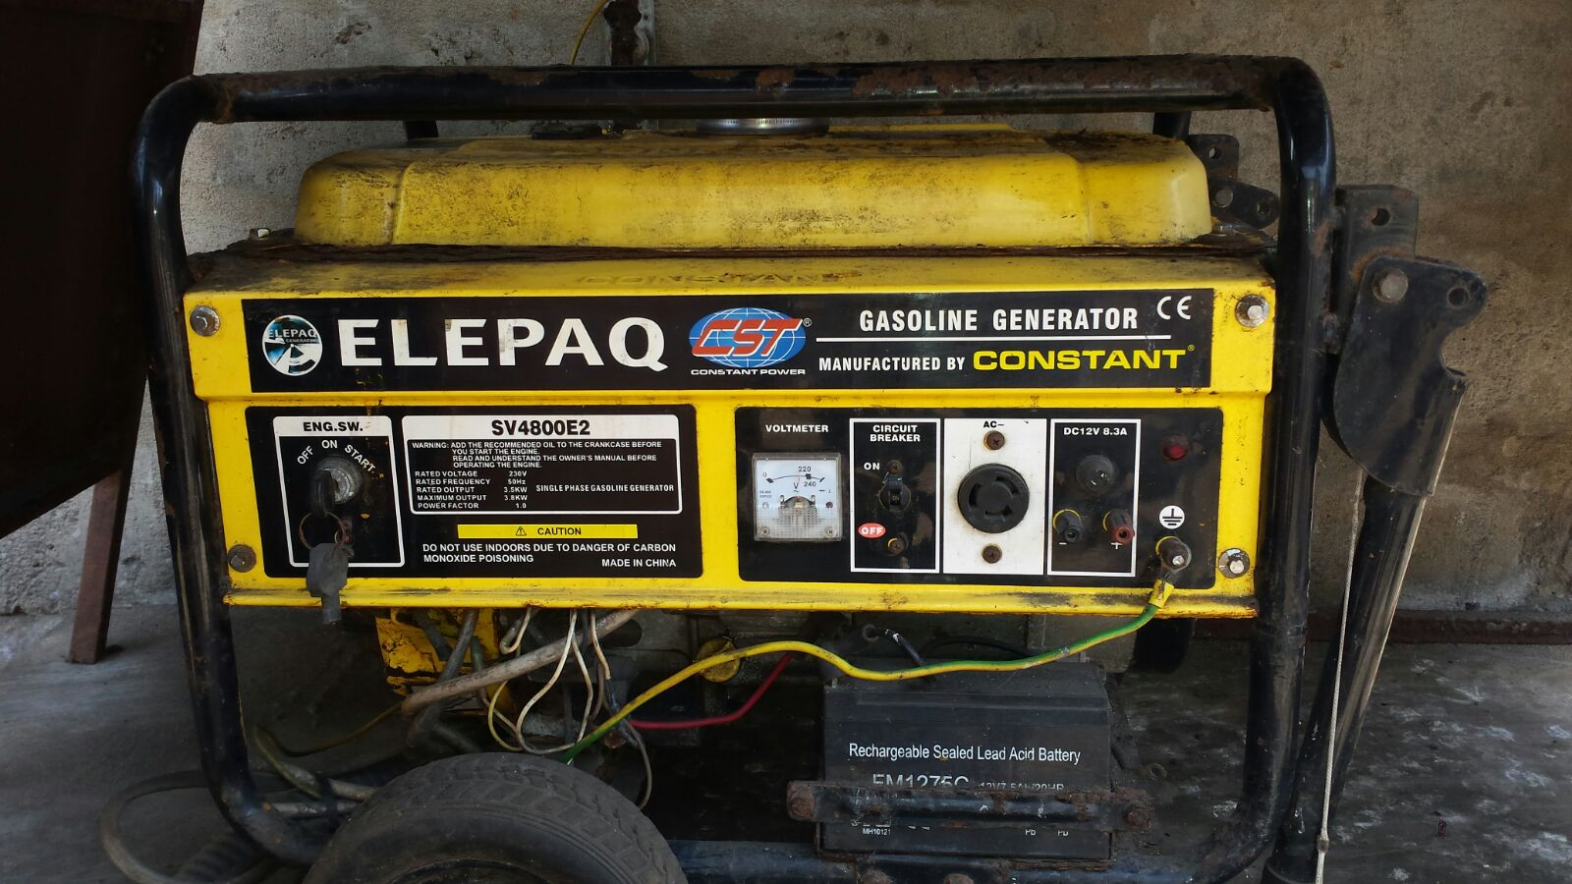
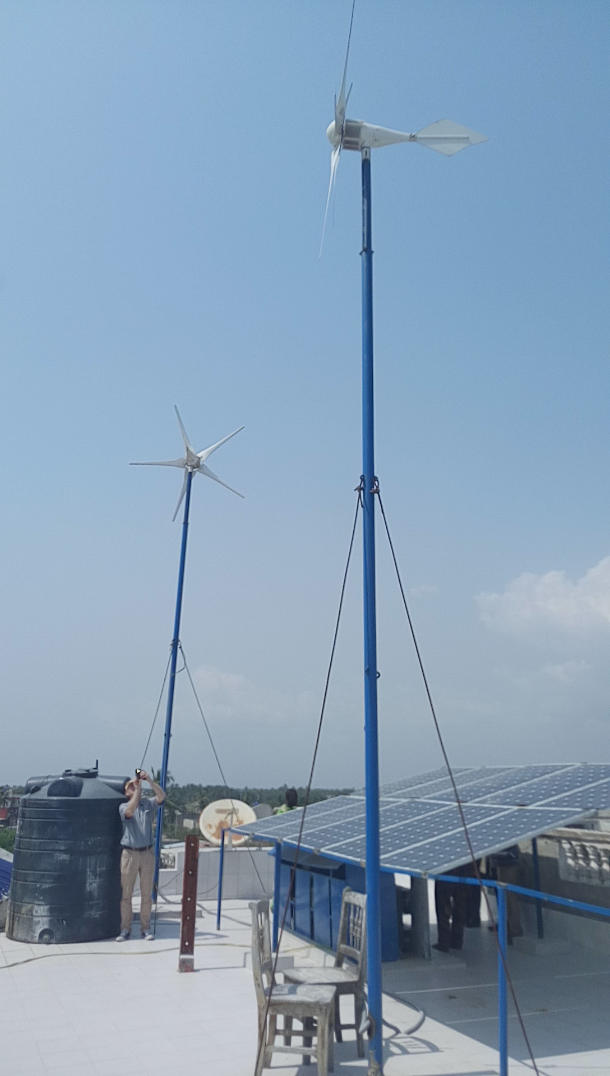
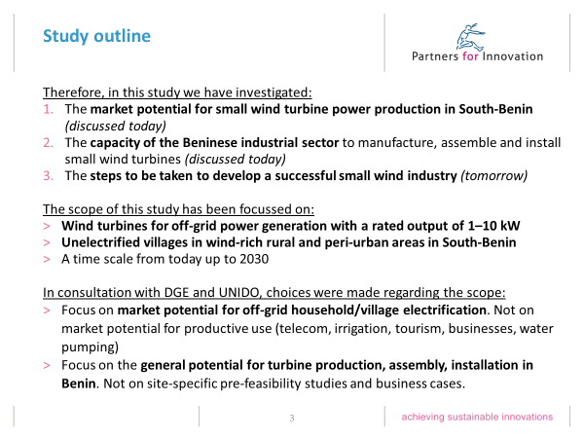
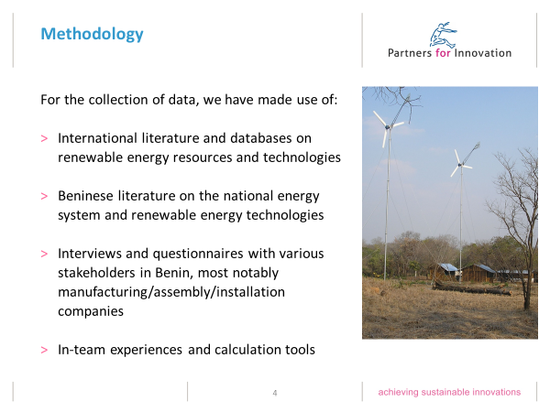
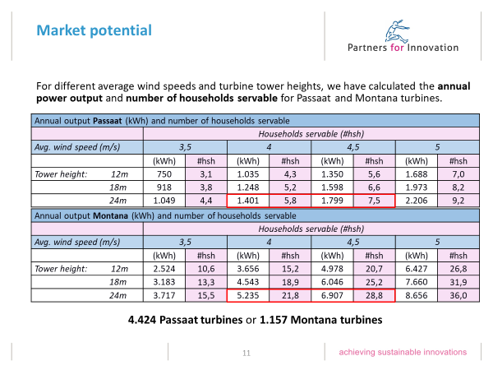
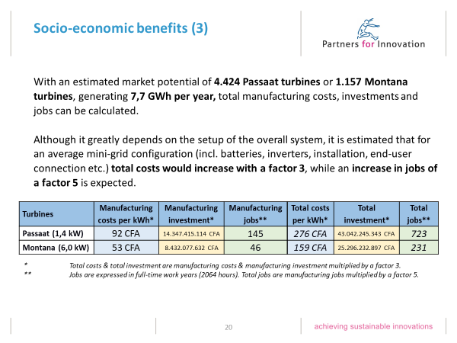
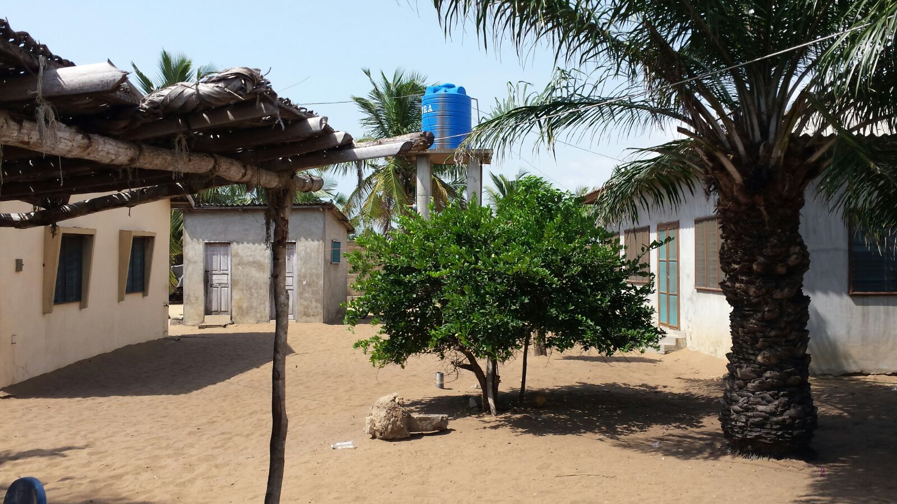

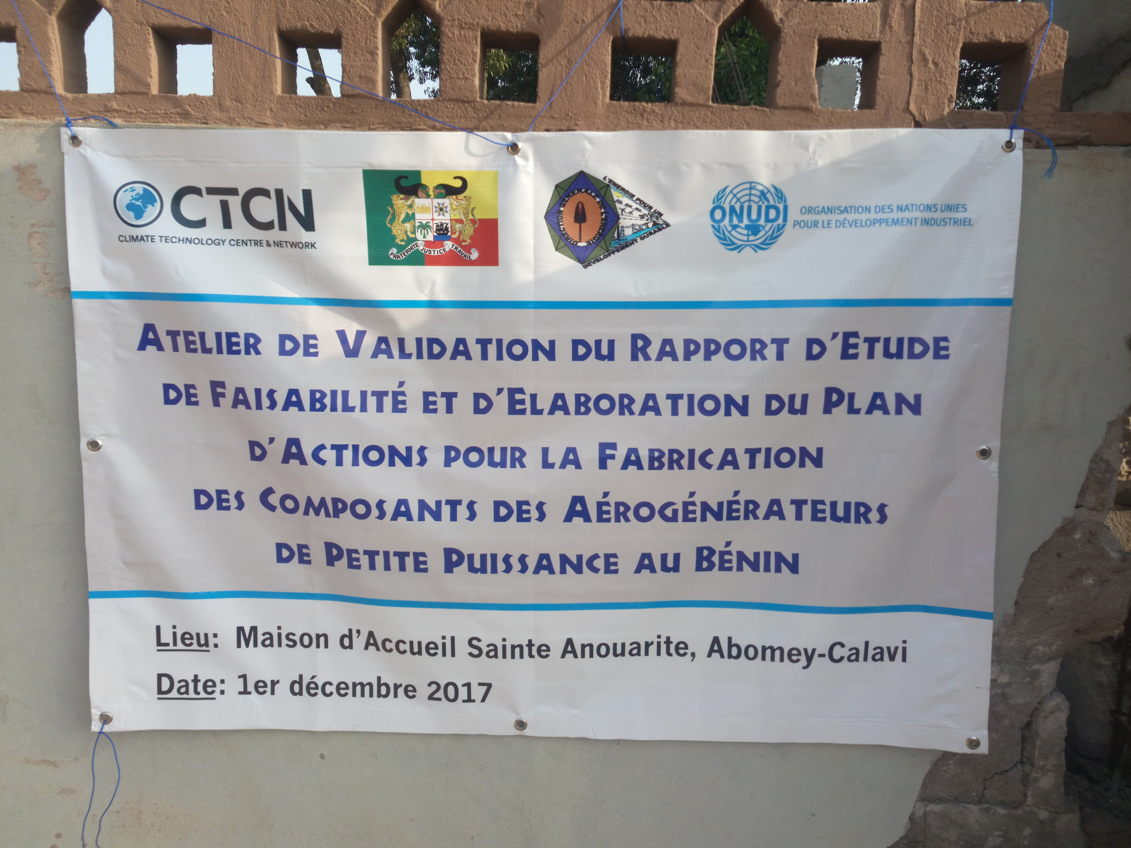
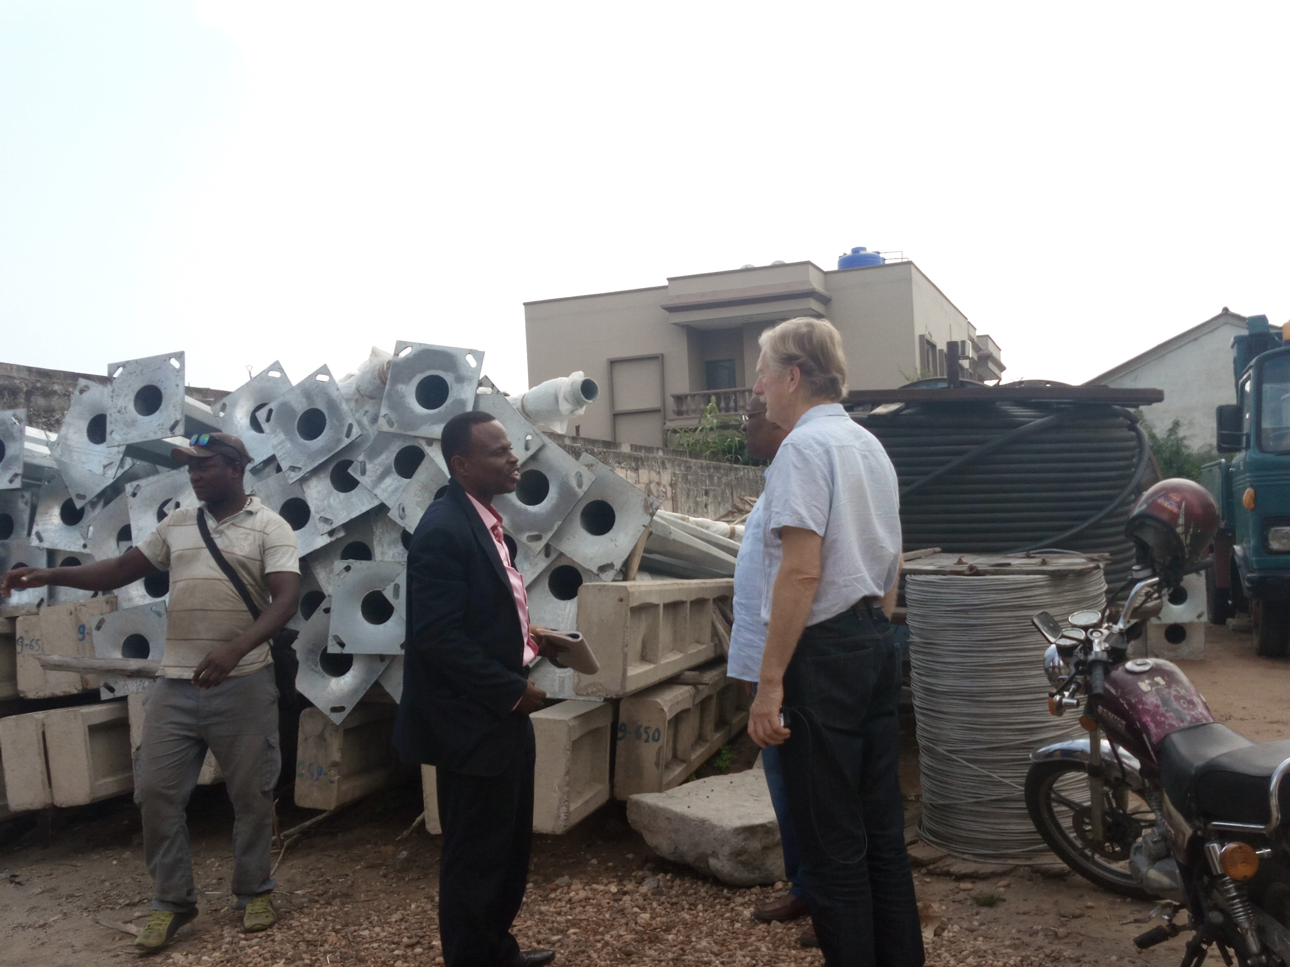

5. Information for TA impact description
The information in the table below will be used to produce the CTCN TA Impact Description. The TA Impact description is a 2-page summary document for communication purposes. Please copy information from sections above and technical delivery reports as required.
Challenge: Approx. 500 characters with spaces | In order to accelerate and expand renewable energy-based electrification, Benin aims to also utilize  its wind resources to complement solar, hydro and biomass energy. In spite of positive signs regarding the potential for small scale wind in coastal areas, deployment of the technology has not taken off. Barriers include the cost of small wind technology, which is why investment activities have been limited, as well as a lack of public and political awareness of the opportunities.
CTCN Assistance: 2 to 4 bullet points. Approximately 450 characters with spaces | -Assessing the feasibility of local manufacturing of small wind technology in Benin  -Developing an action plan for kick-starting the development of a small wind sector in Benin
Anticipated impact: 2 to 4 bullet points to summarise anticipated impact. Approximately 250 characters with spaces. As a minimum, please include one of the following: i) Quantity of greenhouse gas emissions reduced, avoided or sequestered; or ii) Number of people with increased capacity to adapt to the impacts of climate variability and change. | -5 kton of CO₂-eq/year greenhouse gas emissions avoided (if all identified localities are electrified)  -200.000 people given access to affordable and clean electricity (Residents in windy off-grid areas in South-Benin)
Linkages and contribution to NDC: 2 to 4 bullet points. Approximately 350 characters with spaces | -Contributes to NDC goal of reducing greenhouse gas emissions with 49 MT CO₂-eq between 2021 and 2030: 5 kT CO₂-eq is expected per year if all identified localities are electrified.  -Contributes to NDC goal of increasing domestic renewable energy production: 7,7 GWh renewable energy production is expected per year if all identified localities are electrified.  -Contributes to NDC goal of increasing household energy access with 600 localities between 2021 and 2030: 87 localities are expected to be electrified.
The narrative story: Approximately 1200 characters with spaces | This technical assistance responded to Benin’s request to receive support with testing the feasibility of, and thereby laying the fundament for, the establishment of locally manufactured small wind technology in the country. Benin, with low electricity access rates particularly in rural regions, is striving to increase access through renewable energy, but wind energy has so far not been exploited - in spite of good potentials.  The CTCN assistance addressed the inquiry by carrying out a feasibility study of local component manufacturing, involving the local experts into the study to ensure applicability of outcomes. Following up on that, the assistance focused on the development of an action plan, outlining the necessary steps to establish a local sector for manufacturing and deployment of small wind turbines.  Through the CTCN assistance, stakeholders in Benin were informed of the potential for small wind turbine manufacturing in the country, and were provided with clear guidance on the path to follow when aspiring to kick-start the local small wind sector.
Contribution to SDGs: Always include contribution to SDG 13, and to the extent possible, please include contribution to 2 other SDGs, describing the contribution with a few sentence for each SDGs concerned. A complete list of SDGs and their targets is available here: https://sustainabledevelopment.un.org/partnership/register/ | Output 2 (the Action Plan) contributes to the planning of measures that help mitigate the impact of climate change (SDG 13), by providing clear guidance on the steps to follow for stimulating clean energy production in Benin.  Access to affordable, reliable, sustainable and modern energy for all (SDG 7) is promoted in this CTCN assistance by generating and sharing knowledge on the opportunities that small wind energy offers for electrification.
Note: Please see example of a TA Impact Description at the following link:
https://www.ctc-n.org/sites/www.ctc-n.org/files/benin_a_ag_forestry.final_.pdf
Annex 1 (for internal use in donor and UN reporting)

A. Standardised CTCN performance indicators for donor and UN internal reporting
Please add quantitative values for indicators relevant to the particular TA in the list below. Non-relevant indicators should be left blank. Please only fill in the table for activities and outputs conducted or produced directly by the CTCN assistance.

CTCN standardised performance indicators | Quantitative value | Qualitative description  List the various elements corresponding to the quantitative value
- Overview
Number of active person-days (not full duration) of technical assistance provided to counterparts or stakeholders by international experts and consultants | 55 | Man-days allocated to non-Beninese experts
Number of active person-days (not full duration) of technical assistance provided to counterparts or stakeholders by national experts and consultants | 35 | Man-days allocated to Beninese expert
Number of for external communication and outreach activities conducted to showcase the assistance (news release, newsletters, articles on website, etc.) | 10 | Publications on website/newsletter PfI, invitation of journalists to in-country stakeholder meeting, local newspaper publications
- Events (other than trainings) held as part of the assistance
Number of international and multi-country (at regional or sub-regional level) technology and knowledge sharing events
Number of participants in the events above
Number of national technology and knowledge sharing events | 2 | First and second stakeholder meeting
Number of participants in the events above | 41 + 62 | First stakeholder meeting, second stakeholder meeting
Number of public-private events related to technologies
Number of participants in the events above
- Training and capacity building activities conducted during the assistance
Number of training sessions and capacity strengthening activities
Number of people who received the training
Number of men
Number of women
Total number of organisations trained
Number of research organisations, laboratories and universities
Number of private companies
Number of cities and local government
Number of communities
Number of ministries
Number of specialised governmental institutions
Number of non-profit organisations
Level of satisfaction of participants after the training (from training feedback form). Categories include: From very satisfied, satisfied, partly not satisfied, not satisfied at all
Percentage of participants that increased their capacities thanks to the training (from training feedback form). Categories include: Significantly, very, moderately, to none.
Percentage of men
Percentage of women
- Tools, technical reports and information material supported by the assistance
Total number of tools, technical reports and information material supported by the assistance (excluding mission, progress and internal reports) | 1 | Final report, incl. Action Plan
Number of tools strengthened, revised or developed
Number of technical reports strengthened, revised or created
Number of other information materials strengthened, revised or created
- Policies, laws and regulations supported by the assistance

Number of policies, strategies, and plans drafted addressing climate change adaptation
Number of policies, strategies, and plans drafted addressing climate change mitigation
Number of documents developed to inform other policies, strategies, and plans on climate change adaptation (sectoral strategies, national development plans, etc.)
Number of documents developed to inform other policies, strategies, and plans on climate change mitigation (sectoral strategies, national development plans, etc.) | 1 | Action Plan for setting up new branch of local RE-sector
Number of laws, agreements, or regulations drafted addressing climate change adaptation
Number of laws, agreements, or regulations drafted addressing climate change mitigation
Number of documents developed to inform laws, agreements, or regulations on climate change adaptation
Number of documents developed to inform laws, agreements, or regulations on climate change mitigation
- Institutional strengthening supported by the assistance
Number of institutional arrangements in place to coordinate near and long-term national adaptation plans (NAPs)
Number of organisations with increased technical capacity to advance near and long term national adaptation plans (NAPs) which integrate EbA
Number of organisations with increase awareness and knowledge among countries to better own and drive national adaptation planning processes
- Partnerships and cooperation
Number of private companies directly engaged in the assistance (that partnered with the proponent, the beneficiaries or the CTCN to implement the assistance)
Number of South-South collaboration enabled during or through the assistance, when stakeholders from other countries were involved in the assistance
Number of North-South collaboration enabled during or through the assistance, when stakeholders from other countries were involved in the assistance
Number of Triangular collaboration enabled during or through the assistance, when stakeholders from other countries were involved in the assistance

B. Indicators of anticipated impacts that may occur after the TA is completed
CTCN standardised performance indicators | Quantitative value  Insert the request value and unit | Content  List the elements included in the number provided | Expected timeline  Indicate when the indicator and value are expected to be achieved | Responsible institution  Indicate the institution(s) that will play leading role in enabling the indicators and anticipated values to be achieved
16. Anticipated finance mobilised
- Anticipated amount of public/donor investment mobilised (in USD) from the beneficiary country for climate change activities as a result of the TA
- Anticipated amount of public/donor investment mobilized (in USD) from international and regional sources for climate change activities as a result of the TA | 5-8 million USD | -Roadmap development  -Targeted implementation  -Coalition building  -Knowledge development | 2018-2021 | International and regional sources through the Government of Benin
- Anticipated amount of private investment mobilised (in USD) from the beneficiary country for climate change activities as a result of the TA | 50-80 million USD | Manufacturing and installation of 1000+ turbines (long-term) | 2022-2025 | -
- Anticipated amount of private investment mobilised (in USD) from international and regional sources for climate change activities as a result of the TA
17. Policies
- Anticipated number of policies, strategies, plans, addressing climate change mitigation officially proposed, adopted, or implemented as a result of the TA | Various policy adaptations | Removal of tariff and other legal barriers for wind turbine manufacturing & deployment | 2018-2021 | Government of Benin
Anticipated number of policies, strategies, plans, addressing climate change adaptation officially proposed, adopted, or implemented as a result of the TA.
- Anticipated number of laws, agreements, or regulations addressing climate change mitigation officially proposed, adopted, or implemented as a result of the TA.
Anticipated number of laws, agreements, or regulations addressing climate change adaptation officially proposed, adopted, or implemented as a result of the TA.
- Anticipated laws, policies, regulations, strategies and plans where climate change mitigation will be mainstreamed as a result of the TA
Anticipated laws, policies, regulations, strategies and plans where climate change adaptation will be mainstreamed as a result of the TA
18. Anticipated number of public-private partnerships created | 1 | Stakeholder coalition | 2018-2021 | Coalition leader (to be determined)
19. Anticipated twinning arrangements created as a result of the TA
20. Anticipated number of technology projects prepared and implemented to support action on low emission and climate-resilient development | 1 | Multi-annual program containing production and installation of 4000 turbines | 2025 | Government of Benin
21. Anticipated number of strengthened National Systems of Innovation and technology innovation centres in recipient country | 1
22. Anticipated Clean Energy Generation Capacity  Clean supported by the TA that has achieved financial closure | +6MW | 1000+ small wind turbines | 2022-2025 | -
23. Anticipated and projected GHG reductions. Quantity of greenhouse gas (GHG) emissions, measured in metric tons of CO_{2-e}, anticipated to be reduced or sequestered as a result of projects supported by the TA | 5 ktonnes GHG/year | Assuming substitution of diesel-powered generators (750 g CO₂-eq/kWh) | 2022-2025 | -
24. Anticipated clean energy generation capacity supported by the TA that has achieved financial closure
25. Anticipated and projected greenhouse gas emissions reduced or avoided through 2030, in metric tons of CO_{2-e}, from adopted laws, policies, regulations, or technologies related to clean energy/sustainable landscapes as a result of the TA | 5 ktonnes GHG/year | Assuming substitution of diesel-powered generators (750 g CO₂-eq/kWh) | 2022-2025 | -
26. Anticipated number of people improving their livelihood as co-benefits as a result of the TA | 200.000 | Residents in windy off-grid areas in South-Benin | 2022-2025 | -
27. Anticipated technology types effectively deployed in the country | 3 | Small wind turbines, often integrated with solar PV and batteries | 2022-2025 | -
28. Anticipated UNFCCC processes implemented as a result of the TA (NAMA, NAPA, NDC, etc.) | 4 | NDC-targets (see p.5) | 2022-2025
29. Anticipated Technology Needs Assessments (TNA) and technology Action Plans (TAP) as a result of the TA
30. Anticipated cooperative research, development and demonstration programmes within and between developed and developing country Parties facilitated as a result of the TA | 1 | Setup of centre of technical expertise | 2018-2021 | Technological Universities (to be determined)
31. Anticipated improved climate change observation systems and related information management in developing country Parties.

Annex 2 (for internal use – to be filled in by the CTCN)
CTCN evaluation
This section will be completed by the relevant CTCN Technology Manager.

- Evaluation of the timeliness of the TA implementation as measured against the timeline included in the response plan;
- Evaluation of TA quality as defined in the response plan;
- Overall performance of the Implementers;
- Overall engagement of the NDE and Proponent;
- Lessons learned on the CTCN process and steps taken by the CTCN to improve.

